**Testing and Documentation – ANPR API**

**Endpoint –** http://ecoparkanpr.40238855.qpc.hal.davecutting.uk/

**Endpoint –** The ANPR API is hosted on the QPC Rancher Kubernetes server kindly provided by David Cutting, it runs on a flask container using Python and utilizing yolo v5 object detection and tesseract OCR engine.

**Security –** The API uses an API-Key to enhance security and prevent unauthorized use and prevent potential abuse of resources that are required when using the system such as CPU/GPU load.

The ANPR API serves one purposes, passing an image to the system and returning a registration plate as a string to the Python GUI application for entry and exit from the Ecopark car parks.

**ANPR API Usage**

|  |  |  |  |
| --- | --- | --- | --- |
| **API Function** | **Request Type** | **Parameter** | **Pass** |
| Get a registration plate from an input image. | POST | NA | **Yes** |

**Function 1 –** Get a registration plate from an input image

|  |  |
| --- | --- |
| Parameters | API-KEY=<YOUR API KEY> |
| image = <uploaded image in .jpg/.png format> |

**Expected Response**

Identified number plate(s) returned as string encapsulated in a list.

**Actual Response**

**Test Query Used**

An image titled **20220302174141x99rmj.jpg** is passed in using the key name “image”, this is uploaded to the flask container and the processing is done in the container.

**Rancher Logs**

Within the rancher deployment we can view the logs also of the processing also, the 4 different tesseract results are output in the logs and then post processing occurs to remove duplicates and replace bad characters.

**Test image (20220302174141x99rmj.jpg)**

**Error Scenarios**

If a non-allowed method is used the API will respond with a 405.

If no registration is detected or found the API will respond with a blank result.

If a wrong API-Key is specified the API will response with a 400 and an error message.

**Postman Tests**

We can also use postman and JS functions to verify our responses from the API to further troubleshoot issues using the tests tab provided.

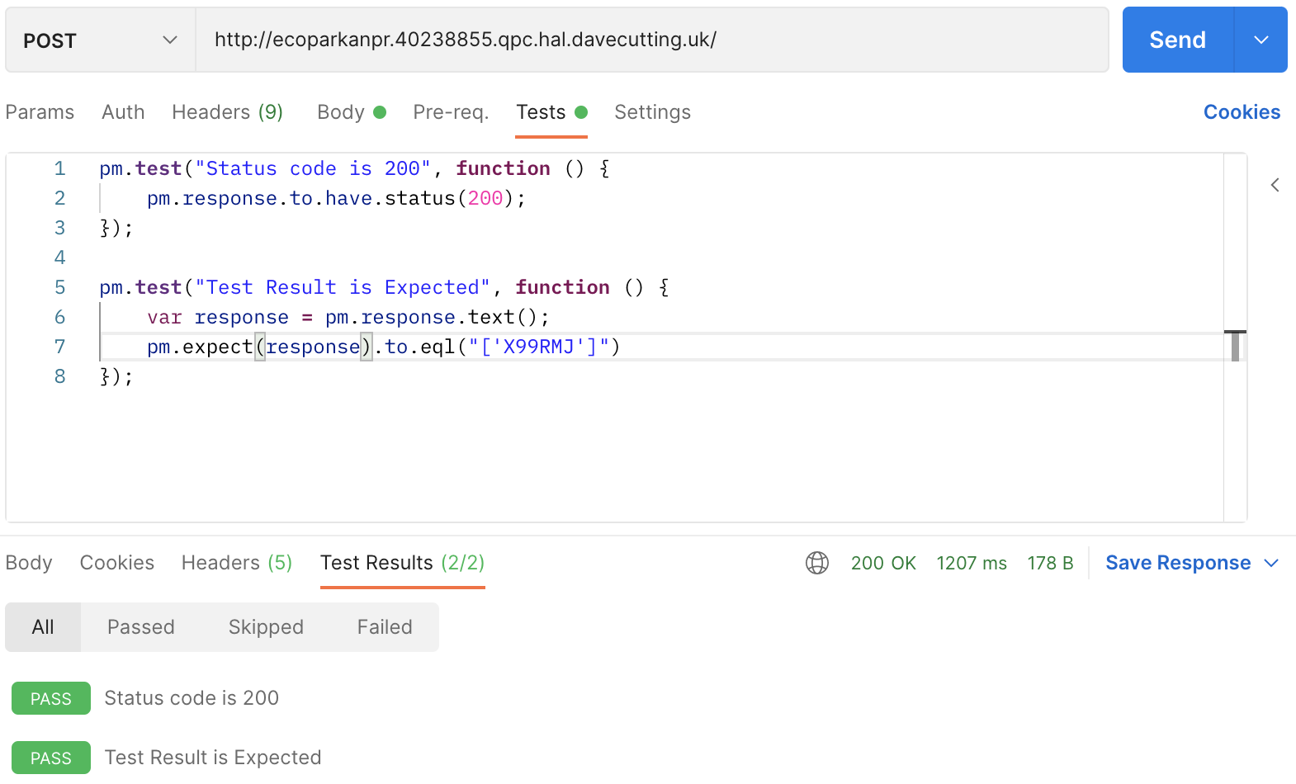

Validating response code

Validating response value