**The Relationship Between Stereotypic Thinking and the Exploration-Exploitation Spectrum**

**Introduction**

The age-old debate of nature versus nurture has often delved into whether humans are born as blank slates or inherit certain traits. This discussion extends to the question of whether our thoughts objectively represent reality or are subject to biases influenced by external factors we may not be aware of. Ulrich Neisser, in his book "Cognition and Reality: Principles and Implications of Cognitive Psychology," argues that our perception of reality is influenced by expectations, beliefs, and past experiences.

Human cognition operates through a blend of Top-down and Bottom-up processes (Sarter, Givens, & Bruno, 2001).  
Top-down processes are driven by higher-level cognitive functions, such as beliefs, expectations, and past experiences, which influence our perception and decision-making. One manifestation of this cognitive bias is stereotypic thinking, a cognitive distortion that involves making generalizations about groups of people based on their membership in that group (Fiske et al., 2002). Stereotypic thinking is influenced by various factors, including humans' natural tendency to categorize, our need for order and meaning, and our desire for security (Jost, 2006). For instance, research by John Jost has shown that individuals tend to favor their in-group over out-groups (Jost et al., 2003). This bias can manifest in various contexts, such as racial attitudes among white individuals towards African Americans (Dijksterhuis et al., 2000), and the Israeli-Palestinian conflict where both groups exhibit negative perceptions of each other (Bar-Tal & Teichman, 2005).

Conversely, Bottom-up processes are data-driven, originating from external stimuli and working their way up to higher cognitive functions. The exploration-exploitation spectrum is a well-established cognitive framework that provides insights into how individuals approach decision-making. Exploration is deeply rooted in neural mechanisms, involving associative activation in the brain (Daw et al, 2006). In the realm of exploration, individuals are characterized by a willingness to take risks (Harada, 2020), a global attention (Good & Michel, 2013), and a preference for divergent thinking (Martín-Brufau & Corbalán, 2021). Exploration can be manifested as both under- and over-exploration depending on various factors, including the context and the individual's past experiences (Good & Michel, 2013). On the other side of the spectrum, exploitation is marked by risk aversion, focused attention, and convergent thinking (Herz, Baror & Bar, 2020). Specific cortical substrates are involved in making exploratory decisions, further emphasizing the neural basis of exploitation.

Given these complexities in both exploration and exploitation, as well as the interplay between Top-down and Bottom-up cognitive processes, a critical question emerges:   
Do individuals who naturally lean towards a more explorative cognitive style—evidenced by risk-taking, global attention, and divergent thinking—exhibit lower levels of Top-down influenced stereotypic thinking when encountering people from their out-groups? This question aims to bridge the gap between these cognitive styles and stereotypic thinking, offering a comprehensive understanding of how they may interact.

**Methods**

* **Participants**

A total of 22 participants (8 men, 14 women; 3 Arabs, 19 Jews; ages 18-30) with normal vision and no cognitive impairments were recruited for the study. All participants provided informed consent, in accordance with the ethical guidelines set by Bar Ilan University.

* **Experimental Design**

The study employed a remote experimental design, consisting of four computer-based tasks administered in a randomized order on participants' personal computers.

* **Tasks**
* Implicit Association Test (IAT)

The Implicit Association Test (IAT) is designed to measure implicit biases by assessing automatic associations between contrasting social groups and evaluative attributes (Greenwald et al., 1998). In this adaptation, the focus is on Jewish and Arab names. Participants use the 'A' or 'L' keys to sort words into 14 distinct blocks. These blocks are organized into three main types: Classification of Jewish and Arab names (Figure 1.1), Classification of pleasant and unpleasant attributes (figure 1.2), and Combined tasks that mix names and attributes (Figure 1.3). Notably, the positions and pairings of these categories are switched during the combined tasks. Response times exceeding 10,000 ms were flagged.

Figure 1.1

Figure .2

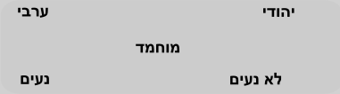

Figure 1.3

* Iowa Gambling Task (IGT)

The Iowa Gambling Task (IGT) is used to simulate real-life decision making and is often used to assess decision-making skills and risk-taking behavior (Bechara et al., 1994). Participants chose from four virtual decks (A, B, C, D) aiming to maximize profits from an initial loan of $2000. Each deck had fixed win (Figure 2.1 & 2.2) and penalty (Figure 2.3 & 2.4) rates, with a 50% chance of incurring a penalty after each card selection.

Figure .2



Figure 2.1

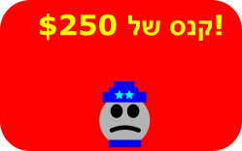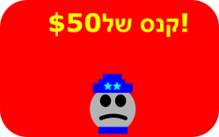

Figure 2.3

Figure 2.4

- Navon Task

The Navon Task is designed to measure how quickly people process global and local information. The basic finding is that people are faster in identifying features at the global level than at the local level, known as the global precedence effect (Navon, 1977; Navon, 2003). Participants had 50 trials and up to 4 seconds per trial to identify target letters ('H' or 'O') at either the global (Figure 3.1) or local level (Figure 3.2) or none (Figure 3.3) when, responding with a key press ('b' for presence, 'n' for absence).

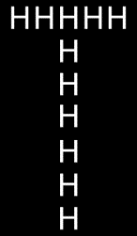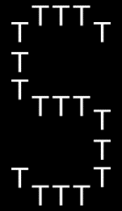

Figure 3.1

Figure 3.2

Figure 3.3

* Alternative Uses Task (AUT)

The Alternate Uses Task (AUT) is a task that measures divergent thinking by asking participants to think of as many possible uses for a common object (Guilford, 1967).  
The AUT measures divergent thinking through four metrics: Fluency, Originality, Flexibility, and Elaboration. Participants were given five objects (Paperclip, Shoe, Brick, Pen, Spoon) and asked to generate alternative uses for each, without a time constraint.

**Results**

**Calculation and Classification Methodologies**

* 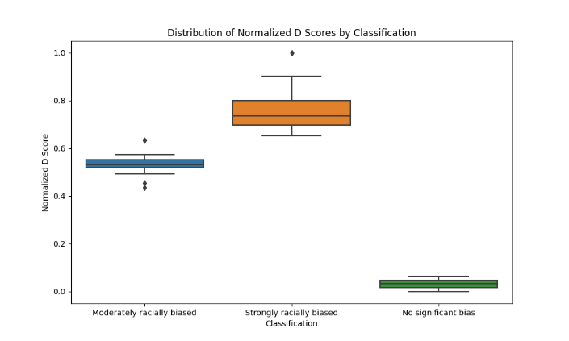Implicit Association Test (IAT) (Figure 4)

D Scores were extracted and normalized using the Min-Max normalization formula: $\{Normalized D Score\} =\{\{IAT D Score\} - \{Min D Score\}\}\backslash \{\{Max D Score\} - \{Min D Score\}\}$

Participants were classified into:

- 0: No significant bias

- 1: Moderate bias

- 2: Strong bias

Figure 4

* Iowa Gambling Task (IGT) (Figure 5)

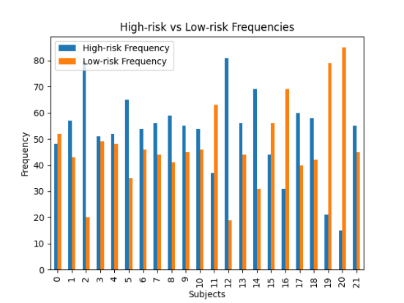Metrics such as high-risk (F{high}) and low-risk (F{low}) frequencies and average reaction times (RT{high}) and (RT{low}) were calculated.

Participants were classified into:

- 0: Risk-Averse & Impulsive

- 1: Risk-Averse & Deliberative

- 2: Risk-Taker & Deliberative

- 3: Risk-Taker & Impulsive

Figure 5

* 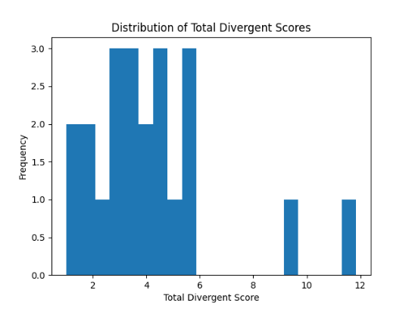Alternative Uses Task (AUT) (Figure 6)

Metrics like Fluency (F), Flexibility(X), Originality (O), and Elaboration (E ) were calculated for each idea category. The Total Divergent Score was calculated as:

$$\{Total Divergent Score\} = \{sum\{Divergent Scores\}\}\backslash \{5\}$$

* Navon Task (Figure 7)

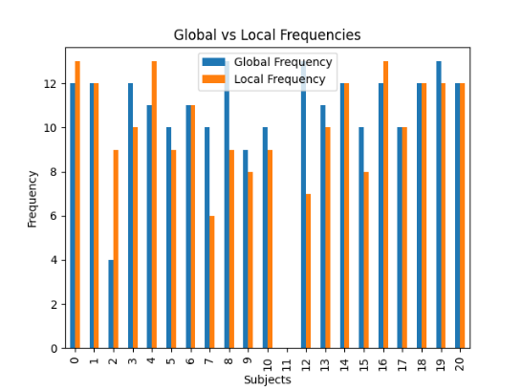Frequency (F(global)) and (F{local}) and average reaction time (RT{global}) and (RT{local}) for identifying global and local features were calculated.

Figure 6

-Participants were classified into:

- 0: Local-Focused & Slow

- 1: Local-Focused & Fast

- 2: Global-Focused & Slow

- 3: Global-Focused & Fast

**Statistical findings**

Implicit Association Test (IAT) (Figure 8)

The mean Normalized D Scores for the three groups were as follows:

Figure 7

Group 0 (No significant bias): 0.032

Group 1 (Moderate bias): 0.531

Group 2 (Strong bias): 0.773

The standard deviation for Group 2 was 0.118, indicating higher variability in their scores.

| **Descriptive Statistics** | | | | | | | |
| --- | --- | --- | --- | --- | --- | --- | --- |
|  | | **Normalized D Score** | | | | | |
|  | | **0** | | **1** | | **2** | |
| Valid |  | 2 |  | 12 |  | 8 |  |
| Missing |  | 0 |  | 0 |  | 0 |  |
| Mean |  | 0.032 |  | 0.531 |  | 0.773 |  |
| Std. Deviation |  | 0.046 |  | 0.052 |  | 0.118 |  |
| Minimum |  | 0.000 |  | 0.435 |  | 0.653 |  |
| Maximum |  | 0.065 |  | 0.633 |  | 1.000 |  |
|  | | | | | | | |

Figure 8

Total Divergent Score: A significant difference was found between the groups (F=4.732, p=0.021, η²=0.332), indicating varying levels of divergent thinking across groups.

| **ANOVA – Total Divergent Score** | | | | | | | | | | | | | |
| --- | --- | --- | --- | --- | --- | --- | --- | --- | --- | --- | --- | --- | --- |
| **Cases** | | **Sum of Squares** | | **df** | | **Mean Square** | | **F** | | **p** | | **η²** | |
| Classification IAT |  | 43.974 |  | 2 |  | 21.987 |  | 4.732 |  | 0.021 |  | 0.332 |  |
| Residuals |  | 88.280 |  | 19 |  | 4.646 |  |  |  |  |  |  |  |
|  | | | | | | | | | | | | | |

Navon Classification: No significant difference was observed (F=0.941, p=0.408).

| **ANOVA - Classification Navon** | | | | | | | | | | | | | |
| --- | --- | --- | --- | --- | --- | --- | --- | --- | --- | --- | --- | --- | --- |
| **Cases** | | **Sum of Squares** | | **df** | | **Mean Square** | | **F** | | **p** | | **η²** | |
| Classification IAT |  | 2.773 |  | 2 |  | 1.386 |  | 0.941 |  | 0.408 |  | 0.090 |  |
| Residuals |  | 28.000 |  | 19 |  | 1.474 |  |  |  |  |  |  |  |
|  | | | | | | | | | | | | | |

IGT Classification: No significant difference was found (F=0.359, p=0.703).

| **ANOVA - Classification IGT** | | | | | | | | | | | | | |
| --- | --- | --- | --- | --- | --- | --- | --- | --- | --- | --- | --- | --- | --- |
| **Cases** | | **Sum of Squares** | | **df** | | **Mean Square** | | **F** | | **p** | | **η²** | |
| Classification IAT |  | 0.583 |  | 2 |  | 0.292 |  | 0.359 |  | 0.703 |  | 0.036 |  |
| Residuals |  | 15.417 |  | 19 |  | 0.811 |  |  |  |  |  |  |  |
|  | | | | | | | | | | | | | |

**Discussion**

The crux of our study lies at the intersection of two cognitive phenomena: stereotypic thinking and the exploration-exploitation spectrum. Rooted in the age-old debate of nature versus nurture, our research aims to explore whether cognitive styles, specifically those leaning towards exploration, influence the extent of stereotypic thinking. This question is grounded in the theoretical frameworks provided by Ulrich Neisser, who posits that our perceptions are shaped by cognitive biases, and by Daw et al., who explore the neural mechanisms behind the exploration-exploitation spectrum.

Our study employed a multi-faceted approach, utilizing the Implicit Association Test (IAT), Iowa Gambling Task (IGT), Alternative Uses Task (AUT), and Navon Task to measure implicit biases, risk-taking behavior, divergent thinking, and attentional focus, respectively. Participants were classified into various groups based on statistical analyses, including mean scores, standard deviations, and ANOVA tests.

The results from the IAT revealed varying levels of racial bias across groups, with Group 2 showing the highest mean score of 0.773 and the most variability. However, when these results were cross-referenced with the IGT and AUT findings, no significant correlations were found. This suggests that, contrary to our initial hypothesis, a more explorative cognitive style does not necessarily correlate with lower levels of stereotypic thinking.

The ANOVA results further supported this, showing significant variations in divergent thinking but no significant differences in risk-taking behavior and focus level across groups. This indicates that while cognitive flexibility may vary among individuals, it does not serve as a reliable predictor for the extent of their implicit biases.

The absence of a clear correlation between implicit biases and other psychological traits suggests that more nuanced methods may be necessary for capturing the complexity of human cognition and behavior. This could include the incorporation of additional variables such as emotional intelligence or even physiological measures. The limitations of our study include sample size and the cross-sectional nature of the research, which restricts our ability to make longitudinal claims.

While our study did not conclusively support our initial hypotheses, it opens the door for further exploration into the intricate relationships between unconscious biases, risk-taking behavior, and cognitive flexibility. Future research could benefit from a longitudinal design and the inclusion of additional psychological or physiological variables.

**Bibliography**

- Neisser, U. (1976). Cognition and Reality: Principles and Implications of Cognitive Psychology. W. H. Freeman & Co.

- Sarter, M., Givens, B., & Bruno, J. P. (2001). The cognitive neuroscience of sustained attention: where top-down meets bottom-up. Brain Research Reviews, 35(2), 146-160.

- Fiske, S. T., Cuddy, A. J. C., Glick, P., & Xu, J. (2002). A model of (often mixed) stereotype content: Competence and warmth respectively follow from perceived status and competition. Journal of Personality and Social Psychology, 82(6), 878–902.

- Jost, J. T. (2006). The End of the End of Ideology. American Psychologist, 61(7), 651–670.

- Jost, J. T., Glaser, J., Kruglanski, A. W., & Sulloway, F. J. (2003). Political Conservatism as Motivated Social Cognition. Psychological Bulletin, 129(3), 339–375.

- Dijksterhuis, A., van Knippenberg, A., Kruglanski, A. W., & Schaper, C. (2000). On Making the Right Choice: The Deliberation-Without-Attention Effect. Science, 311(5763), 1005–1007.

- Bar-Tal, D., & Teichman, Y. (2005). Stereotypes and Prejudice in Conflict: Representations of Arabs in Israeli Jewish Society. Cambridge University Press.

- Greenwald, A. G., McGhee, D. E., & Schwartz, J. L. K. (1998). Measuring Individual Differences in Implicit Cognition: The Implicit Association Test. Journal of Personality and Social Psychology, 74(6), 1464–1480.

- Bechara, A., Damasio, A. R., Damasio, H., & Anderson, S. W. (1994). Insensitivity to future consequences following damage to human prefrontal cortex. Cognition, 50(1-3), 7-15.

- Navon, D. (2003). What does a compound letter tell the psychologist's mind? Acta Psychologica, 114(3), 273-309.

- Guilford, J. P. (1967). The Nature of Human Intelligence. McGraw-Hill.

- Herz, N., Baror, S., & Bar, M. (2020). Overarching States of Mind. Trends in Cognitive Sciences, 24(3).

- Harada, T. (2020). The effects of risk-taking, exploitation, and exploration on creativity. PLOS ONE, 15(7), e0235698.

- Good, D., & Michel, E. J. (2013). Individual Ambidexterity: Exploring and Exploiting in Dynamic Contexts. Journal of Psychology, 147(5), 435-453.

- Martín-Brufau, R., & Corbalán Berná, J. (2021). Foraging for New Ideas: Search and Research in Divergent Thinking Tasks. Creativity Research Journal, 33(3), 246-254.

- Daw, N., O'Doherty, J., Dayan, P., & others. (2006). Cortical substrates for exploratory decisions in humans. Nature, 441, 876–879.

**This work was performed for at least 60 hours without monetary compensation.**