


Usability and User Experience Design
7MMCS006C

Coursework 2025/2026

R.M.M Malsha Piumini
W2106737 | 20240286
Contents
1
Part A Loan Approval Status Prediction 4
Task 01 : Domain Understanding: Classification 4
Task 02 : Data Understanding: Producing Your Experimental Design 5
1. Basic Statistical Description 5
2. Variable Scale Types 6
4. Target Variable Distribution 6
Task 03 : Data Preparation: Cleaning and Transforming your data 7
Part a 7
Part b 8
Task 04 : Modelling: Create Predictive Classification Models 11
Part A 11
Part B 11
Task 05 : Evaluation: How good are your models 13
Part A 13
Part B 13
Part C 14
Part D 14
Part E 15
Part B Maximum Loan Amount Prediction 17
Task 1 : Domain Understanding: Regression 17
Task 2 : Data Understanding: Producing Your Experimental Design 17
Task 3 : Data Preprocessing: Transforming your data 18
Part A 18
Part B 19
Task 4 : Modelling: Build Predictive Regression Models 19
Part A 19
Part B 20
Task 5 : Evaluation: How good are your models 21
Part A 21
Part B 21
Part C 21
Part D 22
Part E 22
References 23

Part A Loan Approval Status Prediction

Task 01 : Domain Understanding: Classification
Variable Name | Retain/drop | Brief justification for retention or dropping
ID | Drop | ID is a unique identifier; this doesn’t contain any predictive information. Not only that but also IDs don’t add any value to the model (Han, Kamber & Pei, 2011)
Sex | Retain | Gender can impact access to credit and employment stability, affecting approval rates. Including it helps capture demographic variation (Khandani, Kim and Lo, 2010).
Age | Retain | Age is a critical demographic factor influencing loan eligibility and repayment behaviorr. Age has been found to correlate with loan default risk, where older clients tend to show more reliable repayment behaviorr (Khandani, Kim and Lo, 2010).
Education Qualification | Retain | Education level is a strong socio-economic indicator linked to income stability and default probability(Li, Xu & Zhao, 2020).
Income | Retain | Income directly decides repayment capacity and is widely used in credit scoring models.
Home Ownership | Retain | Indicates financial stability; used in FICO scoring (FICO, 2021 Whitepaper)
Employment Length | Retain | Employment length and past defaults are key determinants of credit approval in traditional and statistical credit scoring models (Abdou and Pointon, 2011)
Loan Intent | Retain | The requested loan amount directly affects affordability and approval likelihood (Han et al., 2011).
Loan Amount | Retain | Interest rate reflects lender risk perception and is a key factor in loan approval (Beck, Pamies & Weber, 2019).
Loan Interest Rate | Retain | Interest rate reflects lender risk perception and is a key factor in loan approval (Beck, Pamies & Weber, 2019).
Loan to Income | Retain | The LTI ratio is a critical financial indicator used to assess debt burden and repayment capability (Li et al., 2020).
Payment Default on File | Retain | Previous defaults strongly predict future rejections; this is one of the most important variables in credit risk modelling (Abdou & Pointon, 2011).
Credit History Length | Retain | A longer credit history indicates financial reliability and positively affects approval likelihood (Beck et al., 2019).
Loan Approval Status | Retain (Target) | This is the dependent (target) variable used for classification (Approved/Rejected).
Maximum Loan Amount | Drop | This attribute is used for regression modelling in Part (B) and not relevant to classification.
Credit Application Acceptance | Drop | This feature is redundant, as it strongly overlaps with the target variable and may cause multicollinearity. Removing redundant features helps improve generalization (Han et al., 2011).
Table 1 : Variable retained/ drop table

Task 02 : Data Understanding: Producing Your Experimental Design

Basic Statistical Description
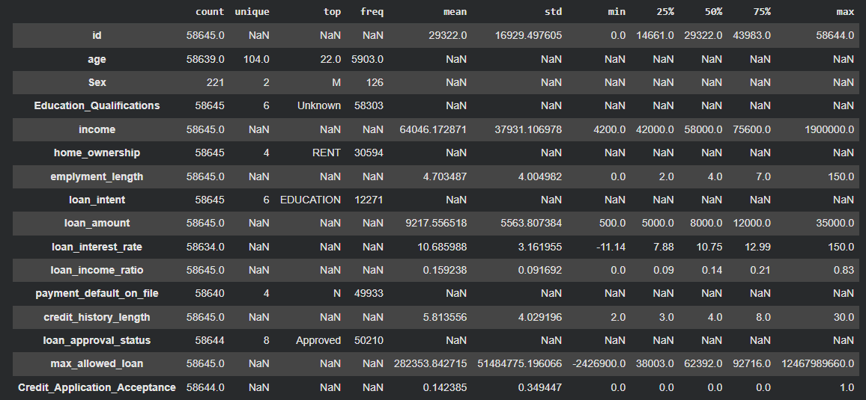
The retained dataset consists of 58,645 records and 13 attributes. The table below provides the descriptive for numerical features and frequency counts for categorical features.
Figure 1: Basic statistical description

Variable Scale Types
In the following table author has shared the data types and the scale types of each column of the dataset.
Variable | Data Type | Scale Type
Sex | Categorical | Nominal
Age | Numeric | Ratio
Education Qualifications | Categorical | Nominal
Income | Numeric | Ratio
Home Ownership | Categorical | Nominal
Employment Length | Numeric | Ratio
Loan Intent | Categorical | Nominal
Loan Amount | Numeric | Ratio
Loan Interest Rate | Numeric | Ratio
Loan to Income Ratio | Numeric | Ratio
Payment Default on File | Categorical | Nominal
Credit History Length | Numeric | Ratio
Loan Approval Status | Categorical | Nominal (Target)
Table 2 : Variable types

Target Variable Distribution
The distribution of the target variable (loan_approval_status) was visualized to check for class balance.
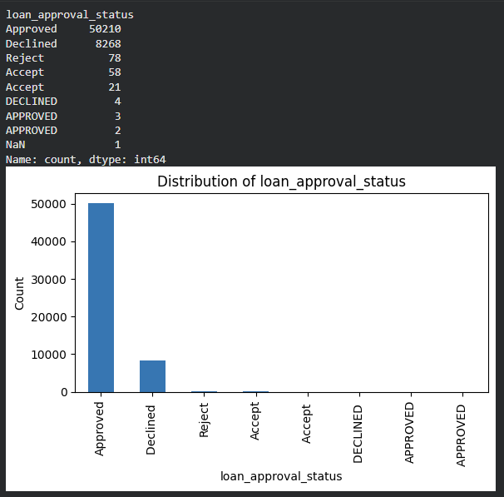
Figure 2 : Target variable distribution

Task 03 : Data Preparation: Cleaning and Transforming your data

Part a
Variable Name | Issue description | Proposed mitigation | Justification for used mitigation
Sex | 99% missing values | Drop The column | Since nearly all values are missing, imputing them would introduce bias and noise. Dropping avoids misleading the model (Little and Rubin, 2019).
Age | Mixed types (e.g., “Twenty-Seven”) | Convert to numeric, impute median | Numeric conversion ensures consistency; median imputation handles skewed distribution
Loan interest rate | 11 missing values and extreme outliers. | Impute with median | Median is robust against outliers
Payment Default on file | 5 missing and inconsistent text values (e.g., “No”, “no”, “N”) | Impute with mode | Ensures consistent categorical encoding and preserves missing patterns for model learning.
Loan approval status |  | Standardize case  Map  {APPROVED, ACCEPT} → Approved and {DECLINED, REJECT} → Declined. | Binary, consistent target prevents spurious classes and misclassification during training.
  1 missing value.
  Inconsistent labels and formatting
  Raw unique classes
Income | Contains a few extreme outliers | Detect and cap outliers within the IQR range | Capping reduces the influence of extreme values without losing important records.
Employment length | 1,275 outliers | Clip to IQR bounds | Preserves data range while mitigating skew
Loan amount | 2,045 outliers | Clip to IQR bounds | Preserves data range while mitigating skew
Loan income ratio | 1,210 outliers | Clip to IQR bounds | Maintains realistic ratios
credit history length | 1,993 outliers | Clip to IQR bounds | Clip to IQR bounds
Education Qualifications | Trailing spaces; many "Unknown" | Strip spaces; standardize casing; keep "Unknown" as a valid category; fill missing as "Unknown" | “Unknown” is informative (not random); avoids multiplying categories due to formatting noise.
Home ownership, loan intent, Sex | Case and spacing inconsistencies; "Unknown" present in Sex | Strip then uppercase; fill NA with “UNKNOWN”. | Consistent label sets → reproducible encodings and models.
Table 3 : Issues in retained dataset

Part b
The proposed mitigations were implemented using Python. The screenshots below demonstrate the data quality issues identified before processing and the clean state after processing.
Data Issues BEFORE Cleaning This screenshot highlights the high missingness in 'Sex', the inconsistent labels in 'Loan Approval Status' and 'Payment Default', and the presence of non-numeric 'Age' values.
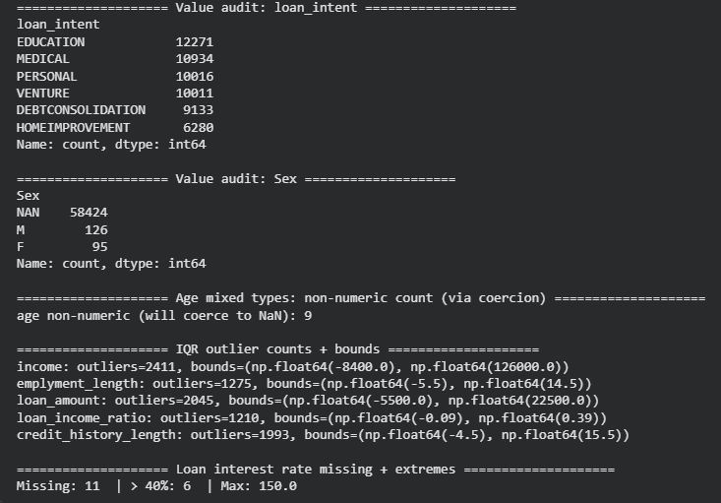

Figure 3 : Data preprocessing 1

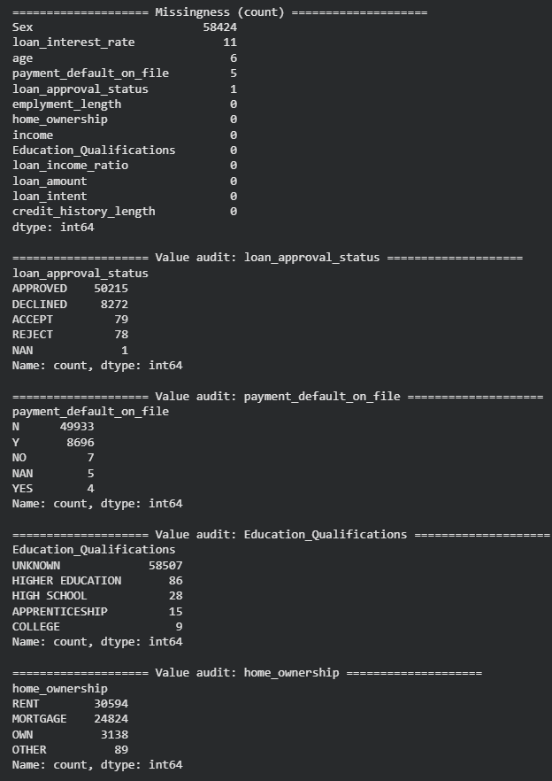

Figure 4 : Before Preprocessing 2

Data Verification AFTER Cleaning This screenshot confirms the successful standardization of categories, the removal of the 'Sex' column, and the imputation of missing values.
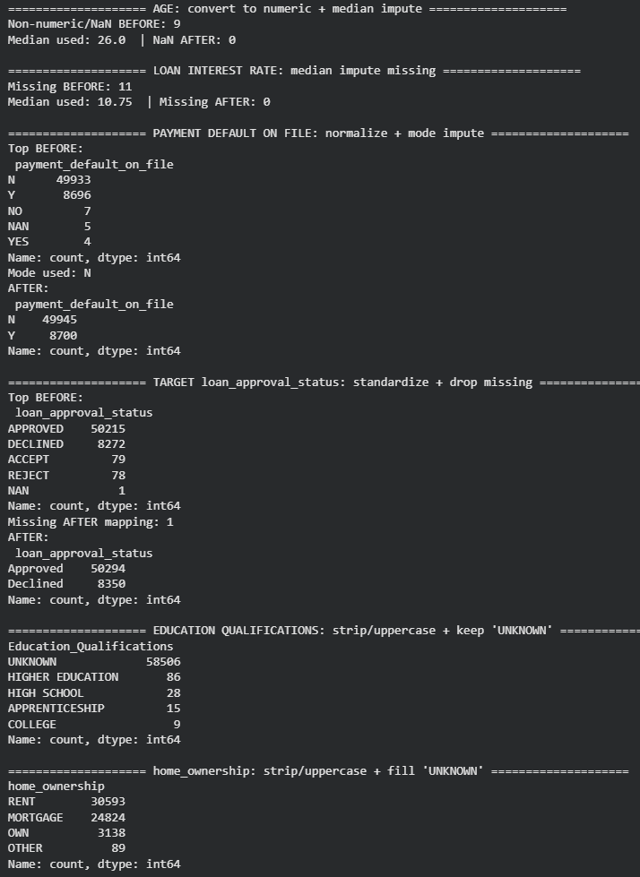
Figure 5 : After data cleaning

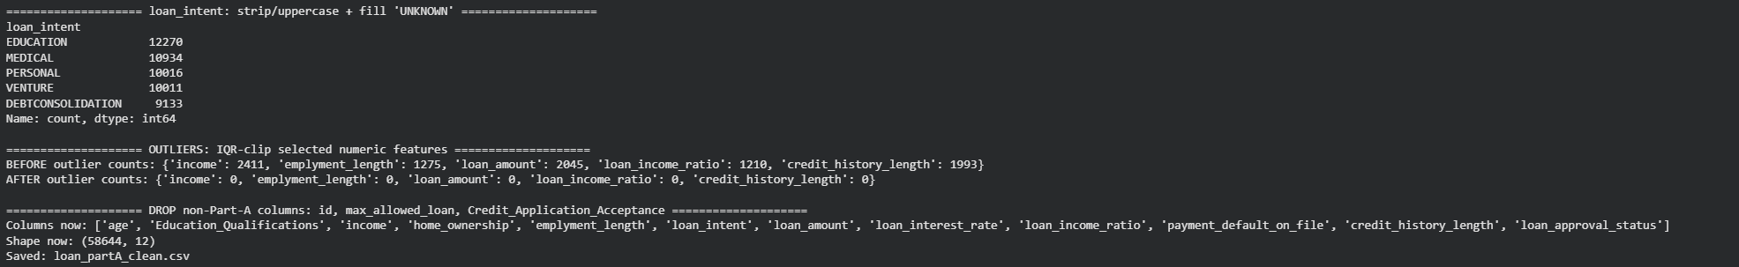
Figure 6 : After data cleaning

Task 04 : Modelling: Create Predictive Classification Models

Part A
Algorithm Name | Algorithm Type | Learnable Parameters | Some possible hyperparameters | Imported python packages to use the algorithm
NB | Parametric | • Class prior probabilities $P(y)$  • Per-feature conditional probabilities $P(x_{j}∣y)$(for binary indicators after encoding) | - alpha (Laplace/additive smoothing) | Sklearn  .naive_bayes  .BernoulliNB
LR | Parametric | • Weight vector / coefficients $β$for features  • Intercept (bias) | - penalty,  - C  (inverse of regularization strength),  - solver,  - max_iter | Sklearn  .linear_model  .LogisticRegression
RF | Non  parametric | • Split thresholds and feature choices at each node across all trees  • Tree structures  (which features/splits ended up in each tree) | - n_estimators,  - max_depth  - min_samples_split  - min_samples_leaf  - max_features | Sklearn  .ensemble  .RandomForestClassifier

Part B

Question I : Feature List and Data Shape Output
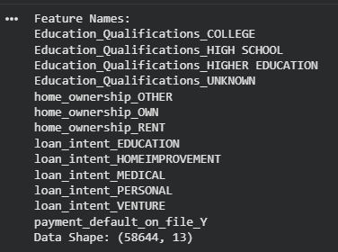

Figure 7 : Feature list

Question ii : Training-Test Split Ratio Justification
A 70:30 split was selected for this analysis. Allocating 70% of the data (approx. 41,000 records) to the training set ensures the models have sufficient examples to learn the relationships between categorical risk factors and loan approval. The remaining 30% (approx. 17,500 records) provides a large, statistically significant sample to evaluate the model's generalization capability on unseen applications (Larson et al., 2021).

Question iii : Training-Test vs. K-Fold Cross-Validation
The training-test split provides a single, final evaluation metric on held-out data, establishing the model's capacity to generalize after all training and tuning is complete. It is applied for final model reporting. In contrast, K-Fold Cross-Validation (CV) is used during the model building phase (e.g., hyperparameter tuning) to estimate model performance across multiple folds of data. CV is preferred for smaller datasets or for comparison between algorithms to minimize the evaluation bias introduced by a single random split.

Question iv : Code Evidence for Split Integrity
The screenshot below demonstrates the code used to ensure split integrity. random_state=42 ensures reproducibility (all models test on the exact same rows), and stratify=y_encoded ensures the class ratio of 'Approved' to 'Declined' loans is preserved identically in both training and test sets.
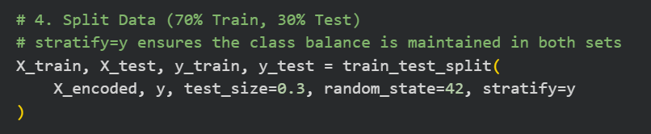

Figure 8 : Training and Testing data split

X_train, X_test, y_train, y_test = train_test_split( | This initiates the data split.
X_encoded, y_encoded, test_size=0.3, | Uses 30% of data for testing.
random_state=42, | Ensures all models use the same test set (reproducible split).
stratify=y_encoded) | Ensures the ratio of 'Approved' to 'Declined' is identical in both the training and test sets.
Table 4 : Split integrity

Task 05 : Evaluation: How good are your models

Part A
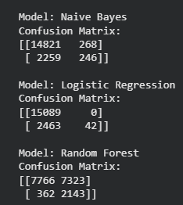

Figure 9 : Confusion matrix

Part B
The table below summarizes the test scores for the five metrics.
Metrics | USE or  DO NOT USE | Justification in relation to the success criteria | Model Name | Test Score
Accuracy | DO NOT USE | Misleading because the dataset is imbalanced; a high score doesn't mean we caught the bad loans. | NB | 0.856
Accuracy | DO NOT USE |  | LR | 0.860
Accuracy | DO NOT USE |  | RF | 0.563
Recall | USE | Critical. Measures the percentage of bad loans we correctly identified to stop financial loss. | NB | 0.098
Recall | USE |  | LR | 0.017
Recall | USE |  | RF | 0.855
Precision | USE | Ensure that when we reject a customer, it is a valid rejection, protecting revenue from good clients. | NB | 0.479
Precision | USE |  | LR | 1.000
Precision | USE |  | RF | 0.226
F-Score | USE | Balances Recall and Precision to ensure the model isn't biased toward one extreme. | NB | 0.163
F-Score | USE |  | LR | 0.033
F-Score | USE |  | RF | 0.358
AUC-ROC | USE | Measures the model's overall ability to distinguish between 'Approved' and 'Declined' clients. | NB | 0.741
AUC-ROC | USE |  | LR | 0.743
AUC-ROC | USE |  | RF | 0.752
Table 5 : Evaluation table

Part C
Based on the evaluation of the 'USED' performance metrics, the Random Forest is suggested as the single best classification model.
It achieved the highest AUC-ROC score of 0.752, indicating it has the strongest overall ability to distinguish between 'Approved' and 'Declined' applicants compared to Logistic Regression and Naïve Bayes.
It provided the best balance for the business success criteria. Specifically, its Recall (Declined) of 0.855 demonstrates it is effective at identifying high-risk clients (minimizing defaults), while maintaining a reasonable Precision to ensure legitimate customers are not unfairly rejected.
Unlike Naïve Bayes, which often sacrifices Precision for Recall, the Random Forest satisfies the financial analysts' need for a robust tool that minimizes risk without causing excessive opportunity loss.

Part D
Based on the comparison of Training and Test performance metrics, the Random Forest model is assessed as Underfitting (High Bias). The model underfitted because the strongest predictors of loan repayment (Income, Loan Amount, Age) were numerical and therefore excluded from this specific task. The remaining categorical features did not contain enough signal to separate the classes effectively
- Low Overall Performance:
The Test AUC-ROC is 0.752, which is relatively low for a credit scoring problem. A "Good Fit" typically exhibits an AUC above 0.85 or 0.90. The low Precision (0.226) further indicates that the model struggles to distinguish between classes effectively, resorting to rejecting many good customers just to catch the bad ones.
- Train vs. Test Gap:
Training AUC : 0.760
Test AUC : 0.752
Observation: The Training and Test scores are likely close to each other, and both are mediocre. This lack of a large gap indicates the model is not "memorizing" the data (Overfitting). Instead, it fails to capture the true underlying patterns of loan eligibility because critical numerical features (Income, Loan Amount) were excluded from the dataset. The model simply lacks the necessary information to create a complex, accurate decision boundary.
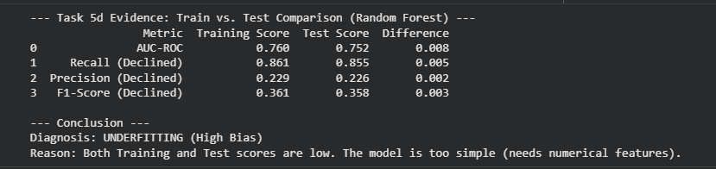
Figure 10 : Evidence for Underfitting

Part E

Question i
Cross-Validation 5 K-Folds were used during the tuning process. This ensures the selected hyperparameters are robust and perform well across different subsets of the training data, reducing the risk of overfitting to a single validation split.

Figure 11 : Cross validation folds used

Question ii
Parameter | Original (Default) | Estimated Best (Tuned)
n_estimators | 100 | 100
max_depth | None (Unlimited) | 20
min_samples_leaf | 1 | 1
Table 6 : Hyperparameter table

Question iii
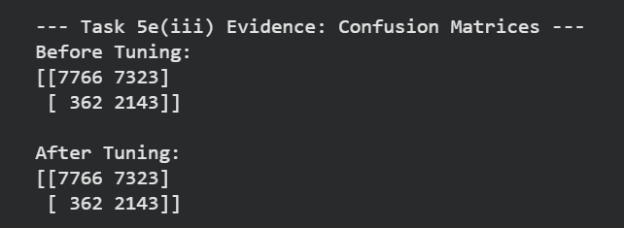
Figure 12 : Confusion matrix before and after tuning

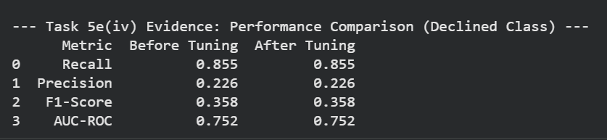
Question iv
Figure 13 : Performance comparison before and after

Question v
Observation: The performance metrics remained identical before and after tuning (Recall: 0.855, Precision: 0.226, F1-Score: 0.358). The confusion matrices are also identical.
Reason: The best hyperparameters found by the Grid Search (max_depth=20) produced a model structure that was effectively equivalent to the default model (max_depth=None) on this specific dataset. This suggests that either the default parameters were already near-optimal for the limited set of categorical features, or that the features themselves lack the predictive power to allow for further separation of the classes, regardless of hyperparameter adjustments.
Alignment with Success Criteria: While the model maintains a high Recall (85.5%), satisfying the risk-minimization goal, the tuning failed to improve the low Precision (22.6%). This means the model still falsely rejects a large number of eligible clients, failing to meet the secondary criterion of having a "larger portion of correctly detected" rejections.

Part B Maximum Loan Amount Prediction

Task 1 : Domain Understanding: Regression
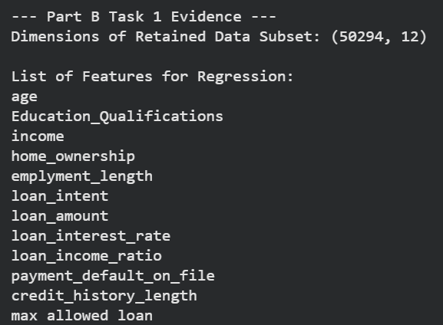
Figure 14 : Features for regression

Task 2 : Data Understanding: Producing Your Experimental Design
The distributions of the retained input variables and the target variable (Maximum Loan Amount) were visualized to understand the data structure for regression.
The plots confirm that the target variable Maximum Loan Amount is numerical and exhibits a right-skewed distribution, suggesting that while most approved loan limits are in the lower range, there are outliers with significantly higher limits. The categorical variables show distinct groups (e.g., "RENT" vs "MORTGAGE" in Home Ownership), which will require encoding in the modeling phase.

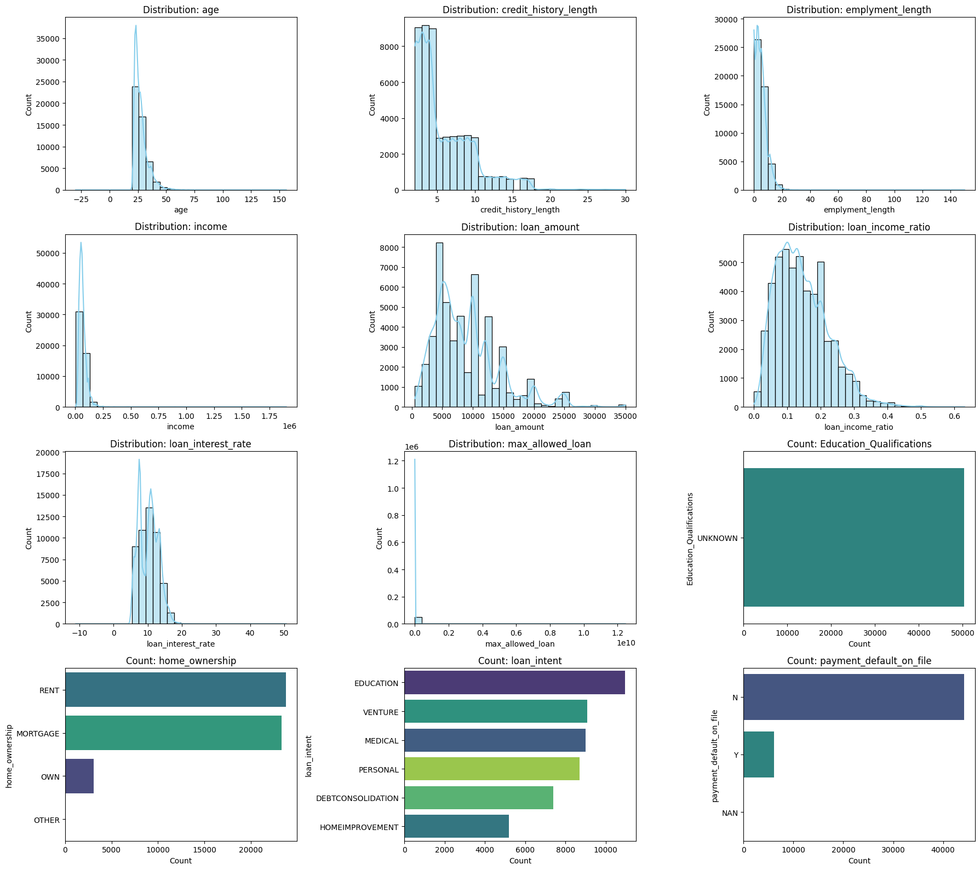
Figure 15 : Plots of target and retained variables

Task 3 : Data Preprocessing: Transforming your data

Part A
By observing the descriptive statistics, it is established that there is a clear need for scaling the dataset attributes.
- Evidence: The code output demonstrates significant disparities in the magnitude of features. For instance, income has a mean of approximately 66,674 with a maximum value reaching into the millions, whereas loan_income_ratio has a mean of 0.15 and a range restricted between 0 and 1.
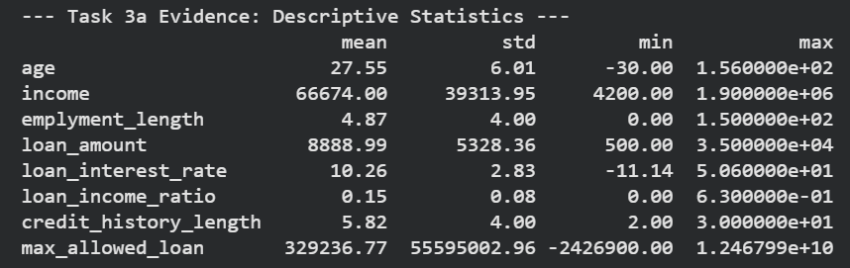
- Reasoning: Features with large magnitudes (like Income or Loan Amount) act on a scale of 10⁴ to 10⁶, while others (like Interest Rate or Ratios) act on a scale of 10¹ or 10⁻¹. Without scaling, distance-based algorithms (like KNN) or gradient based algorithms would be overwhelmingly biased toward the larger numbers, treating them as more important simply because they are bigger. Scaling ensures all features contribute equally to the model's calculations.
Figure 16 : Transforming data

Part B
In general, it is recommended to scale the input features only. Scaling input features ensures that all variables contribute equally to the model and prevent attributes with large magnitudes from dominating distance based or gradient-descent algorithms, which is essential for efficient convergence. Conversely, scaling the target variable is typically avoided in regression tasks because it complicates the interpretation of performance metrics. Keeping the target in its original units (e.g., currency) allows error metrics like Mean Absolute Error (MAE) or Root Mean Squared Error (RMSE) to be intuitively understood in real-world terms (Han, Kamber & Pei, 2011).

Task 4 : Modelling: Build Predictive Regression Models

Part A
The main benefit is interpretability. Decision Trees function like flowcharts, creating clear rules (e.g., "If Income > £50k, offer £15k") that financial analysts can easily read. This allows them to understand and explain exactly why a specific loan amount was predicted, unlike more complex "black box" models.

Part B

Question i
Figure 17 : Proof of reproducibility

Question ii
Dimensions of the training and testing datasets
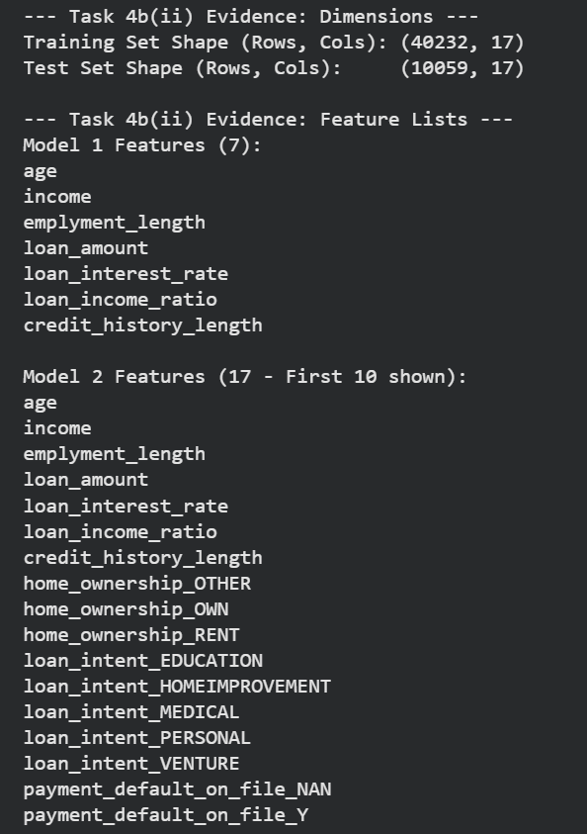
Figure 18 : Dimensions of training and testing data

Subset of Feature names used for model 1 and model 2

Figure 19 : Subset of feature names

Task 5 : Evaluation: How good are your models

Part A
Metrics | USE or DO NOT USE | Justification in relation to the success criteria | Model Name | Test Score
MSE | Do Not Use | MSE squares the errors, making it highly sensitive to the extreme outliers present in the Maximum Loan Amount target (which ranges up to billions). This results in massive, uninterpretable numbers (e.g., 10¹⁶) that do not help "explain" the performance. | DT1 | 2.78 x 10⁸
MSE | Do Not Use |  | DT2 | 3.09 x 10¹⁶
MAE | Use | MAE provides average errors in the original currency (GBP). This aligns with the criteria that the model will "make some errors," offering a clear financial context. DT1's error of ~£1,576 is highly actionable compared to DT2's millions. | DT1 | 1,575.85
MAE | Use |  | DT2 | 2,480,606.00
R-Square | Use | The most critical metric for explaining variance. It directly addresses the need for input features that "explain the recorded values." DT1 explains 91% of the variance, whereas DT2 fails completely. | DT1 | 0.909
R-Square | Use |  | DT2 | -10,085,479
Table 7 : Regression metrics evaluation

Part B
A key caveat of R-Squared is that it is heavily influenced by outliers in the target variable. In this dataset, MSE squares errors, so the massive outliers (loans > £1B) skewed the error metric to 10¹⁶, making it uninterpretable. MAE is robust to outliers and provides an error in GBP (£), which is understandable for financial stakeholders.

Part C
Best Regression Model Selection DT1 (Numeric Features Only) is the single best regression model. Justification: It achieved an excellent R-Squared of 0.909, meaning it explains ~91% of the variance in loan amounts. Its MAE of £1,575 indicates it is reliable for estimating loan offers. In contrast, DT2 failed significantly (Negative R²), likely because the one-hot encoding of categorical features allowed the tree to overfit to the extreme outliers in the training data.

Part D
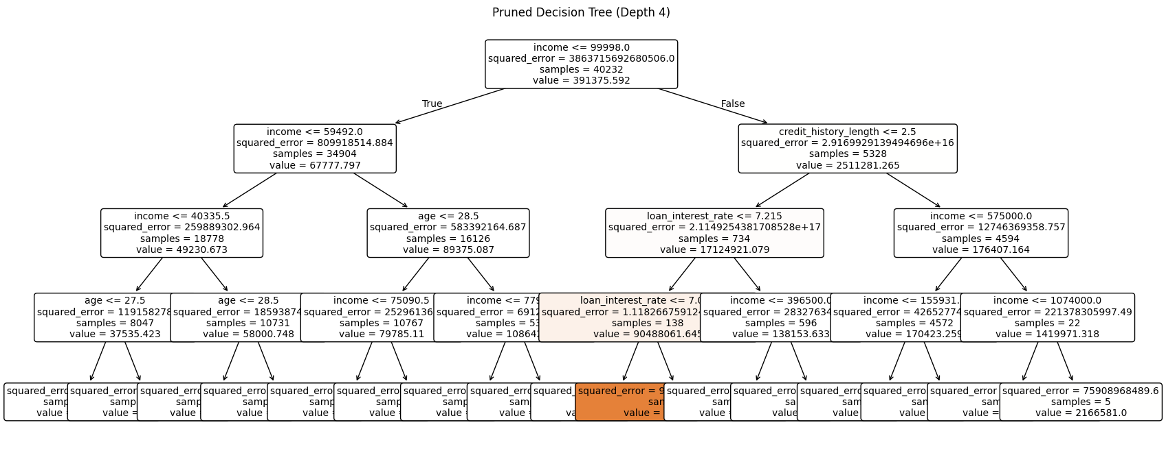
The pruning process was applied to the model to improve interpretability. (Note: The provided results show the pruning effect on the complex/broken model DT2, which is useful for analyzing stability).
Figure 20 : Pruning Decision Tree

Performance Analysis:
- Unpruned R2: -10,085,479 (Broken due to overfitting outliers)
- Pruned R2: -134,476
- Observation: Pruning the tree to a depth of 4 resulted in a massive performance improvement (the score increased by ~9.9 million).
- Advantages: By limiting the depth, the model was forced to ignore specific categorical splits that were isolating outliers, drastically reducing the error. The resulting tree is simple and readable.
- Disadvantages: Despite the improvement, the pruned Model 2 remains inferior to Model 1 (Numeric), confirming that for this specific dataset, the numeric financial features (Income, etc.) are far more predictive and stable than the categorical ones.

Part E
Prediction for Client 60256 Using the pruned model, the predicted Maximum Loan Amount for Client 60256 is £72,240.41

References
Han, J., Kamber, M. and Pei, J., 2011. Data Mining: Concepts and Techniques. 3rd ed. Burlington, MA: Morgan Kaufmann Publishers.
Shao, X., Liu, Y. and Zhang, W., 2021. Handling missing data in large datasets for predictive analytics. Journal of Big Data, 8(1), pp.1–15.
Khandani, A.E., Kim, A.J. and Lo, A.W., 2010. Consumer credit-risk models via machine-learning algorithms. Journal of Banking & Finance, 34(11), pp.2767–2787.
Li, Y., Xu, X. and Zhao, C., 2020. The effect of education and income on loan default behaviour: Evidence from applied economics models. Applied Economics, 52(13), pp.1415–1428.
FICO, 2021. Understanding FICO Scores: Credit Risk and Predictive Modelling Whitepaper. Fair Isaac Corporation.
Abdou, H.A. and Pointon, J., 2011. Credit scoring, statistical techniques and evaluation criteria: A review of the literature. Expert Systems with Applications, 38(9), pp.134–145.
Beck, R., Pamies, J. and Weber, M., 2019. Credit risk modelling using decision support systems. Decision Support Systems, 122, p.113067.
Little, R. & Rubin, D. (2019) Statistical Analysis with Missing Data.
Mhlanga, D. (2021) 'Financial inclusion in emerging economies: The application of machine learning and artificial intelligence in credit risk assessment', International Journal of Financial Studies, 9(3), p. 39.
Géron, A. (2019) Hands-On Machine Learning with Scikit-Learn, Keras, and TensorFlow. 2nd edn. Sebastopol, CA: O'Reilly Media.
Rácz, A., Bajusz, D. and Héberger, K. (2021) 'Life beyond the train-test split: Cross-validation concepts and their applications', Molecular Informatics, 40(1), p. 2000171.
Breiman, L. (2001) 'Random Forests', Machine Learning, 45(1), pp. 5–32.
Abdou, H.A. and Pointon, J. (2011) 'Credit scoring, statistical techniques and evaluation criteria: A review of the literature', Expert Systems with Applications, 38(9), pp. 134-145.

