Team No: Team 7

Class: CSE 3330; Fall 2023

Module: Project 2 Part 3

Deliverable: Project 2 Part 3 Document

Date: 12/03/2023

Contributors:

Abhisekh Bajracharya

Chanuthi Subasinghe

Richard Olu Jordan
HONOR CODE

I pledge, on my honor, to uphold UT Arlington’s tradition of academic integrity, a tradition that values hard work and honest effort in the pursuit of academic excellence. I promise that I will submit only work that I personally create or that I contribute to group collaborations, and I will appropriately reference any work from other sources. I will follow the highest standards of the spirit of the Honor Code.

TABLE OF CONTENTS

1. Introduction

2. Create Database Tables

3. Load Data Into Database Tables

4. TASK 1: SQLite Terminal Queries

QUERY 1 Query description: Add an extra column ‘Late’ to the Book_Loan table. Values will be 0-for nonlate returns, and 1 for late returns. Then update the ‘Late’ column with '1' for all records that have a return date later than the due date and with '0' for those were returned on time.
Query for Query 1: ALTER TABLE Book_Loans ADD Late INT; UPDATE Book_Loans SET Late = (CASE WHEN (Book_Loans.Returned_date BETWEEN Book_Loans.date_out AND Book_Loans.due_date) THEN 0 ELSE 1 END); SELECT * FROM Book_Loans;

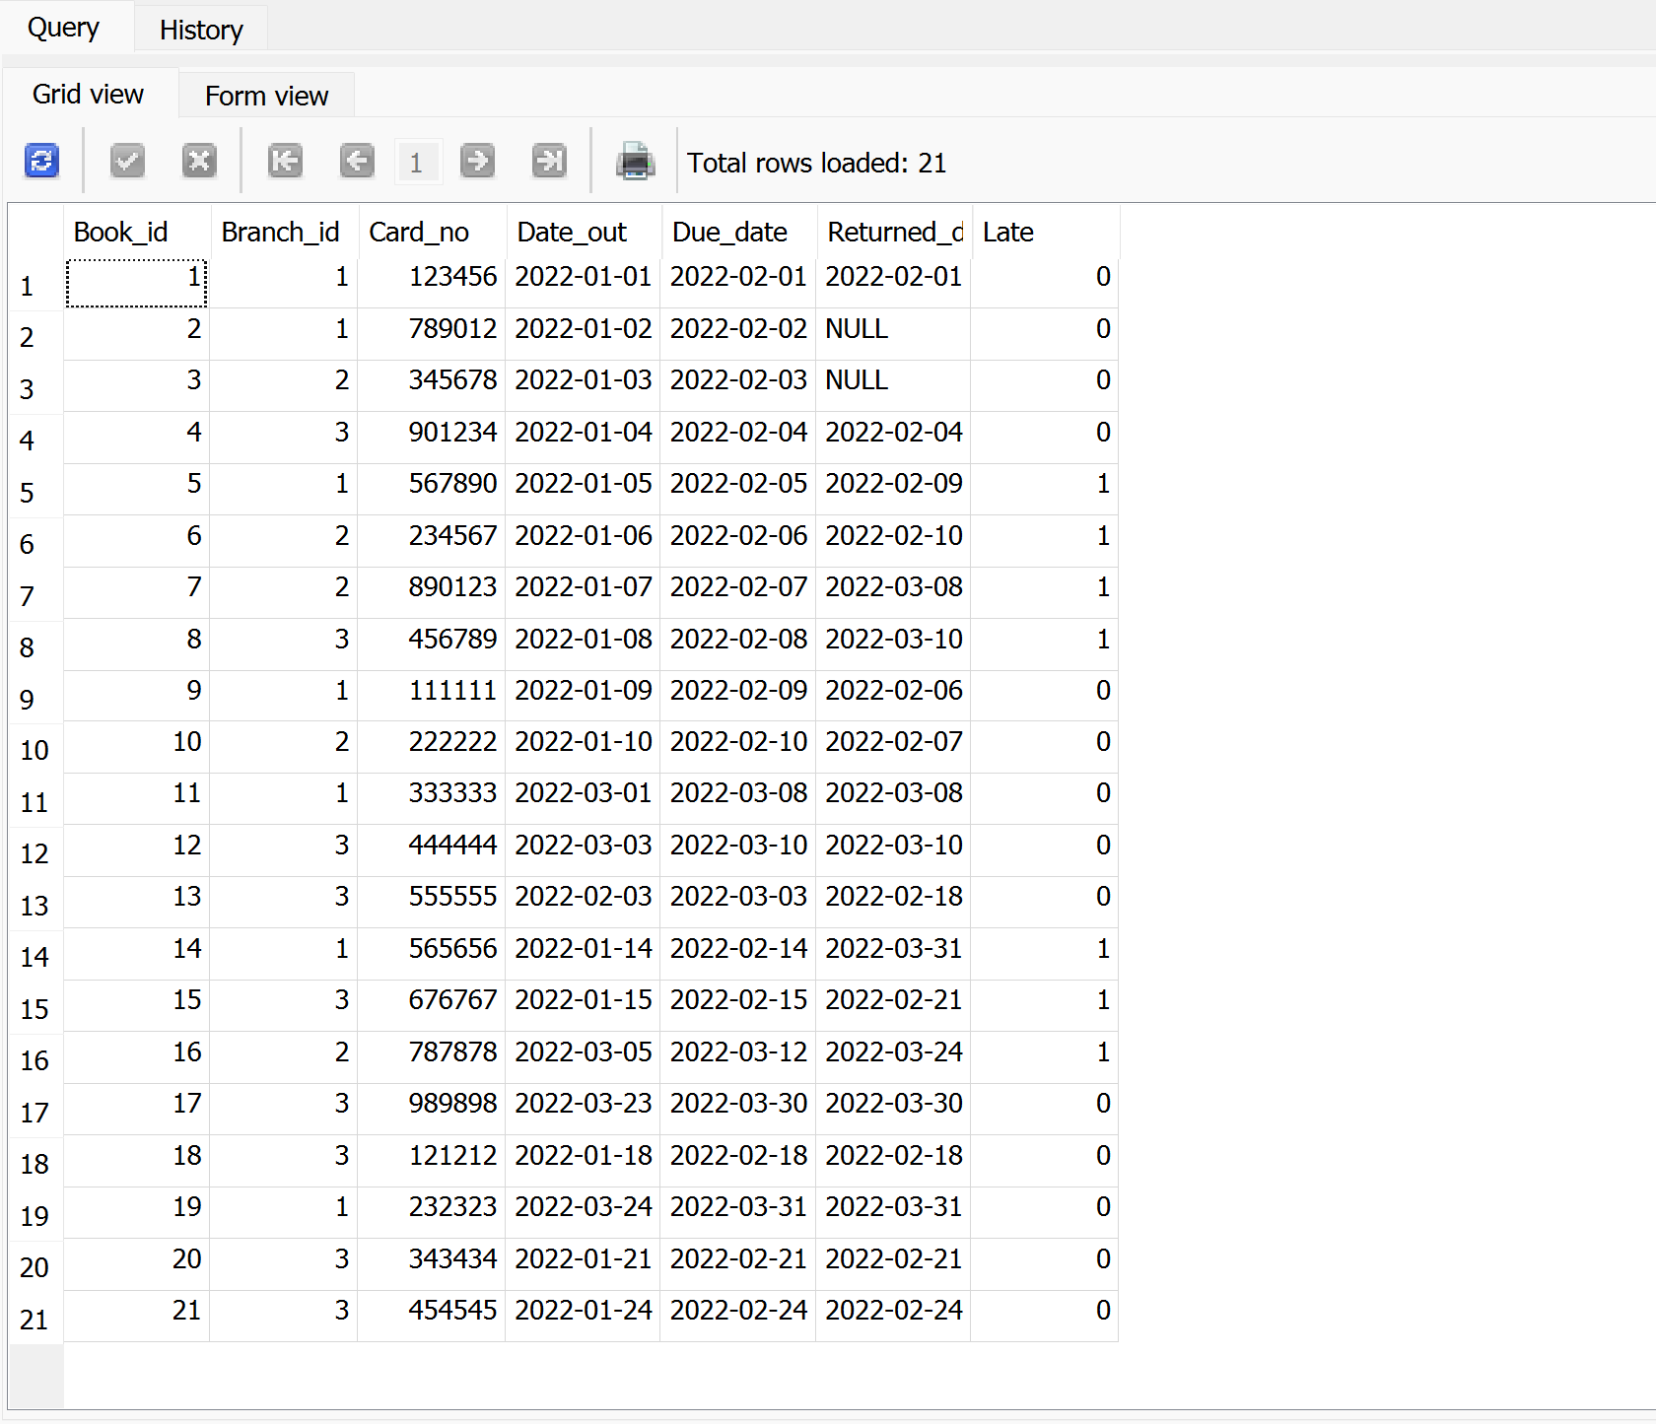

5. TASK 2: GUI Interface Queries

6. Team Contributions List

