**Framework Setup**

# About this document:

This document provides an overview of the contents of our software package (provided on our GitHub[1] repo). It explains the different software projects that you can find and the steps that you need to take to compile and run them yourself. Support is exclusively provided for Windows 10 or 11.

Our software package assumes a working setup i.e., Acoustophoretic boards, firmware, and any necessary calibration data, as our examples require these to run. Also, most of our current examples are specifically designed for top-bottom board setups. However, other setups can be used.

# Folder Overview:

Our content is structured in the following sub-folders, each of them focussing on a key aspect related to a software package:

1. **Libraries (zipped)**: We provide a compilation of pre-compiled binaries for all the libraries we use to avoid compatibility issues. This folder contains all you need to run our software straight away with setup instructions provided below.
2. **OpenMPD**: This folder contains the core algorithms supporting our development. It contains our board controller and a set of supported high-performance multi-point solvers (*GS-PAT*, IBP, and naive). These components are developed in C++ and their source code, together with documentation and example applications (in C++) can be found in this subfolder.
3. **OpenMPD_Client**: In an effort to make development easier, we integrated our core algorithms into the Unity 3D game engine. This sub-folder contains the Unity implementation, as well as a set of application examples about the use of the main components of the framework (main structure, primitives and tools).

These files can be found in our online repository (GitHub[2]) together with the full *OpenMPD* framework tutorial.

# Installation procedure:

## Tools required:

Running our software requires the following software tools to be installed on your home computer.

1. **Microsoft Visual Studio** **(Toolset v141 [vs2017] or v142 [vs2019])**: Any version of Visual Studio will work provided you install **v141** or **v142**of the C++ toolset , you must also install C# if you want to use our Unity integration. We used either [Visual Studio 2017](https://docs.microsoft.com/en-us/visualstudio/install/install-visual-studio?view=vs-2017) and [Visual Studio 2019](https://docs.microsoft.com/en-us/visualstudio/install/install-visual-studio?view=vs-2019) during development, and are the versions we recommended.
2. **OpenCL SDK:** Our solver uses OpenCL, you will need to get a suitable developer SDK, this depends on your GPU manufacturer (Nvidia, AMD, Intel). Although OpenCL implementations should work on any GPU platform, all our development environments utilise NVIDIA GPUs and their [CUDA Toolkit](https://developer.nvidia.com/cuda-toolkit). GPU driver version is also an important component to include in this installation, it can be done by Nvidia Experience software (<https://www.nvidia.com/en-gb/geforce/geforce-experience/>).
3. **Unity (optional)**: You will need this if you want to create applications in C#. We used version 2019.3.4f1, however it should be compatible with any version.

## System requirements:

* **Windows 10 or 11**: Our software was developed for these platforms. Using a different version of Windows might be possible, but will require you to change the “*Software SDKs*” in the Properties of your Visual Studio C++ project.
* **Graphics Card:** Our OpenCL solver requires workgroup sizes of at least 512 compute units. This is well within the capabilities of current GPUs, but you can check these running applications such as [GPU_Caps_Viewer](https://gpu-caps-viewer.softonic.com/). Due to this requirement, it is highly recommended to use an external graphics card with up to date drivers (e.g., NVIDIA and Cuda SDK) when running these examples. We have found success using laptops with powerful graphics cards provided ‘optimus’ is disabled in the BIOS, i.e., you must disable any integrated graphics card making sure only the discrete graphics card is being utilised.

## Installation steps:

Please follow the steps below once you have downloaded and installed the tools above making sure that Visual Studio is closed during the process.

* **Clone the Libs repository “*OpenMPD_libs*”** (from our GitHub[3]), unzip it and store it in a local folder on your computer. You will need to use the path to this local folder later (step 4). We strongly advise not placing the libs folder anywhere which Microsoft Onedrive manages.
* **Declare a LIBS_HOME environment variable**, pointing to your local folder:

1. Go to “*Control Panel*”🡪 “*System and Security*”🡪 “*System*”.
2. On the left side panel, click on “*Advanced System Settings*” (requires admin/elevated rights).
3. The *System Properties* dialogue box will open (see Figure 1, left), showing the tab “*Advanced*”. Click the “*Environment Variables*” button to the bottom right of the dialogue box.
4. The *Environment Variables* dialogue box will open (see Figure 1, right). In the bottom panel (System variables), select “*New*”.

* Enter LIBS_HOME as your “*Variable Name*”.
* Copy the path to the folder as your “*Variable Value*”. The path should point inside the unzipped folder (e.g. *“<path_to_your_folder>\0.libraries*”).
* Click “*OK*”

1. If you are using an NVIDIA GPU then please install the CUDA SDK, and the NVIDIA Experience to keep your drivers updated. Once installed, you can check if your CUDA SDK installation created its environment variable correctly (variable CUDA_PATH should appear in your System variables), otherwise you will need to do it manually by repeating the step 4 (using CUDA_PATH as a variable name and the path pointing to the CUDA installation as the variable value). To avoid driver issues, please install the latest drivers for the NVIDIA graphics card drivers before running the *OpenMPD* framework.
2. Make sure that in the Visual Studio installation, the module “desktop development with c++” is included to avoid any potential compilation issues. Alternatively, open Visual Studio Installer and click on modify, then add this module by ticking the box on it and pressing the modify button on the bottom-left of the window.

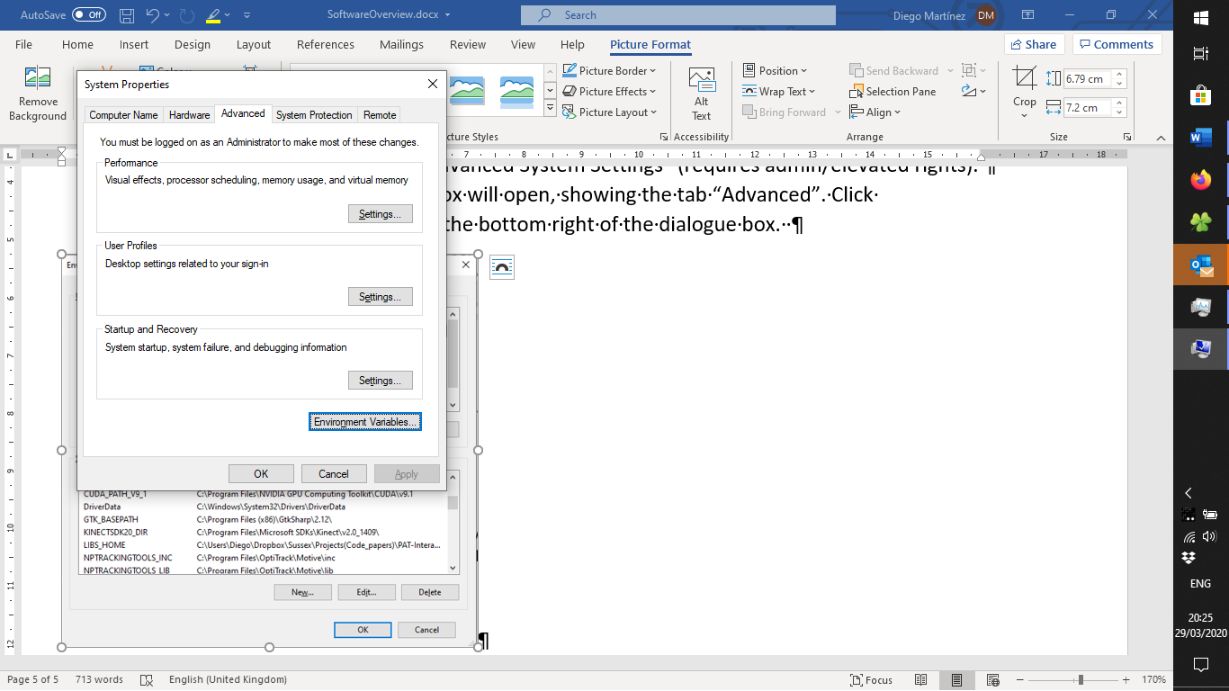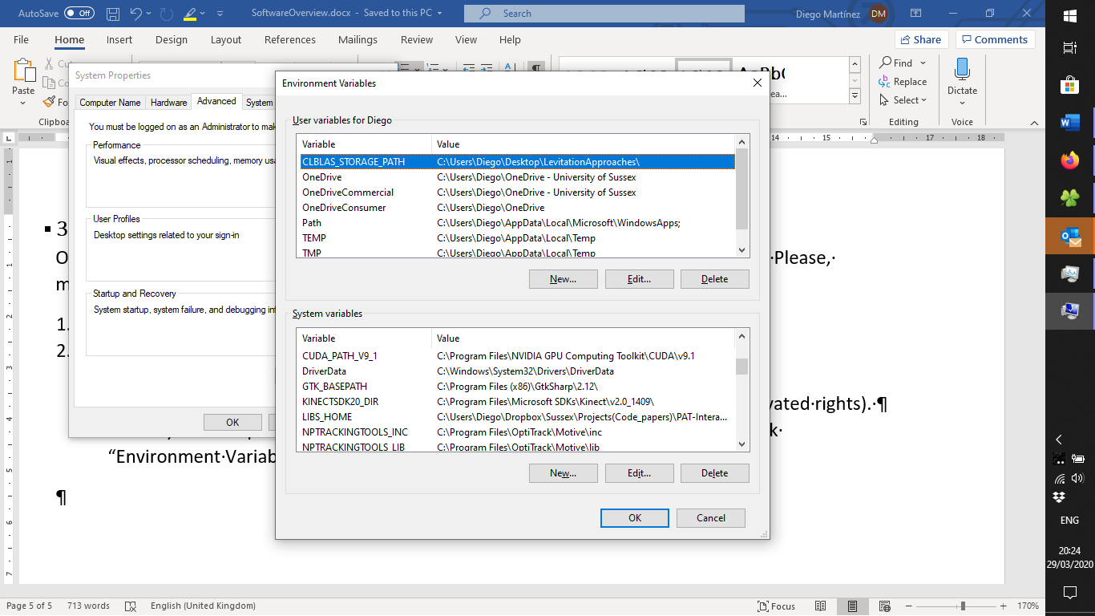

Figure 1: Creating your LIBS_HOME environment variable.

* **Compiling C++ project:** If the steps above were successful, you should be able to open, compile, and run our C++ project. Please refer to “*OpenMPD* Tutorial Guide” for instruction about the framework, the main components, and examples.

1. Link removed due to anonymity.
2. Link removed due to anonymity.
3. https://github.com/RMResearch/OpenMPD.