【Stage 1】

1. Single-cell sequencing and tumorigenesis: improved understanding of tumor evolution and metastasis



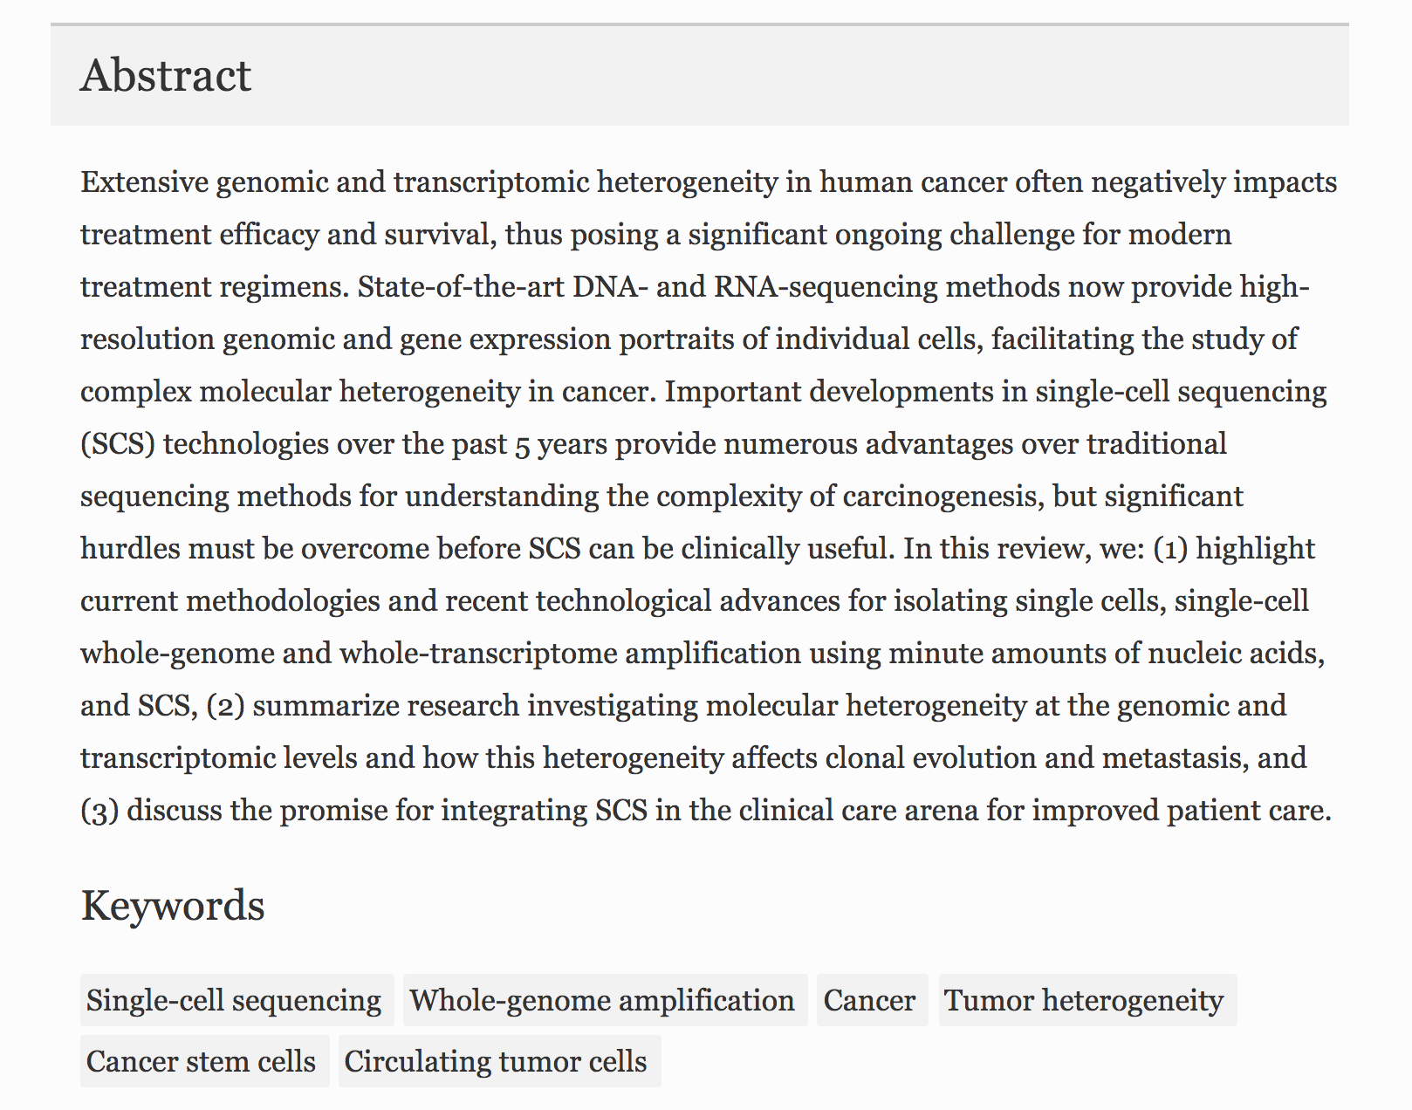

Source：<https://link.springer.com/article/10.1186%2Fs40169-017-0145-6>

1. Design and computational analysis of single-cell RNA-sequencing experiments

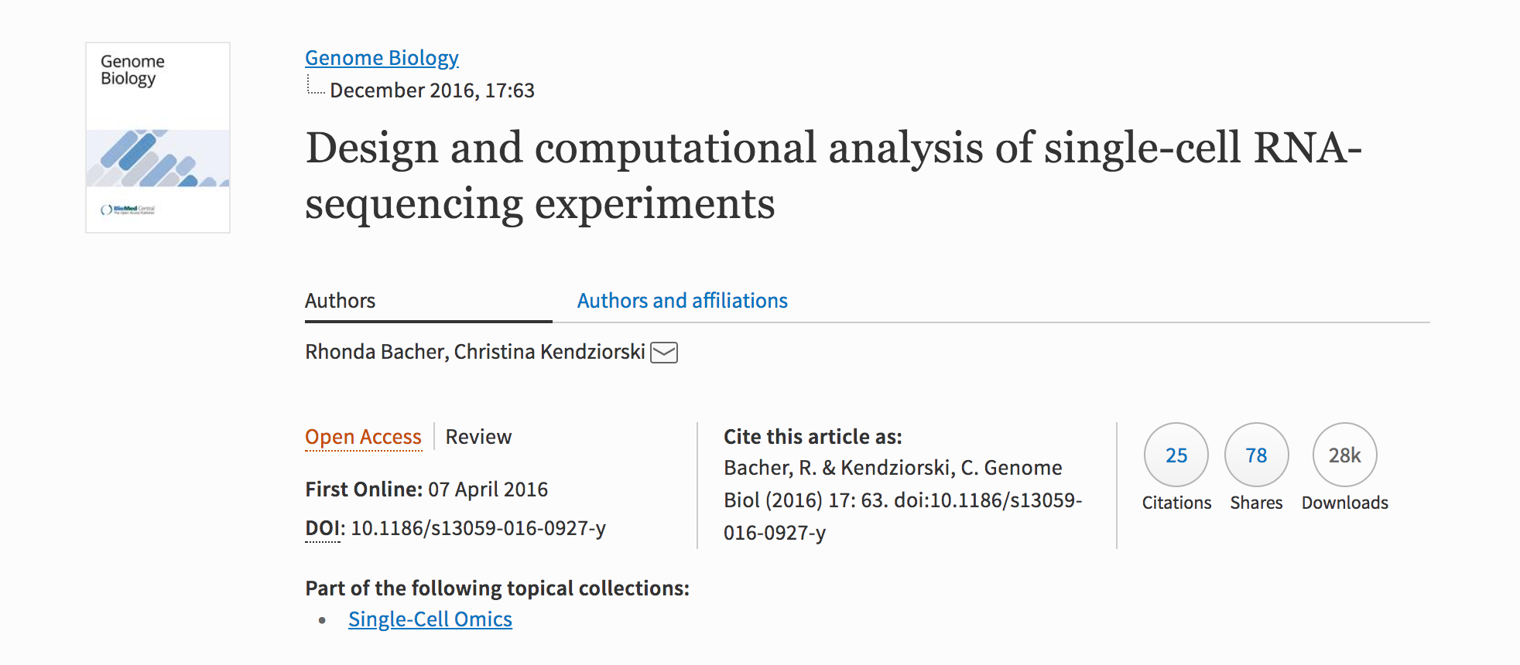

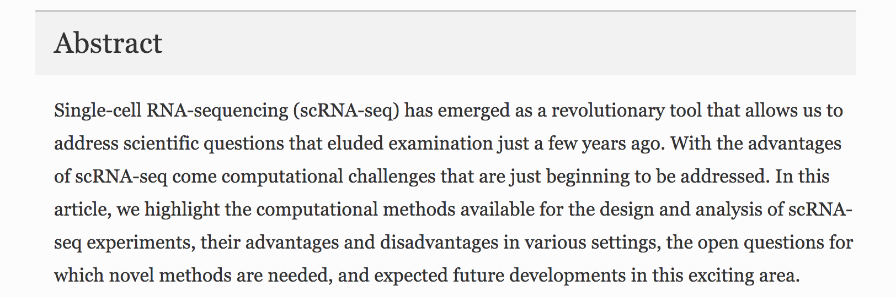

Source：<https://link.springer.com/article/10.1186/s13059-016-0927-y>

【Stage 2】

1. DTWscore: differential expression and cell clustering analysis for time-series single-cell RNA-seq data

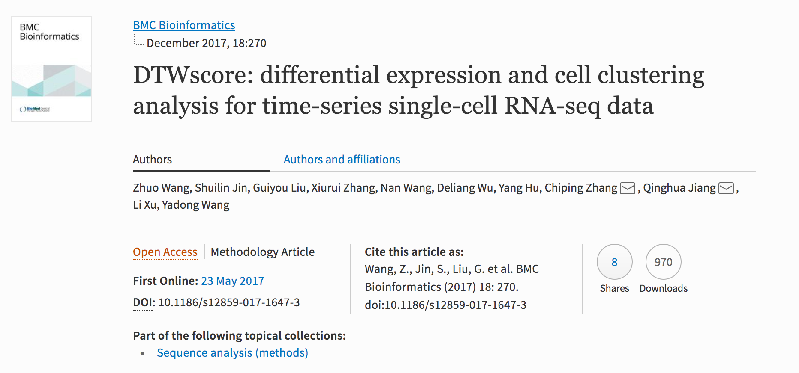

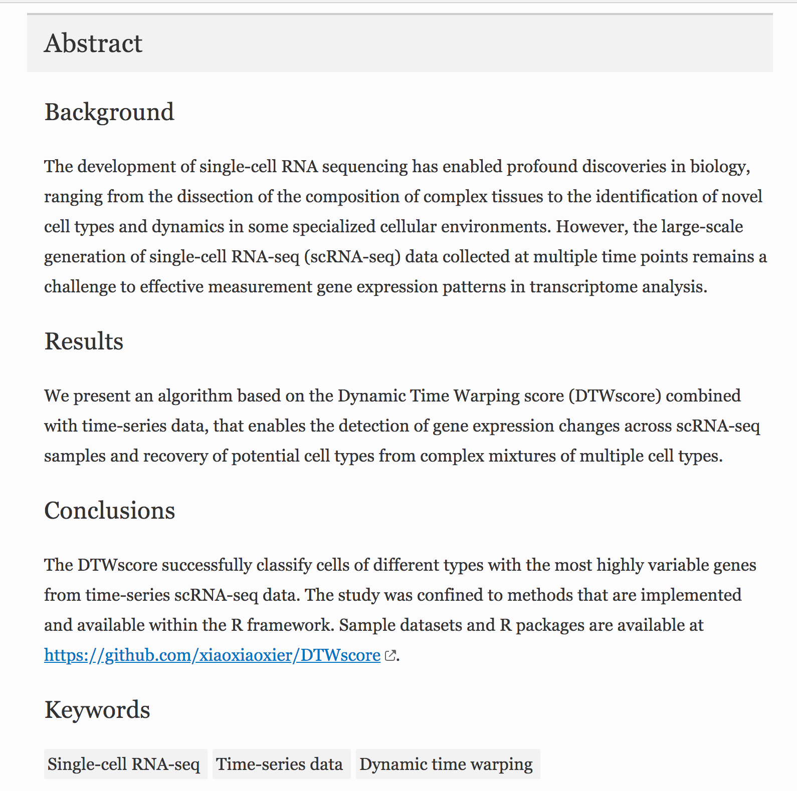

Source：<https://link.springer.com/article/10.1186/s12859-017-1647-3>

1. Removal of batch effects using distribution-matching residual networks

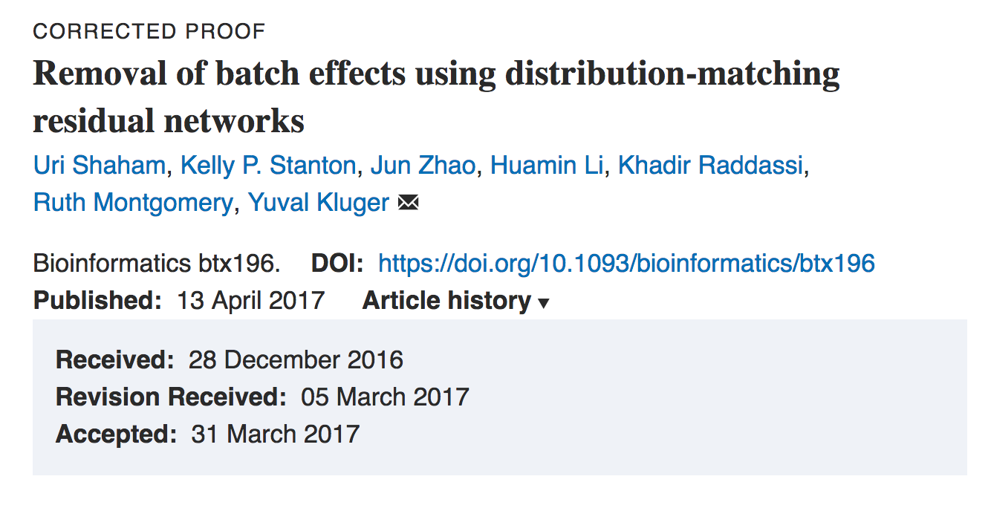

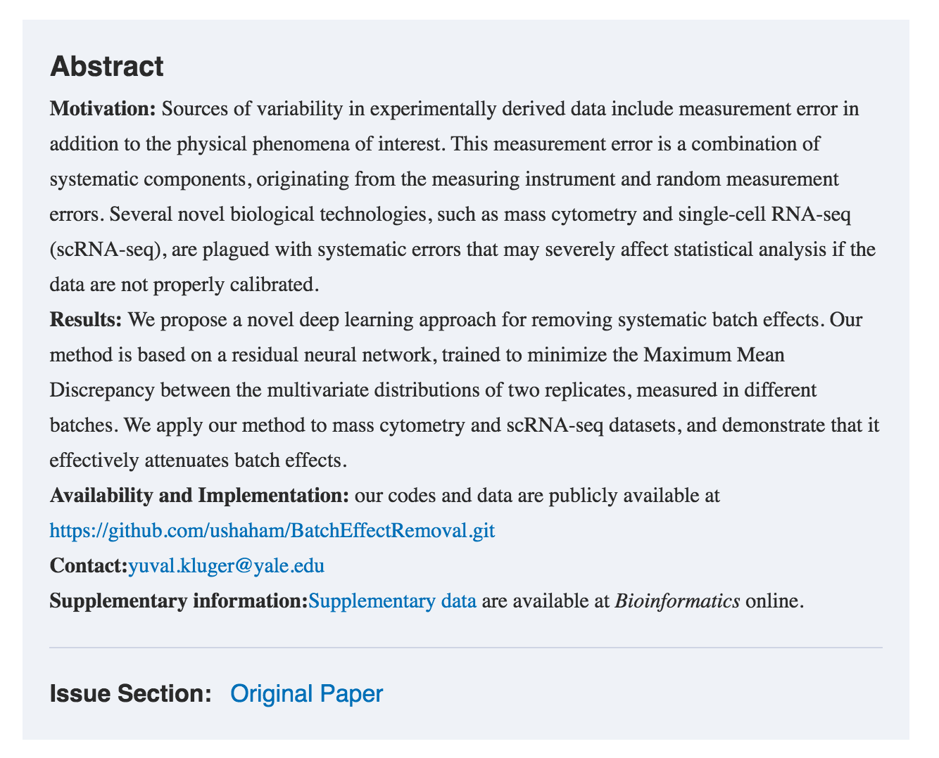

Source：

<https://academic.oup.com/bioinformatics/article-lookup/doi/10.1093/bioinformatics/btx196>

1. SCODE: an efficient regulatory network inference algorithm from single-cell RNA-Seq during differentiation

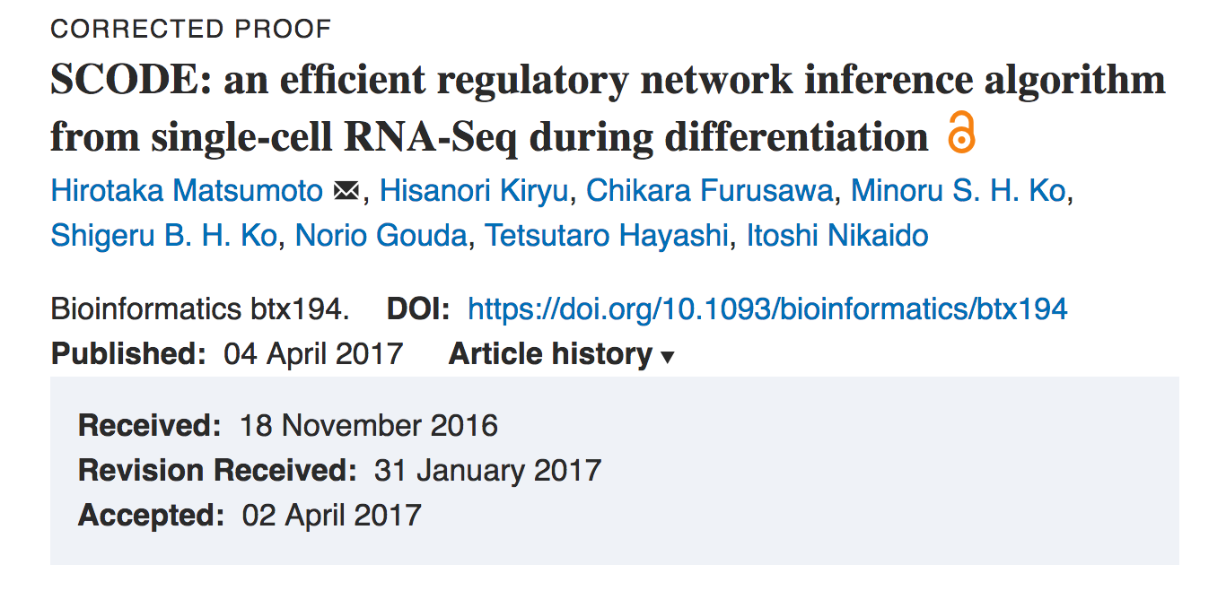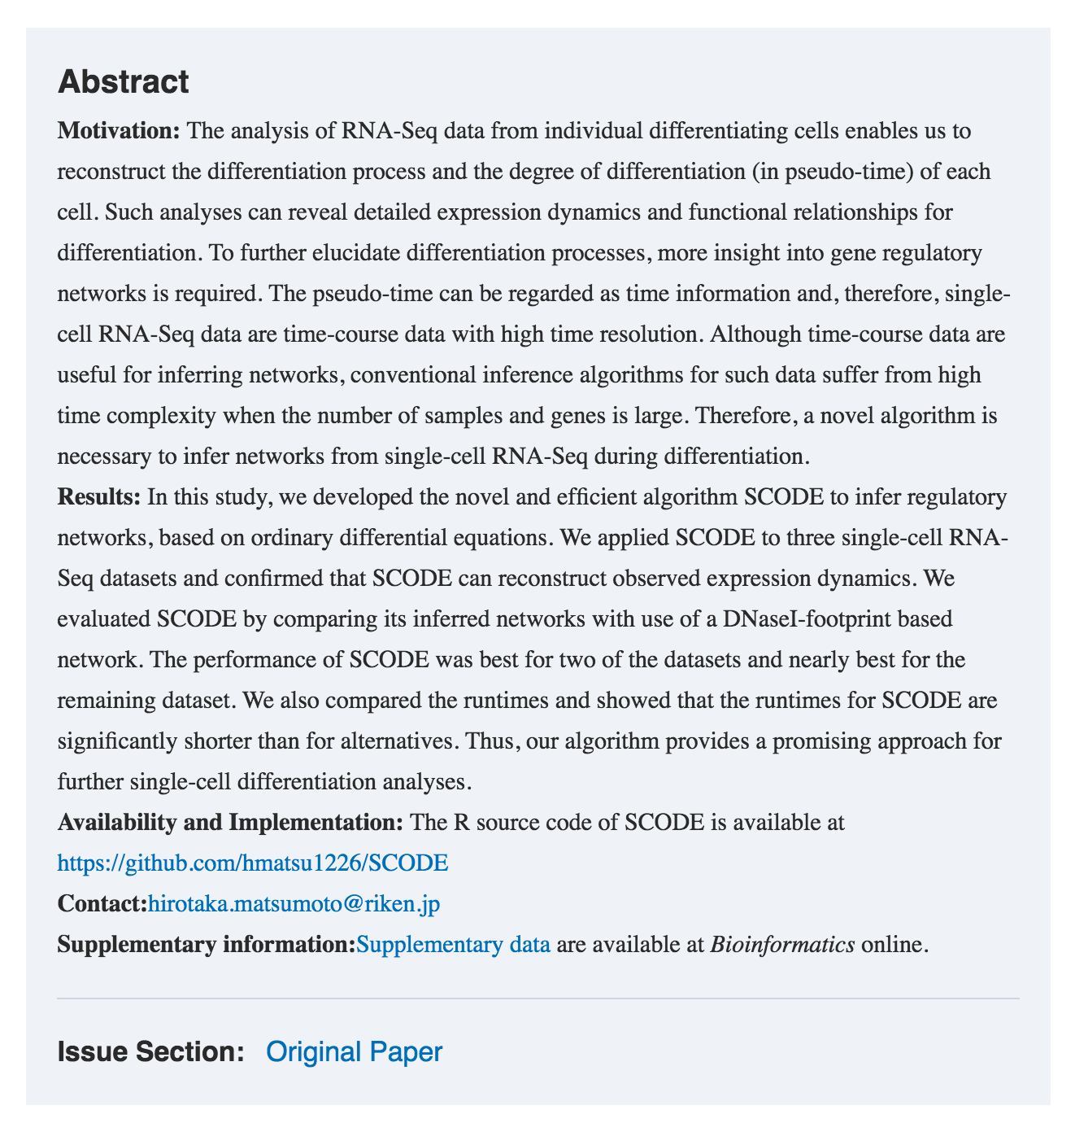

Source：

<https://academic.oup.com/bioinformatics/article-lookup/doi/10.1093/bioinformatics/btx194>