# **DL -ICP2**

Task 1:

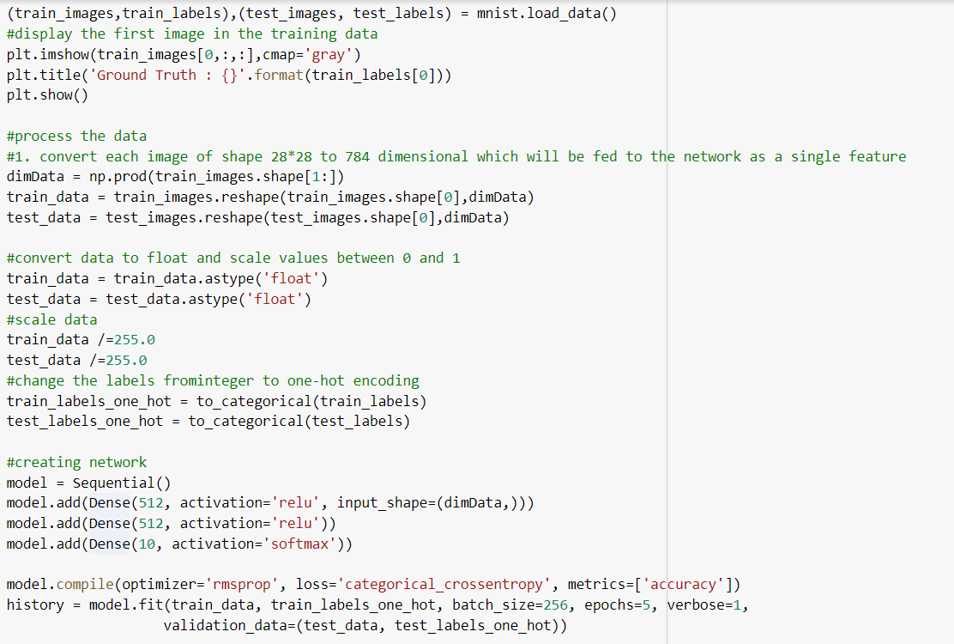

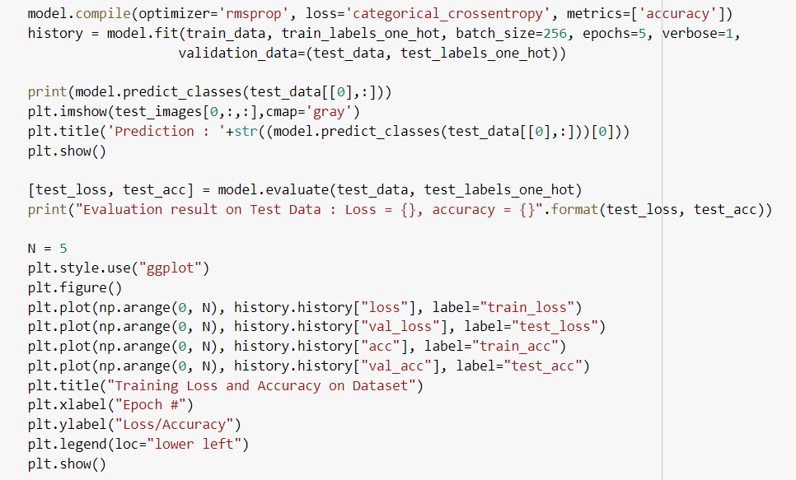

Output:

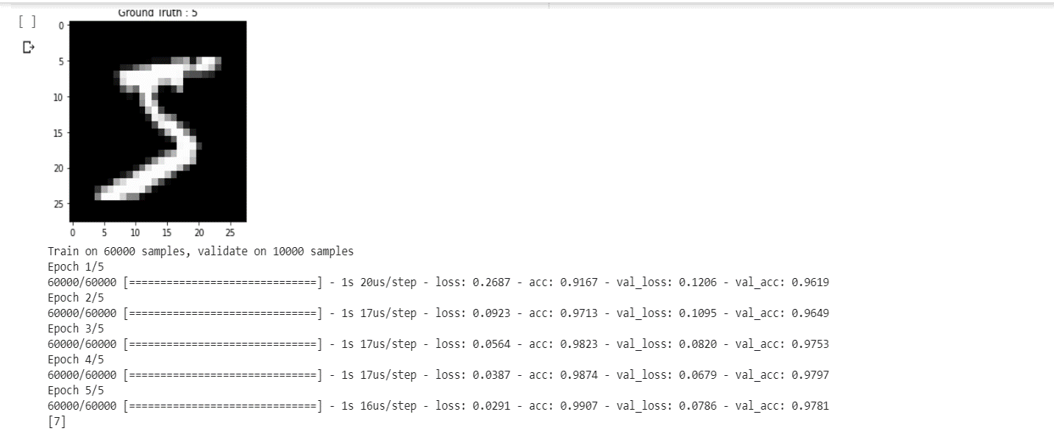

We can see the accuracy and loss of the training and validation sets above for the sequential models with 5 epochs.

Task 2:





Output:

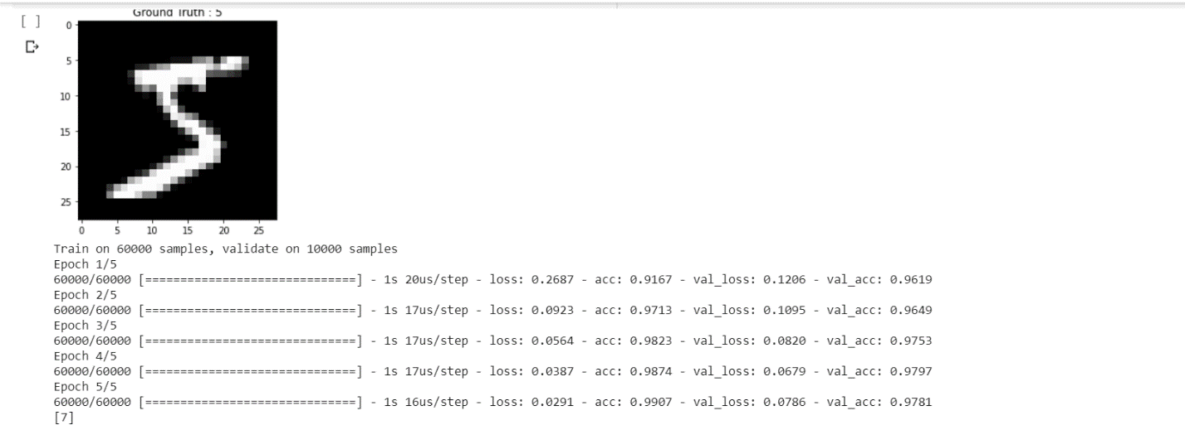

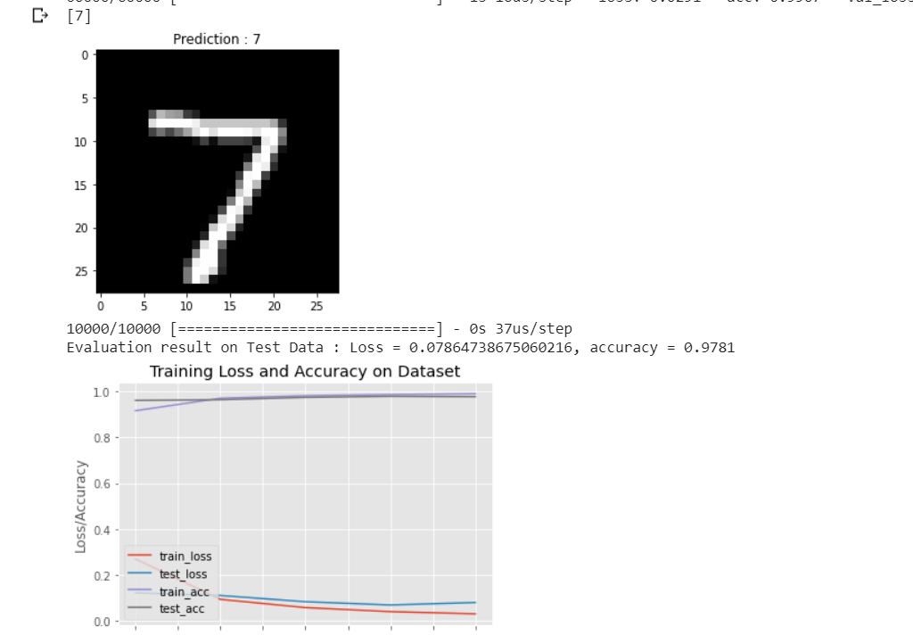

Above we can see the first image from the dataset we can see the ground truth which is the original image and the predicted image and accuracy and loss for the data.

Task 3:

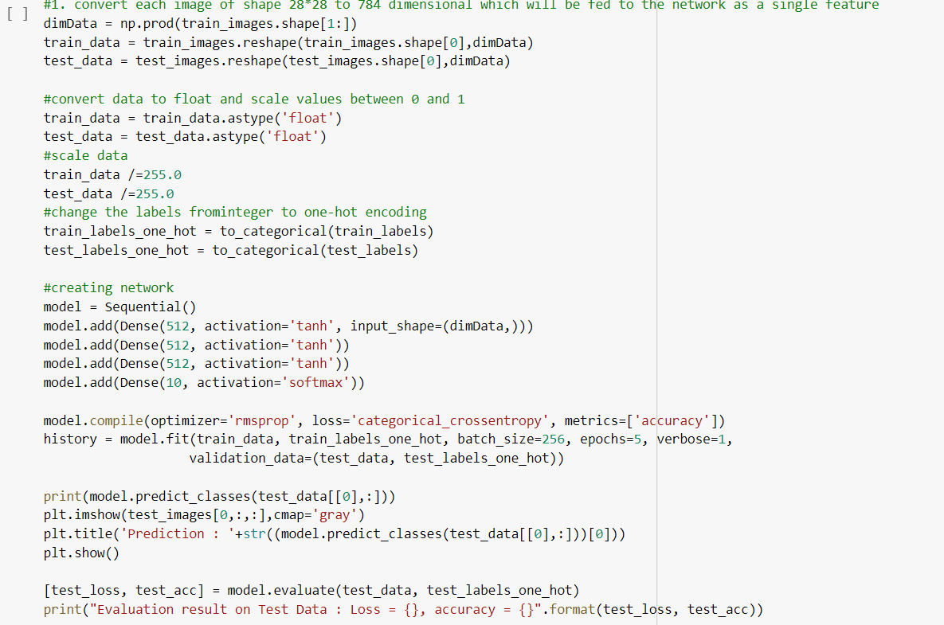

Output:

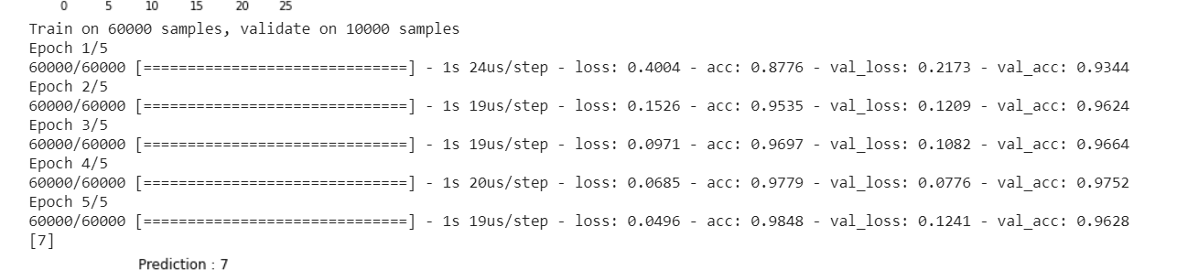

We can see the extra hidden layers and change in activation layers to tanh and change in the accuracy and loss functions as well.

Task 4:

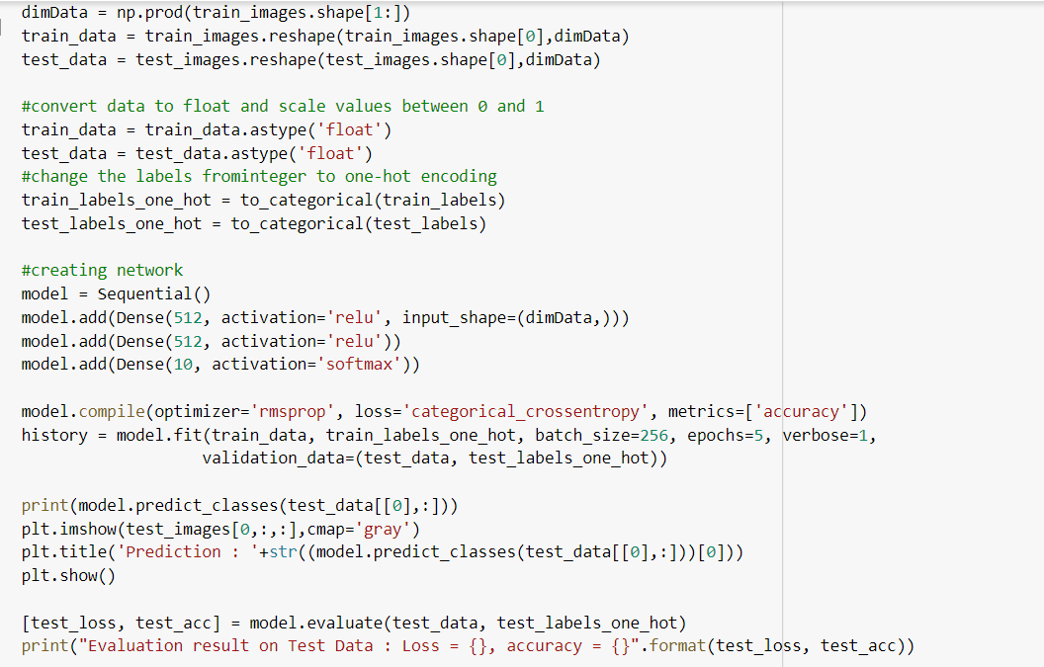

Output:

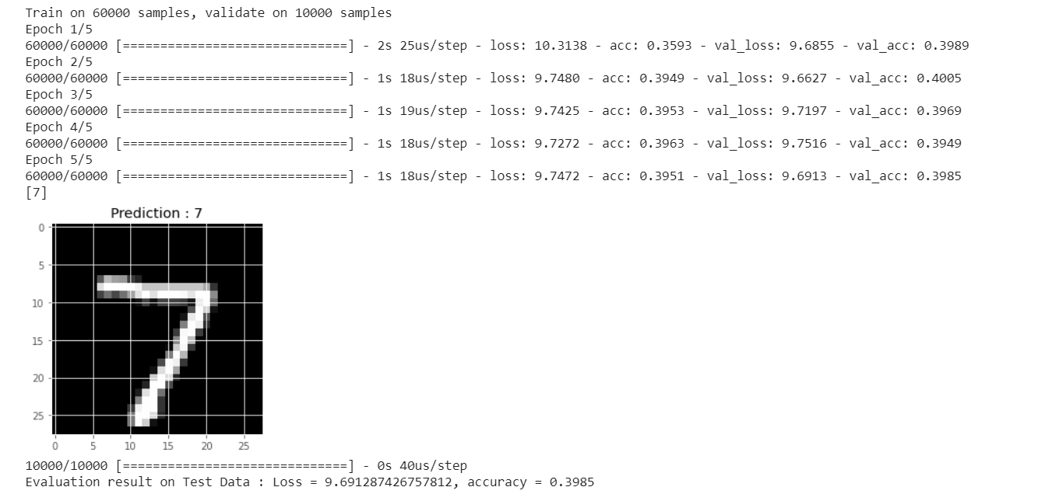

Once we removed the scaling, we can see the variable difference in the accuracy and loss as well. Its always advisable to scale the data.