# Deep Learning – ICP 1

Task-1:

Given the diabetes dataset and we have the outputs which vary with the number of hidden layers.

Below are the screenshots for the given task and their outputs.

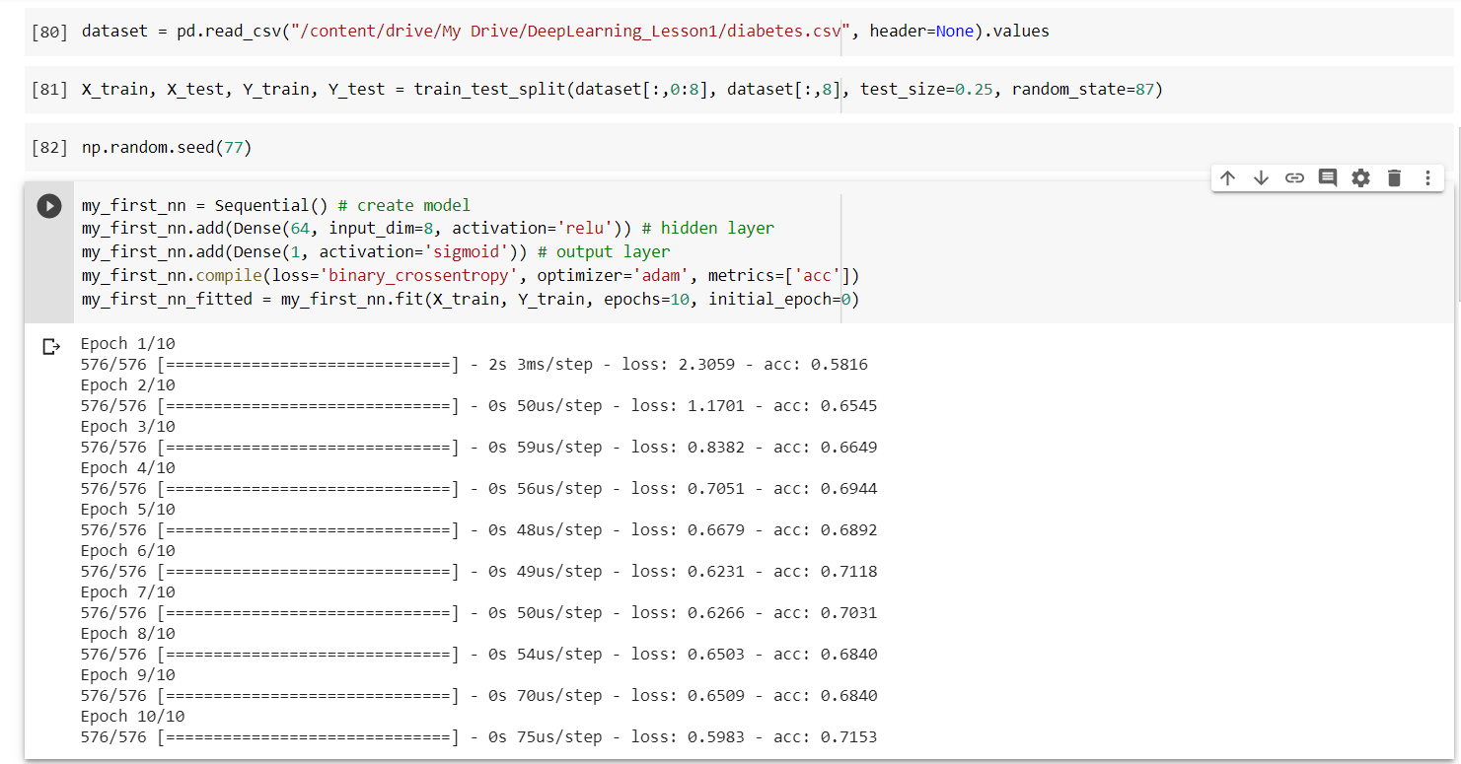

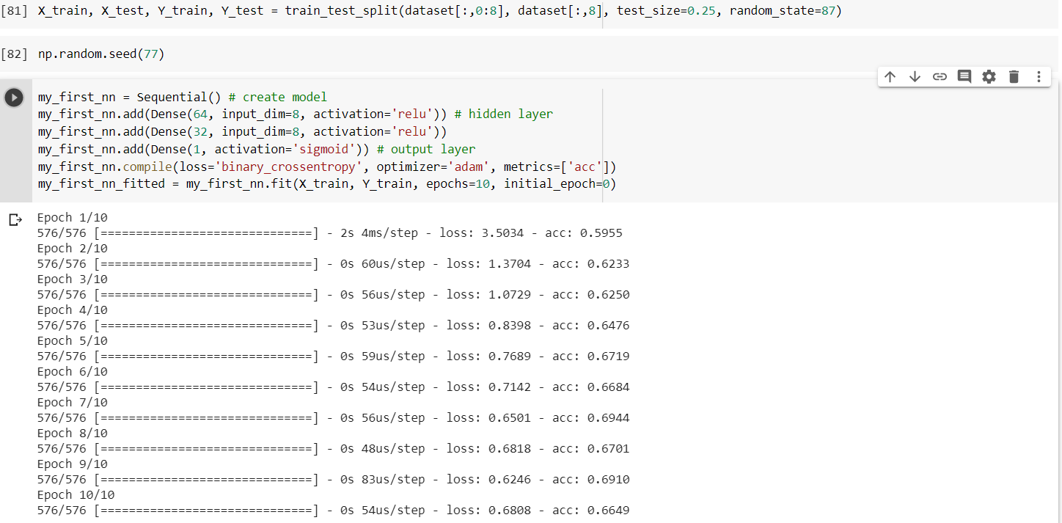

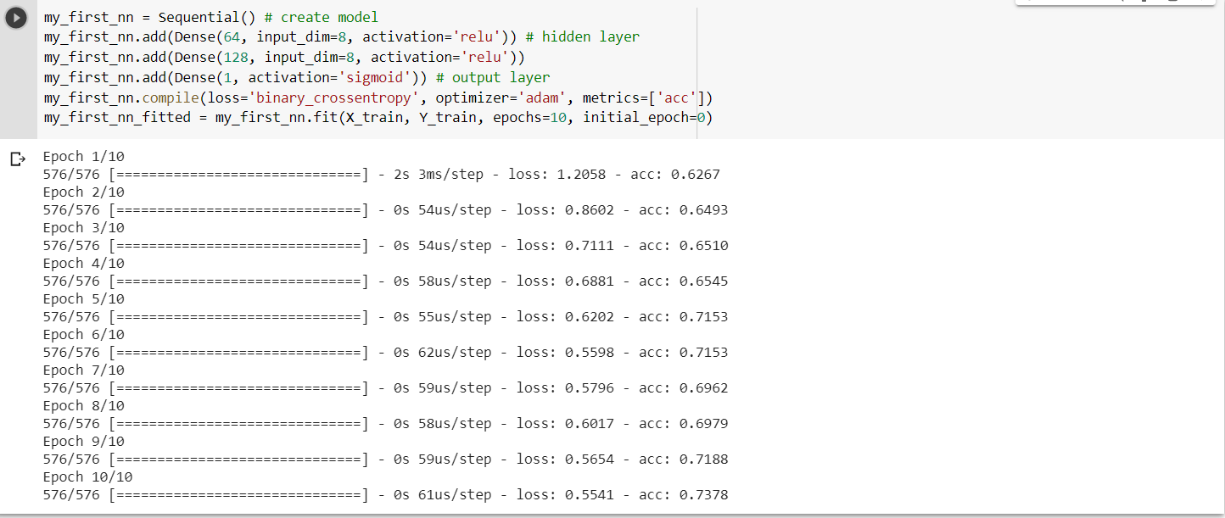

And the screen shots of the model evaluation respectively are below:

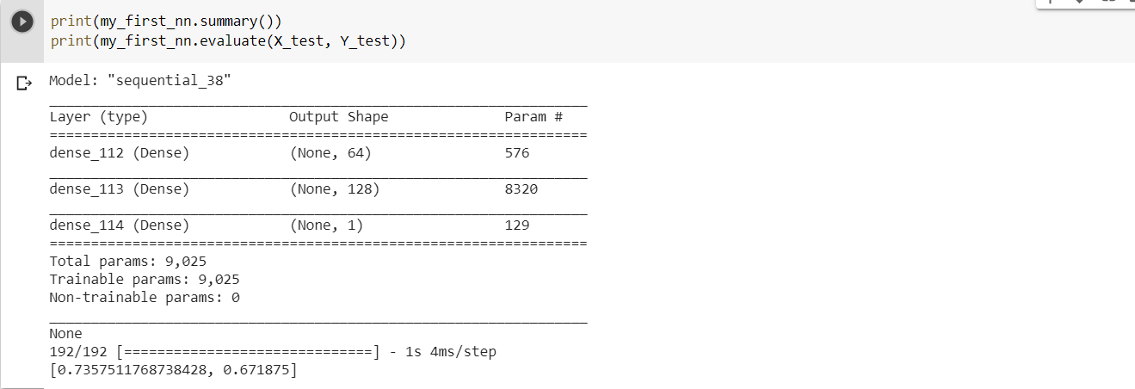

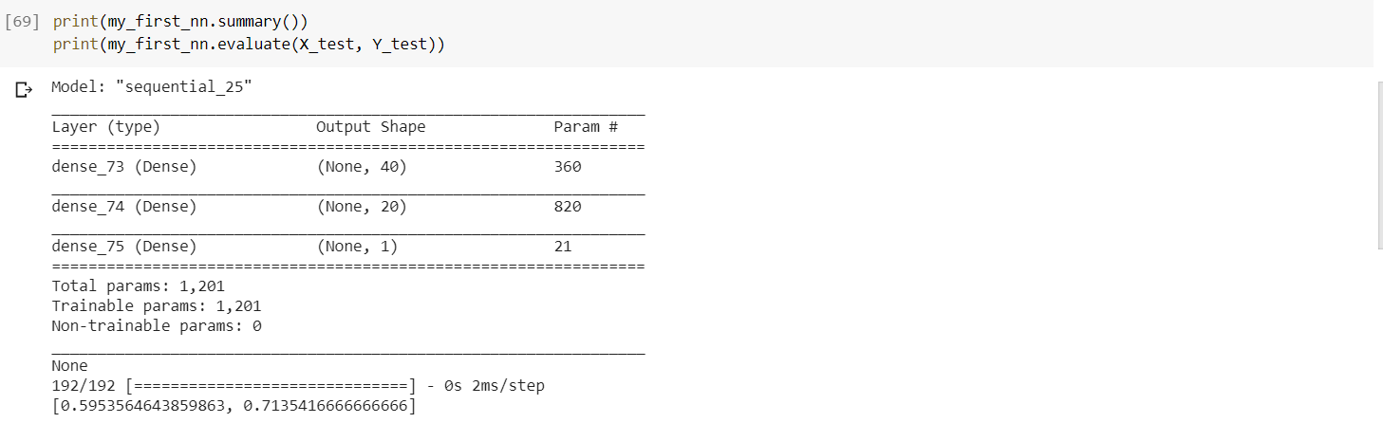

Task-2:

Here we have loaded the breastcancer.csv file and normalized the data.

We have used the adam, sgd, adadelta optimizers and have not seen change in the accuracy and the loss functions but it will depends on the datasets and the number of layers and neurons.

Since the dataset did not have any null values the values before normalizing and after does not vary.

Below are the screenshots for the task given and their outputs.

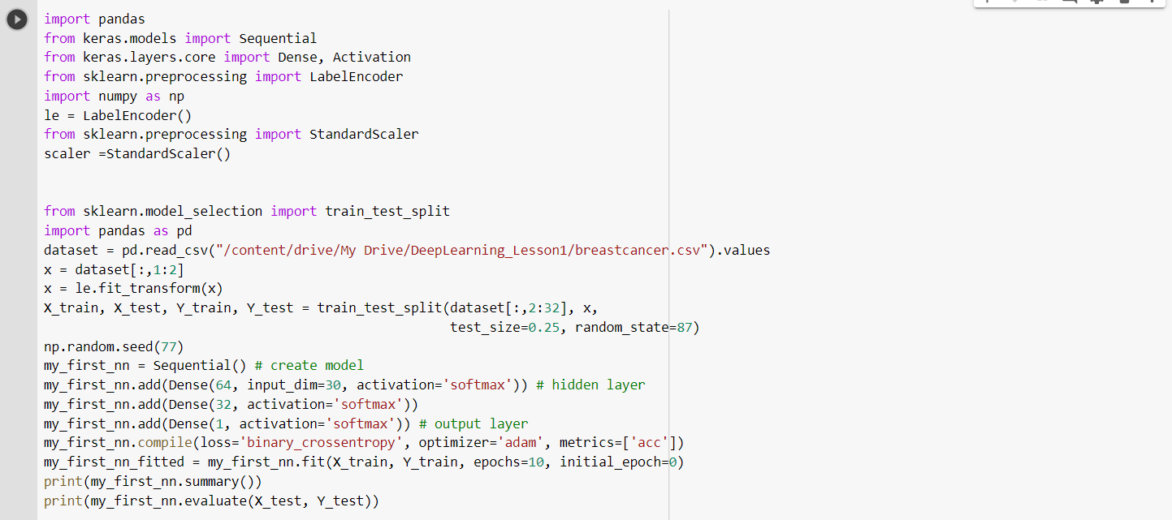

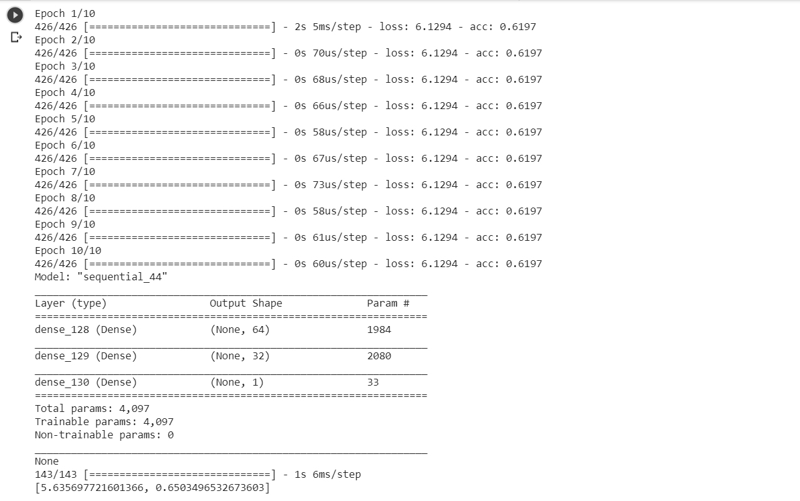

With sgd optimizer:

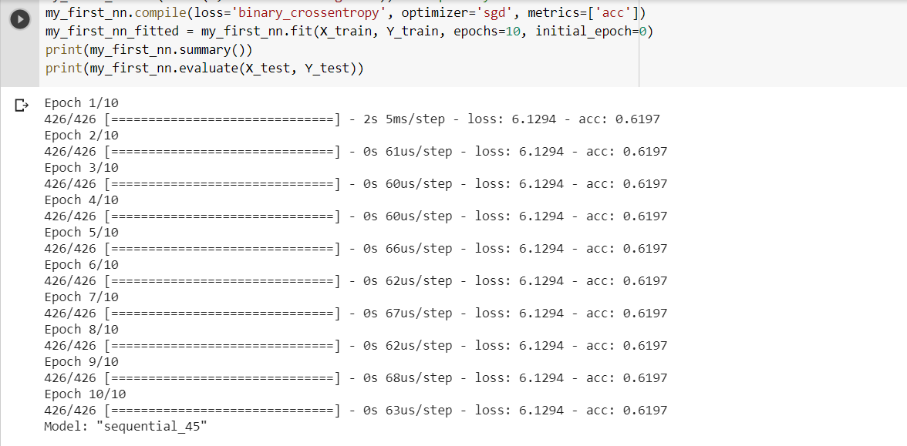

With adadelta optimizer:

