# Deep Learning ICP- 3

Task 1:

Sentiment Analysis for IMDB data.

Identifying errors:

The input dimensions value is 2000 i.e the size of vocabulary in data and the output dimension is 3.

We have used softmax activation function because it can also classify the multiclass classification whereas sigmoid only classifies binomial classification. Here we cannot use sigmoid because this is multi class, but also the accuracy when using softmax is high.

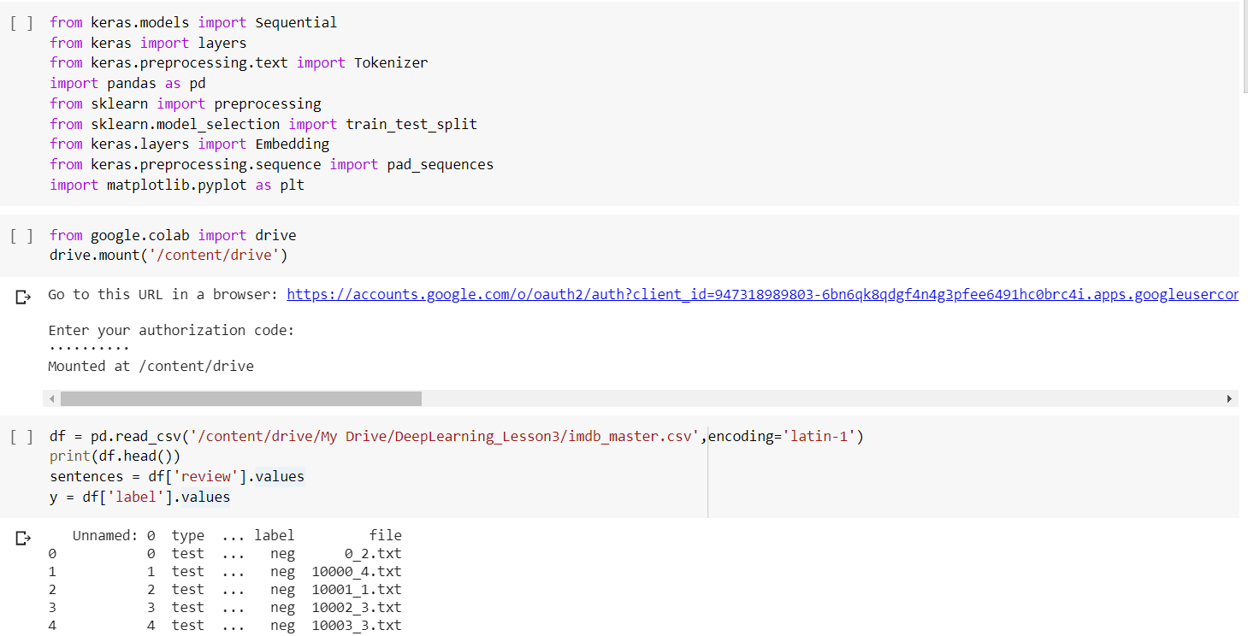

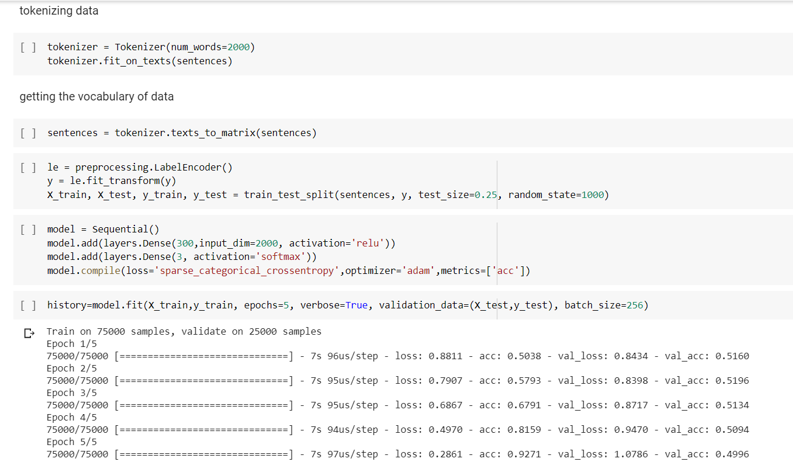

Task 2: After adding the Embedding layer and decreasing the number of epochs we can see the accuracy of the model got slightly decreased than that of the without embedding layer.

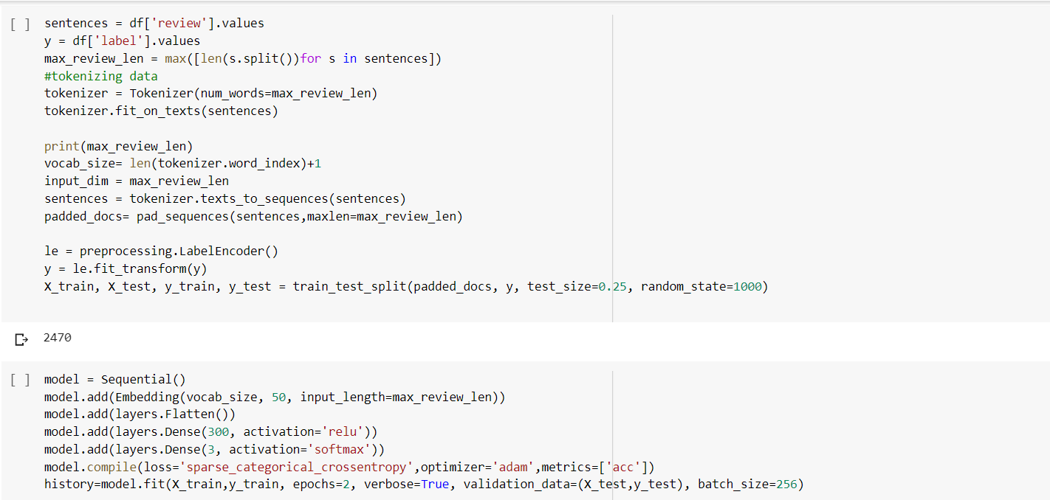

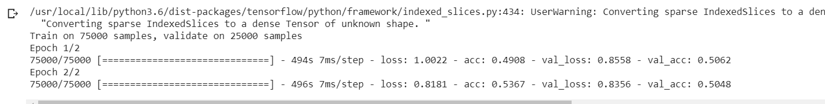

Task 3:

We have imported data from fetch_20newsgroups from sci-kit learn datasets.

With the help of embedding layer we had fit the data and visualized loss and accuracy of both train and validation sets using matplotlib.

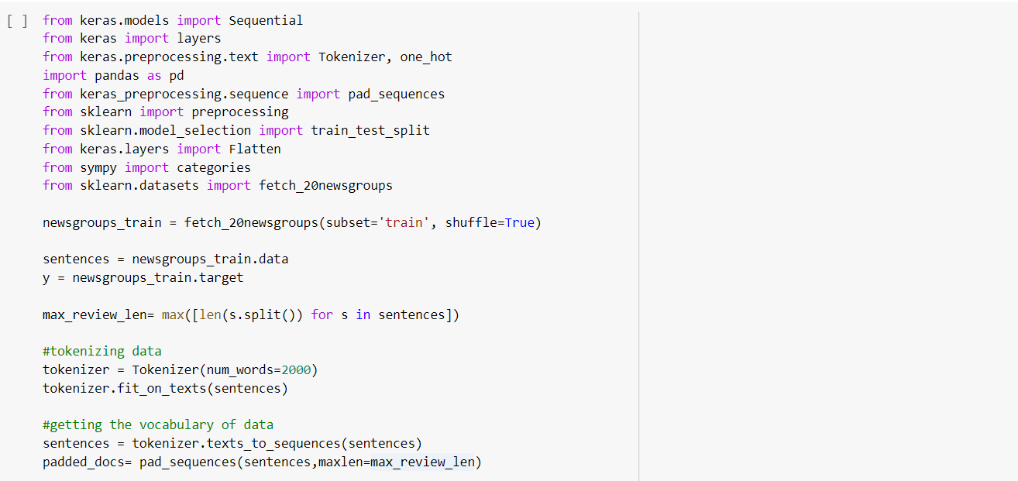

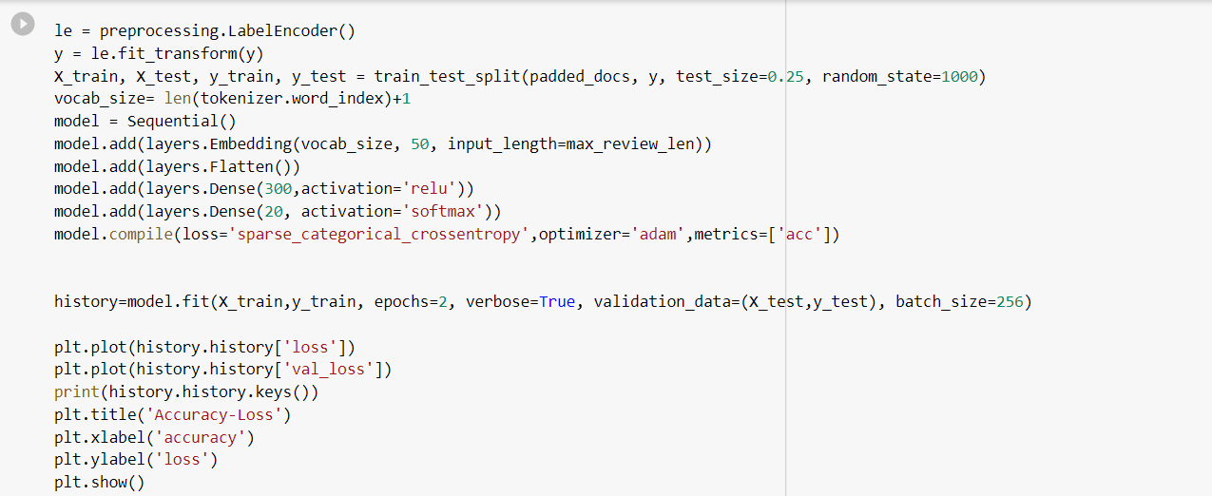

Task 4:

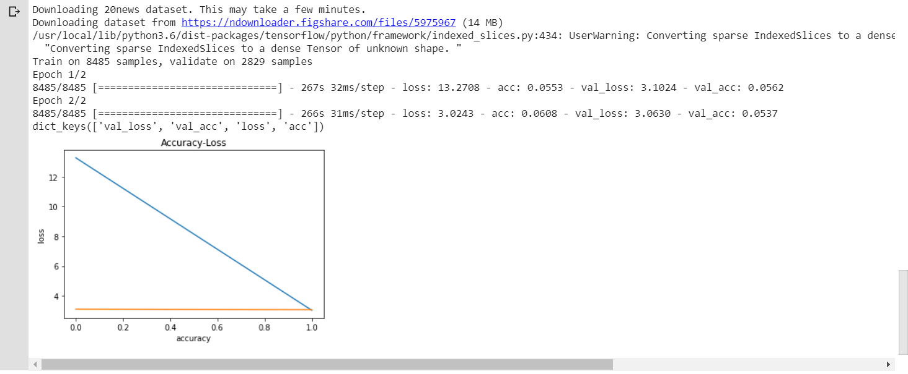

Task 5: Bonus Question

To predict the data and plot accuracy and loss using the tensor board.

We have imported tensor board and plotted the scalars for the newsgroups dataset.

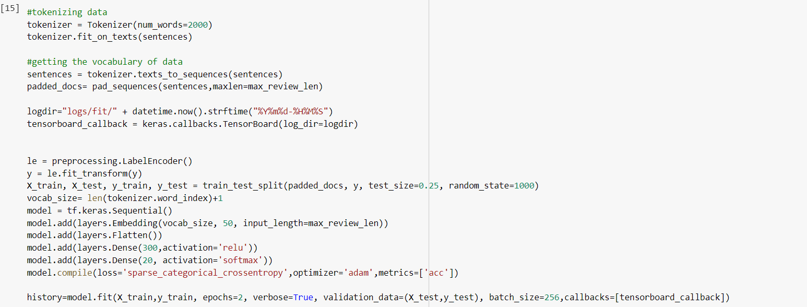

Below is the accuracy for training and validation data.

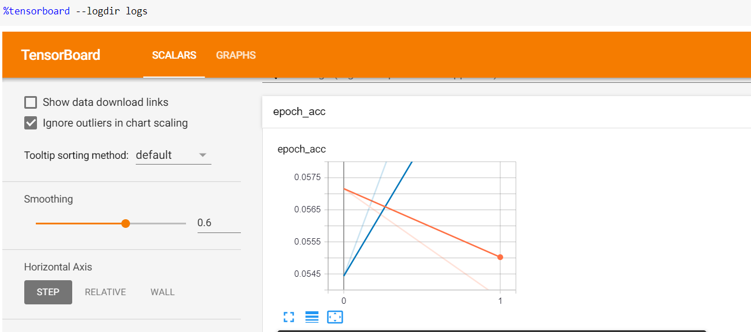

Below is the loss for the training and validation data.

