DL-ICP4

Task 1: When there are less convolutional networks and pooling, the accuracy is shown as below:

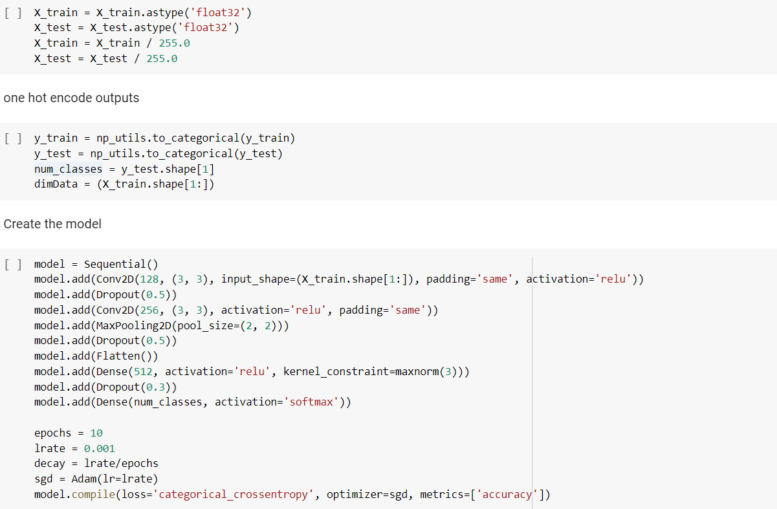

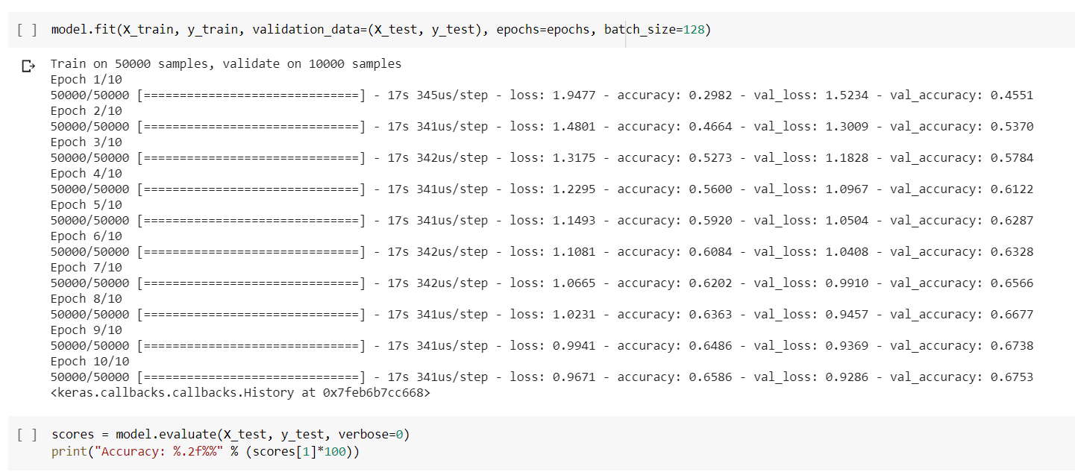

Task 2: when we increase the network and pooling we can also see the increase in accuracy of the model.

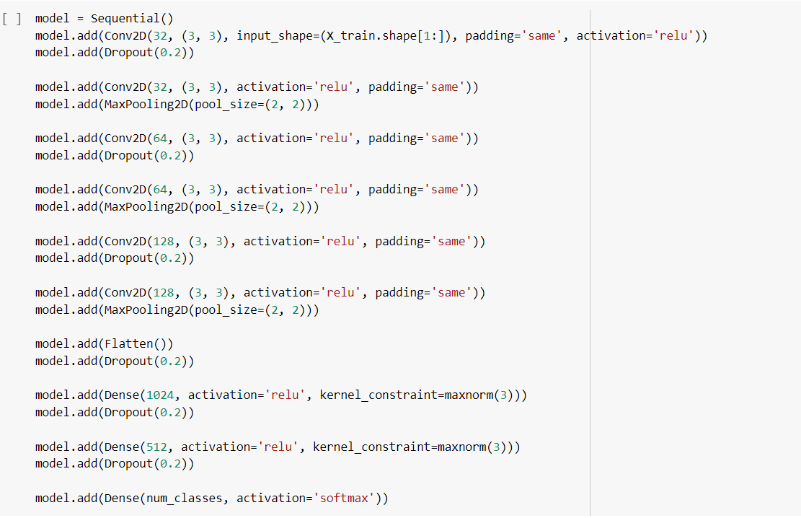

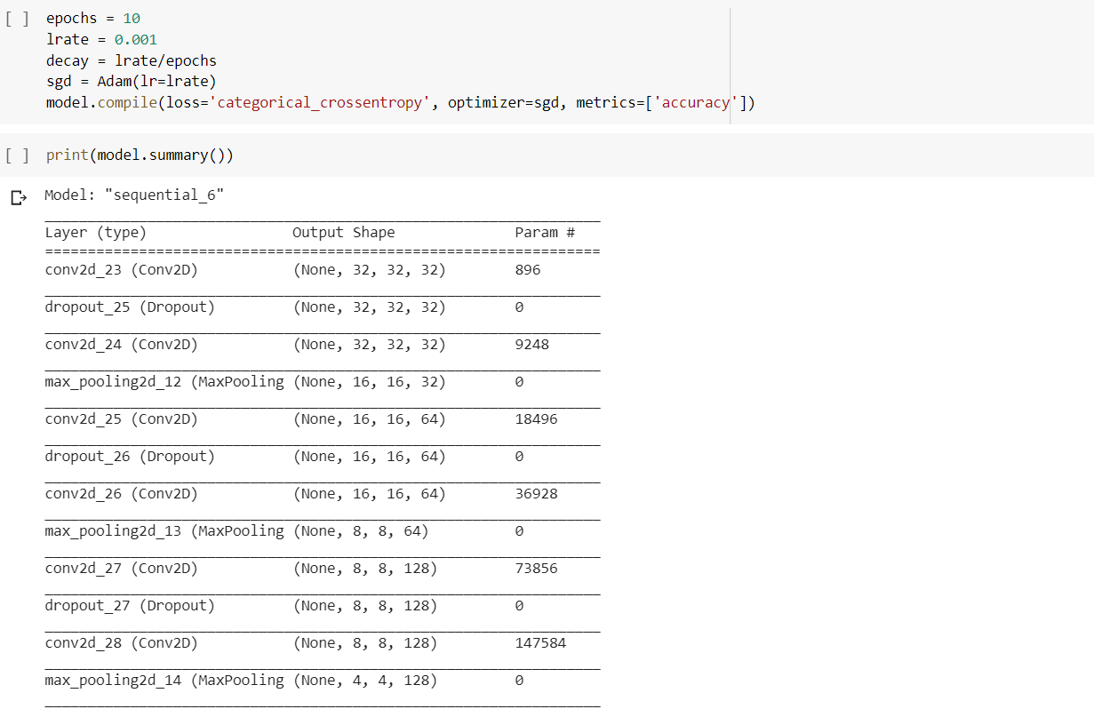

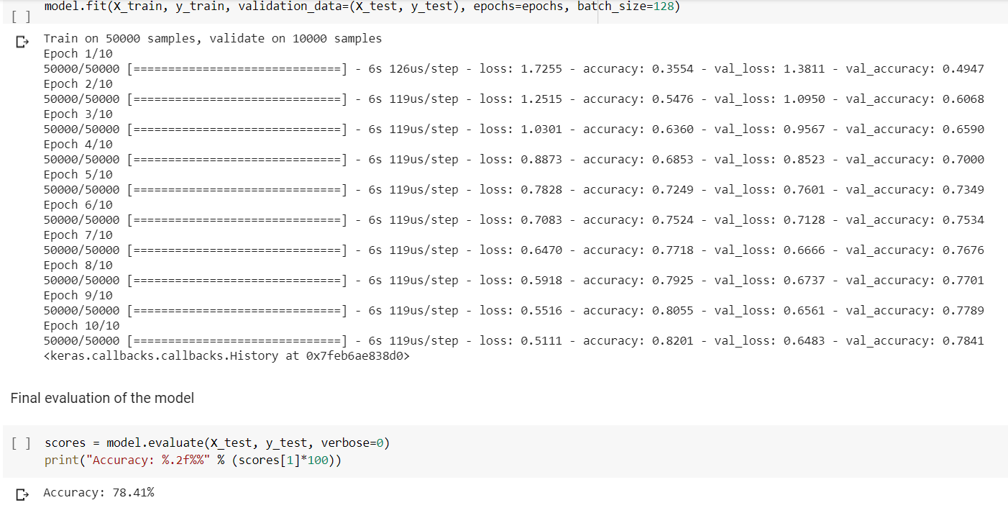

We have also changed the sequential model to the keras API model which is as below:

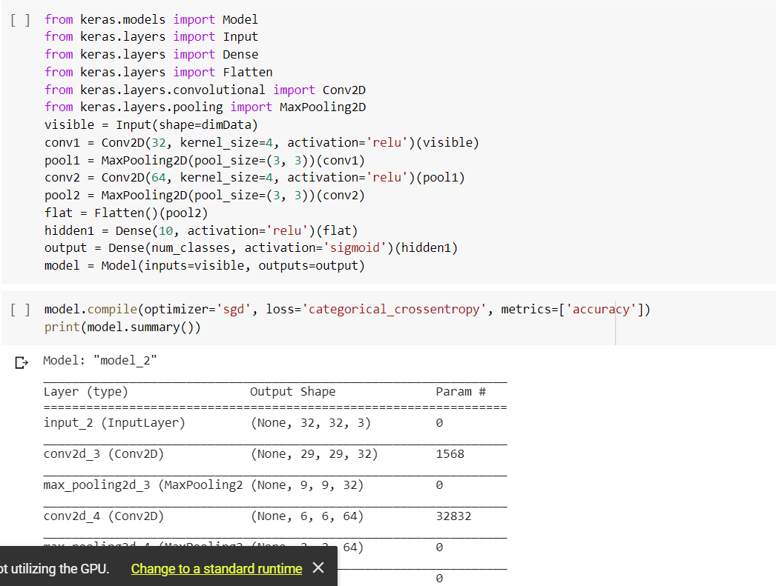

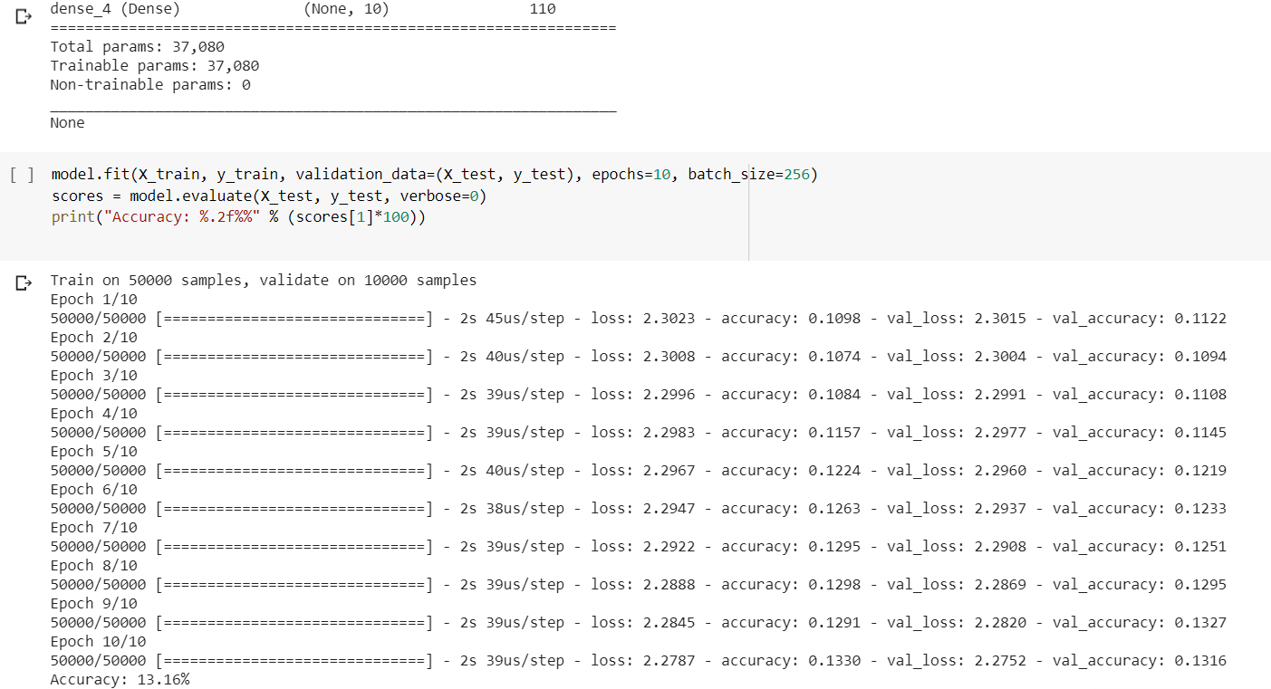

Task 3: Here we can see the predicted labels and the actual labels for first 4 images are same, hence we can say that our model predicted correctly. However, probability of each image to be predicted correctly is given as below:

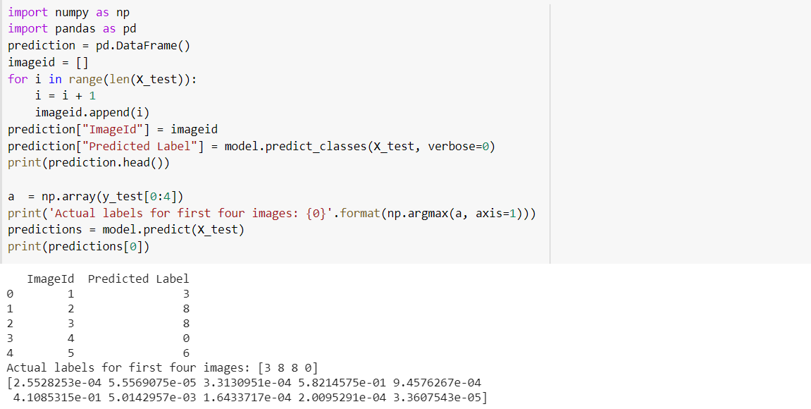

Task 4: save the images in your local file system.

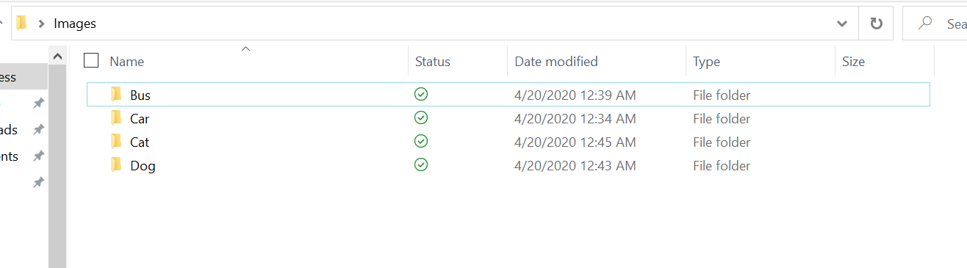

Load the images and train them and prepare a model for the train and test data as shown below:

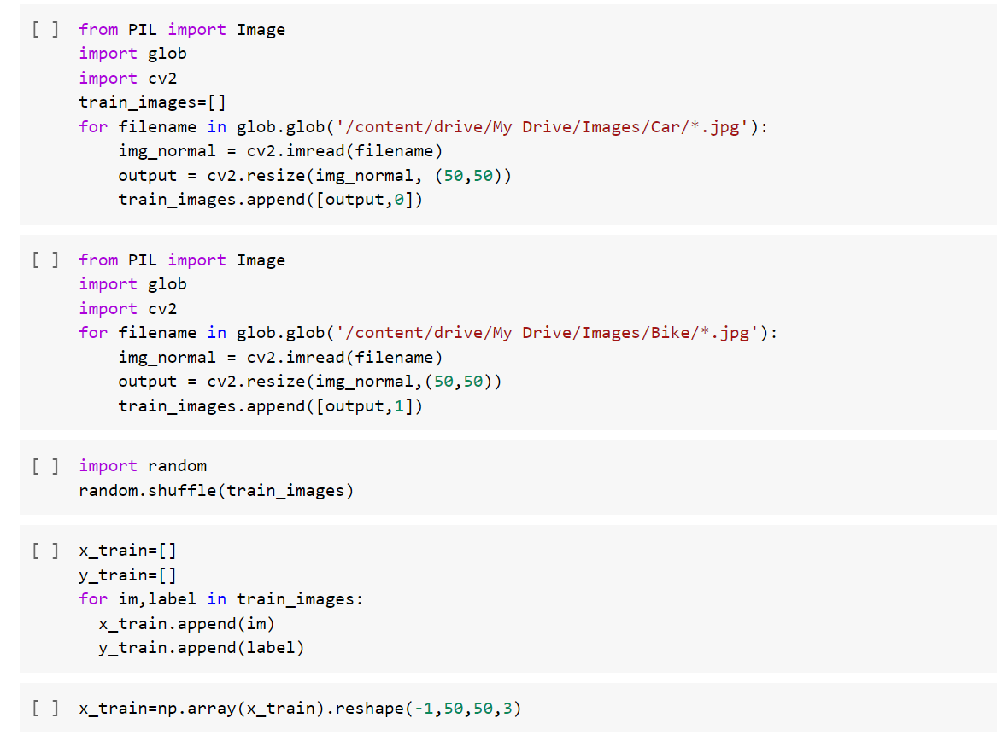

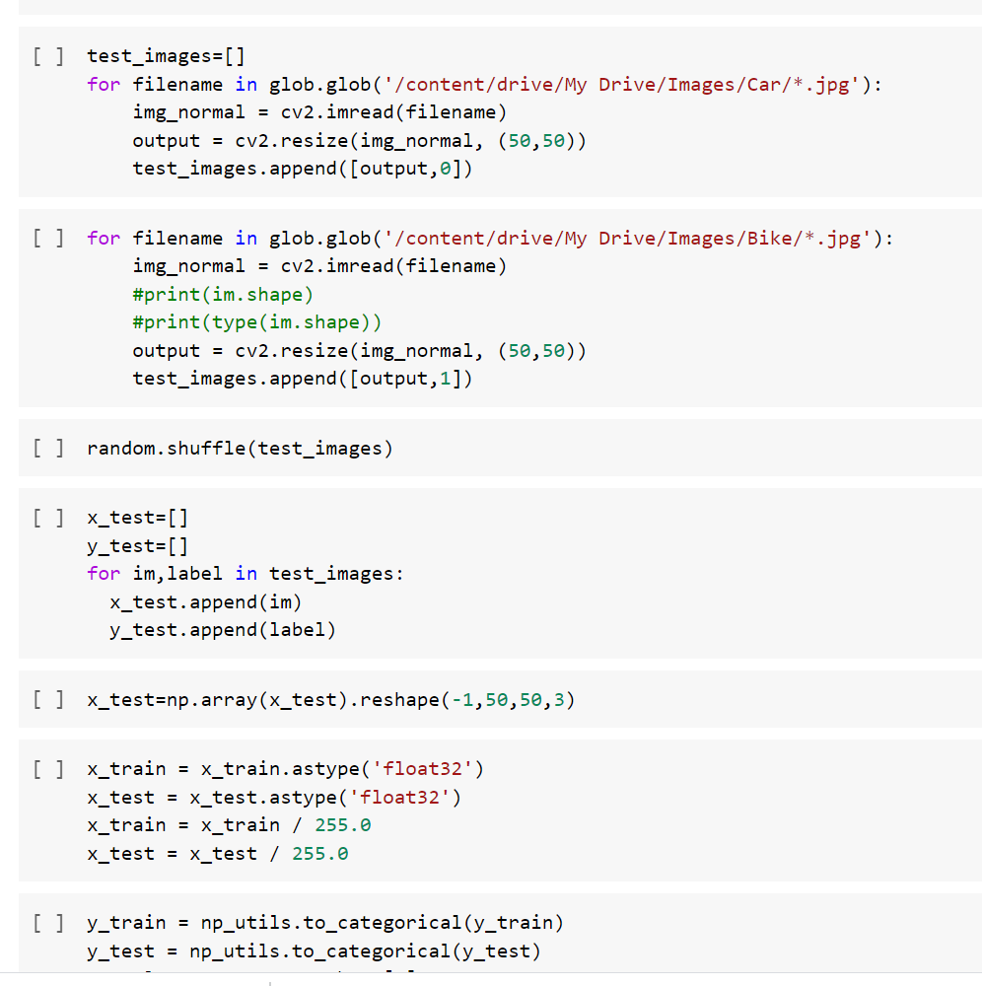

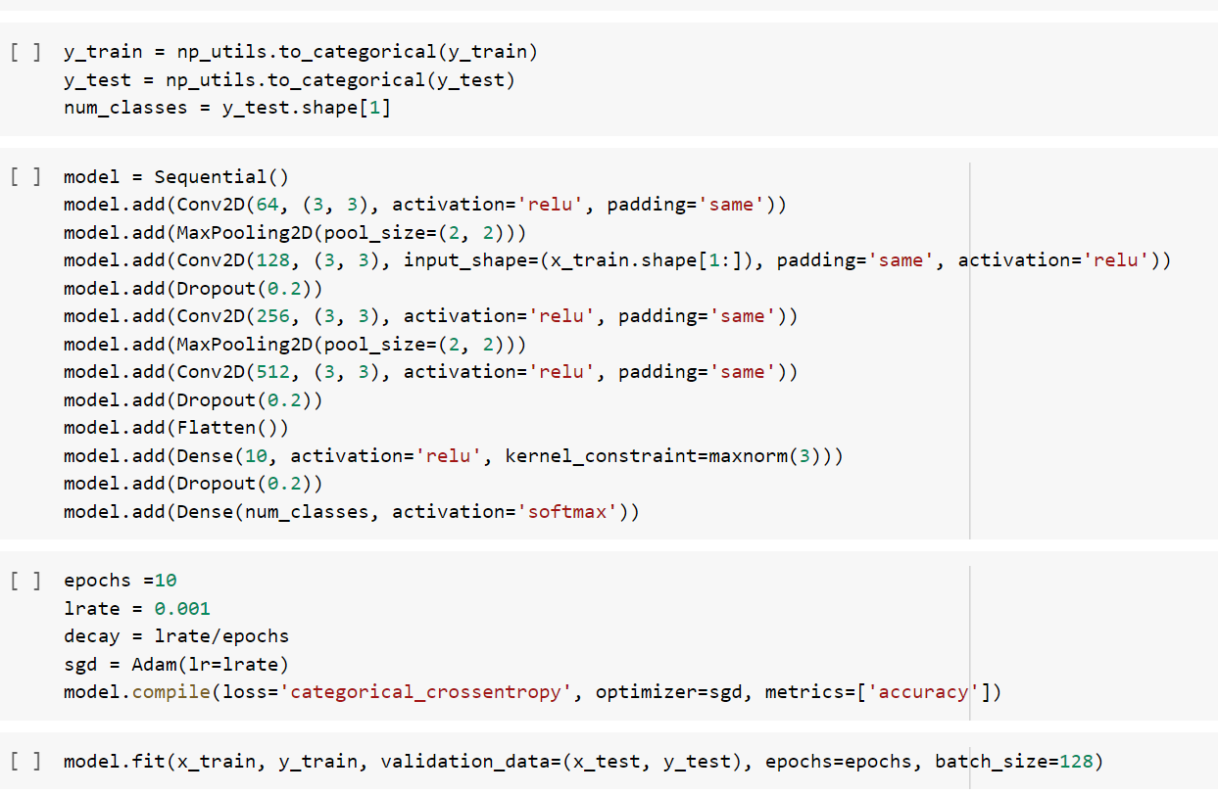

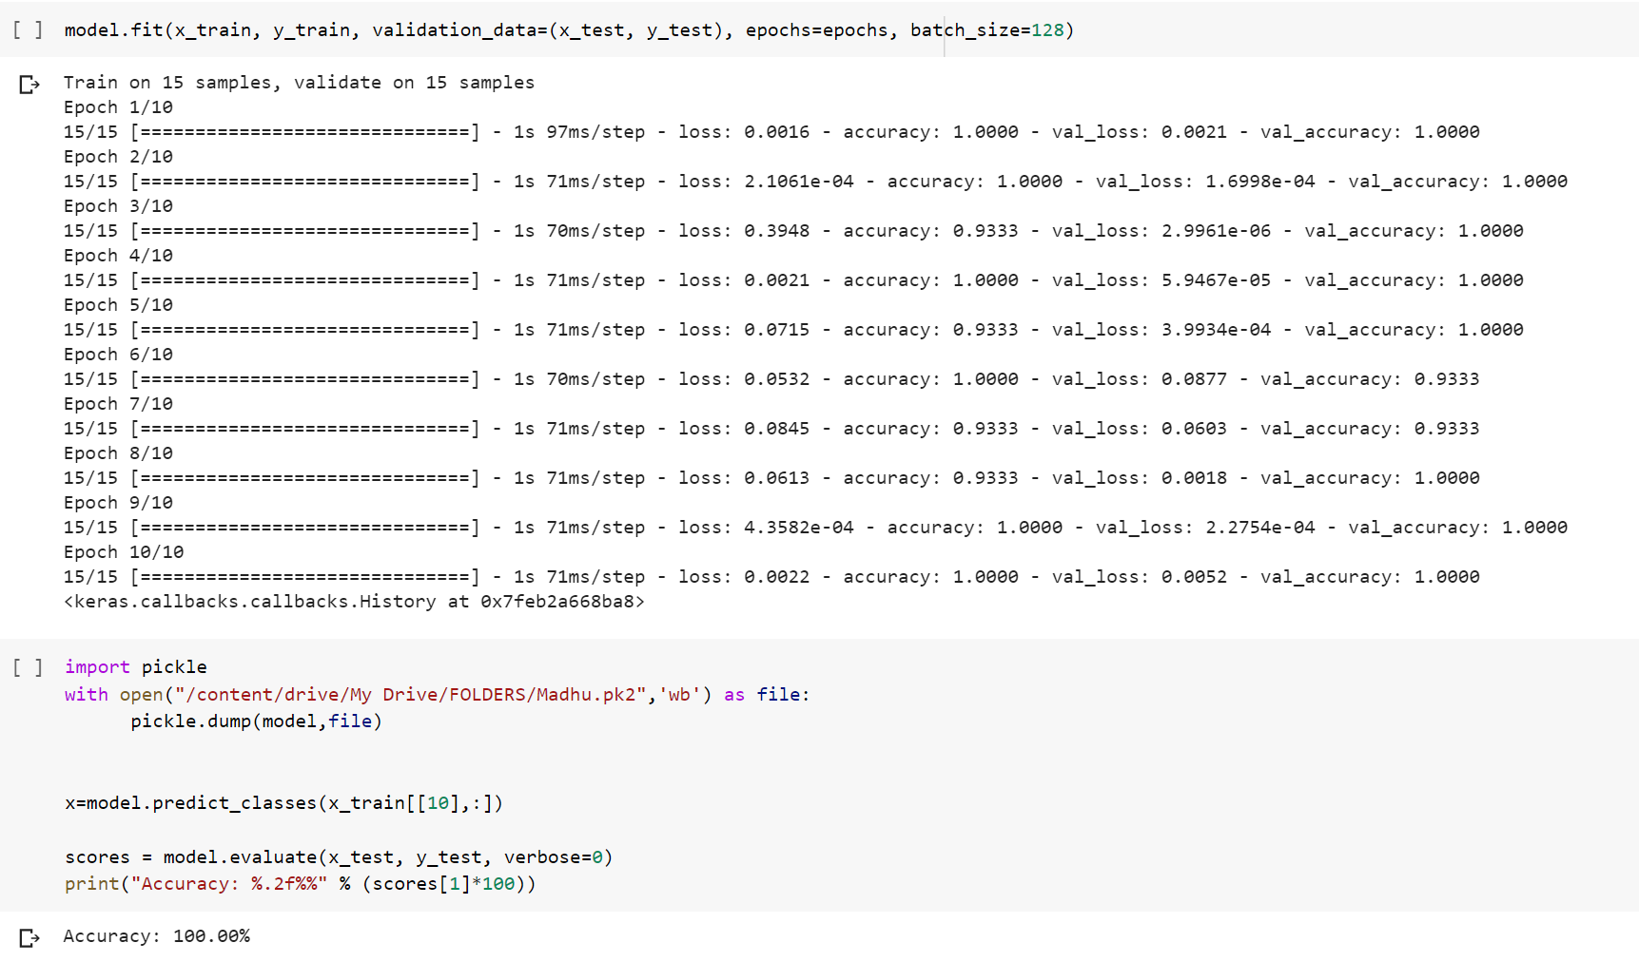

Now using the flask library, we can render the index.html file in the browser:

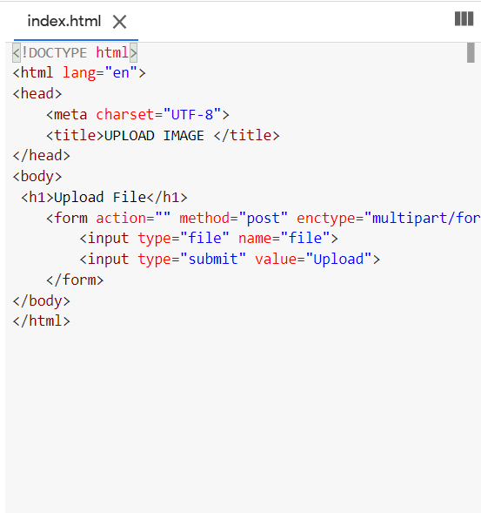

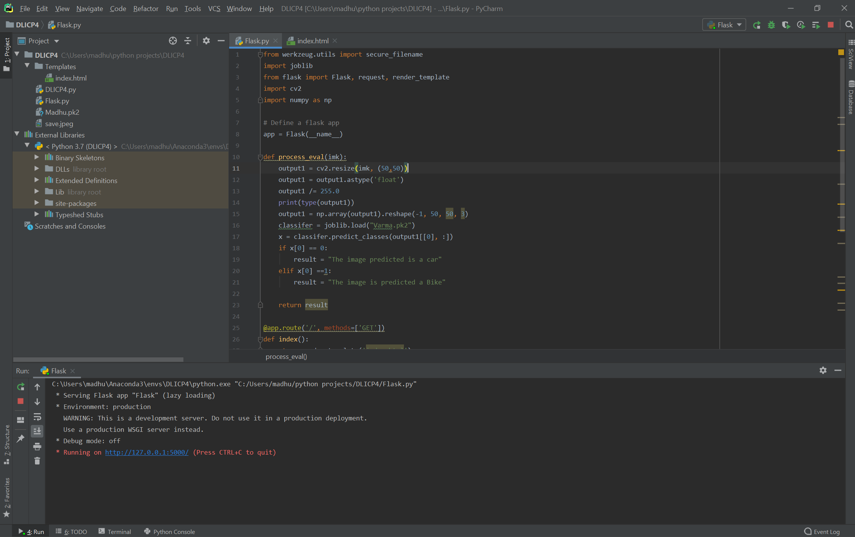

By navigating through the URL, we can get as below:

By browsing the image the model will predict as follows:

