**STUDENT MANAGEMENT SYSTEM**

**1.Student Management System with models: Student, Course.**

**-Student.cs**

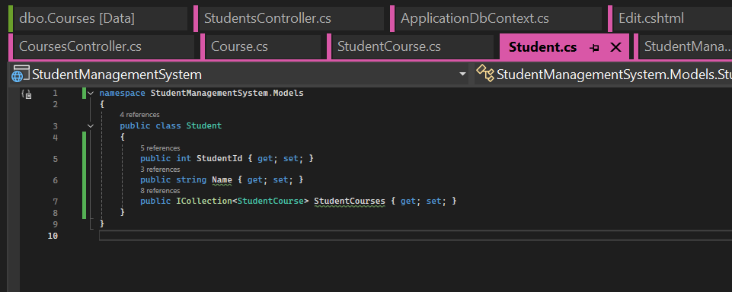

**-Course.cs**

**2.Many-To-Many (a student can enrol in multiple courses.)**

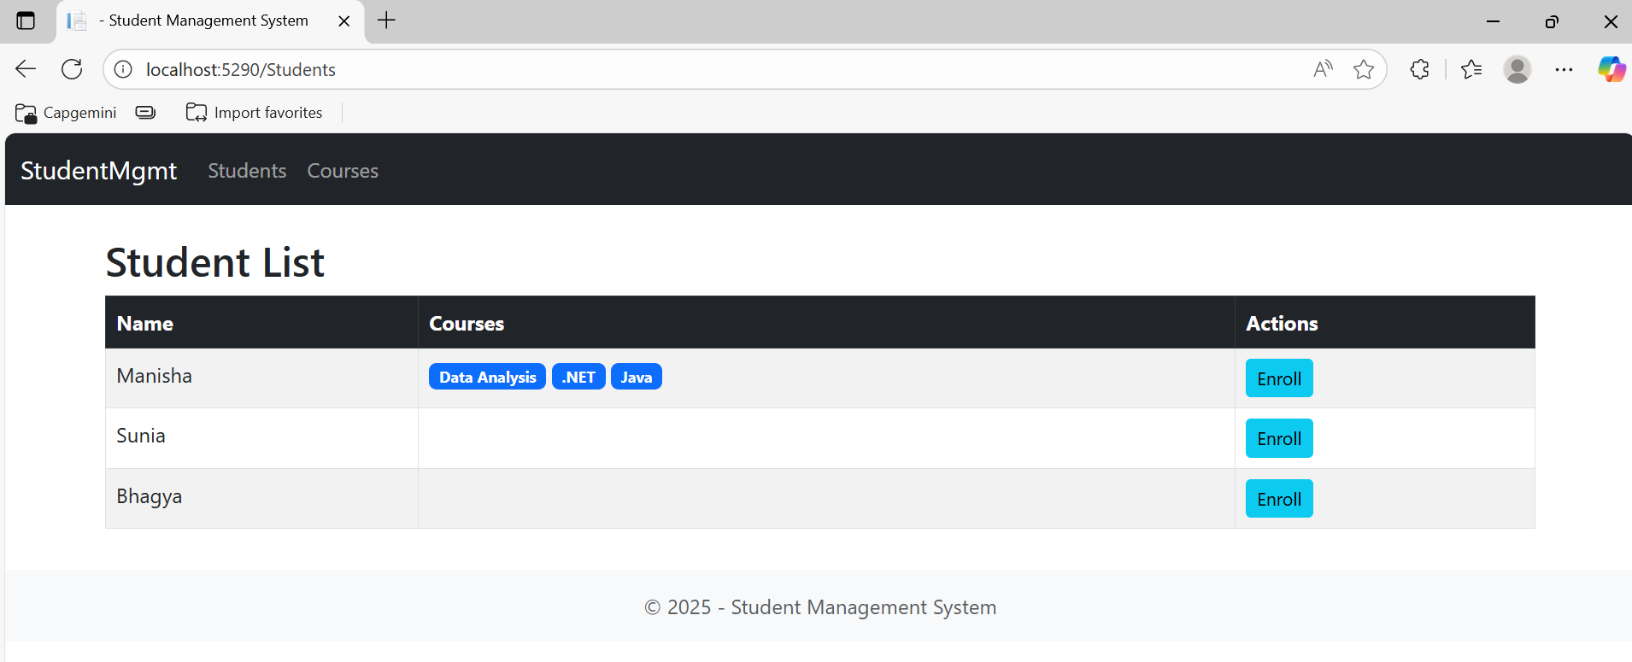

**3.First Migration and Update Database.**

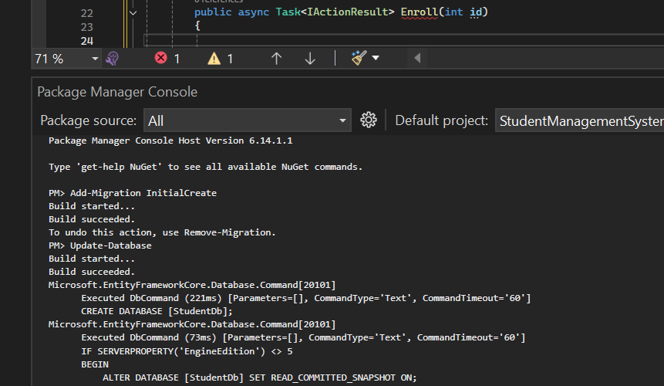

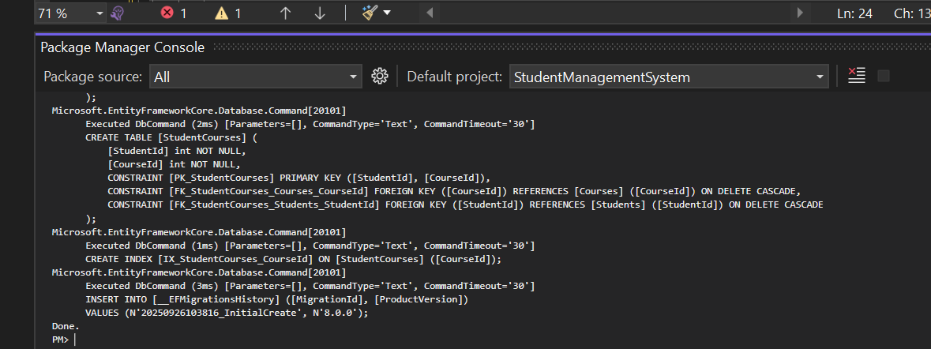

**-Home Page**

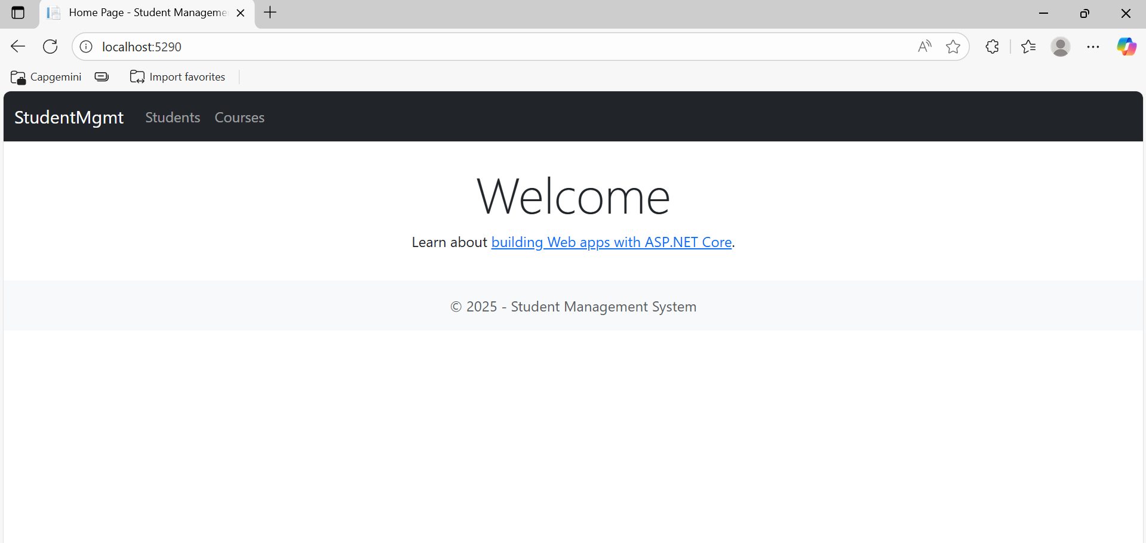

**-Student Enrolment Page And List**

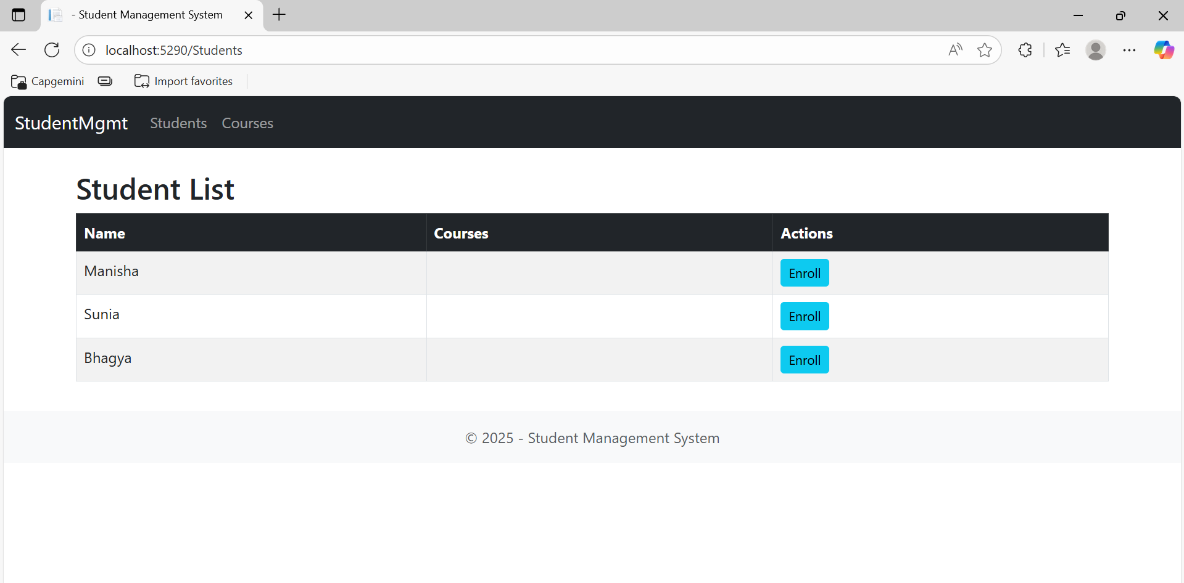

**-TO enrol into the courses**

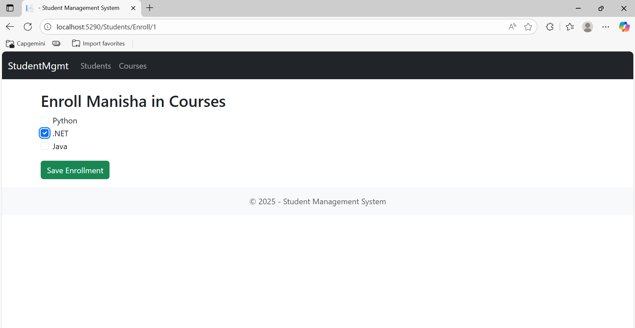

**-List of the students and courses that they have enroled**

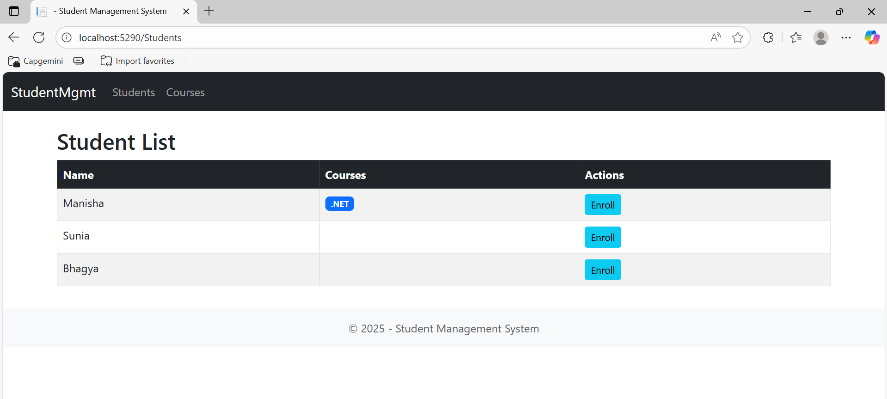

**-Course list that they have**

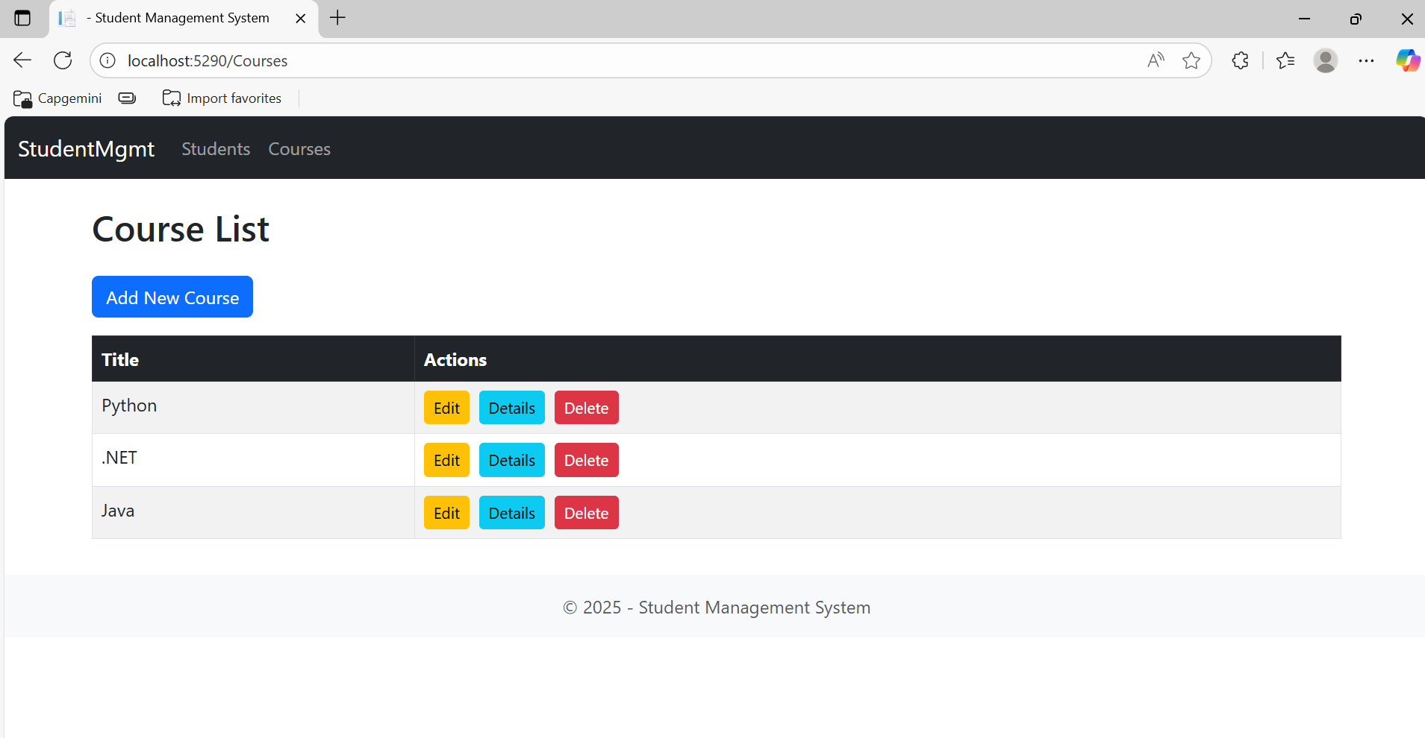

**-To add a new course**

**-Here I tried to edit python course and changed to data analysis.**

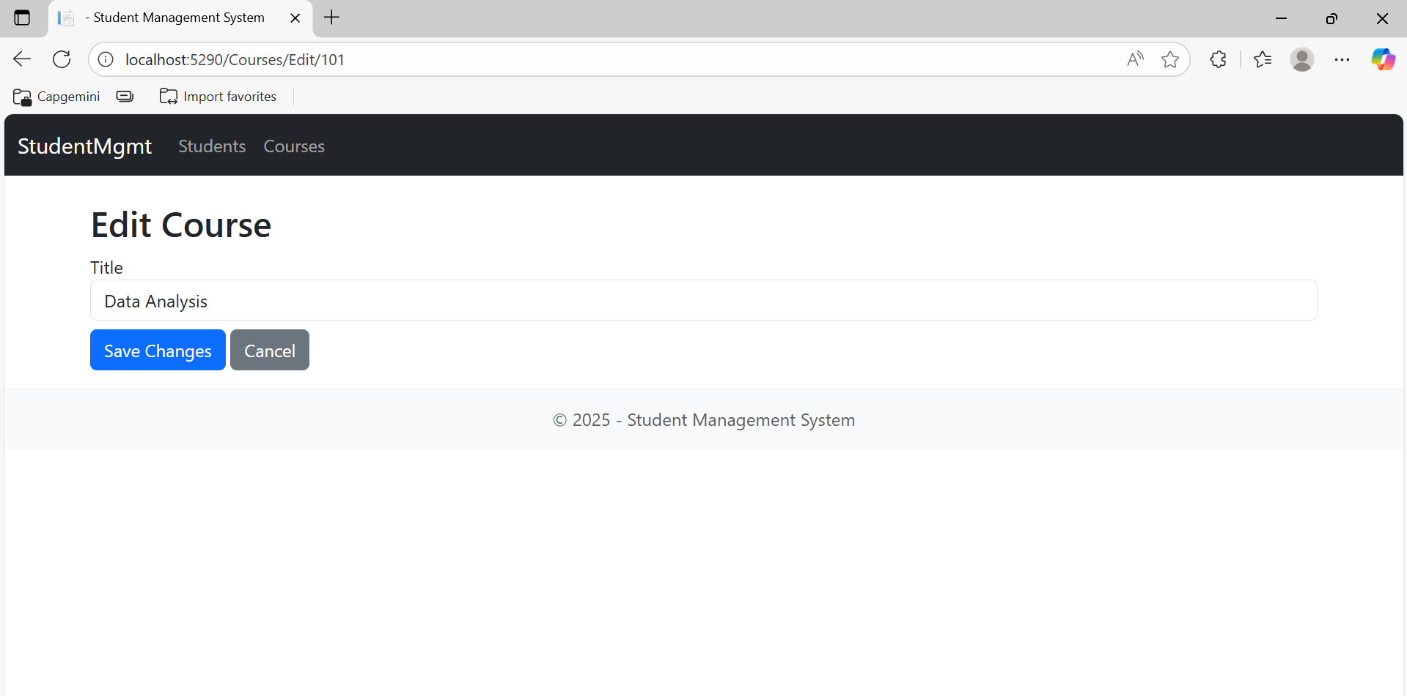

**-Course list after the edit changes.**

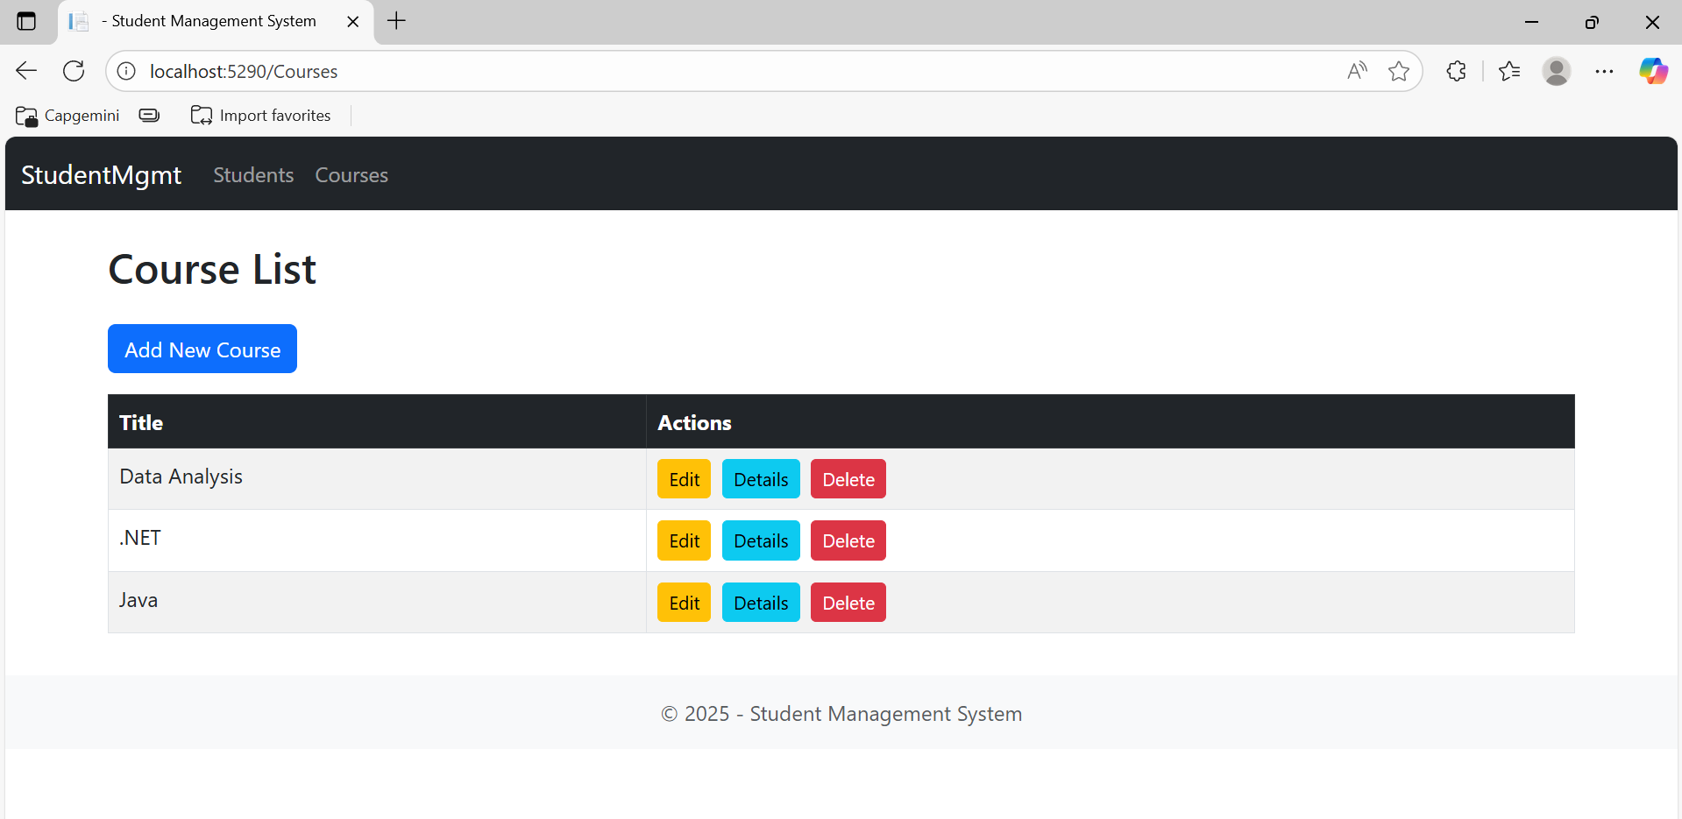

**-To check the course details.**

**-To delete the course.**

