CSG1105 Applied Communications - Assignment 2

Name – Manula Ranasinaghage
Id – 10674833
Campus – ECU , Sri Lanka

Task 1 - SMTP Protocol Analysis
1. Introduction to SMTP and Task Objectives
Simple Mail Transfer Protocol (SMTP)
A simple mechanism for sending emails across networks is called the Simple Mail Transfer mechanism (SMTP). SMTP establishes the rules and process for transmitting messages from one mail server to another until they reach their destination, much like a digital postal system. SMTP ensures that emails are sent to the right place each time by directing them via a network of servers.
SMTP is a "push" protocol, which means that it is made especially to transfer messages from the sender outward. This separates it from protocols such as IMAP or POP, which are used to retrieve or "pull" emails for the receiver to read. SMTP employs a set of commands, each of which has a specific function in managing the email's path. For example, the RCPT TO command shows the destination, but the MAIL FROM command identifies the sender. Together with other instructions, these help organize the email and direct it around the network.
Table 1
SMTP Commands
(self-created).

SMTP usually uses predefined ports, such 25 or 587, to connect to servers. Modern versions also have encryption options to increase security, which is especially crucial when dealing with sensitive data. But since SMTP doesn't offer encryption on its own, security layers are frequently added to it to safeguard data while it's being transmitted.

2. SMTP Protocol Process and Analysis.
Connection Establishment: TCP Handshake
By establishing a dependable connection between two devices, the TCP three-way handshake makes sure that both parties are prepared to send data. Three crucial phases are involved in this process:
1. SYN (Synchronize): The client sends a SYN packet to the server with a starting sequence number and a connection request.
2. Synchronize-Acknowledge (SYN-ACK): The server sends back a SYN-ACK packet. This packet acknowledges the client's SYN and provides its own sequence number, indicating that the server is ready to connect.
3. ACK (Acknowledge): The client responds with an ACK packet to verify that it has received the server's SYN-ACK. After this step, which formally creates the connection, data flow may begin.
By ensuring that two devices are in sync, this handshake makes data sharing safe and dependable.
Note. Wireshark capture showing the TCP three-way handshake, including SYN, SYN-ACK, and ACK packets exchanged to establish a reliable connection for SMTP communication (self-created).

Figure 1
TCP Three-Way Handshake Process
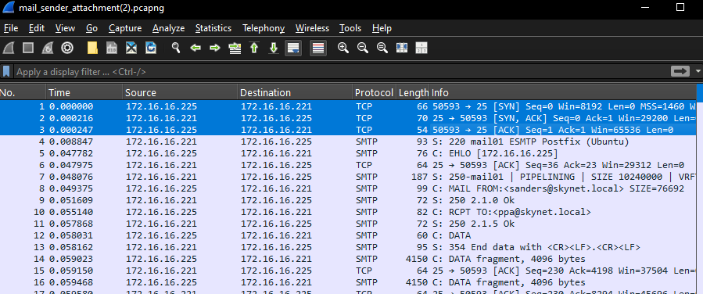

SMTP Commands in Sequence
To enable email transmission, the client and server exchange a number of SMTP instructions following the handshake.
- 220 Server Greeting: To signal that it is prepared to accept an SMTP connection, the server sends a 220 message as an initial welcome.
- EHLO (Extended Hello): The client introduces itself to the server by responding with an EHLO command. An improved form of the HELO instruction in conventional SMTP, EHLO enables the client to convey certain capabilities.
- Server’s 250 Response: The server responds with a series of 250 messages outlining the capabilities it provides throughout the session (e.g., SIZE, PIPELINING). The server's readiness to process more instructions is confirmed by this exchange.
- MAIL FROM: To notify the server of the email message's origin, the client uses the MAIL FROM command to specify the sender's email address.
- RCPT TO: This command tells the server where to send the message by allowing the client to determine the recipient's email address.
- DATA: The email body and any attachments begin with the DATA command. The server replies with a 354 message after receiving DATA, indicating that it is prepared to accept the message's contents.

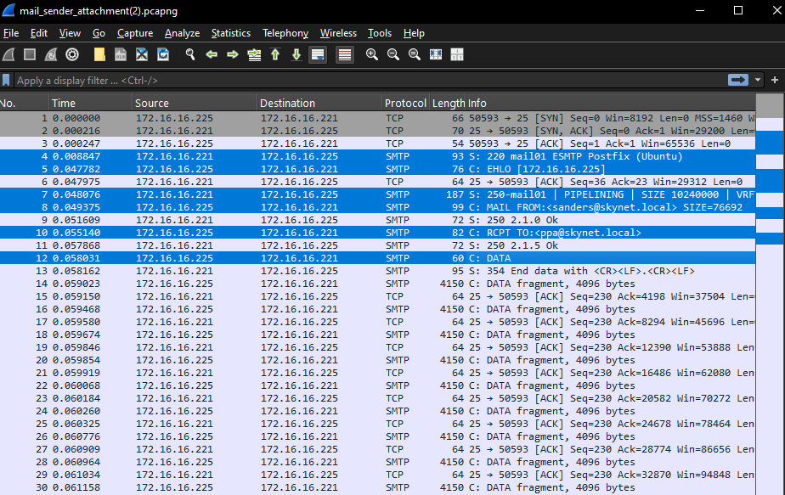
Note. Captured SMTP packet exchange in Wireshark, illustrating the sequence of commands during an email transfer, including EHLO, MAIL FROM, and RCPT TO commands (self-created)
Figure 2
SMTP Protocol Packet Flow in Wireshark

(self-created).

Figure 3
SMTP Commands
Message Transfer
The client starts sending the email content in a series of packets as soon as the DATA instruction is issued. The email body and message headers (sender, receiver, topic, and date) are contained in these packets. Since this SMTP session is insecure, all material is shown in the capture as plain text, which makes the message easy to read.
Figure 4
Message content

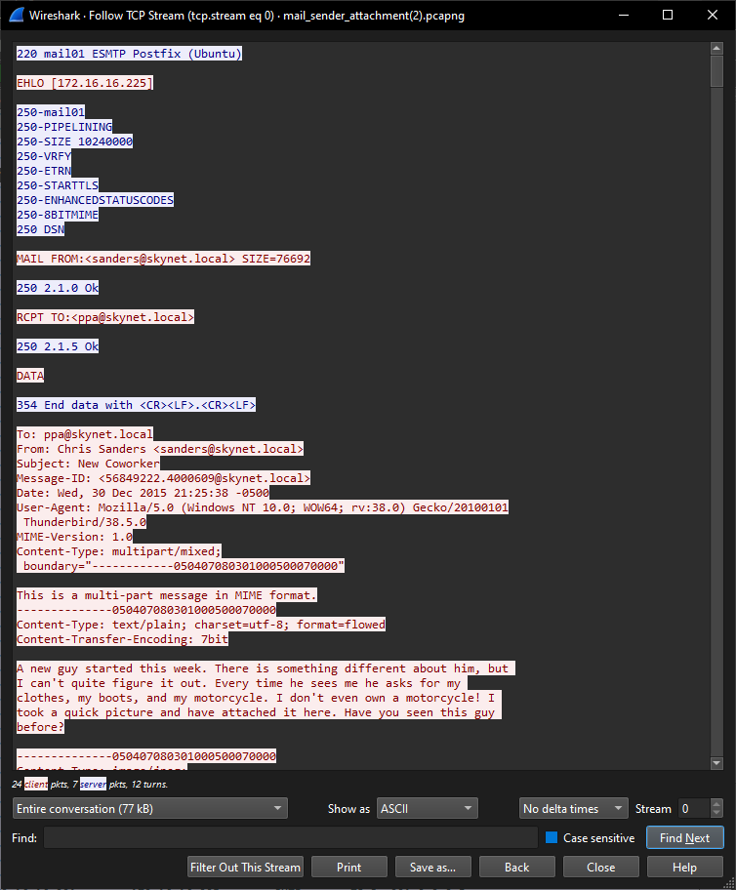
(self-created).

The TCP stream may be followed to see the message content in Wireshark. The email also contains a base64-encoded attachment. The message body displays this encoding, and if you would like to read the associated file, you may manually decode the encoded content.
Figure 5
Follow Stream Method
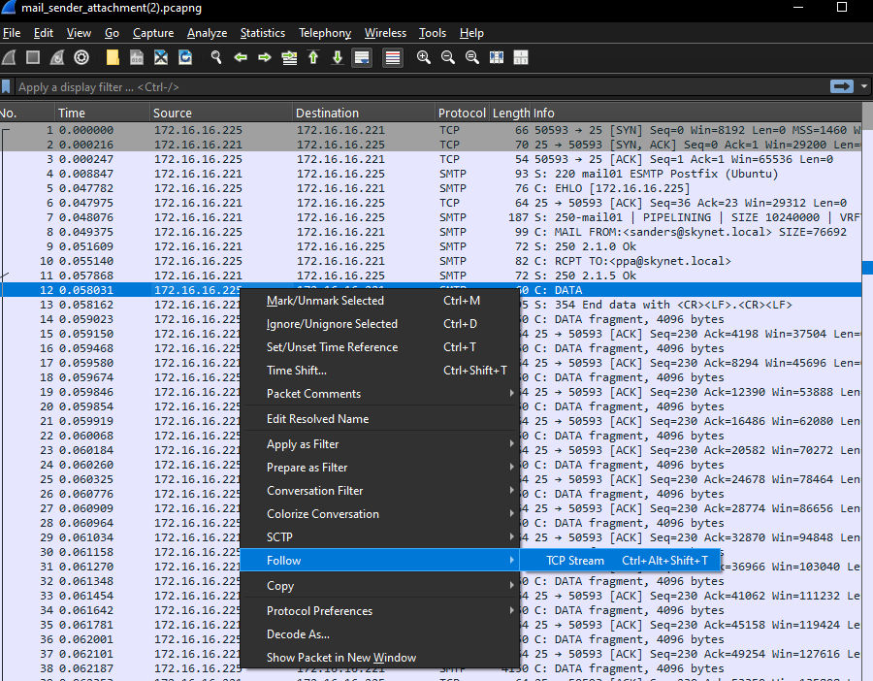
(self-created).

Ending the SMTP Session
The server confirms successful reception of the email by sending a response after the transmission is finished. After receiving an ACK packet from the server, the client formally ends the SMTP session by sending a QUIT signal. The server confirms that the connection is ended by responding with a 221 response.
The TCP session is then ended with a sequence of FIN and ACK packets, guaranteeing a clean disconnect.
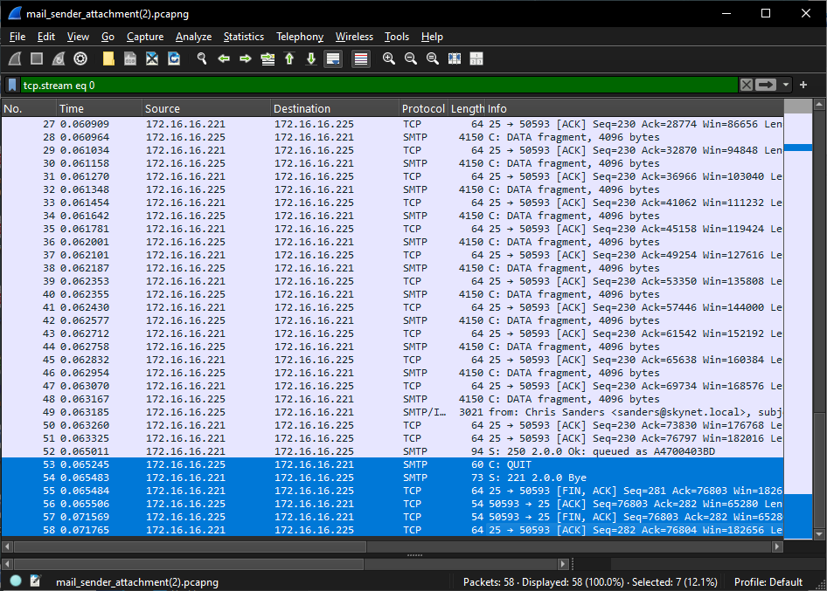
Figure 6
SMTP ending packets
(self-created).

3. Key Observations and Analysis
Summary of Protocol Flow
From connection formation to message transport and session termination, the SMTP transaction recorded throughout this session offers a comprehensive picture of how the protocol functions. Every command-response interaction demonstrates how easy and effective SMTP is for sending messages.
Security Considerations
The absence of encryption in this session is a crucial finding. Sensitive information (such as email content and sender/recipient addresses) is vulnerable to possible monitoring since SMTP sends data in plain text by default. This highlights how critical it is to use SMTPS or other security measures in settings where email privacy is essential.
Task 2
1. Network Design Overview
The network is divided into three main subnets: Subnet A, Subnet B, and Subnet C. Each subnet has a unique IP range and a /24 subnet mask. In order to make it easier to identify and manage devices based on their location on the network, these discrete IP ranges are intended to conceptually partition the network. This business provides scalability for future expansion, enhances security, and simplifies troubleshooting.
The chosen IP ranges for each subnet are as follows:
- Subnet A: 192.168.10.0 - 192.168.10.255
- Subnet B: 192.168.20.0 - 192.168.20.255
- Subnet C: 192.168.30.0 - 192.168.30.255
Each subnet can have a maximum of 254 host addresses thanks to the use of a /24 subnet mask, which offers sufficient IP capacity for future growth without requiring changes to the network's IP scheme. A summary of each subnet's IP setup is also given in Table 1 below, which shows the IP range, subnet mask, default gateway, and DNS server that are all allocated to each subnet.
Table 1
Device Subnet Configuration Table
Note: These IP ranges were selected to keep the network organized, reduce the possibility of addressing conflicts, and facilitate growth(Self Created).

2. DHCP Configuration and Dynamic IP Allocation
An important networking technology that makes IP address distribution easier in both small and big networks is the Dynamic Host Configuration technology (DHCP). DHCP removes the need for network managers to manually set each device's IP address, which may be difficult and prone to errors, by dynamically assigning IP addresses to devices as they join the network. In dynamic situations, like offices, schools, or public Wi-Fi networks, where devices connect and disconnect from the network often, DHCP is very helpful.
Each PC's setup information is included in Table 2 below, which includes the DNS server, subnet mask, default gateway, and dynamically allocated IP address format. Because devices may easily get a new IP if they are transferred to a different subnet, DHCP also enables flexible address management.
Table 2
PC Configuration Table (Dynamic DHCP Allocation)
(Self Created)

3. Routing Solution and Justification
Because of its effectiveness, dependability, and adaptability, Open Shortest Path First (OSPF) is a dynamic routing system that is often utilized in IP networks. OSPF automatically determines and updates the optimal routes based on connection costs, adjusting to changes in the network topology, in contrast to static routing, which involves manually configuring and fixing routes. Because of this, OSPF is very useful in networks with complicated routing needs and numerous subnets.
OSPF has been chosen as the main routing protocol in this network due to its sophisticated capabilities that operate well in dynamic settings.
Routing Benefits of OSPF:
- Automatic Route Calculation: OSPF is quicker and more effective by calculating the shortest path depending on link prices.
- Scalability: OSPF can accommodate more subnets as necessary, making it appropriate for networks of all sizes.
- Redundancy: OSPF may reroute traffic via alternate routes in the case of a primary route failure, guaranteeing continuous connectivity.
In Table 3 below, the IP configuration of router interfaces is provided, showing IP addresses and subnet masks for each interface.

Table 3
Router Interface Configuration Table
(Self Created)

4. Simulation Mode Testing and Observations
With the help of Cisco Packet Tracer's simulation mode, users can see how packets move across the network in great detail and visually examine data routing, spotting any problems before they become serious.
Packet Tracer's simulation mode was used to transmit a message from PC-A (Subnet A) to PC-H (Subnet B) in order to verify the network's operation. The message successfully followed the best route determined by the routing protocol while OSPF was enabled. This validated inter-subnet connectivity and efficient routing.

(self-created).

Figure 7
Step 1 of PC-C to H
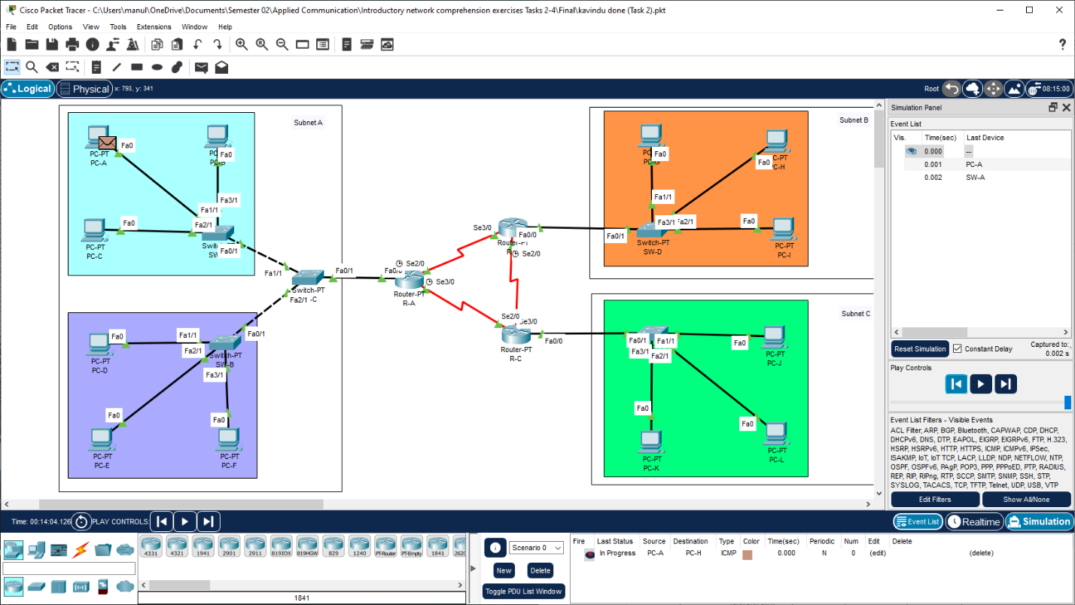
Figure 8
Step 2 of PC-C to H
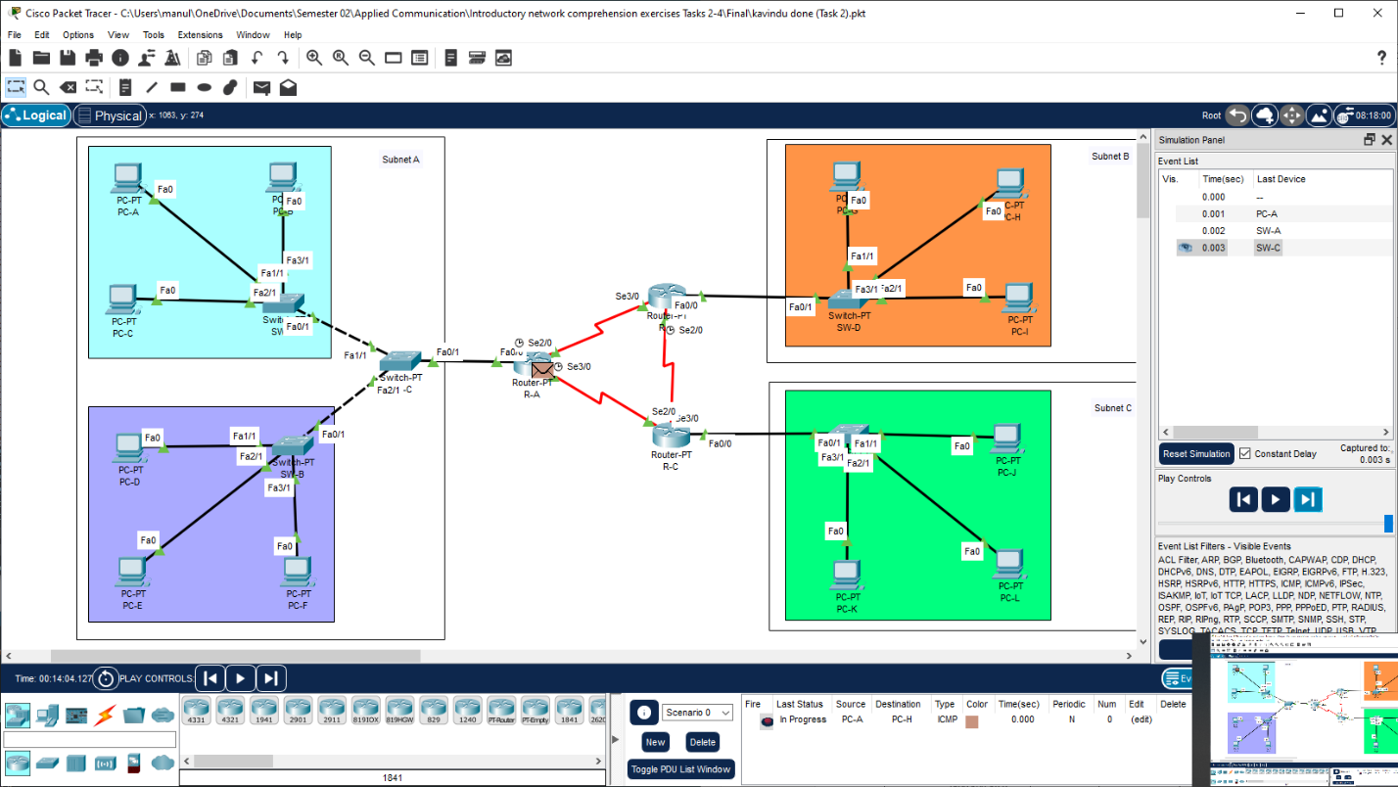
(self-created).

Figure 9
Step 3 of PC-C to H
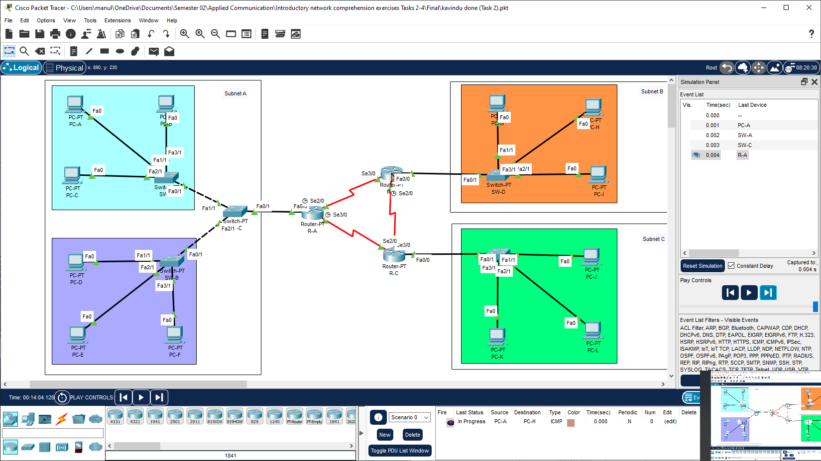
(self-created).

Figure 10
Step 4 of PC-C to H
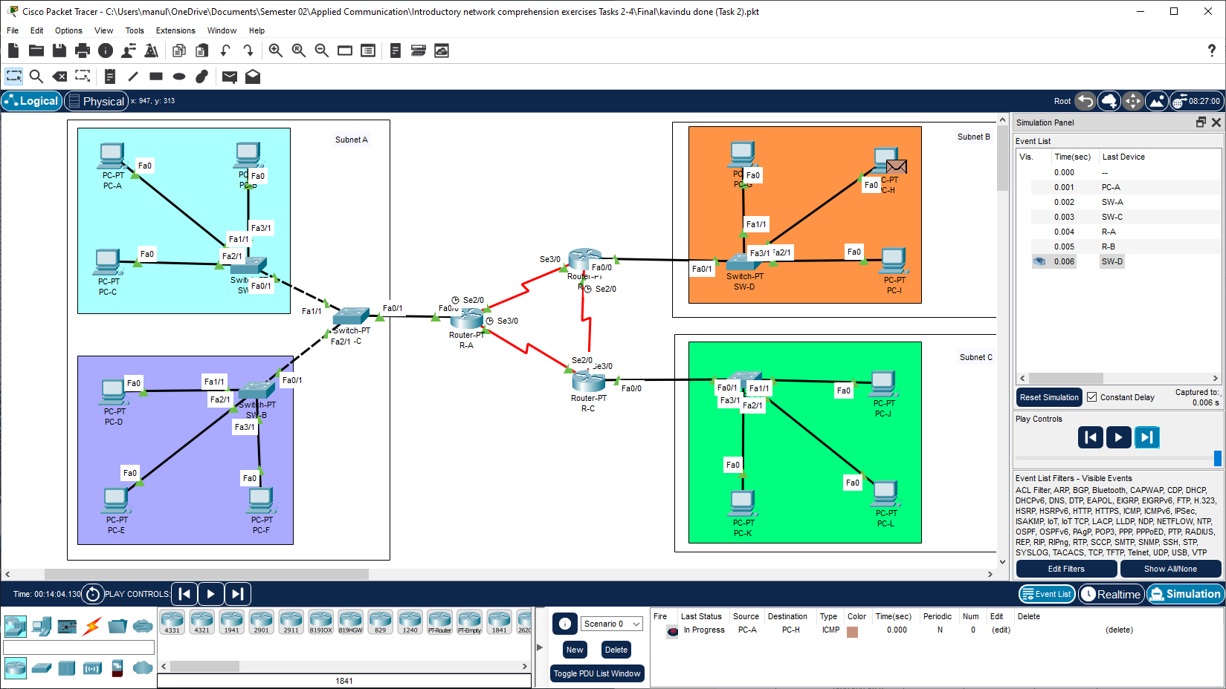

Figure 11
Step 5 of PC-C to H
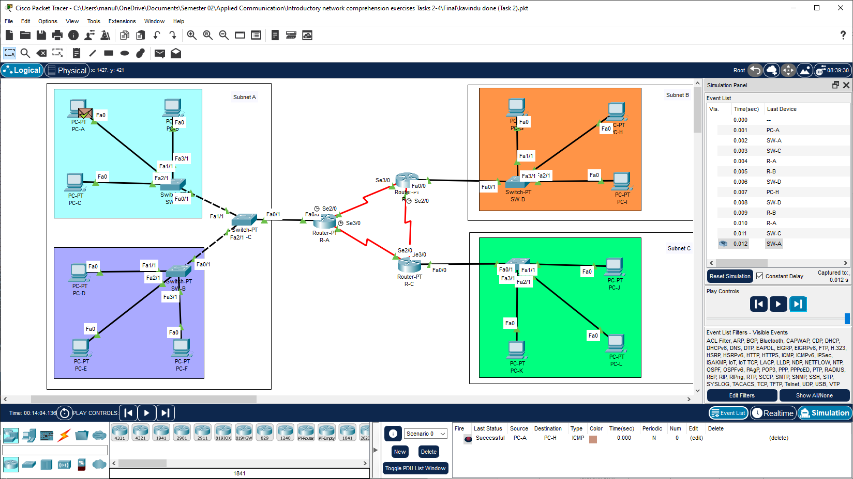

(self-created).

Link Failure Simulation
In order to observe OSPF's adaptive capabilities, the connection between Routers A and B
was disabled for resilience testing.
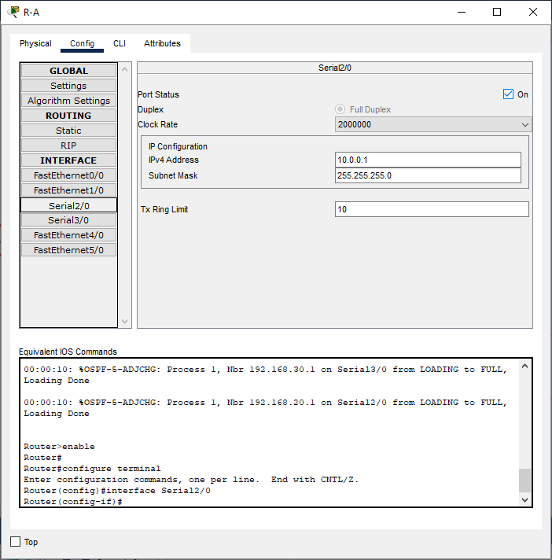
To show that the protocol can continue to function even in the event of a connection loss, OSPF dynamically recalculated the routes and diverted the message from Router A to Router C, and then from Router C to Router B. This flexibility keeps data flowing between subnets efficiently and reduces downtime.
(self-created).

Figure 12
R-A To R-B connection Disable
Figure 13
Step 1 of PC-A to H
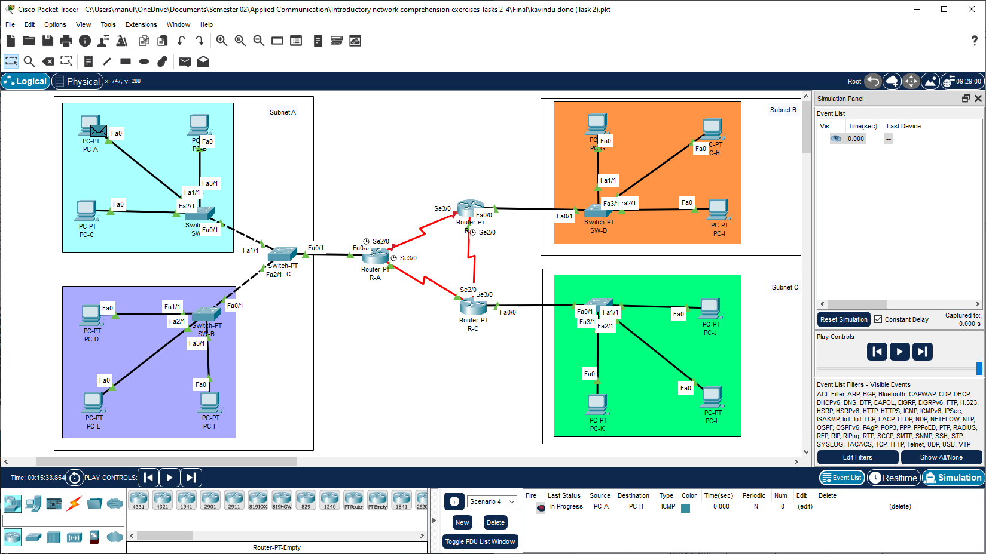
(self-created).

Figure 14
Step 2 of PC-A to H
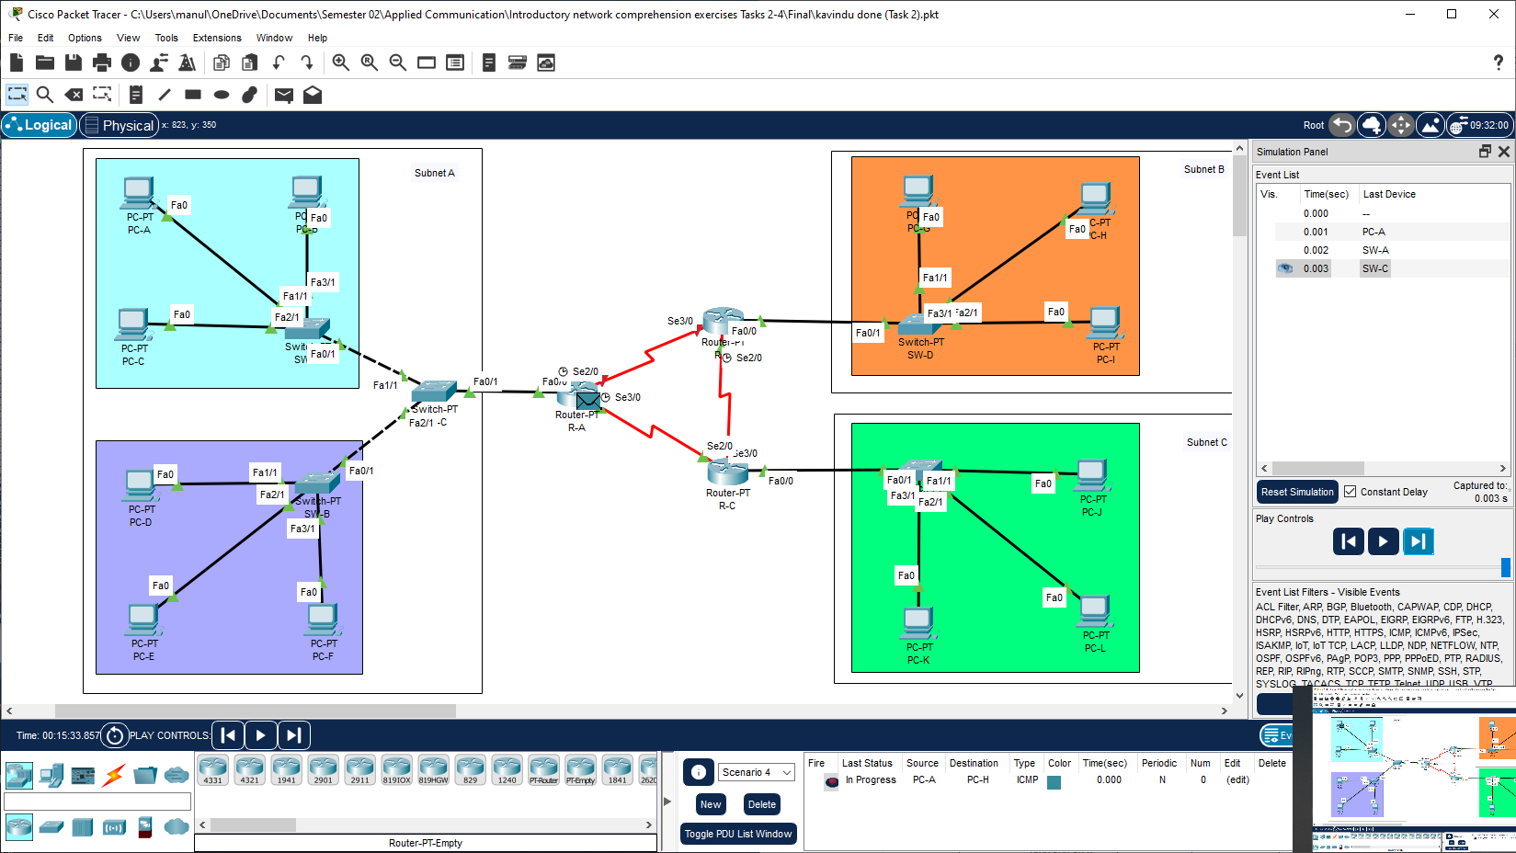
(self-created).

Figure 15
Step 3 of PC-A to H
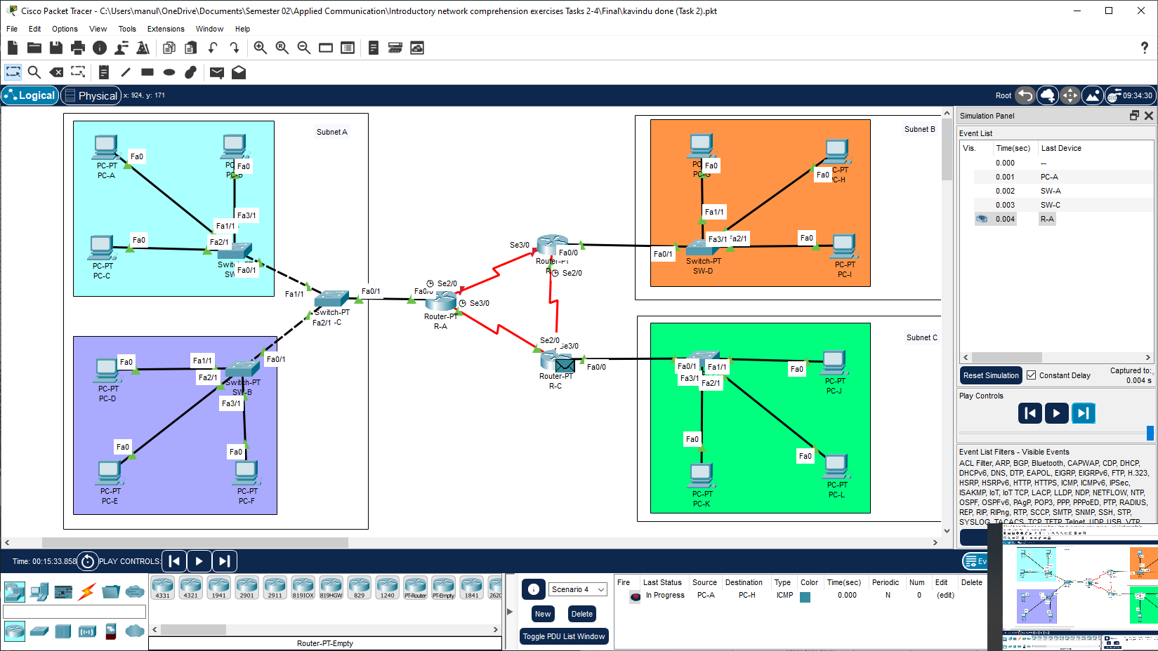
(self-created).

Figure 16
Step 4 of PC-A to H
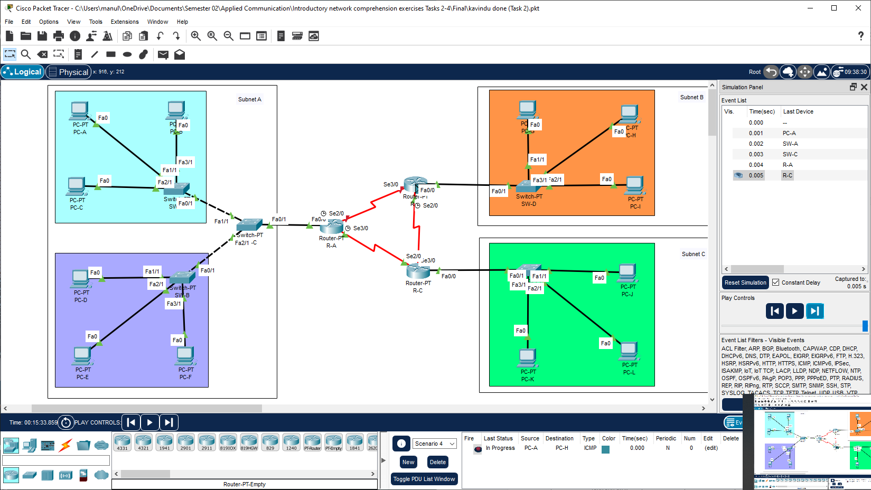
(self-created).

Figure 17
Step 5 of PC-A to H
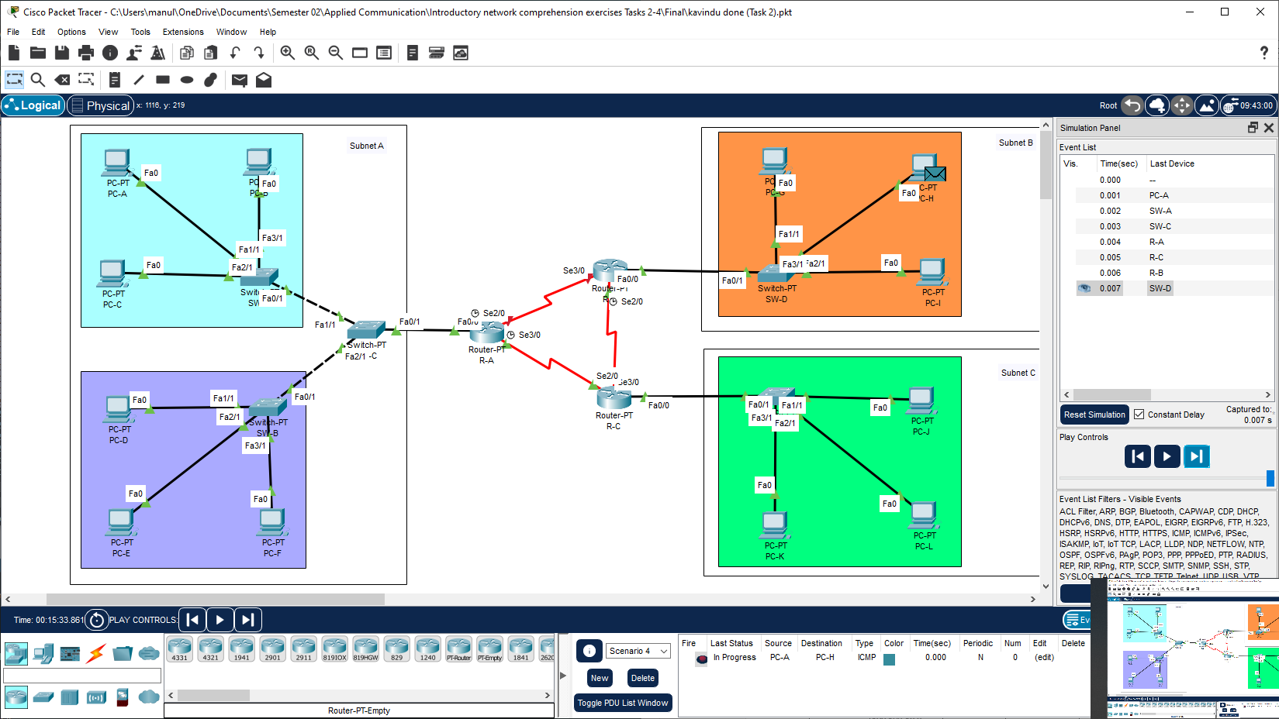
(self-created).

Figure 18
Step 6 of PC-A to H
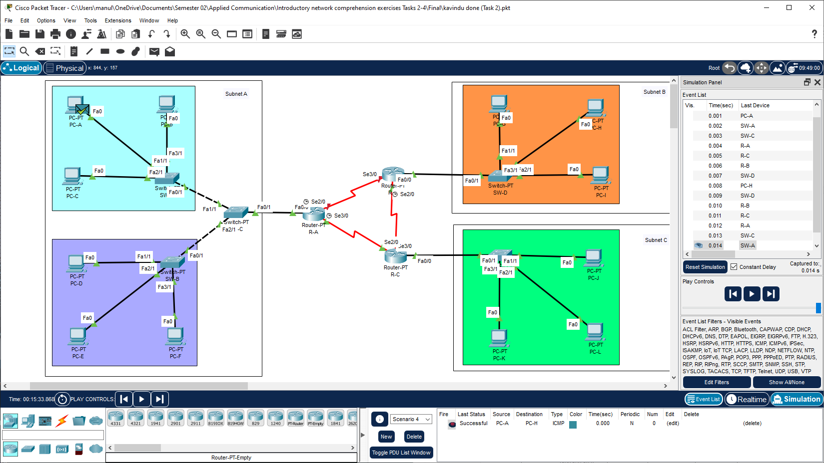
(self-created).

5. Network Design Evaluation and Recommendations
With OSPF and DHCP, the system works well, however there is room for some improvements.
Shortcomings and Recommendations
- Initial Configuration Delay: DHCP startup may cause a delay in IP address assignment when the network is switched on. This delay might result in failed packet transfers between devices right after starting since OSPF and DHCP require time to properly setup.
Recommendation: After turning on the network, give it a little time to make sure the OSPF and DHCP setups are finished. As an alternative, important devices might have instant availability by employing static IPs.
- Lack of Physical Redundancy: If several links break at once, the network design's lack of redundant links between routers may impair connectivity.
Recommendation: Increasing the number of links connecting routers would improve fault tolerance and enable the network to continue operating even in the event of a link loss.
Limited Traffic Segmentation: Devices in the same subnet are not segregated in the absence of VLANs, which might result in excessive broadcast traffic and decreased security.
Recommendation: By dividing devices according to department or role, VLANs would improve traffic control and security by lowering broadcast traffic within the network.

Task 3: OSI Layer 2 Implementation and Analysis
1. Introduction to VLANs and Router-on-a-Stick Configuration
Virtual LANs (VLANs) have been used to divide the network into segments in order to improve flexibility, security, and traffic control. Three separate VLANs are included in this configuration:
- VLAN 75: Comprising PCs A, D, and F for one network segment.
- VLAN 150: Includes all other PCs, forming another segment.
- VLAN 225: Allocated for Wi-Fi, connecting laptops via an Access Point (AP) on SW-C.
Router A was configured as a Router-on-a-Stick to enable connectivity between these VLANs. This approach makes use of a single physical interface on Router A that is marked with IEEE 802.1Q and has distinct sub-interfaces for every VLAN. The router may transport traffic between VLANs via these virtual interfaces as each sub-interface is given an IP address that matches its VLAN.
2. VLAN and IP Configuration Details
Allocating IP Addresses to VLANs to allow for each VLAN's own IP ranges and subnet masks, the original /24 subnet was split up. The setup looks like this:
Table 1
VLAN IP Ranges and Masks
(self-created).

A router on a stick Configuration of Sub-Interfaces
Sub-interfaces were established on Router A under FastEthernet0/0, and each was given a VLAN with a unique IP address:
- FastEthernet0/0.75: VLAN 75, IP 192.168.1.129/26
- FastEthernet0/0.150: VLAN 150, IP 192.168.1.193/26
- FastEthernet0/0.225: VLAN 225, IP 192.168.1.1/25
Devices in each VLAN can interact as needed because of this setup, which gives the router the ability to control inter-VLAN routing.
3. Switch and DHCP Configuration
Every switch was set up to handle VLANs using the configuration shown below:
- Access Ports: These are PC-specific ports that make sure every device connects to the designated VLAN.
- Trunk Ports: Attached to Router A, these ports let tagged traffic from every VLAN to go between switches and the router.
Additionally, Router A is a DHCP server that assigns IP addresses dynamically inside each VLAN. Every VLAN has a DHCP pool that is set up as follows.
- VLAN 75: IP range 192.168.1.128 - 192.168.1.191
- VLAN 150: IP range 192.168.1.192 - 192.168.1.255
- VLAN 225: IP range 192.168.1.1 - 192.168.1.127

By ensuring automated IP assignment, this configuration minimizes the need for human configuration and the possibility of mistakes.
4. Laptop Connection via VLAN 225 Wi-Fi
To offer wireless connectivity, laptops are included into VLAN 225 via a Wireless Access Point (AP). Devices without wired connections, including laptops, can easily join to the network thanks to the AP's ability to act as a bridge between wired and wireless network segments. The AP is set up with the SSID "VLAN 225 Wi-Fi," and it uses VLAN 225 to make sure that all laptops that are connected have IP addresses that fall into the VLAN 225 range.

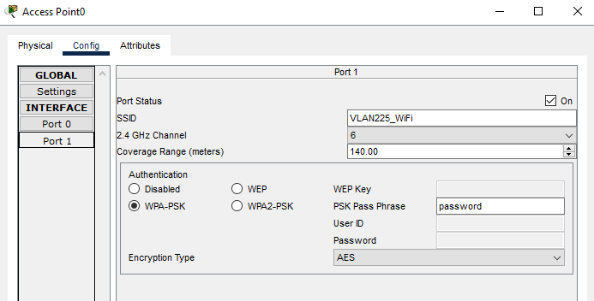
(self-created).

Figure 19
Access Point

WPA-PSK authentication is part of the AP's setup, which increases security by needing a password to access the network. By limiting access to the network to authorized laptops, this configuration makes it secure and adaptable. Through Router A's DHCP configuration, the AP dynamically distributes IP addresses, allowing laptops to connect to other devices in VLAN 225 and to other VLANs through inter-VLAN routing that is controlled by Router A.

5. Connectivity Testing and Results in Simulation Mode
To verify network segmentation and inter-VLAN routing, connection tests were conducted both inside and across VLANs using Packet Tracer's simulation mode:
- Intra-VLAN Testing: VLAN segregation was confirmed when devices in the same VLAN were able to successfully ping one another. For instance, PC-A in VLAN 75 had no trouble communicating with PC-D and PC-F.
Figure 20
Step 1 of PC-A to D
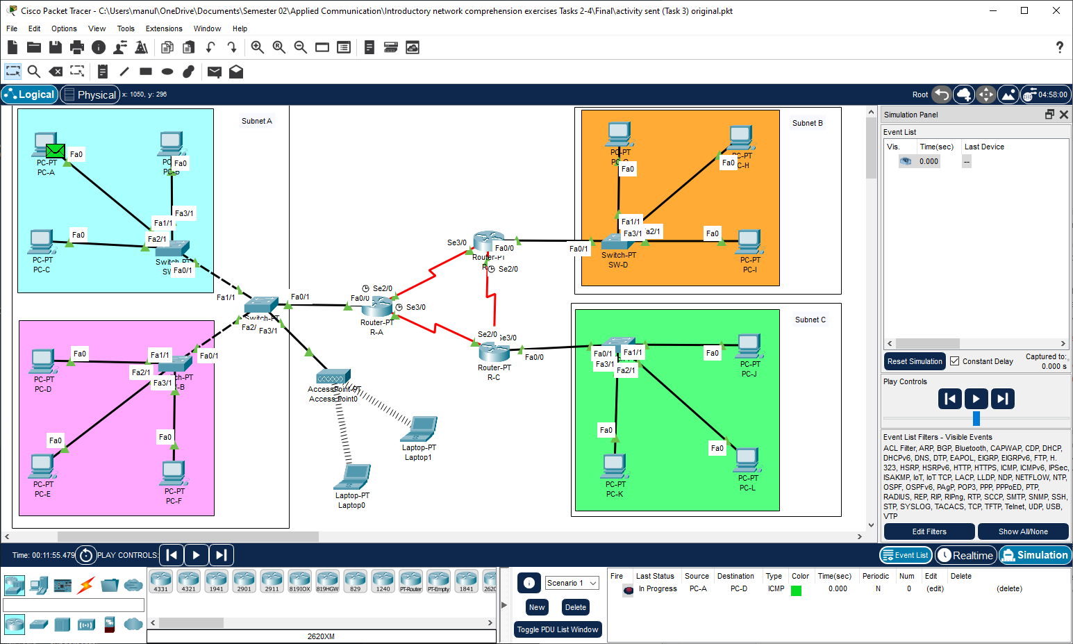
(self-created).

Figure 21
Step 2 of PC-A to D
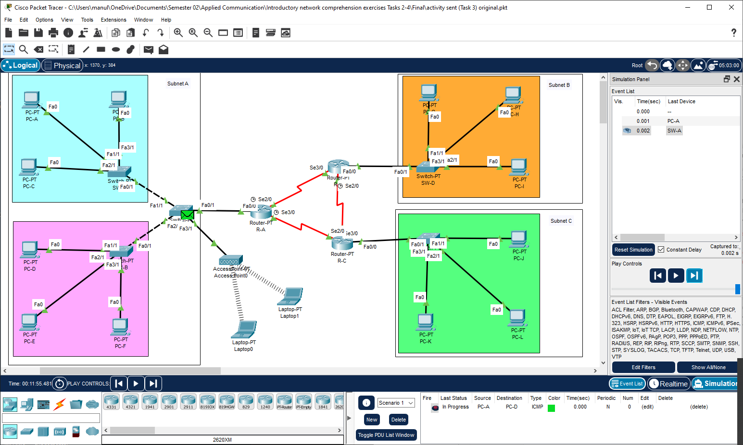
(self-created).

Figure 22
Step 3 of PC-A to D
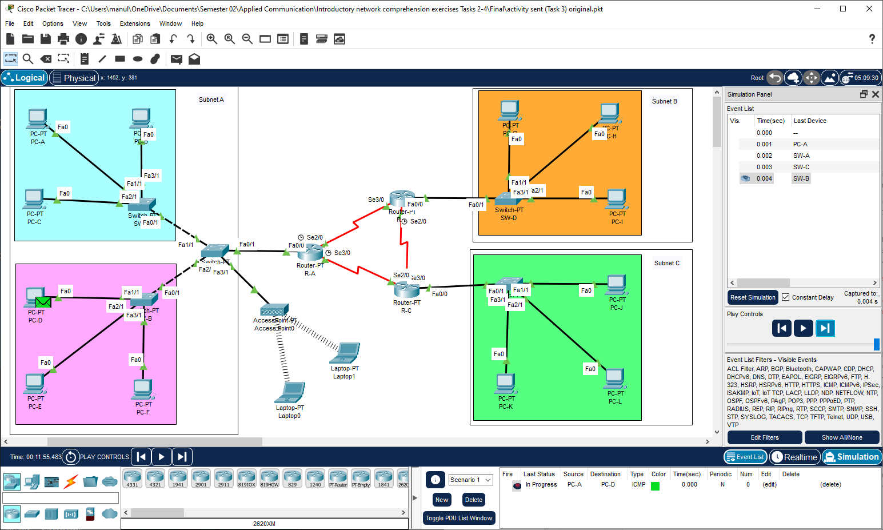
(self-created).

Figure 23
Step 4 of PC-A to D
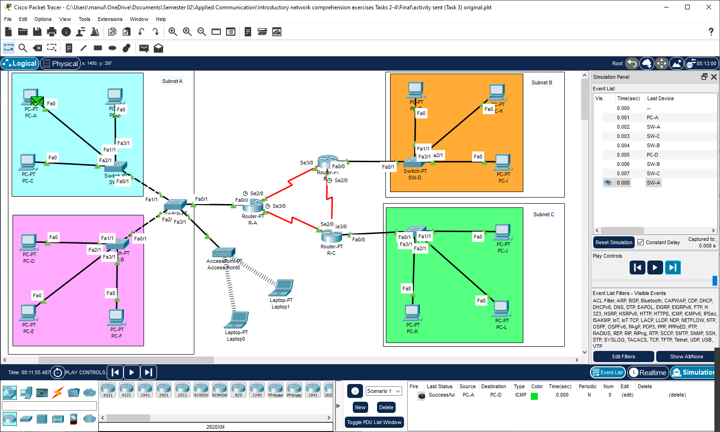
(self-created).

- Inter-VLAN Testing: Devices in various VLANs were able to interact with each other because of the Router-on-a-Stick setup. To confirm successful inter-VLAN routing, PC-A in VLAN 75, for instance, might ping devices in VLANs 150 and 225.

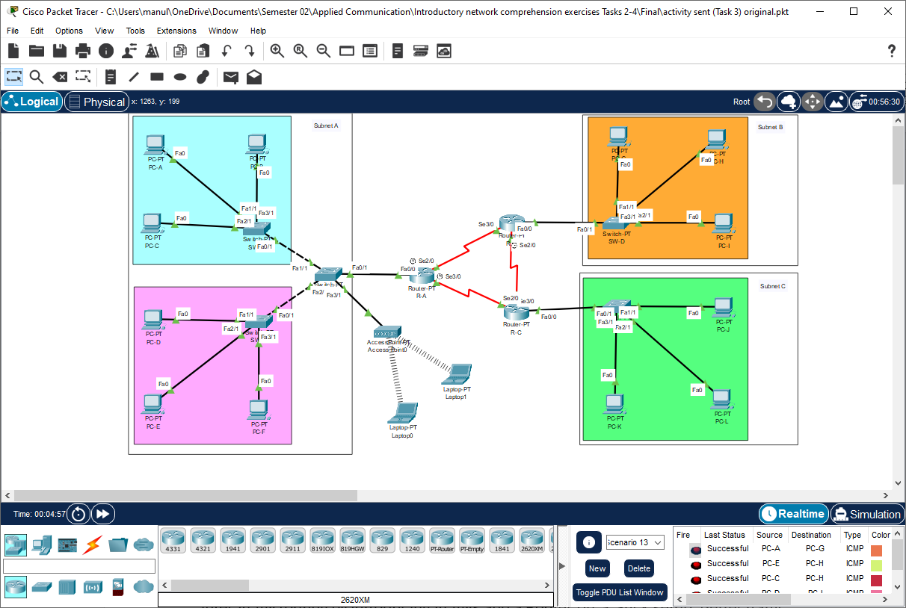
(self-created).

Figure 24
Inter-VLAN Testing

Testing with Router Interface Enabling and Disabling There were tests in the simulation where router interfaces were turned on and off. Communication between VLANs was momentarily disrupted when interfaces were deactivated, demonstrating the significance of interface stability. Connectivity was restored by re-enabling the interfaces, proving the configuration's resilience.
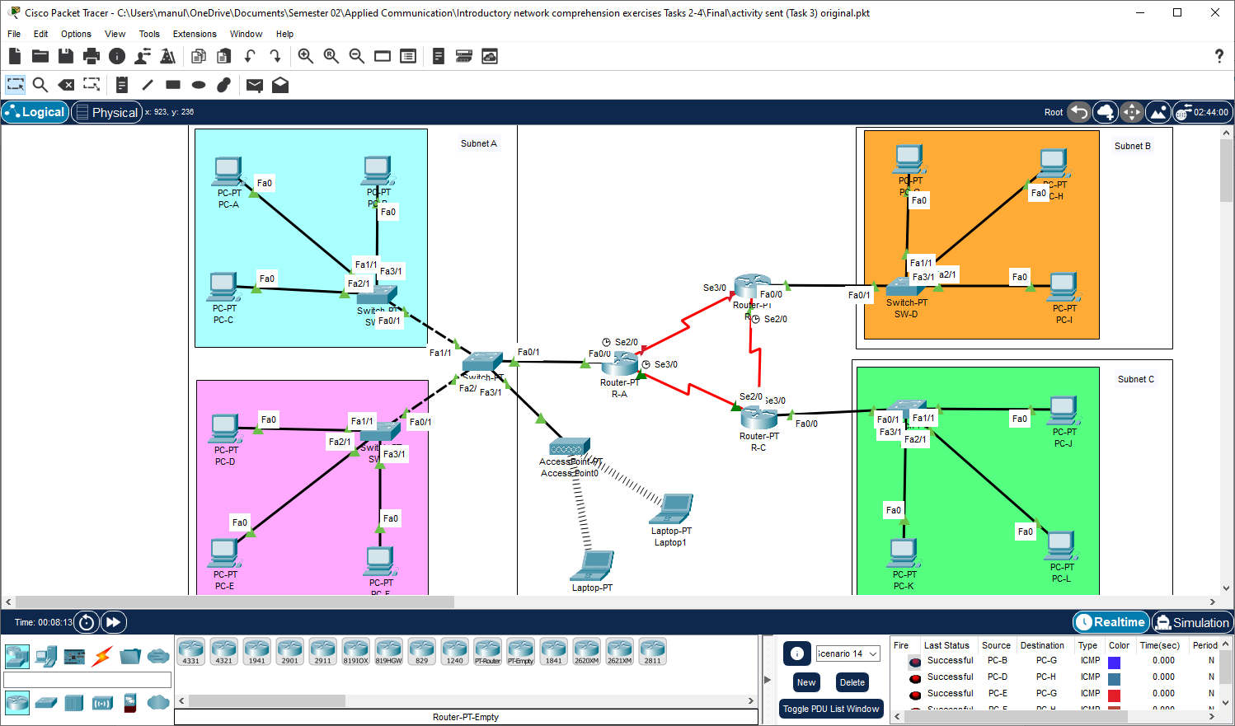
(self-created).

Figure 25
Testing with Router Interface Enabling and Disabling

6. Comparison with Task 2’s Network Design
In Task 2, every device shared the same network segment on a simple network without VLANs. On the other hand, Task 3 created distinct network segments and necessitated inter-VLAN routing by introducing VLANs and a Router-on-a-Stick setup. Better traffic management and control were made possible by this change, and each VLAN's DHCP pool was customized for effective IP distribution.
7. Analysis of Results and Recommendations
Successes of the Design:
- Enhanced Traffic Control: By reducing pointless broadcast traffic, VLAN segmentation enables effective network administration.
- Automated IP Allocation: Device administration is made easier by DHCP pools customized for each VLAN, which automate IP distribution.
- Inter-VLAN Connectivity: Router-on-a-Stick meets inter-device communication needs by facilitating smooth communication across VLANs.
Recommendations and Shortcomings:
- Redundant Links for Reliability: By establishing redundant links between Router A and switches, connectivity loss in the case of a single link failure would be avoided.
- Security Enhancements: By limiting which VLANs may interact, the implementation of Access Control Lists (ACLs) would provide an additional degree of protection.
- Scalability: By reducing the processing load on Router A, switching from the Router-on-a-Stick configuration to a Layer 3 switch might enhance performance for future growth.

Task 4
Packet Transmission from PC-A to PC-L: Simplified Explanation
Router-A and Router-B are the two primary routers that a packet passes through on its way from PC-A to PC-L. To guarantee that the packet reaches its intended location, each router modifies its addresses. This is a detailed explanation of what takes place at each router.
1. Starting Point: PC-A
First, PC-A sets the destination IP to be PC-L's (192.168.30.3) and the source IP to be its own (192.168.10.3). The destination MAC is set to Router-A's MAC address to route the packet to the router, while the source MAC is PC-A's distinct MAC address.

2. At Router-A (Router0)
- Ingress (Receiving Side): Router-A verifies that the packet was sent to a separate network by looking up the destination IP (192.168.30.3) when it gets it on its Fa0/1 interface. There is no change in the Layer 3 (IP) addresses, with PC-A's IP serving as the source and PC-L's as the destination.
When it comes to Layer 2 (MAC) addresses, PC-A's MAC serves as the source, while Router-A's MAC serves as the destination, enabling Router-A to properly receive the message.
- Egress (Forwarding Side): Router-A transfers the packet to Router-B after processing it, updating the Layer 2 (MAC) addresses. Now, Router-A's outgoing Serial3/0 interface MAC is the source MAC, while Router-B's MAC address is the destination MAC. The packet's intended final destination (PC-L) is guaranteed to be constant since the IP addresses stay the same.
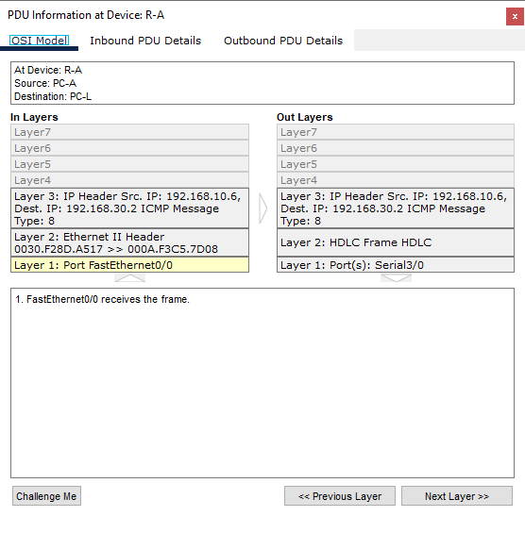
(self-created).

Figure 26
PDU information of RA

3. At Router-B (Router4)
- Ingress (Receiving Side): The packet is received by Router-B via its Serial2/0 port. In this case, PC-A's IP address is still the source, while PC-L's IP address is still the destination. However, Router-B is aware that it is the subsequent step in the packet's transit since the Layer 2 addresses display Router-A's MAC as the source and Router-B's MAC as the destination.
- Egress (Forwarding Side): Router-B makes one more modification to the MAC addresses before sending the message to PC-L's subnet. The packet can reach PC-L directly because the source MAC is set to the MAC of the Fa0/1 interface of Router-B and the destination MAC is changed to PC-L's MAC. Because the IP addresses don't change, end-to-end communication is possible.

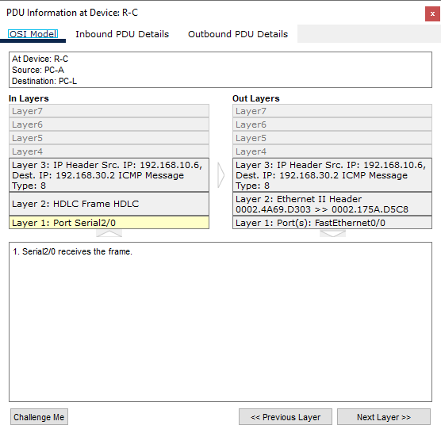
(self-created).

Figure 27
PDU information of RC
4. Final Destination: PC-L
The packet demonstrates that Layer 3 addresses (IP) are consistent from beginning to end by arriving at PC-L with the identical source and destination IPs that PC-A configured. However, each router has modified the Layer 2 (MAC) addresses to guarantee that the packet is successfully routed via every network segment.

Table
Device | Interface | Source IP Address | Destination IP Address | Source MAC Address | Destination MAC Address
PC-A | Fa0 (Ingress) | 192.168.10.3 | 192.168.30.3 | 0030.F28D.A517 | 000A.F3C5.7D08
Router0 | Fa0/1 (Ingress) | 192.168.10.3 | 192.168.30.3 | 0030.F28D.A517 | 000A.F3C5.7D08
Router0 | Serial3/0 (Egress) | 192.168.10.3 | 192.168.30.3 | 000A.F3C5.7D08 | 0002.175A.D5C8
Router4 | Serial2/0 (Ingress) | 192.168.10.3 | 192.168.30.3 | 000A.F3C5.7D08 | 0002.175A.D5C8
Router4 | Fa0/1 (Egress) | 192.168.10.3 | 192.168.30.3 | 0002.175A.D5C8 | 0002.4469.D303
PC-L | Fa0 (Ingress) | 192.168.10.3 | 192.168.30.3 | 0002.175A.D5C8 | 0002.4469.D303

(self-created).

