# FlatCaptureNow2

# Purpose

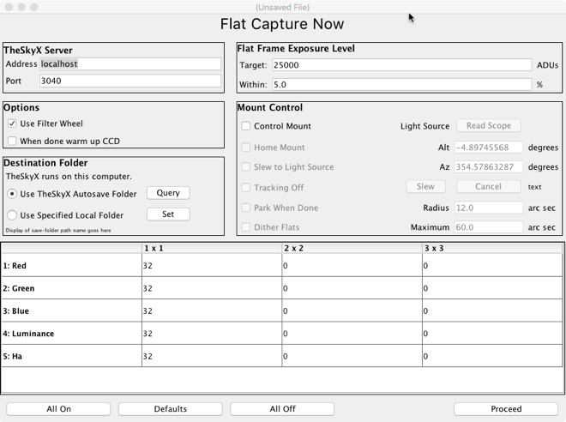FlatCaptureNow2 is a control program that connects to TheSkyX Professional Edition and directs it to take a set of flat frames. It’s designed to use at the end of your imaging session and does not have any “delayed start” options. I usually initiate the acquisition and then leave it running while I am closing up the observatory and putting other things away. The “2” is a reference to this being a Java re-implementation of the original program, which was implemented in Python.

The program is designed to take multiple frames for each combination of filter and binning you used in your session. For example, a session might be to capture “32 flats each of 1x1 Luminance and 2x2 Red, Green, and Blue”.

You also need a flat light source for flat frame acquisition and the program can slew your scope to point to it if it is in a fixed location. This might be a light panel in or near your observing site, or a favorite clear patch of the dawn or dusk sky.

The exposure time for a flat is selected to generate a given average brightness across the frame. This value, measured in ADUs, can be found online for your camera, and is usually about 30% of the camera’s “full well depth”. I use 25,000 ADUs for my QSI583. FlatCaptureNow2 manages the exposure time automatically, given the ADU target you want to achieve.

Note that I have only tested this program on my own equipment, a Paramount MX+ and a QSI583wsg camera. I can think of no reason it shouldn’t work on other equipment, and there has been some feedback that it is working on other setups. It has been tested on Mac and Windows computers and should work anywhere that Java can run.

# Initial Set-Up

The first time you run FlatCaptureNow2, enter the Preferences menu and define the default settings that are used every time you set up a new Flats plan.

* Define the default number of frames you would like to take for each filter. (This, and all settings, is just a default and can be changed in each individual plan.)
* Indicate whether you use a filter wheel. If so, list what filters are in the slots. Give each filter a unique name. The filter names are used in the captured file names, so they can contain only letters and digits. Uncheck “Use” for filter slots you don’t have or don’t use.
* Define what binning settings you will ever use. There are 3 levels for each binning. “Default” means it will be included, with the default frame count, in each new plan. “Available” means it will be in the plan, with the number of frames initialized to zero, so you can add frames at that setting but won’t get any as a default. “Off” means it won’t show up in the plan at all.
* Define the default target ADUs you want, and how close (as a percentage) the program should try to get to this value before a frame is accepted. 10% is probably fine, but I generally use 5% because I enjoy watching the program search for good exposures.
* If your light source is in a fixed location, record that location to facilitate slewing to it. The easiest way to record the location is to point the telescope with TheSkyX and then click “Read Scope”. If your light source is near the horizon (e.g. a flat panel in your observatory) you might need to turn off TheSkyX’s “impose slew limits” option in TheSkyX’s “Imaging System Setup” panel, or TheSkyX may refuse the slew, saying it is outside your slew limits.
* Define where TheSkyX is running by specifying the host name or IP address and the port number where TheSkyX listens. You get more functionality if you run FlatCaptureNow2 on the same computer where TheSkyX is running, but it can run elsewhere on your network if desired. (The difference is that if TheSkyX is running on a remote computer, you can’t control where the acquired images are saved from FlatCaptureNow2.)

FlatCaptureNow2 remembers what exposure lengths worked well from previous sessions and uses them as first estimates for new sessions, to speed up finding the right exposure. If, for some reason, these remembered exposures become inappropriate – such as replacing your light source, filters, or camera – the “Reset Time Estimates” button will cause the remembered values to be discarded and recalculated next time. You don’t have to do this – the program will adjust anyway; it will just take longer the first time.

# Normal Use

FlatCaptureNow2 does not control your camera’s cooling circuitry. Your camera should be on, with the temperature regulation set and stable at the temperature desired for your flats.

|  |
| --- |
| To create a new flat frames acquisition plan, start the program to get an empty plan window, or select File/New. The plan will be initialized from the defaults you established in Preferences and can be adjusted from there. Once defined, your flat frames plan can be saved to disk for easy reuse.  The bottom half of the plan window is a matrix of all filters and binning values you have selected, and the number of frames that will be taken of each of those. Click on a cell to type a different number of frames. |

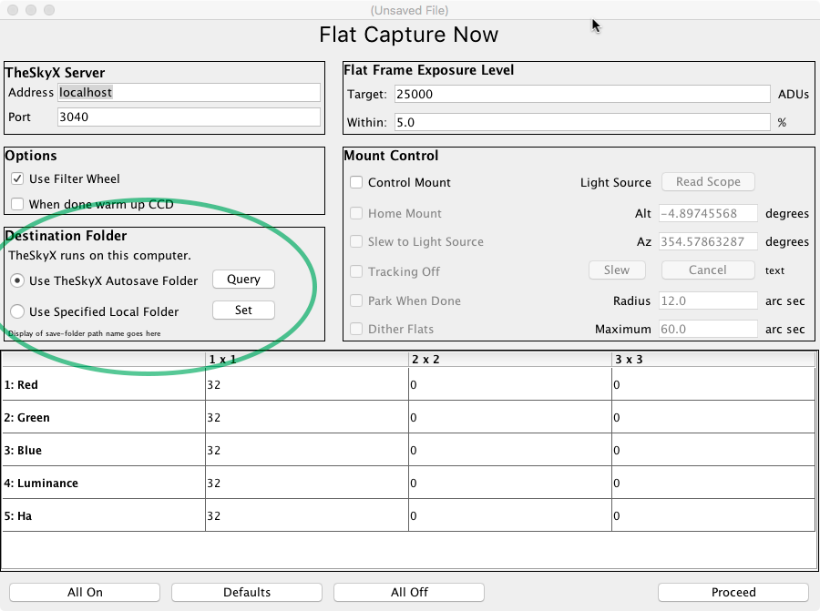***Where the flat frames go:*** If FlatCaptureNow2 is running on a different computer from TheSkyX, you can’t control where the frames are saved from FlatCaptureNow2. Instead, the save location is controlled on TheSkyX’s computer, using TheSkyX’s AutoSave button.If FlatCaptureNow2 and TheSkyX are running on the same computer, then you can select “local folder” and use the Set button to define the folder where the flat frames go.

In both cases, the destination folder ***must already exist*** before you click Proceed. TheSkyX’s interface can’t create the folder and you will get an error if it doesn’t exist. So if you are using the “TheSkyX Autosave” option, ensure TheSkyX is pointing to an existing folder. Don’t select TheSkyX’s “create date-based subfolders” option, because those folders don’t already exist and the attempt to save frames will fail.

FlatCaptureNow2 does not interact with your camera’s temperature controls, so the camera’s cooler should already be on and at the target temperature. (Since I usually do this process at the end of the imaging run, the camera is already in this state.)

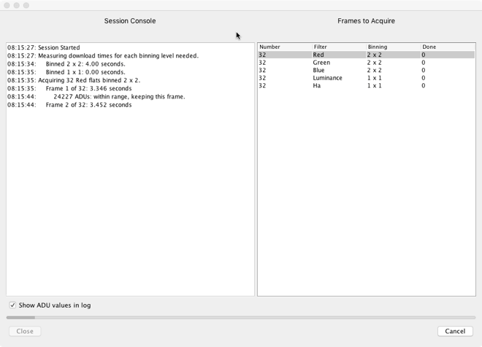When the plan is ready, click Proceed and the following steps will happen:

* A progress window appears showing all the frames that will be taken and where you are in the plan.
* The scope slews to your light source and then turns off tracking, if those options are selected.
* The program asks TheSkyX to take sample bias frames (without saving them) to time camera downloads.
* The program asks TheSkyX to take all the frames listed in the plan. For each filter and binning it will find an exposure that generates the desired average ADU level, and then continue to refine the exposure as acquisition proceeds. If the light conditions change and the frames become too dark or too light, bad frames will be rejected, and the exposure will continue to adjust to get the frames back in the desired range. If the light has changed drastically – such as someone turning on the lights in the observatory – the program may eventually give up and report a failure. In future runs of the plan, the exposures that worked well last time will be used for the initial trial exposures.

# Scope Control

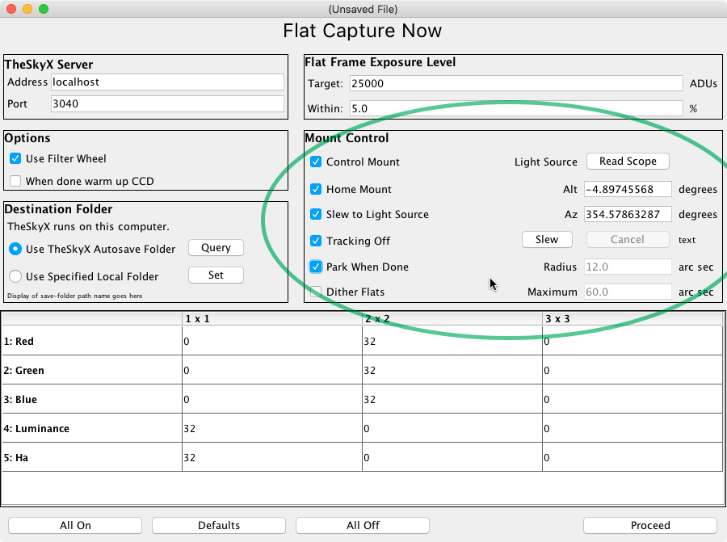Optionally, FlatCaptureNow2 can control your telescope mount to facilitate the capture. There is an overall checkbox for mount control, and then there are checkboxes for a number of mount control steps, that are typically used in this order:

* *“Home mount”* causes a “find home” command to be sent to the mount before the acquisition session begins. (This is meaningful only for Paramount and some other mounts that have a home detection feature and might generate an error on other mounts.) This won’t be necessary if you are running FlatCaptureNow2 at the end of an imaging session, since Home is already known. It may be necessary if capturing flats is the first thing you try to do after powering on the mount.
* *“Slew to light source”* causes the scope to slew to the fixed location of your light source, or your favourite patch of sky. A Paramount needs to know where Home is before it can slew.
* *“Tracking off”* will turn off tracking after the mount slews to the light source, so the drive doesn’t move it away from this position.
* *“Park when done”* will move the mount to park position and disconnect it after the flat acquisition session is complete. A Paramount needs to know where Home is before it can park.

# Dithering Flats

You can also dither the flats, for similar reasons that you would dither actual light frames. This makes sense as a flat, unlike a dark or bias, is an actual image – it’s special only because it is an image of an artificial target. Dithering can correct for minor differences in the uniformness of the light source. It is especially useful if you are doing “T-Shirt flats”, where you are using the dusk or dawn sky as a light source. Dithering averages away any stars that are still showing through in the flats.

So, optionally, one can ask that the collected flat frames be dithered. Because dithering requires moving the telescope,

* It is only available when “control mount” is enabled; and
* It will slow down the acquisition process by one or two seconds per frame.

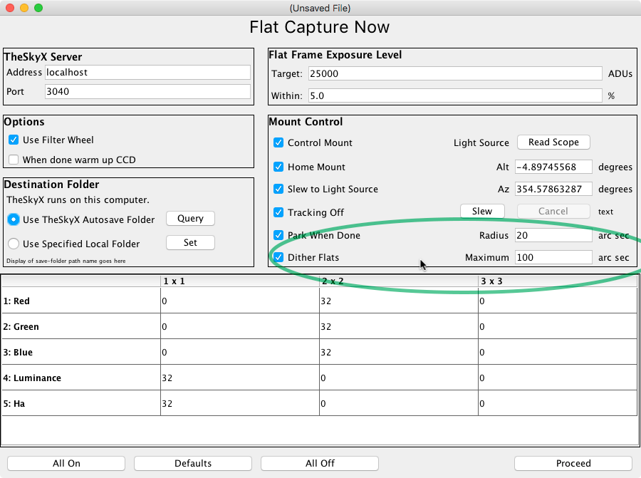Parameters reflected in the Preferences and the plan windows are dither distance and maximum dither range.

Dither distance is the amount, in arc seconds, each “ring” of dithering should extend from the target. Since it is being used to move around the light source to correct any unevenness in the source, it can be quite large – many pixels. Remember that, unlike light frames, you are not “dithering around the donuts”. The donuts are coming from dust spots *on your optics*, and those move with the camera – so the only thing that will be changing when you dither flats is the light source. You are dithering around irregularities in the light source, and those will be large, subtle, and out of focus.

Dithering causes subsequent frames to be taken at locations that “spiral out” from the actual target location. The first ring of frames is taken at the given radius from the target, then another ring at twice that radius, then three times, and so on.

A maximum distance must be specified, in arc seconds, and when the spiral radius exceeds this value the dithering will start over at the target location.

Since dithering involves moving the mount, the “control mount” option, described above, must be turned on, and homing the mount may be required.