# Master Bias Maker

# Introduction

MasterBiasMaker is a program to assist in image calibration for astrophotography. It is a single-purpose program, taking a collection of bias frames and combining them into a single “master bias frame” for use in calibration. It can be used via a graphic user interface or via a command-line interface. Precompiled binaries are available for Mac and Windows platforms. It is written in Python 3 and should run anywhere that Python can run.

The program reads and produces only FITS files, not Jpegs or other image formats.

# Foundation Concepts

## Purpose of Bias Frames

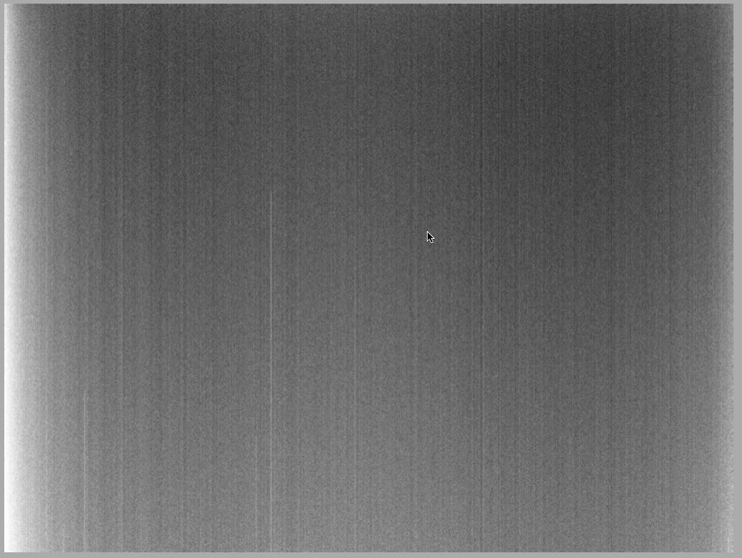Bias Frames are component of the post-processing of astrophotography images.

A bias frame is an exposure of pure darkness (camera shutter closed, or telescope covered), with a zero-length exposure and at the same temperature as the images you plan to calibrate. With the shutter closed or the telescope covered and an exposure length of zero, you would expect such a picture should be completely black, but it won’t be. Instead it is a record of the noise inherent in your CCD chip at that temperature. It is largely *readout noise* which is, as the name suggests, the noise introduced into an image by the action of the electronic circuitry in the camera reading the sensor.

Image calibration software can use a bias frame to remove this noise from your finished image. Normally, bias frames are used to calibrate other calibration frames such as flat frames or dark frames and are not applied directly to your image frames.

If you have a CCD with a regulated cooling system, where the CCD is maintained at a constant and known temperature, you can collect bias frames at another time and save them for later use – you don’t need to waste good dark-sky imaging time taking them. You can make up several collections at different temperatures, and then use whichever set matches, or is closest to, the temperature used on a given imaging night.

## Combining Bias frames into a Master Bias

You should take a large number of bias frames, so you get an average-smoothed picture of what your readout noise looks like. However, most image calibration software wants a *single* bias frame to use for calibration, so you must combine your collected bias frames into a single “master bias”. (If your image calibration software allows you to provide a collection of bias frames, then it is just combining them into a master internally. You can save time by doing the combination once, rather than having your imaging software repeat the process every time.)

There are several algorithms for doing this combination.

Imagine that you have taken a number of bias frames – the more the better – all of the same dimension and binning as the images you will be calibrating. Think of the multiple frames as layers stacked on top of one another: for any given pixel in your master image, there is a stack of input pixel values at that position - one for each of the layered frames. Let’s call this set of values for a given pixel a "column" of values.

For example, suppose you are capturing images that are 11 pixels wide and 12 pixels high. There are 11 x 12 = 132 pixels in each image. Suppose we have taken 5 bias frames for calibration. Each of them is also 11 x 12 pixels in dimension. So, you could think of the collection of bias frames as a collection of 11 x 12 = 132 columns, each with 5 values in it (the values from 5 bias frames).

Several algorithms are available to combine the frames into a single master, each with advantages and disadvantages. Choosing the best algorithm depends on circumstances such as the number of frames to be combined and the amount and type of noise in the frames.

The two most basic combination methods are:

|  |  |
| --- | --- |
| Mean | "Mean" combination combines all the frames using a simple average. Each pixel in the resulting image is the average of the pixels in that column.  This method gives the best signal-to-noise ratio (SNR). However, outlier pixels (pixels that are considerably brighter or darker than the others in their column) in any of the input frames will affect the result so things like stray cosmic ray hits will show through. |
| Median | This combines the frames by taking the *median* value from each column. The median is the middle value if the values are sorted into ascending order (or the average of the two middle values if there is an even number of values).  This tends to reject outlier noise such as cosmic ray hits since they are usually much brighter than the naturally occurring pixels in that region and won’t end up being the middle values. However, it produces a lower SNR than mean combination.  So, this method is a better choice for frames that have sporadic noise but that, overall, are not very noisy. |

Two more advanced algorithms get close to the SNR of Mean while reducing the impact of random noise, close to the performance of Median. They are:

|  |  |
| --- | --- |
| Min-Max Clipped Mean | This method drops the minimum and maximum values (i.e. all the instances of the minimum value and all the instances of the maximum value) from each column and then calculates the Mean of the remaining values. The dropping function can be repeated more than once: for example, you could drop the minimum and maximum values, and the next-to-minimum and next-to-maximum values, and so on.  This works well with noise that is either very bright (cosmic ray hits) or very dark. However, since you are actually throwing away some data, it requires that you have a large number of input frames to work well. At least 10 frames, and preferably many more.  It also can have a problem when a given column only contains one or two values. Throwing away the minimum and maximum throws out all the values, and then the algorithm has to back up and try throwing away less. This can be quite slow. |
| Sigma-Clipped Mean | This method also throws away outlier values and then takes the average of the rest, but it uses statistical techniques to determine what is an outlier value that should be thrown away. It works as follows:  For each column we calculate the *mean* and the *standard deviation* of the values in that column. (*Standard deviation* is a common statistical measure that gives an indication of the amount of variability in a set of data.)  Then we calculate the *z-score* of each value in the column. The *z-score* is the distance of the value from the mean in multiples of standard deviation. So, a z-score of 2 means that the value in question is 2 standard deviations away from the mean.  Finally, we discard any values with a z-score above a given threshold and calculate the mean of the remaining values. For example, a threshold of 2 means “drop any values in a column that are more than 2 Standard Deviations from the mean of that column”.  In normally distributed data, setting the z-score threshold to 2.0 will reject about 5% of the data and keep about 95%. A lower z-score will reject more data (z=1.0 rejects about 32% and keeps about 68%), while a higher z-score will reject less data (z=3.0 keeps about 97%). Using this method requires a bit of experimentation. Start with a z threshold of 2.0 then reduce it with very noisy data or increase it with very clean data.  The z threshold is a floating-point number and should rarely be outside the range 1.0 to 3.0.  This method works very well with a large number of input frames, and is the recommended method (with threshold 2.0) if you have more than about 10 frames. |

# Two Modes of Application Operation

MasterBiasMaker can be used with an interactive graphic user interface (GUI), or from the command line with flags and filenames like a traditional UNIX command.

The command line option is intended to support scripting use of the program and combining it with other processes in your workflow. However, I recommend you start with the GUI to become familiar with the behavior of the program. The command line is less intuitive and does less error checking. The GUI is also the only way to modify the default settings in the program preferences.

|  |
| --- |
| Using the GUI When you start the program as a Windows or Mac application, it will open in GUI mode, with the window shown here. |

## Preferences

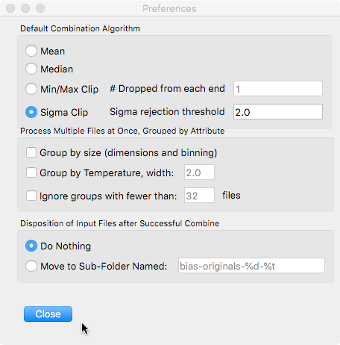Before we explore the main window, on your first use you should visit the Preferences window by selecting Preferences from the MasterBiasMaker (Mac) or File (Windows) menus.

The preferences window sets default values that are used when a new GUI session is started, and when the command line is used with a given setting not specified with a command line option.

The Preferences window is divided into three sections:

### Default Combination Algorithm

In this section you select the combination algorithm (Mean, Median, Min/Max Clip, or Sigma Clip) as described above. For the Min/Max and Sigma options you also specify the relevant numeric parameter, as described above.

### Process Multiple Files at Once, Grouped by Attribute

These settings allow the program to process a large number of bias frames into multiple outputs, grouped by size or other attributes. See the section “Processing Files in Groups”, below, for an explanation of these settings.

### Disposition of Input Files

Optionally, MasterBiasMaker can move your input bias frames to a subfolder after they are processed. This can help keep files organized in certain workflows.

## Main Window

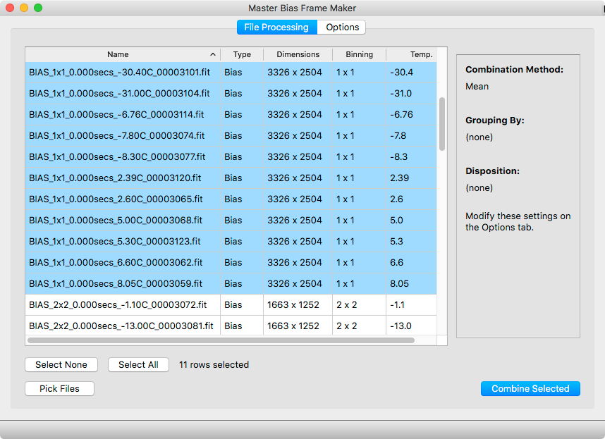The main window has a table, initially empty, that will list your Bias Frame files. There are a number of options that control the combination process. To save window space, these options are manipulated in the *Options* tab and summarized to the right of the file table on the *File Processing* tab.

Start by clicking “Pick Files” or by selecting Open from the File menu. In the dialog that opens, select all the bias frame files you will want processed. You will have a chance to further refine the list, so feel free to pick all the files in a folder if that is more convenient.

The selected files will be listed, along with some of their internal FITS metadata, in the file table. Click on column headings to sort the table by the various attributes.

Visit the Options tab to select your combination algorithm and other options, then go back to the File Processing tab and select one or more of your listed files to actually combine. Command-A or Control-A to quickly select all the files.

By default, the program will only allow you to select files whose FITS metadata says they are Bias files. (This is so you can just Command/Control-A to select all the files in a folder, then Command/Control-A to select all the files in this window, and you will end up with just the Bias frames, not any other stray files that happened to be in the folder.) However, some acquisition programs don’t set that metadata correctly, so if you are certain the files you have picked are Bias files but MasterBiasMaker thinks they are not, you can click the “Ignore FITS file type” checkbox to bypass this check.

The “Combine Selected” button will be enabled once you have files selected and valid parameters chosen. If it is not enabled, something is not valid in your setup. The problem could be:

* No files selected (highlighted)
* Not enough files selected for the Min/Max method (there must be at least 2n + 1 files for min/max parameter n).
* Selected files are not all bias frames and the “ignore” button is not checked.
* Selected files are not all the same size, unless you are processing by groups (see below).

Once you have a valid plan, click the Combine button and you will be prompted for the name of your output file, which will then be created. Combining a large number of files from a high-pixel camera might take several seconds. (On my main computer, combining 32 8-megapixel files with the Sigma Clip method takes about 30 seconds.)

|  |
| --- |
| When using the GUI version, a console window will open during the combination operation, displaying progress results. This window also contains a Cancel button which will interrupt the combination task, in case you realize you forgot some important setting. |

# Processing Files in Groups

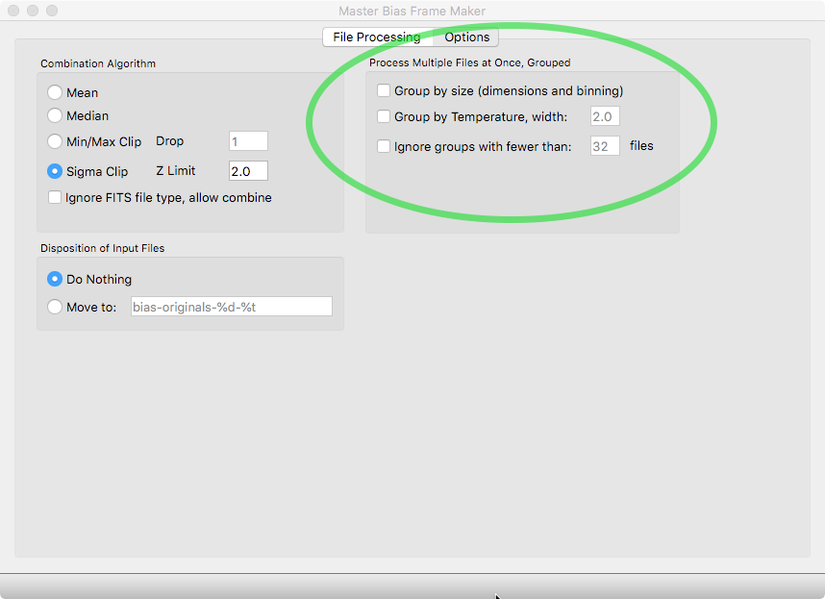You may have a large set of Bias files in one directory but not want, or be able, to combine them all into a single master file. For example, they may be different binning levels, which can’t be combined, or different CCD temperatures, which you don’t want to combine.

On the Options tab, you can select “Group by size” or “Group by temperature”. These are not mutually exclusive; you can select any combination of these settings. If selected, the program will process your files in groups and produce a separate master file for each group. Instead of prompting you for a single output file to produce, the program will prompt you for a *directory* to receive all the created master files.

Temperature grouping is different from size grouping because, while image sizes are fixed values, it is quite possible for temperatures to vary by small amounts between frames. For example, suppose you have files with temperatures of:

|  |
| --- |
| 0.1° |
| ‑9.9° |
| ‑15.07° |
| ‑0.1° |
| ‑10° |
| ‑15° |
| 0° |
| ‑10.2° |
| ‑15.2° |

You probably want that to be considered 3 temperature groups, not 9. Like this:

|  |
| --- |
| 0.1° |
| ‑9.9° |
| ‑15.07° |
| ‑0.1° |
| ‑10° |
| ‑15° |
| 0° |
| ‑10.2° |
| ‑15.2° |

So, if you select temperature grouping, you must specify a width that the program will use to cluster the files into groups. A width of 1.0 (the default) will group files into groups where the temperature varies up to about 1 degree on either side of the group center. The width parameter can be between 0.1 and 50. The clustering uses statistical techniques, and the width parameter is not a “hard” limit — files outside the specified width may be included if the overall grouping result is better.

# Using the Command Line

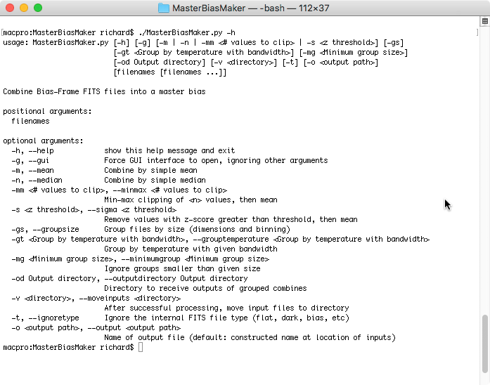To use command line mode, just run the program from your system’s terminal or shell window and specify options and input files as command line arguments.

Run the program with the “-h” flag to get a brief summary of the available options. Every setting discussed in the GUI section above is available as a command-line option. If an important option is not specified on the command line, the value set in the Preferences will be used.