# Master Dark Maker

# Introduction

MasterDarkMaker is a program to assist in image calibration for astrophotography. It is a single-purpose program, taking a collection of dark frames and combining them into a single “master dark frame” for use in calibration. It can be used via a Graphic User Interface or via a command-line interface. Precompiled binaries are available for Mac and Windows platforms.

The program reads and produces only FITS files, not Jpegs or other image formats.

# Foundation Concepts

## Purpose of Dark Frames

Bias Frames are an important part of the post-processing of astrophotography images.

A dark frame is an exposure of pure darkness (camera shutter closed or telescope covered), with the same exposure length and at the same temperature as the images you plan to calibrate. With the shutter closed or the telescope covered, you would expect such a picture should be completely black, but it won’t be. Instead it is a record of the noise inherent in your CCD chip at that exposure time and temperature.

Image calibration software can use a dark frame to subtract such artifacts from your finished image.

With a CCD with a regulated cooling system, where the CCD is maintained at a constant and known temperature, you can collect dark frames at another time and save them for later use – you don’t need to waste good dark-sky imaging time taking them. You can make up several collections at different exposure times and temperatures, and then use whichever set matches the exposure and temperature used on a given imaging night.

Some imaging software can also “scale” dark frames, which means using a dark frame with a different exposure time and scaling the data it contains to match a different exposure time.

Typically, you will take a large number of dark frames then combine them into a single “master” calibration frame. That combination of multiple dark files into a single master dark is what MasterDarkMaker is for.

## Precalibrating Input Flats

You can pre-calibrate the dark frames themselves before combining them into a master by subtracting a “bias frame” from each dark. A Bias frame is a dark frame with an exposure length of zero, so it is a representation of the noise inherent in the camera before any exposure time is added.

You don’t always need to do this. Not using bias frames leaves that inherent noise in your dark frames, which is not a bad thing – that noise will be subtracted from your images during calibration. However, if you are asking your image calibration software to *scale* your dark frames (use dark frames with one exposure time to calibrate images with a different exposure time), then you should first subtract the bias from the dark frames. The noise in bias frames is constant and independent of exposure time and should not be scaled.

So, if you are doing dark-frame scaling, you would normally use bias frames to calibrate the dark frames, and then subtract both the bias frames and the scaled dark frames from your main images.

So, ideally you would prepare dark frames for scaling subtracting a *bias frame* from them. MasterFlatMaker can do this, subtracting a given bias frame from your dark frames before combining them.

If you don’t have a suitable bias frame, you can subtract a constant value, called the “pedestal” from every pixel in your flat images. Consider this a last resort only if you don’t have bias frames. A pedestal value of around 100 is typically used.

## Combining Dark frames into a Master Dark

Imagine that you have taken a number of dark frames – the more the better – all of the same dimension and binning as the images you will be calibrating. Think of the multiple frames as layers stacked on top of one another: for any given pixel in your image, there are a stack of pixel values at that position - one for each of the layered frames. Let’s call this set of values for a given pixel a "column" of values.

For example, suppose you are capturing images that are 11 pixels wide and 12 pixels high. There are 11 x 12 = 132 pixels in each image. Suppose we have taken 5 bias frames for calibration. Each of them is also 11 x 12 pixels in dimension. So, you could think of the collection of bias frames as a collection of 132 columns, each with 5 values in it (the values from 5 flat frames).

Several algorithms are available to combine the frames into a single master, each with advantages and disadvantages. Choosing the best algorithm depends on circumstances such as the number of frames to be combined and the amount and type of noise in the frames.

The two most basic combination methods are:

|  |  |
| --- | --- |
| Mean | "Mean" combination combines all the frames using a simple average. Each pixel in the resulting image is the average of the pixels in that column.  This method gives the best signal-to-noise ratio (SNR). Outlier pixels in any of the input frames will affect the result, but dark frames typically have few outliers, so Mean is often a good choice. |
| Median | This combines the frames by taking the median value from each column. The median is the middle value if the values are sorted into ascending order.  This tends to reject outlier noise such as cosmic ray hits since they are usually much brighter than the naturally occurring pixels in that region. However, it produces a lower SNR than mean combination.  So, this method might be a better choice for frames that have sporadic noise but that, overall, are not very noisy. |

Two more advanced algorithms get close to the SNR of Mean while reducing the impact of random noise such as satellite trails, close to the performance of Median. They are:

|  |  |
| --- | --- |
| Min-Max Clipped Mean | This method drops the minimum and maximum values (i.e. all the instances of the minimum value and all the instances of the maximum value) from each column and then calculates the Mean of the remaining values. The dropping function can be repeated more than once: for example, you could drop the minimum and maximum values, and the next-to-minimum and next-to-maximum values, and so on.  This works well with noise that is either very bright (cosmic ray hits) or very dark. However, since you are actually throwing away some data, it requires that you have a large number of input frames to work well. At least 10 frames, and preferably many more. |
| Sigma-Clipped Mean | This method works as follows:  For each column calculate the Mean and the Standard Deviation of the values in that column.  Then calculate the “z-score” of each value in the column. The z-score is the distance of the value from the mean in multiples of standard deviation. So, a z-score of 2 means that the value in question is 2 standard deviations away from the mean.  We then drop any values with a z-score above a given threshold and calculate the mean of the remaining values. For example, a threshold of 2 means “drop any values in a column that are more than 2 Standard Deviations from the mean of that column”.  This method works very well with a large number of input frames.  In normally distributed data, setting the z-score threshold to 2.0 will reject about 5% of the data and keep about 95%. A lower z-score will reject more data (z=1.0 rejects about 32% and keeps about 68%), while a higher z-score will reject less data (z=3.0 keeps about 97%). Using this method requires a bit of experimentation. Start with a z threshold of 2.0 then reduce it with very noisy data or increase it with very clean data.  The z threshold is a floating-point number and should rarely be outside the range 1.0 to 4.0. |

# Two Modes of Application Operation

MasterDarkMaker can be used with an interactive graphic user interface (GUI), or from the command line with flags and filenames like a traditional UNIX command.

The command line option is intended to support scripting calls to this program and combining it with other processes in your workflow. However, I recommend you start with the GUI to become familiar with the behavior of the program. The command line is less intuitive and does less error checking.

|  |
| --- |
| Using the GUI When you start the program as a Windows or Mac application, it will open in GUI mode, with the window shown here. |

## Preferences

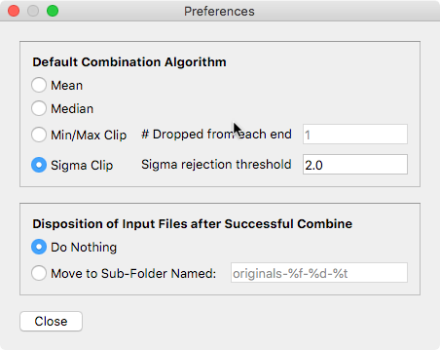Before we explore the main window, on your first use you should visit the Preferences window by selecting Preferences from the MasterDarkMaker (Mac) or File (Windows) menus.

The preferences window sets default values that are used when a new GUI session is started, and when the command line is used and a given setting is not specified with a command line option.

The Preferences window is divided into three sections:

### Default Combination Algorithm

In this section you select the combination algorithm (Mean, Median, Min/Max Clip, or Sigma Clip) as described above. For the Min/Max and Sigma options you also specify the relevant numeric parameter, as described above.

### Pre-Combine Dark File Calibration

in this section you specify how the dark files should be pre-calibrated, as discussed above. The last two options, "prompt user" and "fixed calibration file" both use a bias frame. The difference is that "prompt user" will ask you to locate the calibration frame every time, while "fixed file" remembers the location of a selected calibration file.

### Disposition of Input Files

Optionally, MasterDarkMaker can move your input flat frames to a subfolder after they are processed. This can help keep files organized in certain workflows.

## Main Window

The main window has a large area, initially blank, that will become a table of Flat Frame files, and a set of buttons down the right-hand side. Most of the buttons on the right have the calibration and combination functions we have already discussed.

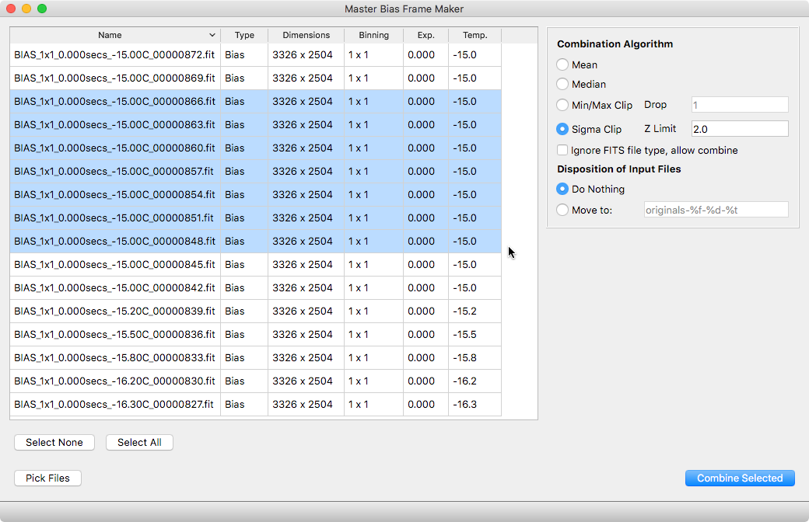Start by clicking “Pick Files” or by selecting Open from the File menu. In the dialog that opens, select all the flat frame files you will want processed. You will have a chance to further refine the list, so feel free to pick all the files in a folder if that is more convenient.

The selected files will be listed, along with some of their internal FITS metadata, in the file table. Now select one or more of them to actually combine. Command-A or Control-A to quickly select all the files.

By default, the program will only allow you to select files whose FITS metadata says they are Dark files. (This is so you can just Command/Control-A to select all the files in a folder, then Command/Control-A to select all the files in this window, and you will end up with just the Dark frames, not any other stray files that happened to be in the folder.) However, some acquisition programs don’t set that metadata correctly, so if you are certain the files you have picked are Dark files but MasterDarkMaker thinks they are not, you can click the “Ignore FITS file type” checkbox to bypass this check.

The “Combine Selected” button will be enabled once you have files selected and valid parameters chosen. If it is not enabled, something is not valid in your setup. The problem could be:

* No files selected (highlighted)
* Not enough files selected for the Min/Max method (there must be at least 2n + 1 files for min/max parameter n).
* Selected files are not all flat frames and the “ignore” button is not checked.

Once you have a valid plan, click the Combine button and you will be prompted for the name of your output file, which will then be created. Combining a large number of files from a high-pixel camera might take several seconds. (On my main computer, combining 32 8-megapixel files with the Sigma Clip method takes about 30 seconds.)

# Using the Command Line

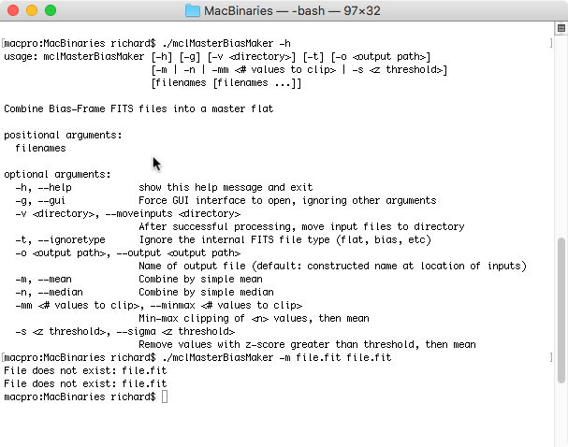To use command line mode, just run the program from your system’s terminal or shell window and specify options and input files as command line arguments.

Run the program with the “-h” flag to get a brief summary of the available options. Every setting discussed in the GUI section above is available as a command-line option. If an important option is not specified on the command line, the value set in the Preferences will be used.