# SPONSORCOIN DEVELOPER SET UP INSTRUCTIONS

1. **Email setup**

Prior to setting up your developers account, an email will have to be delivered to the GitHub admin to grant permission for GitHub collaborator access.

The GitHub collaborator access account invitation will email the prospective developer a conformation response for access.

It is strongly recommended that you use a proton email account since total anonymity for all players on this project for privacy protection. You want your privacy for personal and possibly legal reasons.  Although we are not doing anything illegal, we are aware that with money is substantial, somehow legalities always get involved.

Proton Mail is secure with even the "Proton Mail Application" not being able to read any of your data, everyone should use this anyway as google and other mainstream providers crawls through everything you send and receive.

1. **GitHub Setup**

Download git from <https://git-scm.com/downloads>.

Open the file and install using all the defaults unless you are certain about a specific option.

To validate your setup, open windows file explorer and validate gitBash and gitGui are available and working by right clicking on any directory and selecting.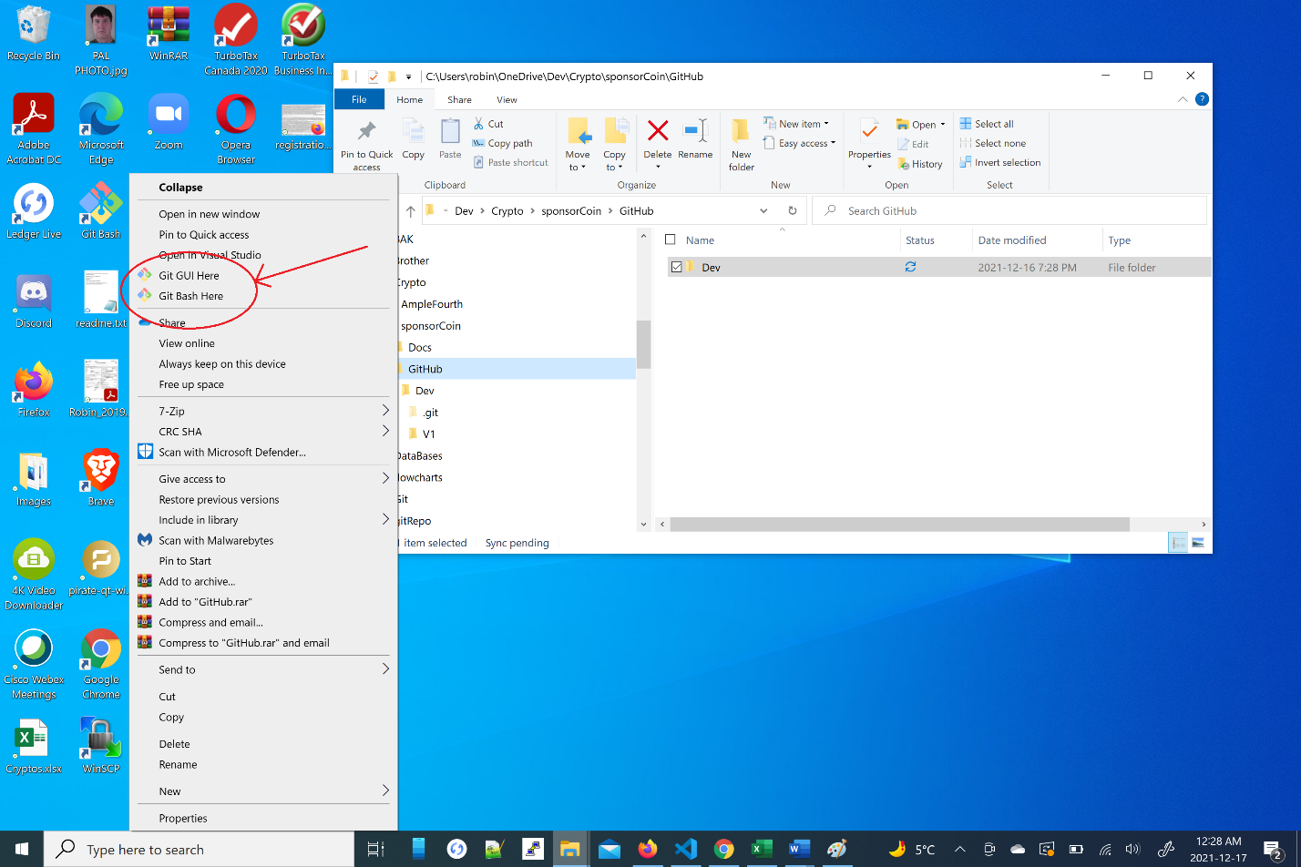

1. **GitHub Setup with Visual Studio Code**

Download the latest Visual Studio Code. If you have an older version installed, download the latest anyway. Clone the sponsorCoin GitHub repository to your local drive using the GitHub Repository URL [**https://github.com/sponsorCoinAdmin/Dev.git**](https://github.com/sponsorCoinAdmin/Dev.git).

Checkout a file, do a simple change and checkin. You will be prompted for your credentials.

1. **SponsorCoin AWS EC2 T2 Mini Instance Server**

This server is located under domain <http://www.stockwidgets.com/sponsorCoin/>

**AWS VM Specs as follows:**

It is a ,“T2 mini”, AWS Linux OS, 2GB Ram 500 GB Disk with low to medium performance currently the public IP is currently **35.183.181.92**, but it is elastic DHCP allocated meaning if we shutdown the server the IP changes.  The domain currently in use is a legacy domain [**www.stockwidgets.com**](http://www.stockwidgets.com), so we do not have to worry about the IP change.  A user Id and SSH key access shall be issued to assigned group members. sponsorCoin.com domain is available will be set it up shortly using AWS Route 53.

**3. Required Additional Tools**

**ii) Putty ~** to be connected with ssh keys when I generate them

**iii) WinSCP ~** to be connected with ssh keys when I generate them

**iv) notepad++**

**Conclusion:** I am setting things up so we are off to a good start.  Please set up accordingly as well.  For the next little while, I will be continuing the set up.  I believe Max is looking into solidity block-chain setup and Serge is looking into converting the HTML to Angular.  I still have to create a white paper and a technical design doc, but I think as a team we have 90% of what is required to make this happen.  As is expected, I am dedicating my time 100% to this project while both of you are dedicated to other work tasks outside of this project.  So work at your own pace, but let's make it happen as the rewards for a successful launch are truly unreal compared to an average job.  Crypto is new and will explode over the next decade, lets be in the game with a product.  Our product.

,is to crypto what, Patreon is to the internet. and Patreon is a 4 Billion dollar internet company, (look it up yourself).

Github Setup with “Visual Studio Code”.