**SALES ANALYSIS**

## Which are the most selling products?

## Which are the most profitable products?

## Which are the most profitable category?

## Which customer segments are the most profitable ?

## What shipping modes sold the most products?

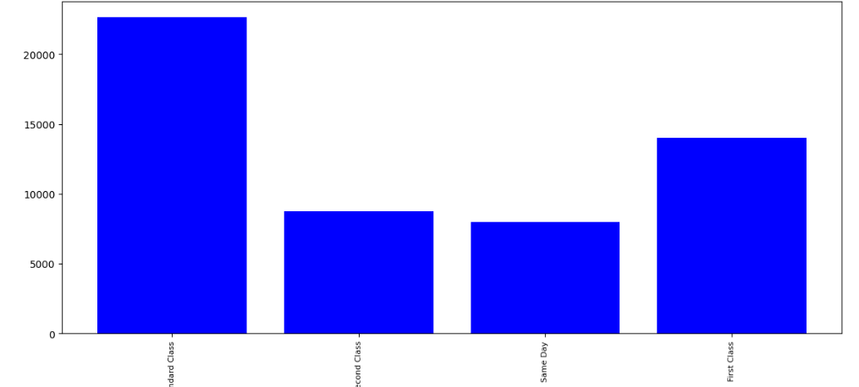

## Visualize the 'Category' column from the Shipmode column dataset standpoints.

## What market sold the most products?

## Which are the Top 10 country by sales?

## Total sales chart by the year

