**DATABASE**

Topic: Female Heart Disease

Prepared ERD using QDB

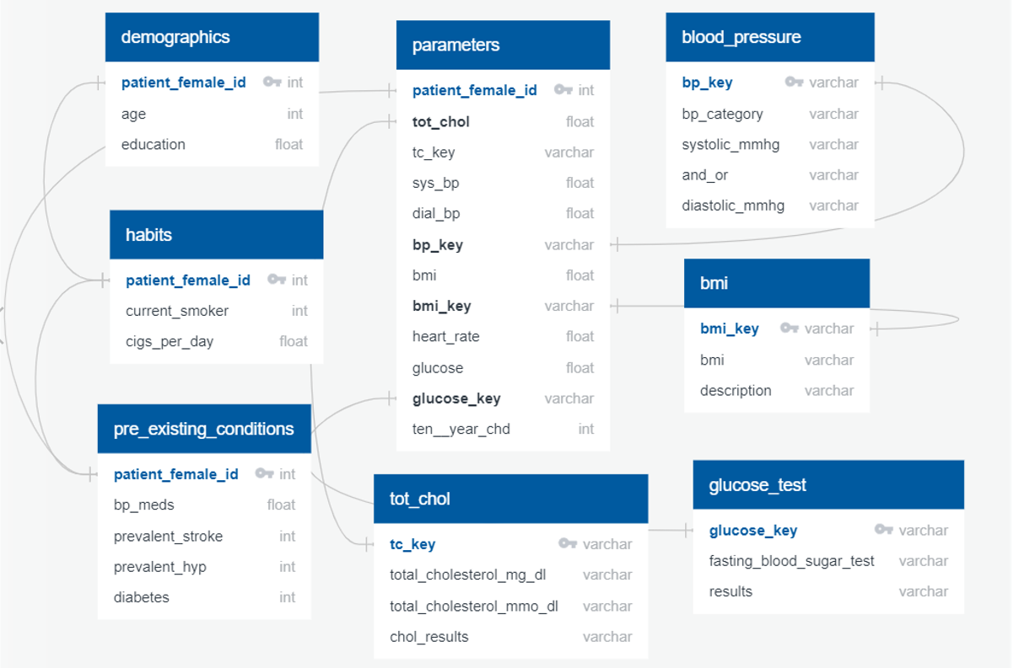

posGrest pgAdmin database

* Created table based on the ERD prepared
* Loaded data into tables

CREATE TABLE "demographics" (

    "patient_female_id" int   NOT NULL,

    "age" int   NOT NULL,

    "education" float   NOT NULL,

    CONSTRAINT "pk_demographics" PRIMARY KEY (

        "patient_female_id"

     )

);

CREATE TABLE "habits" (

    "patient_female_id" int   NOT NULL,

    "current_smoker" int   NOT NULL,

    "cigs_per_day" float   NOT NULL,

    CONSTRAINT "pk_habits" PRIMARY KEY (

        "patient_female_id"

     )

);

CREATE TABLE "pre_existing_conditions" (

    "patient_female_id" int   NOT NULL,

    "bp_meds" float   NOT NULL,

    "prevalent_stroke" int   NOT NULL,

    "prevalent_hyp" int   NOT NULL,

    "diabetes" int   NOT NULL,

    CONSTRAINT "pk_pre_existing_conditions" PRIMARY KEY (

        "patient_female_id"

     )

);

CREATE TABLE "parameters" (

    "patient_female_id" int   NOT NULL,

    "tot_chol" float   NOT NULL,

    "tc_key" varchar   NOT NULL,

    "sys_bp" float   NOT NULL,

    "dial_bp" float   NOT NULL,

    "bp_key" varchar   NOT NULL,

    "bmi" float   NOT NULL,

    "bmi_key" varchar   NOT NULL,

    "heart_rate" float   NOT NULL,

    "glucose" float   NOT NULL,

    "glucose_key" varchar   NOT NULL,

    "ten__year_chd" int   NOT NULL,

    CONSTRAINT "pk_parameters" PRIMARY KEY (

        "patient_female_id"

     )

);

CREATE TABLE "blood_pressure" (

    "bp_key" varchar   NOT NULL,

    "bp_category" varchar   NOT NULL,

    "systolic_mmhg" varchar   NOT NULL,

    "and_or" varchar   NOT NULL,

    "diastolic_mmhg" varchar   NOT NULL,

    CONSTRAINT "pk_blood_pressure" PRIMARY KEY (

        "bp_key"

     )

);

CREATE TABLE "glucose_test" (

    "glucose_key" varchar   NOT NULL,

    "fasting_blood_sugar_test" varchar   NOT NULL,

    "results" varchar   NOT NULL,

    CONSTRAINT "pk_glucose_test" PRIMARY KEY (

        "glucose_key"

     )

);

CREATE TABLE "bmi" (

    "bmi_key" varchar   NOT NULL,

    "bmi" varchar   NOT NULL,

    "description" varchar   NOT NULL,

    CONSTRAINT "pk_bmi" PRIMARY KEY (

        "bmi_key"

     )

);

CREATE TABLE "tot_chol" (

    "tc_key" varchar   NOT NULL,

    "total_cholesterol_mg_dl" varchar   NOT NULL,

    "total_cholesterol_mmo_dl" varchar   NOT NULL,

    "chol_results" varchar   NOT NULL,

    CONSTRAINT "pk_tot_chol" PRIMARY KEY (

        "tc_key"

     )

);

Joined tables created to produce new dataset that includes all data and additional datasets prepared

* Demographics.csv (age, education)
* Habits.csv (currentSmoker,cigsPerDay)
* Pre-existing_conditions.csv (BP Meds, prevStroke, prevalHyp, diabetes)
* Parameters.csv (totChol, sysBP,diaBP, BMI, heartrate, glucose)

* Bmi_pks.csv

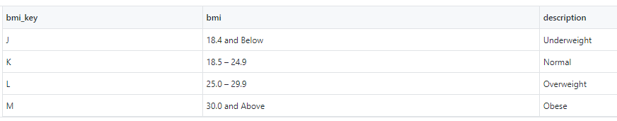

* Bp_pks.csv

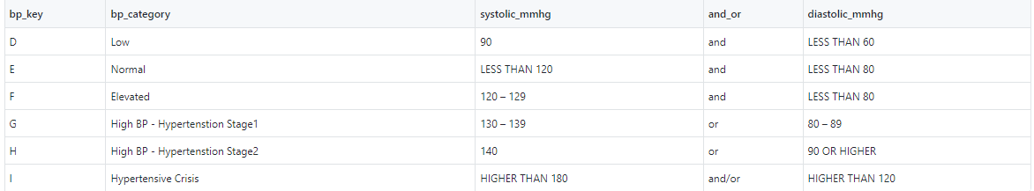

* 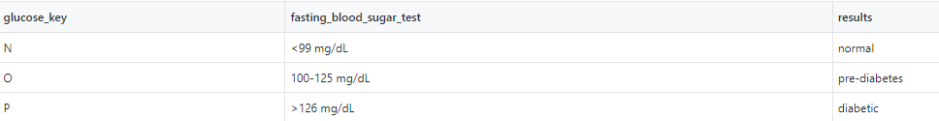Glucose_pks.csv
* Totlchol_pks.csv

