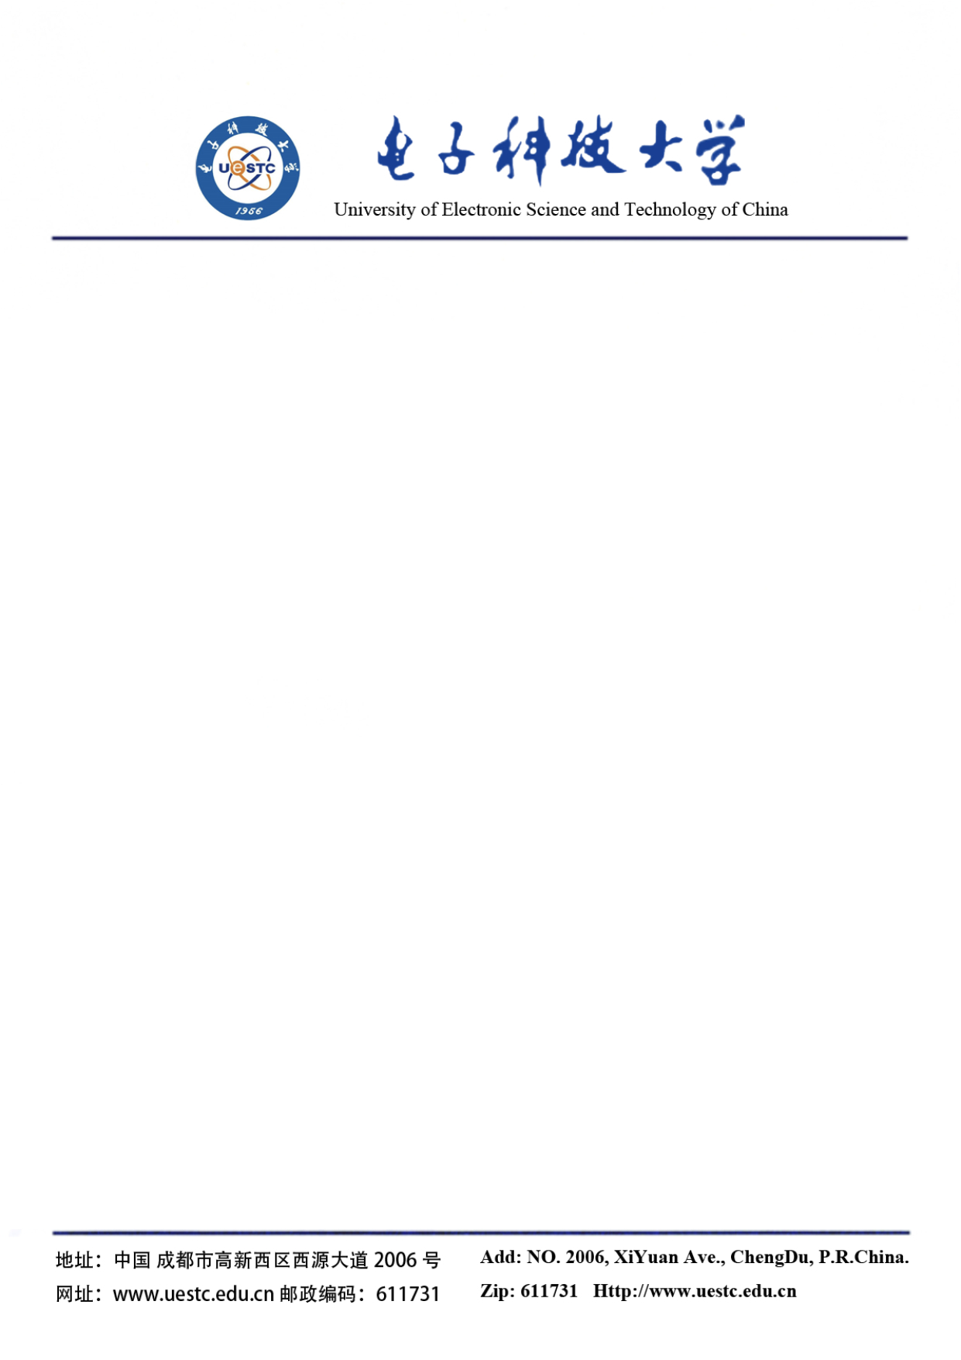

**To Whom It May Concern,**

Upon the request of Mr. CHEN Weigen, a senior at the University of Electronic Science and Technology of China, I am pleased to write this letter to recommend him to your esteemed graduate school on account of his superior course performance.

I have known Weigen for two years in my capacity as his instructor for the Principles of Computer Composition course in the 2020 Fall semester. In my class, he demonstrated an inquisitive scholarship in learning as he was active in class discussions and could raise thought-provoking questions. He also maintained excellent course attendance even though many of my teachings were delivered online due to the unstable pandemic.

What’s worth further mentioning is that he has an efficient approach to learning. By reading a large number of textbooks and articles, he quickly grasped the essential concepts of computer organization and, beyond it, several programming languages and computer/phone operating systems. The high efficiency would enable him to excel in any learning setting in the future.

Based on his excellent performance in my class, I graded him with a score of 87/100 in the final exam. The grade was top 60 among approximately 700 students, which was indeed no small feat given that the course followed a strict grading scheme. I recognize his potential to succeed in your school and wish him all the best in his future endeavors.

Should you need more information regarding his candidacy, please let me know via: [wuxh@uestc.edu.cn](mailto:wuxh@uestc.edu.cn).

WU Xiaohua

Associate Professor

No.251, East 1st Section, 1st Ring Road

Chengdu, UESTC, 610000, China

TEL: 86-1355060436