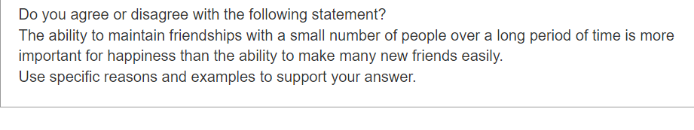

Firstly, in most time, a long time friendship values more than a short one.

Secondly, it is more comfortable to communicate or interact with your old friends.

Your old friends are familiar with your pattern of communication or your favorite taste and thus you will probably feel happiness get along with them. In contrast, those new friends you meet who don't know your preferences so they may offend you in some area. For instance, some people do not prefer to spciy food like hot pot, which is often considered as the best choice in party.