BioSIM' Development Rate Models
Standardized Parameters
Rémi Saint−Amant
Version 1.0.1 (2022-03-01)

Scale factor
General parameters | 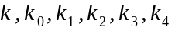
Sharpe&all parameters | 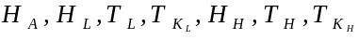
Sharpe&all parameters scale factor | F=10 000
Temperature | 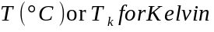
Lower | 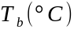
Optimum | 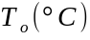
Upper | 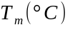
Others | 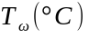
Temperature scale | 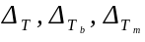
Intermediate computation | 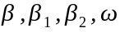

Allahyari (2005) | 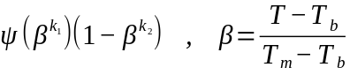
Analytis (1977) | 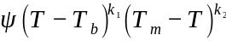
Angilletta (2006) | 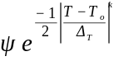
Bieri (1983) | 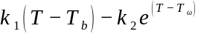
Boatman (2017) | 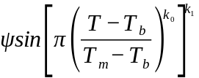
Briere1 (1999) | 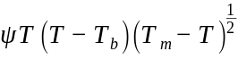
Briere2 (1999) | 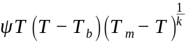
Damos (2011) | 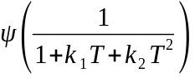
Deva&Higgis | 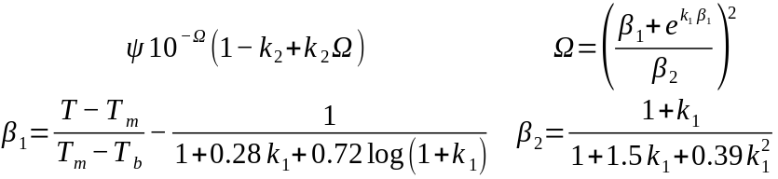
Hansen (2011) | 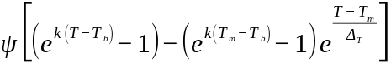
Hilbert&LoganIII | 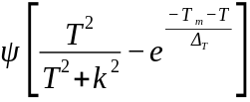
Hilbert&Logan (1983) | 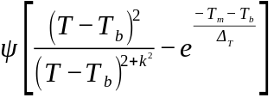
Huey&Stevenson (1979) | 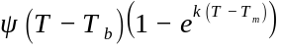
Janisch1 (1932) | 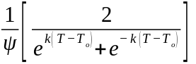
Janisch2 (1932) | 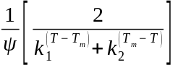
Johnson (1974) | 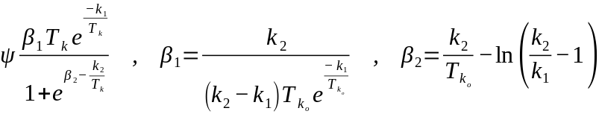
Kontodimas (2004) | 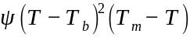
Lactin1 (1995) | 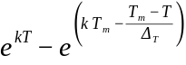
Lactin2 (1995) | 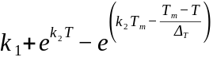
Lamb (1992) | 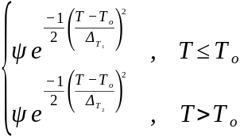
Lobry&Rosso&Flandrois (1993) | 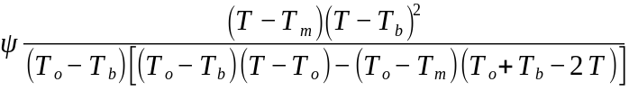
Logan10 (1976) | 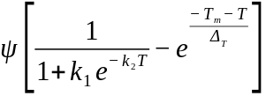
Logan6 (1976) | 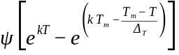
LoganTb (1979) | 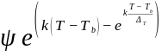
Oneill (1972) | 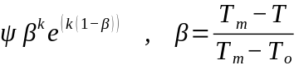
Poly1 | 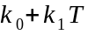
Poly2 | 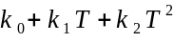
Poly3 | 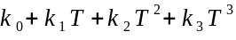
Ratkowsky (1983) | 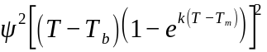
Regniere (1982) | 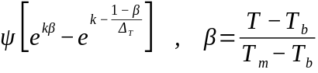
Regniere (1987) | 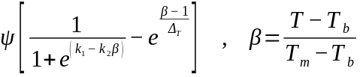
Regniere (2012) | 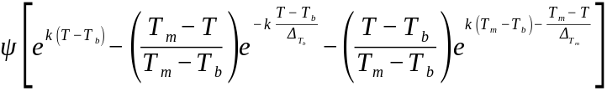
Room (1986) | 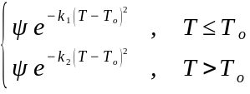
Saint-Amant (2021) | 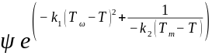
Schoolfield (1981) | 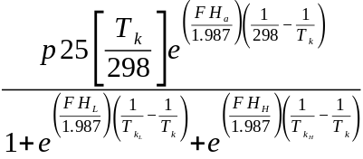
Sharpe&DeMichele (1977) | 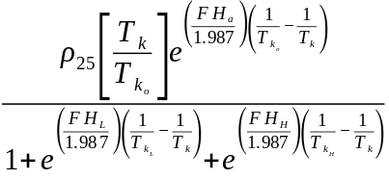
Shi (2011) | 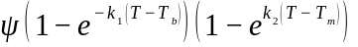
Shi (2016) | 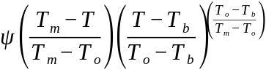
Stinner (1974) | 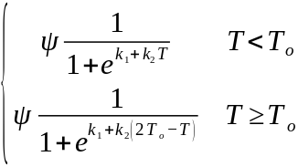
Taylor (1981) | 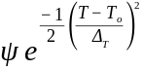
Wagner (1988) | 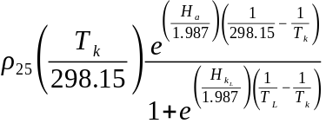
Wang&Engel (1998) | 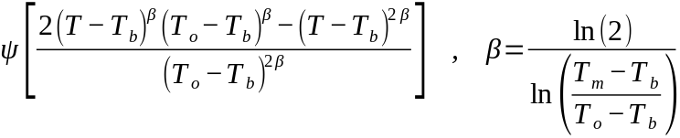
Wang&Lan&Ding (1982) | 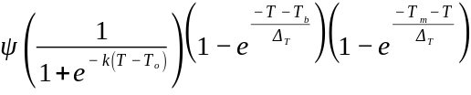
Yan&Hunt (1999) | 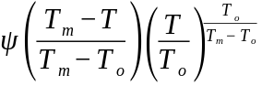
Yin (1995) | 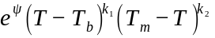

Reference

Sporleder M, Tonnang HEZ, Carhuapoma P, Gonzales JC, Juarez H, Kroschel J. 2013. Insect Life Cycle Modeling (ILCYM) software a new tool for Regional and Global Insect Pest Risk Assessments under Current and Future Climate Change Scenarios. In: Peña JE, ed. Potential invasive pests of agricultural crops. Wallingford: CABI https://doi.org/10.1079/9781845938291.0412

Rebaudo, F., Struelens, Q., Dangles, O. (2018). Modelling temperature−dependent development rate and phenology in arthropods: the DEVRATE package for R. Methods in Ecology & Evolution, 9(4), 1144−1150. https://doi.org/10.1111/2041−210X.12935

