This model aims at describing how size of bagworm egg clusters is related to the date of completion of female development, and from this to predict variation in space (and presumably from year to year) in response to weather. Because egg survival is related to cluster size and winter temperature, this is an important component of a model aiming at predicting this species’ geographical range and performance.

The model was built in three steps: (1) predicting the date of egg hatch, and (2) completion of development by females, and (3) predicting the size of the resulting egg cluster.

Step 1: Egg hatch. We have two sets of data. In 2008, the proportion eggs hatched was estimated by classifying several clusters from an array of sampling points as un-hatched (0% hatch), partly hatched (assigned a 50% hatch value) and fully hatched (100%). We related % hatch to degree-days accumulated from 1 January, above a threshold of 14.4°C (Neak et al. 1987). We used BioSIM to obtain daily air temperature minimum and maximum data from the 8 nearest NCDC weather stations, adjusted for regional thermal gradients. DD were calculated by the modified sine method (Allen 1976)

Proportion hatch was related to accumulated degree-days with a lognormal distribution:

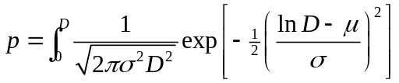

Parameters μ and ρ were estimated with Proc NLMIXED of SAS/9.1 assuming a binomial distribution of egg cluster hatch (assigning ½ of the hatching clusters to “hatched” and ½ to un-hatched categories).

Results are illustrated in Fig. 1. The model described accurately the temporal and spatial patterns of egg hatch in 2008 with μ = 5.123 ± 0.015 and ρ = 0.318 ± 0.028 (AICc=116.7). The degree-day accumulation required for median (50%) hatch (168 DD) is much smaller than that used by Neal et al. (1987), which was about 243 DD°C (Fig. 1a).

In 2009, egg hatch was not observed. However, larvae were sampled and weighted on several occasions in a wide array of locations. The first of these samples was taken in a 3-day period early in the season (Fig. 2a). Knowing that on average a bagworm egg weighs 0.5 mg, a regression was estimated between average larval weight (in mg) in the first sample and degree-days (>14.4°C), 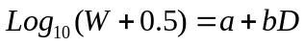. The point at which this regression line crosses 0 is an estimate of the number of degree-days required for hatch 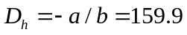 DD (Fig. 2b). Looking up on the cumulative hatch curve of 2008 (Fig. 1a), this is very close to the estimate of 170 DD for 50% hatch. Thus, it is reasonable to use a value of 170 DD to predict 50% hatch.

This hatch model predicts hatch from the beginning of the 4th week of May at the lowest latitudes, to the second half of June at the highest (Fig. 2c).

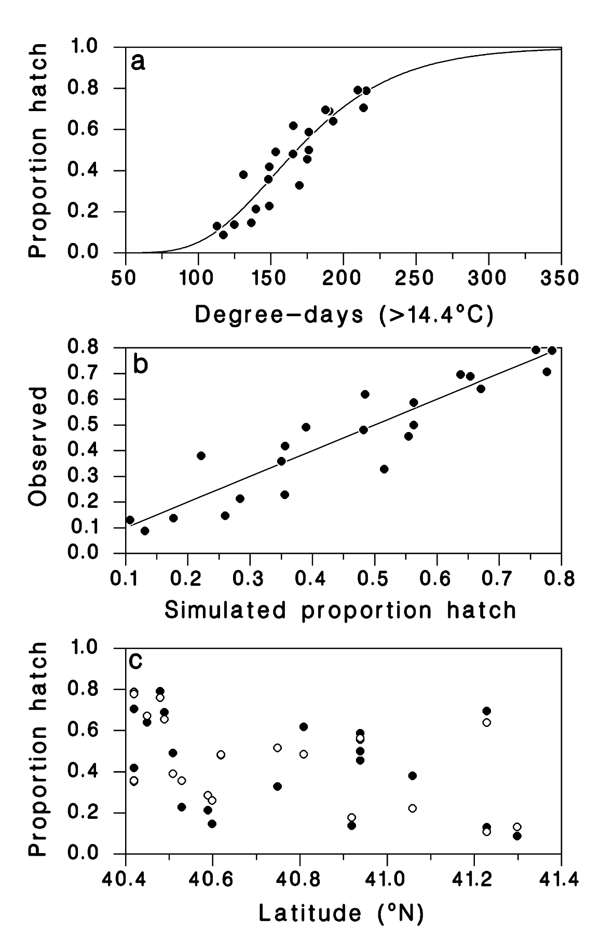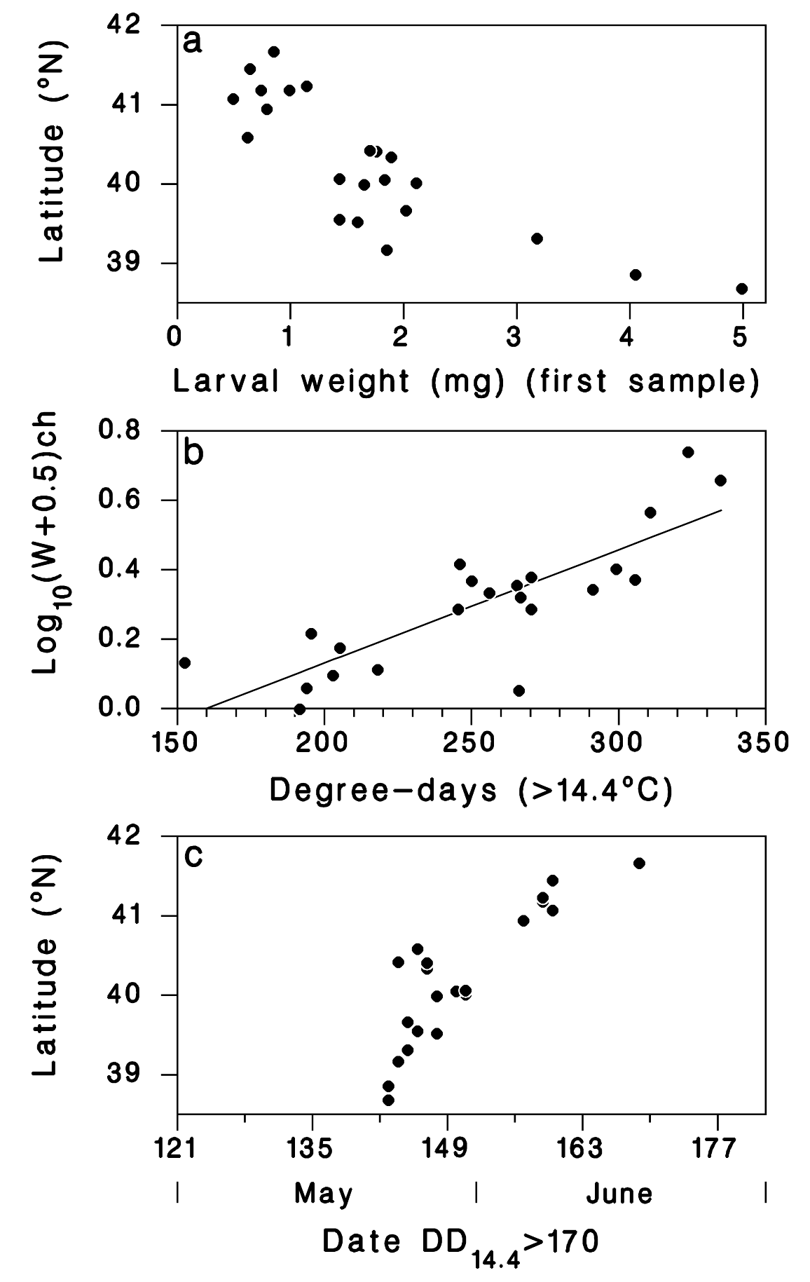
Figure 1 (2008 hatch data) Figure 2 (2009 hatch data)

Step 2: Predicting the date of female development completion. Now that we can predict egg hatch, we need to find a model that predicts the duration of development from hatch to female adult. In 2009 the date of 50% adult development completion was determined in a wide array of location. We sought to determine the best threshold temperature (and the corresponding number of degree days) to predict this. First, the hatch date was calculated with the model of step 1. Then the number of degree-days between hatch and median adult female emergence was calculated. The predicted date of adult emergence was calculated by finding the date at which this number of DD had accumulated after predicted hatch. Finally, a regression between observed and predicted dates of adult emergence was calculated, for threshold values ranging from -30 to 4°C (in steps of 2°C). The optimal threshold was determined by maximizing the correlation between observed and simulated dates of female emergence, while insuring that there was no significant bias (intercept=0, slope=1) in the observed versus simulated dates regression (α=0.05). This led to a threshold of -4°C for a total degree-day sum of 2901.1 ± 191.1 DD (normally distributed, AD₅₁ = 0.291, P = 0.596) for development between egg hatch and adult emergence (Fig. 3).

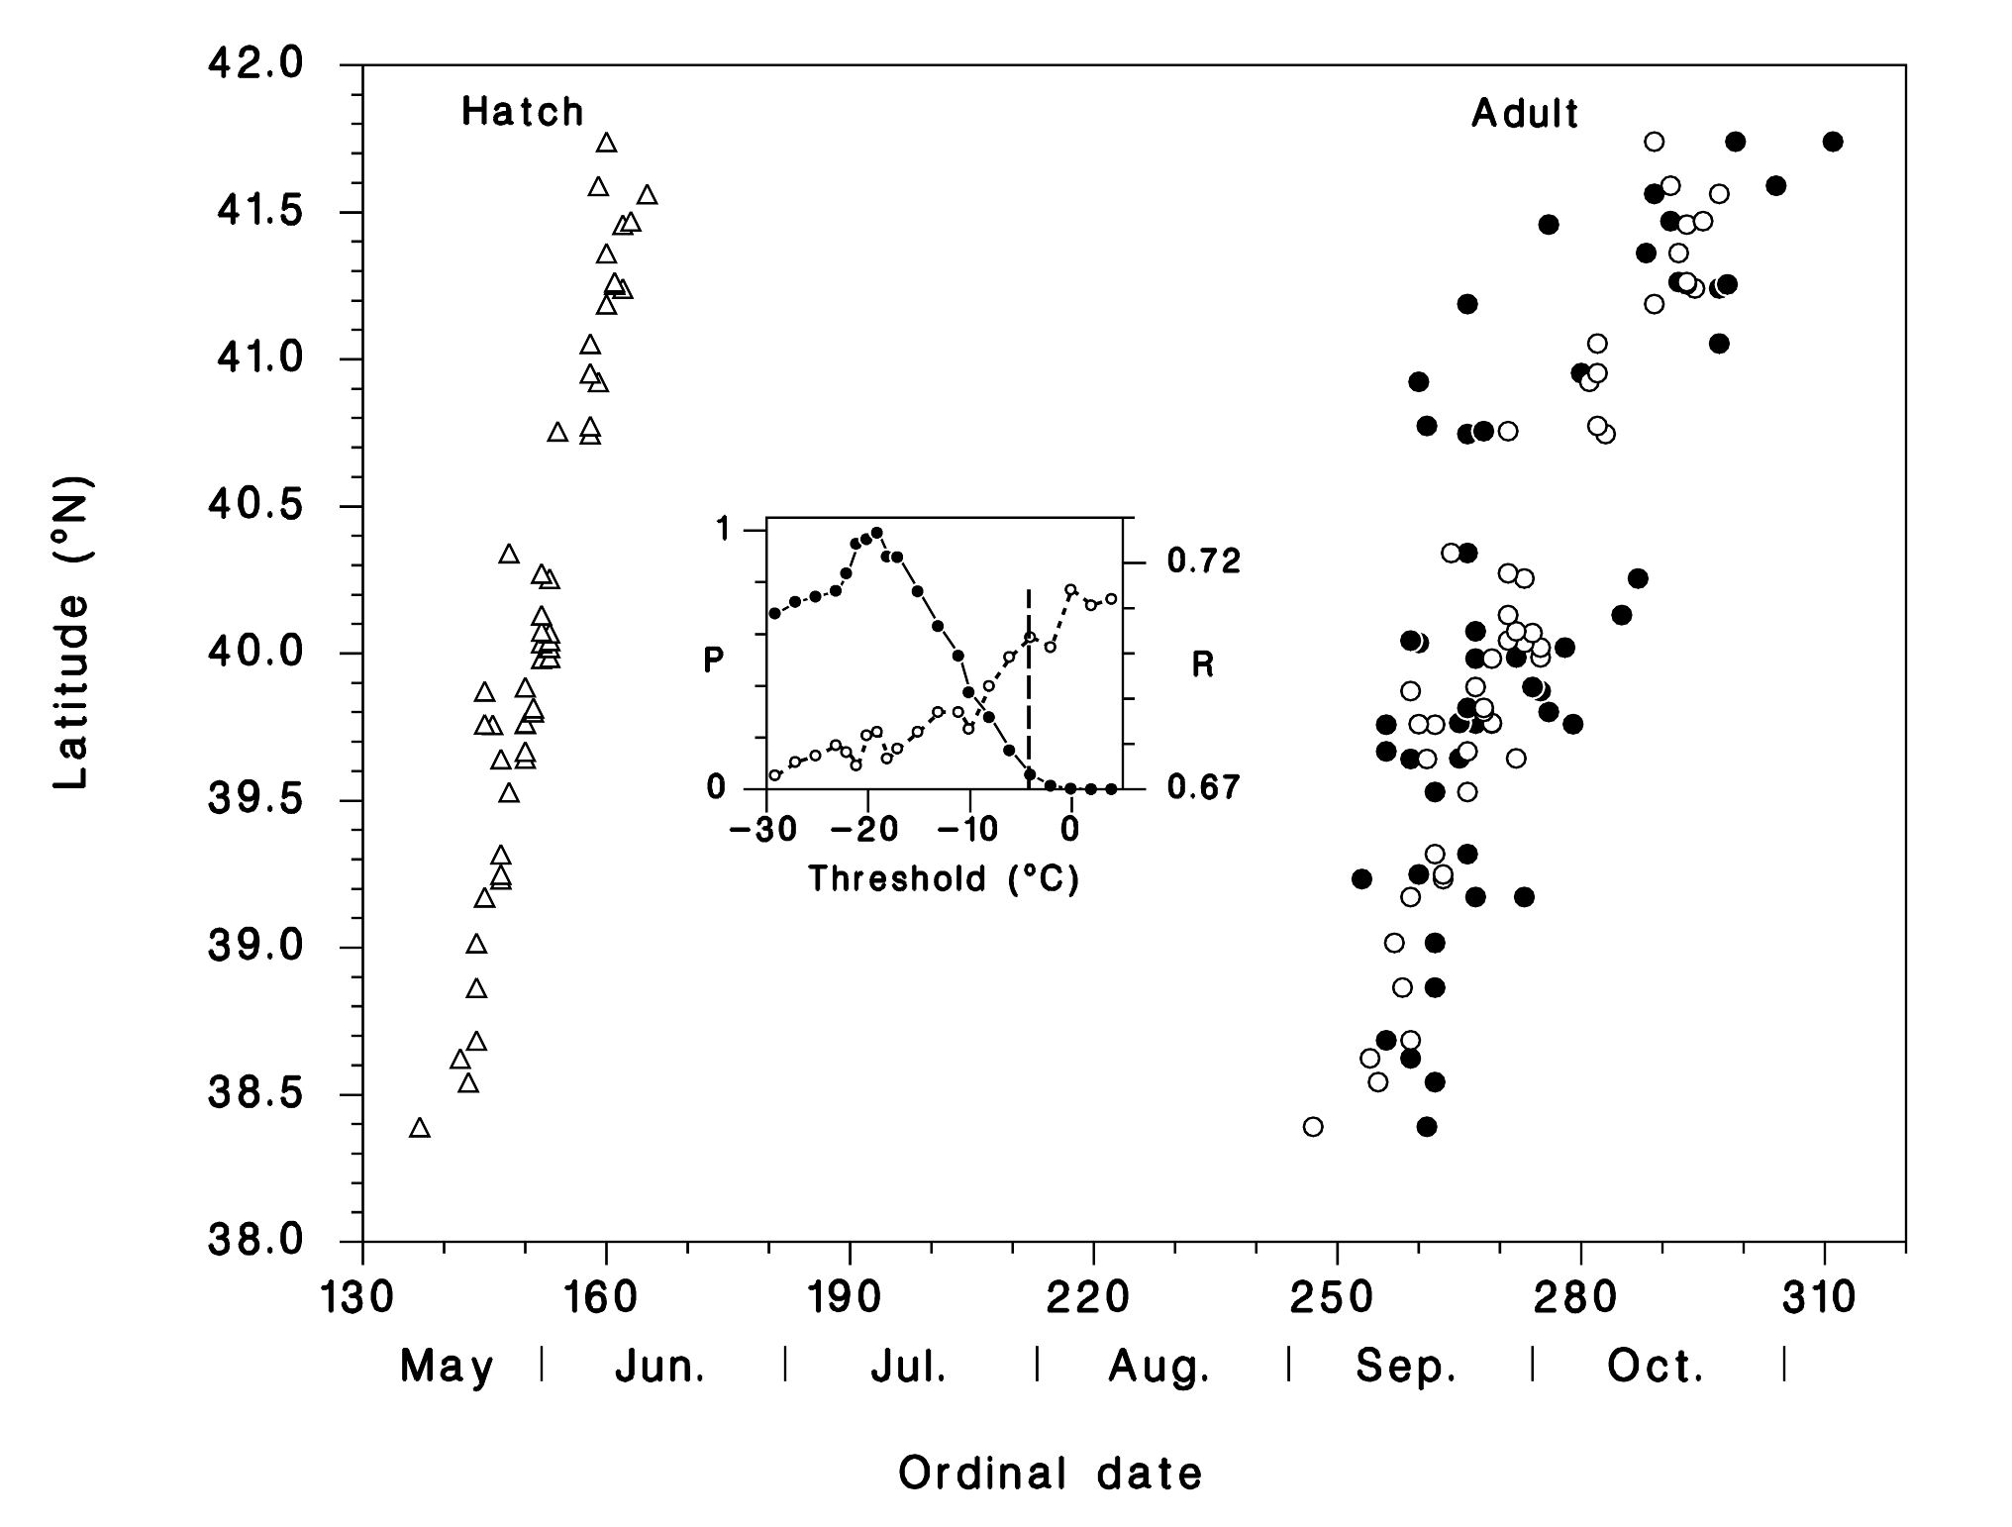
Figure 3. Simulated date of hatch (∆), simulated (○) and observed (●) adult emergence over a range of latitudes. Inset: Optimization of threshold temperature for degree-day summation, based on R (○) and P for no bias in regression between observed and simulated dates of adult emergence.

Step 3: prediction of egg cluster weight. In this step we use an empirical relationship between the date of female emergence t_{f} and the weight of the egg cluster w. This relationship was established by ordinary linear regression analysis:

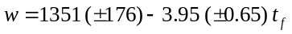 (F_{1,48} = 37.4, P < 0.001, R² = 0.426)

(Fig. 4a). Applied to the date of female emergence simulated by the model developed in steps 1 and 2, this relationship describes the main features of the relationship observed between egg cluster weight and latitude (Fig. 3b).

Next steps:

- Couple this egg-cluster weight predictor to the cold survival model
- Map winter survival under current climate, and under climate change.

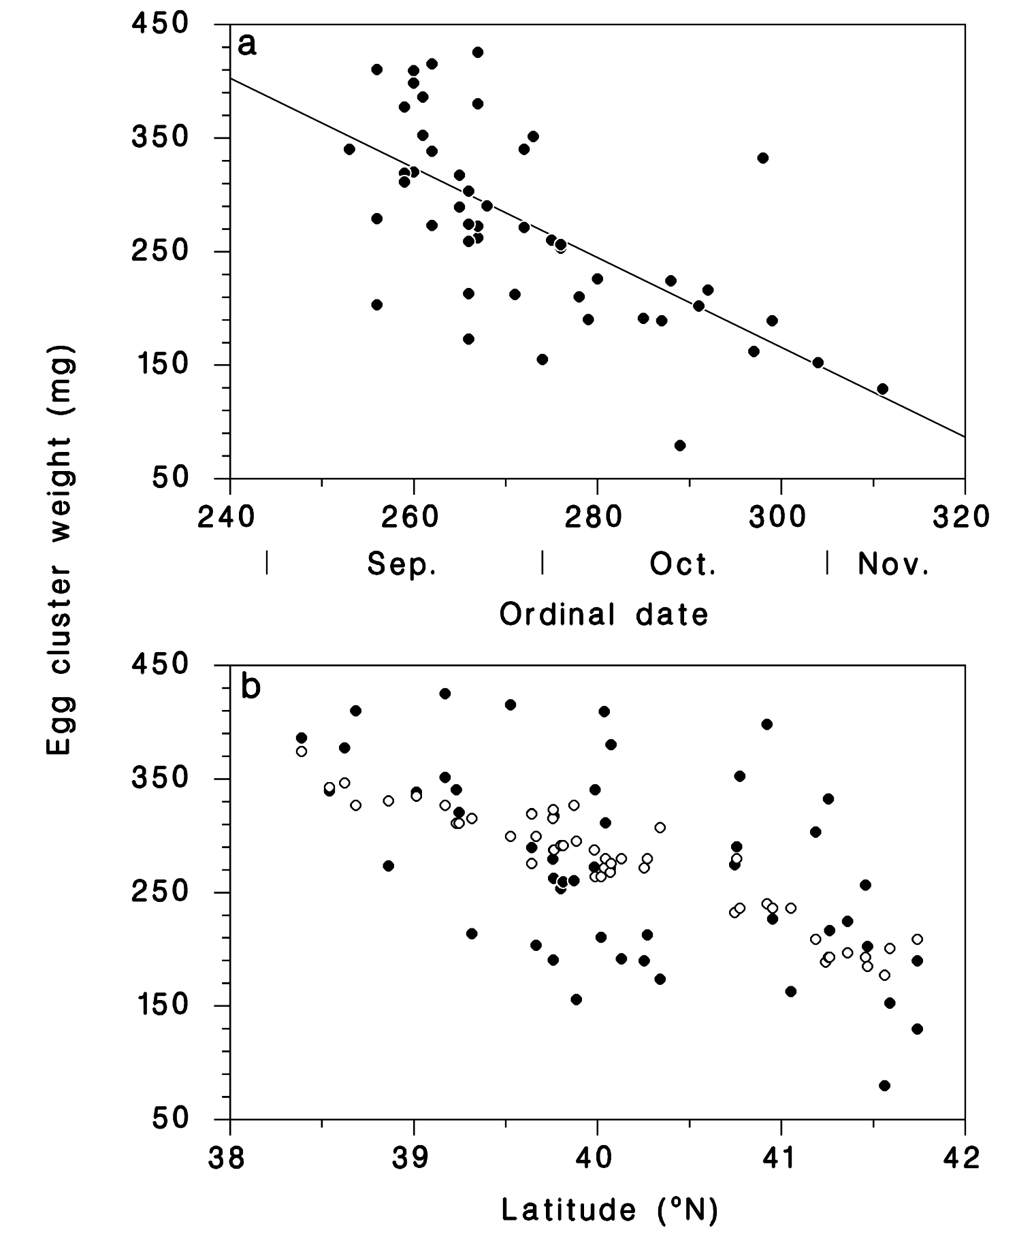
Figure 4. (a) observed relationship between egg cluster weight and date of female emergence. (b) Egg weight versus latitude, either observed (●) or predicted from simulated emergence dates (○).

