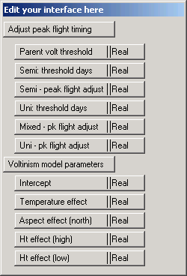
Hi Rémi,
Merci! Thank you for the quick reply.

The front end of the model – “Adjust peak flight timing” - needs to be replaced. Note, the new model still uses temperatures from the current and previous year. From my manuscript:

“The equation for predicted logit-scale of proportional spruce beetle emergence cage captures is:
Logit_{i} = -0.4484 + 0.2057( Day₁₅) – 0.03408(Pri₁₅); [1]
where Day₁₅ is cumulative days, for the year of interest, wherein the daily maximum temperature is  15C; and Pri₁₅ is cumulative days wherein the daily maximum temperature was 15C for the prior year . To determine the day-of-year corresponding to predicted peak emergence, Eq. 1 is solved for logit = 0 (i.e., log-scale odds of 50%). For example, if Pri₁₅ = 75 (75 total days 15C for the prior year) , the 50th percentile beetle will emerge when Day₁₅ = 14.6 (0 = -0.4484 + 0.2057( Day₁₅) – 0.03408(75)). Because partial days are meaningless for predicting date of peak flight, this values is rounded-up to 15. The temperature record is then examined to determine the day-of-year, for the year of interest, corresponding to the 15th cumulative day wherein the maximum daily temperature was 15C.”

So, the new model is somewhat like the old. Structurally, the main difference is that the effect of temperatures for the previous year is now continuous rather than discrete.
The second part of the model (“Voltinism model parameters”), highlighted in the blue box from the BioSIM screen shot above, has the same structure and variables but with new parameter values.
“The equation for predicted logit-scale univoltine brood proportion is:
Logit_{ij} = -4.4034 + 0.01192(Hr₁₇) - 0.8716 (N) + 0.8943(H) - 1.5647(L); [2]
where Hr₁₇ is cumulative hours above 17C accumulated beginning 40 d subsequent to predicted peak emergence; N =1 if bole aspect is north, 0 otherwise; H = 1 if height is 4.6 m, 0 otherwise; L = 1 if height is ground level, 0 otherwise.”

