**Title:** Swing

**Objective:**

* To discuss the swing set of Class
* Overview of swing components
* Layout management
* To create GUI using inputs, button, combo box, menus, Dialogs etc.

**Theory:**

Java Swing is part of Java Foundation Classes. It is used to create window-based applications which makes it suitable for developing lightweight desktop applications.  It is built on the top of AWT (Abstract Windowing Toolkit) API and entirely written in java. Unlike AWT, Java Swing provides platform-independent and lightweight components. The javax.swing package provides classes for java swing API such as JButton, JTextField, JTextArea, JRadioButton, JCheckbox, JMenu, JColorChooser etc.

**Lab Activity:**

**Qn1: Design GUI using JLabel and ImageIcon class.**

**Code:**

import javax.swing.*;

import javax.swing.event.*;

public class lab5Qn1{

    public lab5Qn1(){

        JFrame jf = new JFrame("Icon Image Demo ");

        ImageIcon icon = new ImageIcon("javaLogo.png");

        JLabel l1 = new JLabel("Java Programming ");

        l1.setBounds(200, 50, 100, 30);

        JLabel l2 = new JLabel(icon);

        l2.setBounds(100, 100, 300, 300);

        JLabel l3 = new JLabel("Try it");

        l3.setBounds(300, 350, 80, 30);

        jf.add(l1);

        jf.add(l2);

        jf.add(l3);

        jf.setDefaultCloseOperation(1);

        jf.setLayout(null);

        jf.setSize(500,500);

        jf.setVisible(true);

    }

    public static void main(String[] args) {

        new lab5Qn1();

    }

}

**Output:**

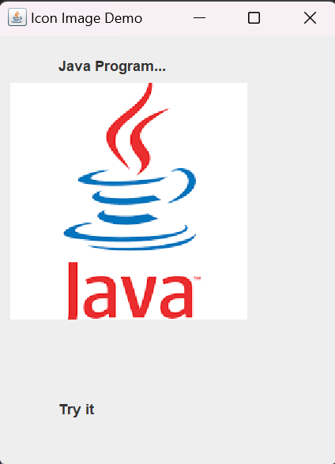

**Qn2 : Design the GUI to find the largest number.**

**Code:**

import javax.swing.*;

import java.awt.*;

import java.awt.event.*;

public class Lab5Qn2 implements ActionListener{

    JTextField t1,t2;

    JLabel l1,l2,l3,result;

    public Lab5Qn2(){

        JFrame jf = new JFrame("Largest ");

        JPanel panel = new JPanel();

        l1 = new JLabel("Find The Largest One ");

        l2 = new JLabel("first number");

        l3 = new JLabel("second number");

        t1 = new JTextField(50);

        t2 = new JTextField(50);

        JButton b = new JButton("Check");

        b.addActionListener(this);

        result = new JLabel("");

        panel.add(l2);

        panel.add(t1);

        panel.add(l3);

        panel.add(t2);

        panel.add(b);

        panel.add(result);

        jf.add(l1);

        jf.add(panel);

        jf.setDefaultCloseOperation(1);

        panel.setLayout(new GridLayout(4,2));

        jf.setSize(500,500);

        jf.setVisible(true);

    }

    @Override

    public void actionPerformed(ActionEvent ae){

        String str1 = new String(t1.getText());

        String str2 = new String(t2.getText());

        int n1=Integer.parseInt(str1);

        int n2 = Integer.parseInt(str2);

        if(n1>n2){

            result.setText(str1+"is the Largest");

        }

        else{

            result.setText(str2 + "is the Largest");

        }

    }

    public static void main(String[] args) {

        new Lab5Qn2();

    }

}

**Output:**

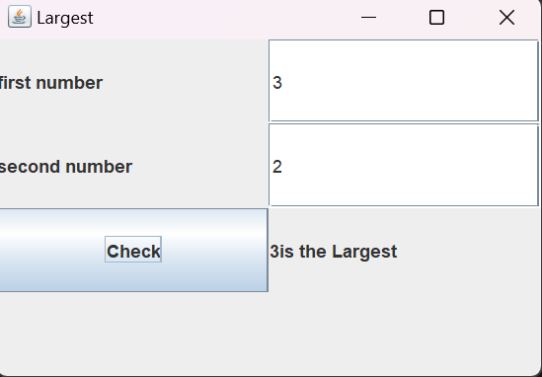

**Qn3 Design the GUI to guess the correct answer.**

**Code:**

import java.awt.*;

import java.awt.event.*;

import javax.swing.*;

public class lab5Qn3 implements ActionListener {

    JButton b1,b2,b3,b4;

    JLabel result,l1;

    public lab5Qn3(){

        JFrame jf = new JFrame("Guess The Answer");

        l1 = new JLabel("Who is the founder of java ?");

        l1.setBounds(200, 50, 160, 20);

        b1 = new JButton("Dennis Ritchie");

        b1.setBounds(200, 100, 100, 50);

        b2 = new JButton("James Gosling");

        b2.setBounds(300, 100, 100, 50);

        b3 = new JButton("Guido Van Rossum");

        b3.setBounds(200, 150, 100, 50);

        b4 = new JButton("Patrick Naughton");

        b4.setBounds(300, 150, 100, 50);

        b1.addActionListener(this);

        b2.addActionListener(this);

        b3.addActionListener(this);

        b4.addActionListener(this);

        result =new JLabel("");

        result.setBounds(250, 250, 200, 50);

        jf.add(l1);

        jf.add(b1);

        jf.add(b2);

        jf.add(b3);

        jf.add(b4);

        jf.add(result);

        jf.setSize(500,500);

        jf.setLayout(null);

        jf.setVisible(true);

    }

    public void actionPerformed(ActionEvent e){

        if(e.getSource()==b1){

            result.setText("you are incorrect");

        }

        if(e.getSource()==b2){

            result.setText("you are correct");

        }

        if(e.getSource()==b3){

            result.setText("you are incorrect");

        }

        if(e.getSource()==b4){

            result.setText("you are incorrect");

        }

    }

    public static void main(String[] args) {

        new lab5Qn3();

    }

}

**Output:**

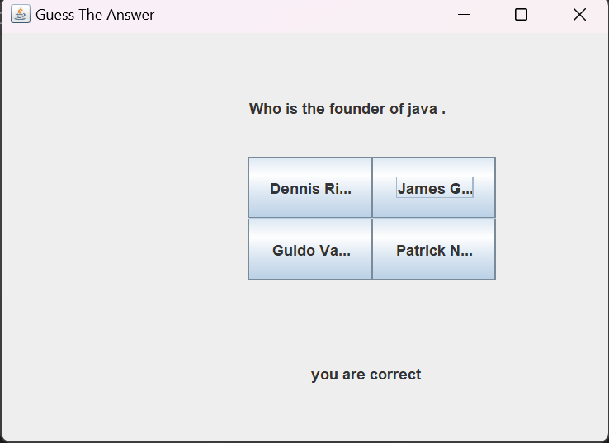

**Qn4 Design the GUI and add event accordingly.**

**Code:**

import java.awt.*;

import java.awt.event.*;

import javax.swing.*;

public class lab5Qn4 implements ActionListener {

    JButton b1,b2;

    ImageIcon icon1 = new ImageIcon("onBulb1.jpg");

    Image image = icon1.getImage();

    Image newimg1 = image.getScaledInstance(300,

300,java.awt.Image.SCALE_SMOOTH);

    ImageIcon icon3 = new ImageIcon(newimg1);

    ImageIcon icon2 = new ImageIcon("offBulb1.jpeg");

    Image image2= icon2.getImage();

    Image newimg2 = image2.getScaledInstance(300,

300,  java.awt.Image.SCALE_SMOOTH);

    ImageIcon icon4 = new ImageIcon(newimg2);

    JLabel l1,l2;

    public lab5Qn4(){

        JFrame jf = new JFrame("BULB");

        b1 = new JButton("off");

        b1.setBounds(250, 100, 100, 20);

        b2 = new JButton("on");

        b2.setBounds(750, 100, 100, 20);

        b1.addActionListener(this);

        b2.addActionListener(this);

        l1= new JLabel(icon3);

        l1.setBounds(10, 170, 500, 500);

        l2= new JLabel(icon4);

        l2.setBounds(530, 170, 500, 500);

        jf.add(b1);

        jf.add(b2);

        jf.add(l1);

        jf.add(l2);

        jf.setSize(1050,700);

        // jf.setLayout(new GridLayout(2,2));

        jf.setLayout(null);

        jf.setVisible(true);

    }

    public void actionPerformed(ActionEvent e){

       if(e.getSource()==b1){

            l1.setIcon(icon2);

       }

       if(e.getSource()==b2){

            l2.setIcon(icon1);

       }

    }

    public static void main(String[] args) {

        new lab5Qn4();

    }

}

**Output:**

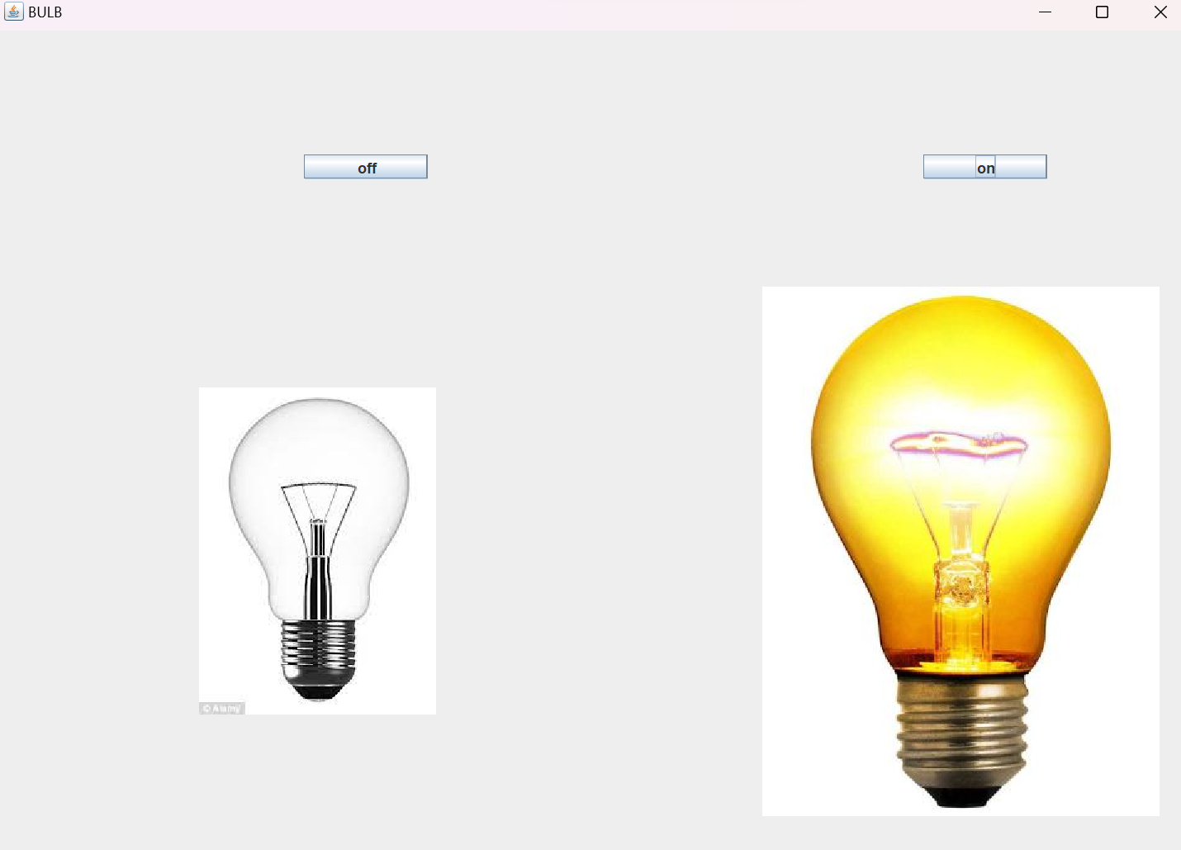

**Qn5: Develop the GUI using JCheckBox, JLabel, JButton and event handling.**

**Code:**

imoprt javax.swing.*;

import java.awt.event.*;

public class lab5Qn5 extends JFrame implements ItemListener {

    JLabel l, l1;

    JCheckBox cb1, cb2, cb3, cb4;

    JButton b;

    lab5Qn5() {

        l = new JLabel("Food Ordering System");

        l.setBounds(50, 50, 300, 20);

        l1 = new JLabel("result");

        l1.setBounds(100, 400, 300, 20);

        cb1 = new JCheckBox("Momo");

        cb1.setBounds(100, 100, 150, 20);

        cb1.addItemListener(this);

        cb2 = new JCheckBox("Pizza");

        cb2.setBounds(100, 150, 150, 20);

        cb2.addItemListener(this);

        cb3 = new JCheckBox("Chowmein");

        cb3.setBounds(100, 200, 150, 20);

        cb3.addItemListener(this);

        cb4 = new JCheckBox("Fry Rice");

        cb4.setBounds(100, 250, 150, 20);

        cb4.addItemListener(this);

        b = new JButton("Submit");

        b.setBounds(100, 300, 80, 30);

        add(l);

        add(cb1);

        add(cb2);

        add(cb3);

        add(cb4);

        add(b);

        add(l1);

        setSize(400, 500);

        setLayout(null);

        setVisible(true);

        setDefaultCloseOperation(EXIT_ON_CLOSE);

        int count = 0;

        b.addActionListener(new ActionListener() {

            public void actionPerformed(ActionEvent e) {

                if (e.getSource() == b) {

                    itemStateChanged(null);

                }

            }

        });

    }

    @Override

    public void itemStateChanged(ItemEvent e) {

        // TODO Auto-generated method stub

        if (e.getSource() == cb1)

            l1.setText("You have Selected one item which is Momo ");

        if (e.getSource() == cb2)

            l1.setText("You have Selected one item which is Pizza ");

        if (e.getSource() == cb3)

            l1.setText("You have Selected one item which is Chowmein ");

        if (e.getSource() == cb4)

            l1.setText("You have Selected one item which is Fry Rice ");

        for(int i=1;i<=4;i++){

        }

    }

    public static void main(String[] args) {

        new lab5Qn5();

    }

}

**Ouput:**

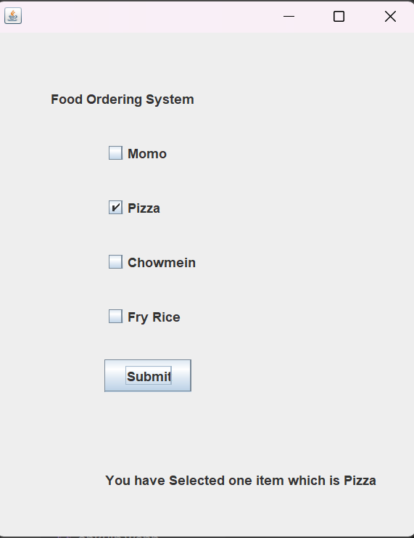

**Qn6: Design the GUI using JRadioButton, JButton,JLabel and appropriate event handing.**

**Code:**

import java.awt.*;

import java.awt.event.*;

import javax.swing.*;

public class lab5Qn6 implements ActionListener {

    JFrame jf;

    JLabel l1, l2;

    JRadioButton jb1, jb2, jb3, jb4;

    JButton btn;

    ButtonGroup bg;

    public lab5Qn6() {

        jf = new JFrame("QN6");

        l1 = new JLabel("Choose Your Payment");

        l1.setBounds(100, 50, 180, 30);

        jb1 = new JRadioButton("Credit Card");

        jb1.setBounds(10, 100, 150, 30);

        jb1.addActionListener(this);

        jb2 = new JRadioButton("Wallet");

        jb2.setBounds(160, 100, 150, 30);

        jb2.addActionListener(this);

        jb3 = new JRadioButton("Bank Transfer");

        jb3.setBounds(10, 140, 150, 30);

        jb3.addActionListener(this);

        jb4 = new JRadioButton("Cash on Delivery");

        jb4.setBounds(160, 140, 150, 30);

        jb4.addActionListener(this);

        btn = new JButton("ok");

        btn.setBounds(10, 180, 80, 40);

        btn.addActionListener(this);

        l2 = new JLabel("Result");

        l2.setBounds(100, 240, 200, 20);

        bg = new ButtonGroup();

        bg.add(jb1);

        bg.add(jb2);

        bg.add(jb3);

        bg.add(jb4);

        jf.add(l1);

        jf.add(jb1);

        jf.add(jb2);

        jf.add(jb3);

        jf.add(jb4);

        jf.add(btn);

        jf.add(l2);

        jf.setLayout(null);

        jf.setSize(300, 300);

        jf.setVisible(true);

    }

    @Override

    public void actionPerformed(ActionEvent e) {

            if (e.getSource() == jb1) {

                l2.setText("You have selected Credit wallet");

            }

            if (e.getSource() == jb2) {

                l2.setText("You have selected Wallet");

            }

            if (e.getSource() == jb3) {

                l2.setText("You have selected bank transfer");

            }

            if (e.getSource() == jb4) {

                l2.setText("You have selected Cash on Delivery");

            }

        }

    public static void main(String[] args) {

        new lab5Qn6();

    }

}

**Ouput:**

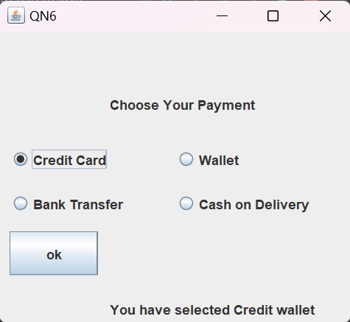

**Qn7: Design the GUI to demonstrate JTabbePane.**

**Code:**

import java.awt.*;

import java.awt.event.*;

import javax.swing.*;

public class lab5Qn7 extends JFrame{

    JFrame jf;

    JLabel l1,l2;

    JTextArea jta;

    JButton btn;

    JCheckBox jcb1,jcb2,jcb3,jcb4;

    JPanel p1,p2,p3;

    Container c1;

    public lab5Qn7(){

        jf = new JFrame("JTabbedPane Example");

        jf.setDefaultCloseOperation(JFrame.EXIT_ON_CLOSE);

        JTabbedPane jtp = new JTabbedPane();

        jtp.setTabLayoutPolicy(JTabbedPane.SCROLL_TAB_LAYOUT);

        jtp.setBounds(3,3,400,300);

        p1=new JPanel();

        p2=new JPanel();

        p3=new JPanel();

        l1 = new JLabel("Welcome to IOC");

        l1.setBounds(1,0,100,20);

        // c1=getContentPane();

        p1.setLayout(null);

        p1.add(l1);

        jcb1 = new JCheckBox("C");

        jcb2= new JCheckBox("C++");

        jcb3 = new JCheckBox("Java");

        jcb4 = new JCheckBox("PHP");

        btn = new JButton("submit");

        p2.add(jcb1);

        p2.add(jcb2);

        p2.add(jcb3);

        p2.add(jcb4);

        p2.add(btn);

        p2.setLayout(new GridLayout(4,1));

        l2 = new JLabel("Leave a COmment");

        l2.setBounds(10,20,150,30);

        jta = new JTextArea("");

        jta.setBounds(10,40,200,200);

        p3.add(l2);

        p3.add(jta);

        p3.setLayout(new GridLayout(2,1));

        jtp.addTab("Dashboard", p1);

        jtp.addTab("Courses", p2);

        jtp.addTab("Comment", p3);

        jf.add(jtp, BorderLayout.CENTER);

        jf.setSize(450, 350);

        jf.setLayout(null);

        jf.setVisible(true);

    }

    public static void main(String[] args) {

        new lab5Qn7();

    }

}

**Ouput:**

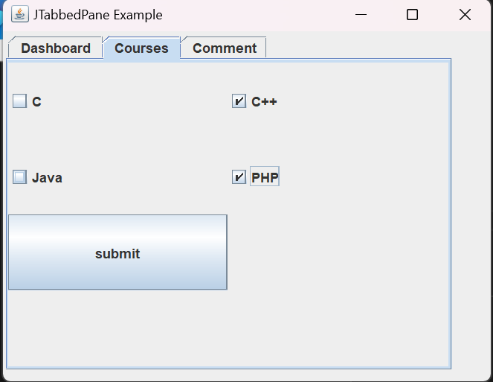 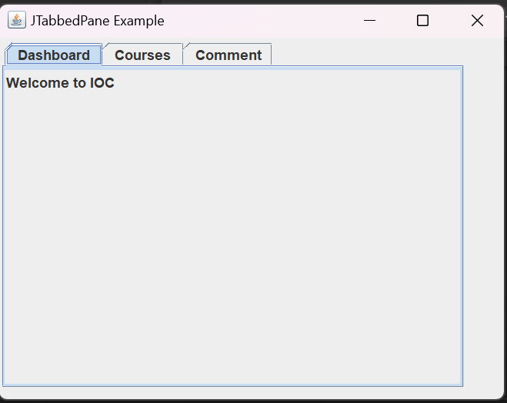

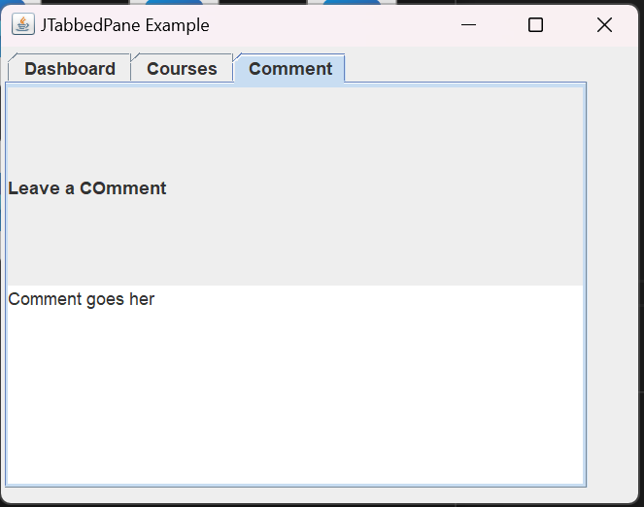

**Qn8: Design the GUI using JList, JScrollPane, JButton and event handling.**

**Code:**

import javax.swing.*;

import java.awt.*;

import java.awt.event.*;

public class lab5Qn8 extends JFrame {

  private JList colorList, copyList;

  private JButton copy;

  private String colorNames[]

      = {"Apple","Orange","Banana","Grapes","Guava","Mango"};

  public lab5Qn8() {

    Container c = getContentPane();

    c.setLayout(new FlowLayout());

    this.setSize(500,150);

    colorList = new JList(colorNames);

    colorList.setVisibleRowCount(5);

    colorList.setFixedCellHeight(15);

    colorList.setSelectionMode(ListSelectionModel.MULTIPLE_INTERVAL_SELECTION);

    c.add(new JScrollPane(colorList));

    copy = new JButton("Copy >>>");

    copy.addActionListener(new ActionListener() {

      public void actionPerformed(ActionEvent e) {

        copyList.setListData(colorList.getSelectedValues());

      }

    });

    c.add(copy);

    copyList = new JList();

    copyList.setVisibleRowCount(5);

    copyList.setFixedCellWidth(100);

    copyList.setFixedCellHeight(15);

    copyList.setSelectionMode(ListSelectionModel.SINGLE_INTERVAL_SELECTION);

    c.add(new JScrollPane(copyList));

    this.show();

  }

  public static void main(String args[]) {

    // JFrame.setDefaultLookAndFeelDecorated(true);

        new lab5Qn8();

  }

}

**Output:**

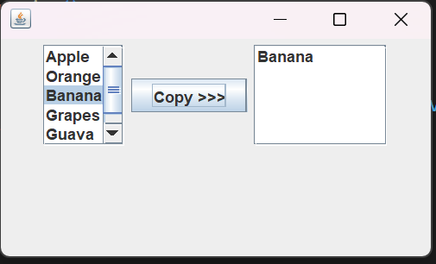

**Qn9: Design the GUI for recording student information.**

**Code:**

import java.awt.Container;

import java.awt.Font;

import javax.swing.*;

import java.awt.event.*;

public class lab5Qn9 extends JFrame implements ActionListener{

    JLabel message;

    JLabel nameLabel, genderLabel;

    JTextField nameField;

    JRadioButton genderMale, genderFemale;

    ButtonGroup genderGroup;

    JLabel addLabel, mobileNoLabel,mailLabel;

    JTextField addField, mobileNoField,mailField;

    JLabel programLabel;

    JComboBox<String> programList;

    JButton add,reset,cancel;

    Container container;

    JOptionPane pane;

    public lab5Qn9() {

        message = new JLabel("Student Info Form");

        message.setFont(new Font("Courier", Font.BOLD, 20));

        nameLabel = new JLabel("Name: ");

        nameField = new JTextField();

        addLabel = new JLabel("Address: ");

        addField = new JTextField();

        genderLabel = new JLabel("Gender: ");

        genderMale = new JRadioButton("Male", true);

        genderFemale = new JRadioButton("Female");

        genderGroup = new ButtonGroup();

        genderGroup.add(genderMale);

        genderGroup.add(genderFemale);

        programLabel = new JLabel("Program: ");

        programList = new JComboBox<String>();

        programList.addItem("BIM");

        programList.addItem("BCIS");

        programList.addItem("BBA-BI");

        mobileNoLabel = new JLabel("Phone: ");

        mobileNoField = new JTextField();

        mailLabel = new JLabel("Email: ");

        mailField = new JTextField();

        add = new JButton("Add");

        reset = new JButton("Reset");

        cancel = new JButton("Cancel");

        add.addActionListener(this);

        reset.addActionListener(this);

        cancel.addActionListener(this);

        container = getContentPane();

        container.setLayout(null);

        setBounds();

        addComponents();

    }

    public void setBounds() {

        nameLabel.setBounds(50, 20, 100, 30);

        nameField.setBounds(130, 20, 200, 30);

        addLabel.setBounds(50, 60, 100, 30);

        addField.setBounds(130, 60, 200, 30);

        genderLabel.setBounds(50, 100, 100, 30);

        genderMale.setBounds(130, 100, 100, 30);

        genderFemale.setBounds(240, 100, 100, 30);

        programLabel.setBounds(50, 140, 100, 30);

        programList.setBounds(130, 140, 200, 30);

        mobileNoLabel.setBounds(50, 180, 100, 30);

        mobileNoField.setBounds(130, 180, 200, 30);

        mailLabel.setBounds(50, 220, 100, 30);

        mailField.setBounds(130, 220, 200, 30);

        add.setBounds(20, 260, 100, 30);

        reset.setBounds(130, 260, 100, 30);

        cancel.setBounds(240, 260, 100, 30);

    }

    public void addComponents() {

        container.add(nameLabel);

        container.add(nameField);

        container.add(addLabel);

        container.add(addField);

        container.add(genderLabel);

        container.add(genderMale);

        container.add(genderFemale);

        container.add(programLabel);

        container.add(programList);

        container.add(mobileNoLabel);

        container.add(mobileNoField);

        container.add(mailLabel);

        container.add(mailField);

        container.add(add);

        container.add(reset);

        container.add(cancel);

    }

    public static void main(String[] args) {

        lab5Qn9 frame = new lab5Qn9();

        frame.setTitle("Student Register Form");

        frame.setVisible(true);

        frame.setBounds(500, 100, 500, 700);

        frame.setDefaultCloseOperation(JFrame.EXIT_ON_CLOSE);

        frame.setResizable(true);

    }

    String g,program;

    @Override

    public void actionPerformed(ActionEvent e) {

        // TODO Auto-generated method stub

        // String name = nameField.getText();

        program = programList.getItemAt(programList.getSelectedIndex());

        if(genderMale.isSelected()){

             g = new String("Male");

        }

        else if(genderFemale.isSelected()){

             g = new String("Female");

        }

        if(e.getSource()==add){

            pane = new JOptionPane("Student Information");

            JOptionPane.showMessageDialog(null, e, "Name: "+"\t\t"+

            nameField.getText()+"\n"+ "Address : " + "\t\t"+ addField.getText() +

            "\n" + "Gender" + "\t\t"+ g + "\n Program: \t\t"+ program +

             "\nMobile Number: \t\t" + mobileNoLabel.getText() + "\n Email:

\t\t"+ mailField.getText(), JOptionPane.INFORMATION_MESSAGE);

        }

        if(e.getSource()== reset){

            nameField.setText("");

            addField.setText("");

            genderMale.setSelected(false);

            genderFemale.setSelected(false);

            programList.setSelectedIndex(0);

            mobileNoField.setText("");

            mailField.setText("");

        }

        if(e.getSource()== cancel){

            System.exit(1);

        }

    }

}

**Output:**

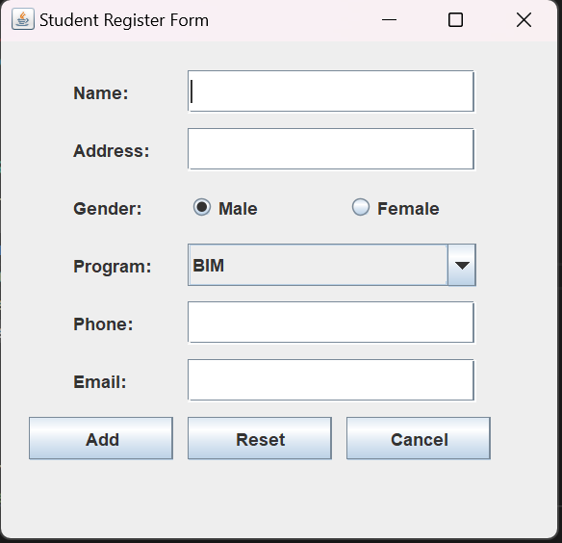

**Qn 10: Design the GUI using JScrollPane and JTable.**

**Code:**

import javax.swing.*;

import javax.swing.table.*;

public class lab5Qn10 {

    public lab5Qn10() {

        JFrame f=new JFrame();

        String[] columnNames = {"ID", "Name", "Project", "Price in $"};

        Object[][] data = {

                {1234, "John", "Pencil", 10},

                {4382, "Mirian", "Pen", 11},

                {2345, "Katy", "Chair", 253},

                {6334, "Agnes", "Table", 456},

                {1177, "Stanley", "flower", 25},};

        DefaultTableModel model = new DefaultTableModel(data, columnNames);

        JTable table = new JTable(model);

        JScrollPane scrollPane = new JScrollPane(table);

        f.add(scrollPane);

        f.setTitle("Table Example");

        f.setSize(400, 300);

        f.setLocationRelativeTo(null);

        f.setVisible(true);

        f.setDefaultCloseOperation(JFrame.EXIT_ON_CLOSE);

    }

    public static void main(String[] args) {

            new lab5Qn10();

    }

}

**Output:**

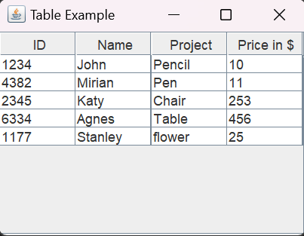

**Qn11: Design the GUI with following menu options.**

**Code:**

import javax.swing.*;

public class lab5Qn11   {

    public lab5Qn11() {

        JFrame f =new JFrame(“menu demo”);

        JMenuBar menuBar = new JMenuBar();

        f.setJMenuBar(menuBar);

        JMenu normalMenu = new JMenu("Normal Menu");

        JMenu radioMenu = new JMenu("Radio Menu");

        JMenu checkMenu = new JMenu("Check Menu");

        menuBar.add(normalMenu);

        menuBar.add(radioMenu);

        menuBar.add(checkMenu);

        JMenuItem newMenuItem = new JMenuItem("New");

        JMenuItem openMenuItem = new JMenuItem("Open");

        JRadioButtonMenuItem firstradio = new JRadioButtonMenuItem("Large Font");

        JRadioButtonMenuItem secondradio = new JRadioButtonMenuItem("Medium

Font");

        JCheckBoxMenuItem firstcheck= new JCheckBoxMenuItem("First Radio

Options");

        JCheckBoxMenuItem secondcheck = new JCheckBoxMenuItem("Second Radio

Options");

        ButtonGroup fontGroup = new ButtonGroup();

        fontGroup.add(firstradio);

        fontGroup.add(secondradio);

        normalMenu.add(newMenuItem);

        normalMenu.add(openMenuItem);

        radioMenu.add(firstradio);

        radioMenu.add(secondradio);

        checkMenu.add(firstcheck);

        checkMenu.add(secondcheck);

        f.setSize(400, 300);

        f.setVisible(true);

    }

    public static void main(String[] args) {

        new lab5Qn11();

    }

}

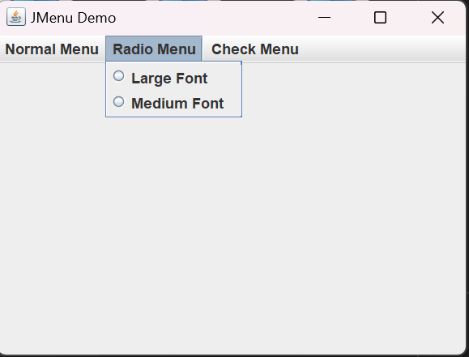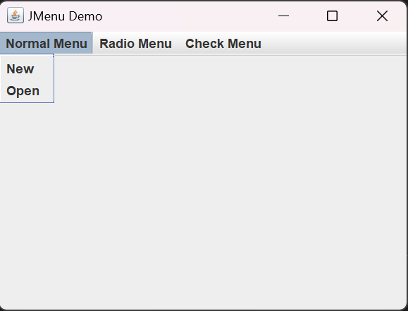**Output:**

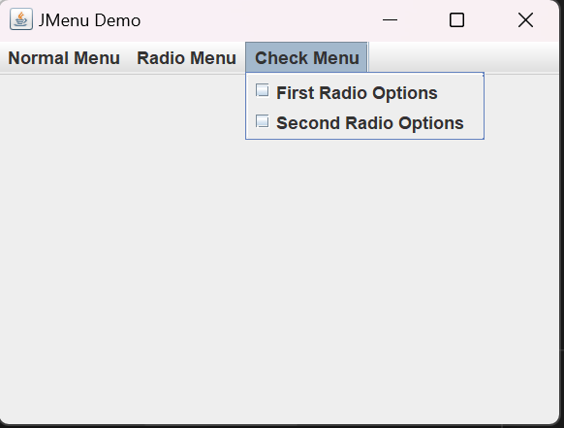

**Conclusion:**

* Learned about Swings components
* Learned about layout manager
* Learned about Event Handling