Neoniche — AI/ML Features
Execution Plan & Implementation Roadmap

Prepared for: Engineering Manager Review | April 2026 | Version 1.0

1. Executive Summary
This document defines a phased execution plan for implementing all AI/ML features scoped for the Neoniche event management platform. Each feature is mapped directly to existing backend route modules and frontend page components, minimising architectural risk and enabling incremental delivery.
The plan is organised into three phases based on complexity, data dependencies, and business value. Phase 1 delivers immediately visible AI capabilities using LLM APIs with zero model-training requirements. Phase 2 introduces ML pipelines that leverage Neoniche's existing PostgreSQL data. Phase 3 covers advanced real-time and cold-start-sensitive features that require multi-event historical data.

Delivery Phases at a Glance
Phase 1 — LLM Quick Wins  Days 1–6 | Phase 2 — ML Pipelines  Days 7–18 | Phase 3 — Advanced Intelligence  Days 19–30
AI Content Generator, Chatbot, Subject line optimisation, Send-time engine, Historical check-in reports, Feedback sentiment analysis | Audience segmentation, Session demand forecasting, Attendee recommendations, No-show prediction, Lead scoring, Fraud detection, Promo analytics | Agenda optimisation (OR-Tools), Crowd flow prediction, AI Matchmaking (Gale-Shapley), Predictive Sponsor ROI, Predictive registration targets

2. Feature Summary — Difficulty & Effort Overview
The table below provides a consolidated view of all AI features, their difficulty rating, delivery phase, estimated effort, and the Neoniche backend files primarily affected.

Feature | Difficulty | Phase | Effort | Key Files (Neoniche)
AI Content Generator | Easy | Phase 1 | 2–3 Days | event.route.js, session.route.js, sponsor.route.js, eventWebsiteBuilder.route.js
Chatbot — Organiser & Sponsor | Easy | Phase 1 | 3–4 Days | server.js (Socket.IO), auth.route.js, sponsorAuth.route.js
Subject line optimisation | Easy | Phase 1 | 1–2 Days | emailCampaign.route.js, emailTemplate.route.js, emailEvent.route.js
Personalised email content | Easy | Phase 1 | 1–2 Days | emailTemplate.route.js, emailCampaign.route.js, registration.route.js
Historical check-in reports | Easy | Phase 1 | 2–3 Days | dashboard.route.js, onsiteUser.route.js
NPS & feedback sentiment | Easy | Phase 1 | 3–4 Days | registration.route.js, feedback.route.js (new)
Notes sentiment (lead) | Easy | Phase 2 | 1–2 Days | sponsorLead.route.js
Send-time optimisation | Medium | Phase 2 | 3–4 Days | emailCampaign.route.js, countryMaster.route.js
Audience segmentation | Medium | Phase 2 | 4–5 Days | registration.route.js, emailEvent.route.js, pass.route.js
Session demand forecasting | Medium | Phase 2 | 5–7 Days | session.route.js, hall.route.js, registration.route.js
Agenda recommendations | Medium | Phase 2 | 4–5 Days | session.route.js, registration.route.js
No-show prediction | Medium | Phase 2 | 5–6 Days | registration.route.js, emailEvent.route.js, pass.route.js
Smart lead scoring | Medium | Phase 2 | 5–7 Days | sponsorLead.route.js, booth.route.js, session.route.js
Predictive sponsor ROI | Medium | Phase 2 | 3–4 Days | sponsor.route.js, sponsorLead.route.js, dashboard.route.js
Promo & fraud detection | Medium | Phase 2 | 4–5 Days | registration.route.js, pass.route.js, auditLog.route.js
Registration target forecast | Medium | Phase 2 | 3–4 Days | registration.route.js, dashboard.route.js
Agenda optimisation (OR-Tools) | Hard | Phase 3 | 5–6 Days | session.route.js, hall.route.js, event.route.js
Crowd flow prediction | Hard | Phase 3 | 7–9 Days | server.js, hall.route.js, PublicOnsiteSessionTracking page
AI Matchmaking | Hard | Phase 3 | 8–10 Days | registration.route.js, sponsor.route.js, booth.route.js, tag.route.js

3. Architectural Foundation — Before Feature Work Begins
The following one-time setup tasks must be completed before any feature development starts. They underpin every AI/ML feature in this plan.
3.1 LLM Provider Abstraction
Create a single wrapper service so the underlying model can be swapped without touching feature code.
- Create services/aiProvider.service.js in neoniche-backend
- Support OpenAI GPT-4o and Anthropic Claude via a common interface: generate(prompt, options)
- Read model selection and API key from .env — add AI_PROVIDER, AI_API_KEY to .env.example
- Estimated effort: 2–3 days
3.2 pgvector Extension (PostgreSQL)
Neoniche already uses PostgreSQL via Sequelize. Enabling the pgvector extension allows embeddings storage inside the existing database — no separate vector DB needed.
- Run: CREATE EXTENSION IF NOT EXISTS vector; on the PostgreSQL instance
- Add a Sequelize migration adding vector columns to session_embeddings and attendee_embeddings tables
- Install pgvector Node.js client: npm install pgvector
- Estimated effort: 1 day
3.3 Python ML Microservice
Node.js handles the API and orchestration. Python-native ML libraries (XGBoost, LightGBM, Prophet, BERTopic, scikit-learn) run in a separate FastAPI microservice that Node calls via HTTP.
- Single FastAPI app: neoniche-ml-service/ alongside existing backend
- Endpoints: /predict/no-show, /predict/session-demand, /cluster/audience, /forecast/registrations, /detect/fraud, /topic-cluster/feedback
- Node backend calls the microservice via Axios — results are cached in PostgreSQL
- Estimated effort: 1 Days (scaffold) + feature-specific routes added per phase
3.4 Event Logging for AI Training Data
The no-show predictor, session forecaster, and lead scorer all require historical data from 3 or more past events. Add AI training log collection from day one — even before the models are built.
- Add ai_event_log table: user_id, event_id, action_type, metadata JSONB, logged_at
- Log in: registration.route.js (registration behaviour), emailEvent.route.js (open/click events), sponsorLead.route.js (lead interactions)
- This adds no user-facing complexity but creates the dataset needed for Phase 2 and 3 models
- Estimated effort: 3–4 days

4. Detailed Execution Plan — Feature by Feature
4.1 AI Content Generator [Easy — Phase 1, Days 1–3]
Generates event descriptions, session summaries, sponsor highlights, and website copy using an LLM. This is the fastest-to-ship feature because Neoniche already has all the structured data needed as context — no training data, no ML, just prompt engineering.
Implementation Steps
- Create services/aiContent.service.js — one function per content type: generateEventDescription(), generateSessionSummary(), generateSponsorHighlight(), generateWebsiteCopy()
- Each function pulls structured data from Sequelize (event name, dates, speakers, categories) and builds a type-specific prompt
- Add POST /api/v1/events/:id/ai-generate to event.route.js — streams LLM response to frontend
- Repeat pattern for session.route.js, sponsor.route.js, and eventWebsiteBuilder.route.js
- Frontend: add Generate with AI button to src/pages/Events/, Session/, Sponsor/, and Marketing/ pages
- Store the draft in the existing content column — no schema change needed. Organiser edits before saving.
Files Affected
- Backend: event.route.js, session.route.js, sponsor.route.js, eventWebsiteBuilder.route.js, services/aiContent.service.js (new)
- Frontend: src/pages/Events/, src/pages/Session/, src/pages/Sponsor/, src/pages/Marketing/
Difficulty Justification
Easy — zero model training. Purely prompt engineering with existing data. Works on event 1, day 1.

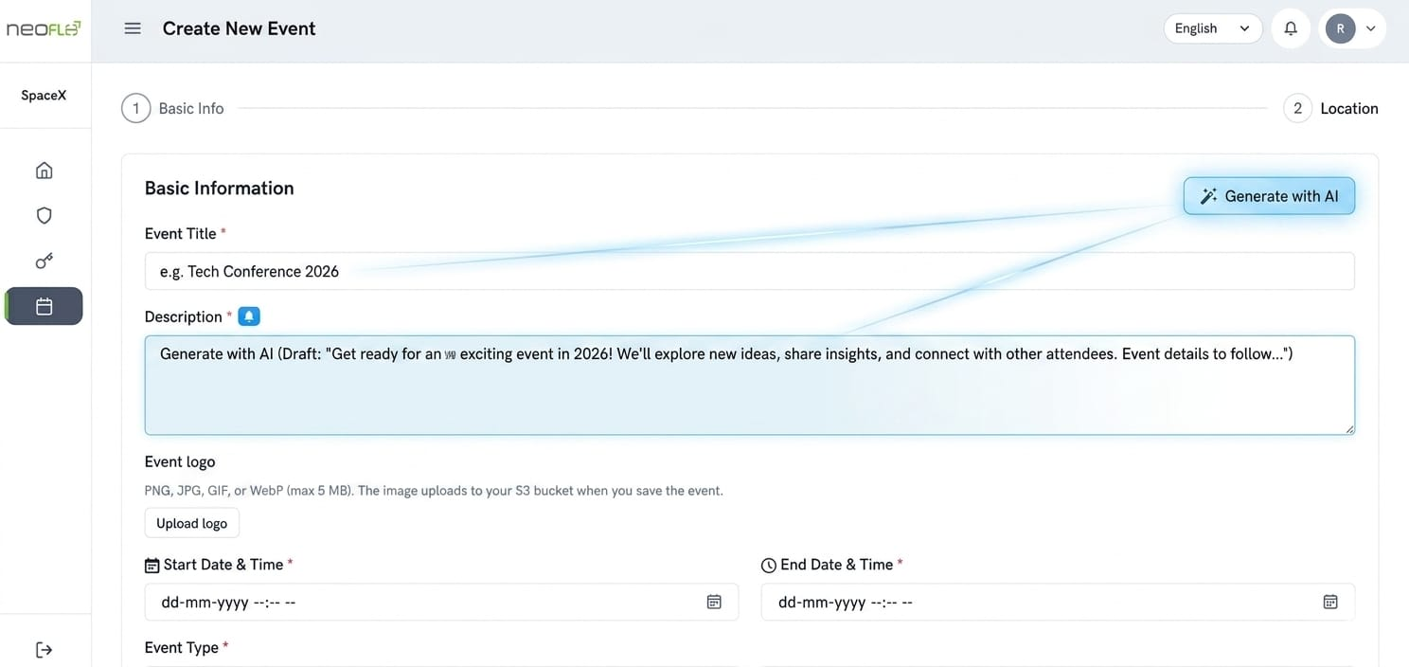

4.2 ChatBot — Organiser & Sponsor How-To [Easy — Phase 1, Days 2–5]
A RAG (Retrieval-Augmented Generation) chatbot scoped per user role. Organisers get a bot that answers platform how-to questions. Sponsors get a bot that answers questions about their booth, leads, and event info. Neoniche already has Socket.IO and separate auth flows for each role — the chatbot uses the same real-time channel.
Implementation Steps
- Enable pgvector (see Section 3.2). Create a docs_embeddings table: content TEXT, embedding vector(1536), role TEXT, source TEXT
- Embed all platform help docs and per-event FAQ text using OpenAI text-embedding-3-small. Store with role = 'organiser' or 'sponsor'
- Create services/chatbot.service.js: on query, embed the question, run cosine similarity against docs_embeddings, retrieve top-5 chunks, inject into LLM prompt
- Add Socket.IO namespace /chatbot in server.js. On message event: authenticate JWT, scope retrieval by role, stream response tokens back
- Organiser bot document set: platform docs + event configuration data. Sponsor bot: sponsor portal docs + their lead and booth data from sponsorLead.route.js
- Frontend: floating chat widget component. Add to organiser layout and sponsor portal layout separately with role-appropriate welcome message
Files Affected
- Backend: server.js, auth.route.js, sponsorAuth.route.js, services/chatbot.service.js (new)
- Frontend: shared ChatWidget component, injected into organiser and sponsor layouts
Difficulty Justification
Easy — RAG is a well-understood pattern. pgvector is already available in PostgreSQL. Socket.IO is already running.

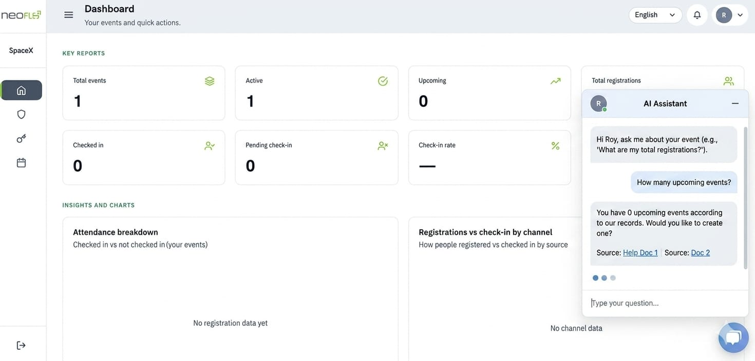
4.3 AI-Powered Email & Campaign Engine [Easy–Medium — Phase 1–2]
Three sub-features that progressively improve email campaign performance. Neoniche already collects all the necessary signals via emailCampaign.route.js and emailEvent.route.js (delivery and open tracking hooks).
4.3a Subject Line Optimisation [Easy — Days 2–3]
- On campaign creation, call LLM to generate 5 subject line variants per campaign
- Create email_subject_variants table: campaign_id, variant_text, open_rate (updated by delivery hook)
- emailEvent.route.js already receives open events — write open rates back to variants table
- After 50+ campaigns: switch to few-shot prompting using the top-performing historical subjects as examples
- Effort: 1–2 Days
4.3b Send-Time Optimisation [Medium — Days 6–9]
- Create email_open_log table: user_id, campaign_id, opened_at timestamp (sourced from emailEvent.route.js hooks)
- Python microservice endpoint /predict/send-time: per user, fit hour-of-Days histogram → return optimal send hour
- Cold-start (new users): use 10–11 AM local time derived from user's country via countryMaster.route.js
- Existing cron scheduler reads per-user optimal send times and batches sends accordingly
- Effort: 3–4 Days
4.3c Audience Segmentation — Auto-Clustering [Medium — Days 8–12]
- Feature extraction from registration, emailEvent, and pass tables: registration-to-event gap (days), pass tier, email open rate, number of sessions booked
- KMeans clustering (k=4–6) in Python microservice. Store cluster labels on user records
- LLM auto-names each cluster: e.g. 'Early Adopters', 'Last-Minute Buyers', 'VIP Delegates', 'No-Shows'
- In campaign builder (src/pages/Marketing/), expose named segments as a filter option alongside existing audience filters
- Effort: 4–5 Days
Files Affected
- Backend: emailCampaign.route.js, emailTemplate.route.js, emailEvent.route.js, countryMaster.route.js
- Frontend: src/pages/Marketing/

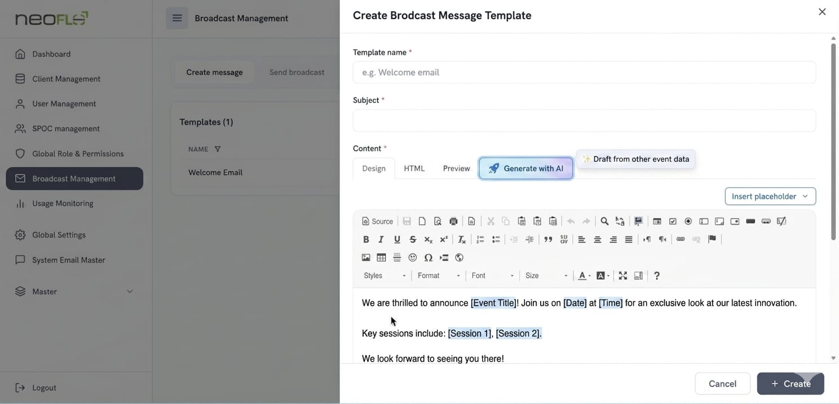

4.4 Personalised Attendee Communication [Easy–Medium — Phase 1–2]
4.4a Personalised Email Content [Easy — Days 3–4]
Neoniche already renders email templates via Nodemailer. This feature injects a personalised paragraph into each outgoing email based on the attendee's profile.
- In emailTemplate.route.js rendering path: call LLM with attendee name, job title, registered sessions, pass type
- LLM returns a 2–3 sentence personalised body paragraph
- Inject the generated paragraph into an existing Handlebars template variable slot — no template redesign required
- Cache generated content per unique profile hash to avoid redundant LLM calls for similar attendees
- Effort: 1–2 Days
4.4b Agenda Recommendations & Session Reminders [Medium — Days 8–12]
- Embed all session descriptions (title + abstract) using OpenAI embeddings. Store in pgvector session_embeddings table
- At registration: embed attendee job title + interest tags → cosine similarity against session_embeddings → top 5 recommended sessions
- Store in attendee_session_recommendations table: attendee_id, session_id, similarity_score
- Session reminders: extend the existing cron scheduler to send reminders 24h and 1h before each booked session using existing Nodemailer templates
- Frontend: show recommended sessions card in attendee portal. UI shows 'Recommended for you' section in session listing
- Effort: 4–5 Days

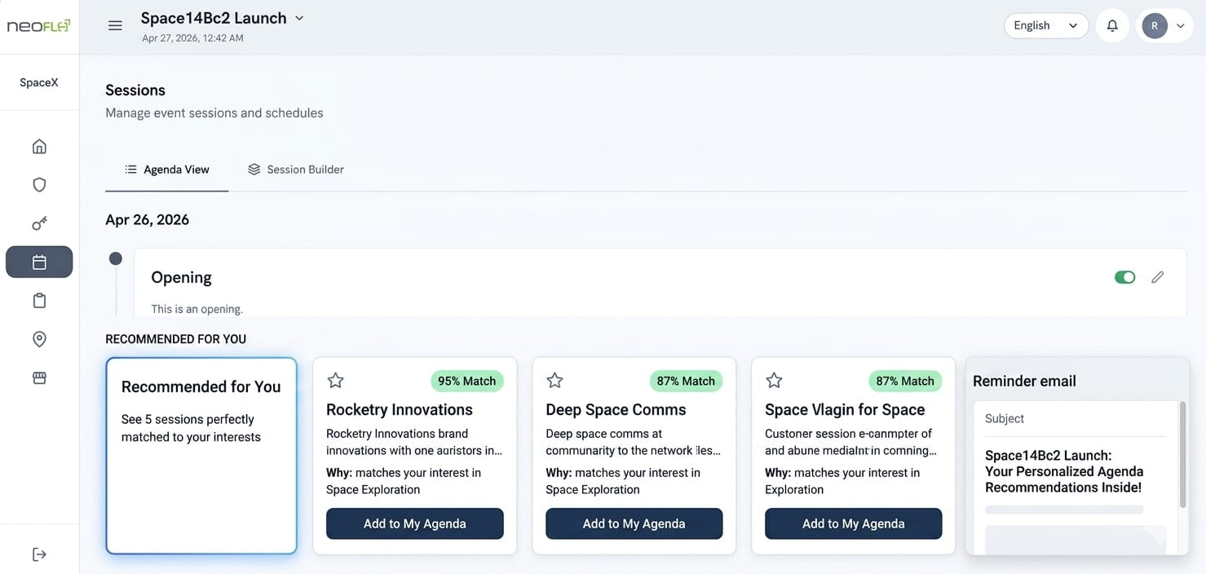
Files Affected
- Backend: session.route.js, registration.route.js, emailCampaign.route.js, emailTemplate.route.js
- Frontend: src/pages/Session/, src/pages/Attendees/

4.5 Session Demand Forecasting [Medium–Hard — Phase 2, Days 9–15]
Predicts expected attendance per session before the event, enabling proactive room assignment, overflow planning, and agenda optimisation. Neoniche has sessions (session.route.js), halls with capacity (hall.route.js), and registrations linked to sessions — all the required features are in the database.
4.5a Session Popularity & Expected Footfall [Medium]
- Feature extraction: join sessions + halls + registrations tables. Compute registration velocity (registrations/day), time slot position, speaker event-repeat count, session topic tags
- XGBoost regressor trained on historical events per tenant. Target variable: actual attendance / session capacity
- Cold-start (first event per tenant): use proportional model — % of total registrants who typically attend sessions of a given type, based on global platform averages
- Store predicted_footfall on the session record (new column in sessions table)
- Python microservice endpoint /predict/session-demand called nightly and on new registrations
- Effort: 5–7 Days
4.5b Auto-Capacity Suggestions & Overflow Alerts [Easy add-on]
- Rule engine in Node: if predicted_footfall > 85% of hall.capacity → trigger overflow alert
- Alert sent via Socket.IO from server.js to organiser dashboard in real time
- System suggests an alternative hall from the same event's hall list, ordered by available capacity
- UI: capacity indicator bar per session in src/pages/Session/ — green / amber / red based on predicted fill %
- Effort: 1 Days additional after forecasting model is live
4.5c Agenda Optimisation — OR-Tools [Hard]
- Constraint satisfaction problem: sessions with predicted footfall + halls with capacities + time slots + speaker availability constraints
- Python service using Google OR-Tools linear programming solver
- Input: all sessions for an event with predicted_footfall, all halls with capacity, existing time slot assignments
- Output: proposed optimal session-hall assignment that minimises overflow risk and maximises space utilisation
- Expose as POST /api/v1/events/:id/optimise-agenda — returns proposed schedule diff vs current arrangement
- IMPORTANT: organiser reviews the diff in a UI modal before applying. System never auto-applies changes to a live event
- Effort: 5–6 additional Days after forecasting is live
Files Affected
- Backend: session.route.js, hall.route.js, registration.route.js, dashboard.route.js, server.js
- Frontend: src/pages/Session/, src/pages/Events/ (agenda optimisation modal)

4.6 Onsite & Attendance Intelligence [Easy to Hard mix — Phase 1–3]
Neoniche already has QR check-in (onsiteAuth.route.js), onsite staff accounts, check-in windows, and public scan flows (PublicOnsiteCheckInEventKey, PublicOnsiteSessionTrackingEventKey). These features add intelligence on top of that existing infrastructure.
4.6a Historical Check-In Reports & Time-Based Patterns [Easy — Phase 1, Days 4–6]
- SQL aggregation in dashboard.route.js: group check-in timestamps into 15-minute buckets → arrival distribution curve
- Compute: peak arrival window, % of attendees who arrived before first session, session attendance rate per session
- LLM generates a 3-sentence narrative summary from the aggregated stats automatically
- Add as a new 'AI Insights' tab to the existing Reports section (src/pages/Reports/) — available after event closes
- Effort: 2–3 Days
4.6b No-Show Likelihood Prediction [Medium — Phase 2, Days 10–15]
- Features from existing tables: days between registration date and event date, pass tier (free vs paid), email open rate, last login timestamp, number of profile updates
- LightGBM binary classifier (attended: yes/no) trained per tenant after 3+ historical events
- Cold-start (insufficient history): use industry benchmarks — 15–25% no-show for free passes, 5% for paid passes
- Score each registrant 7 days before the event. Store no_show_probability on the registration record
- Expose score in src/pages/Attendees/ as a sortable 'Likelihood to Attend' column with colour coding
- Business action: when predicted attendance < hall capacity, surface a recommendation to release waitlist slots or open additional passes
- Effort: 5–6 Days
4.6c Crowd Flow & Congestion Prediction [Hard — Phase 3, Days 19–27]
- Prerequisite: venue staff must consistently use session tracking scans (PublicOnsiteSessionTrackingEventKey) — flag this dependency to the client
- Tag each check-in scan with hall/zone ID (linked via session → hall relationship in Neoniche's data model)
- Aggregate scan events in 5-minute tumbling windows per zone → build a real-time occupancy time series
- ARIMA or simple moving-average model: forecast next 30-minute zone count from last 3 windows of data
- Alert via Socket.IO from server.js to organiser dashboard when predicted zone count exceeds 80% of hall capacity
- Display live heat map of hall occupancy in onsite dashboard (src/pages/Onsite/)
- Effort: 7–9 Days — note this is the highest-infrastructure-complexity feature in the entire list
Files Affected
- Backend: dashboard.route.js, onsiteAuth.route.js, onsiteUser.route.js, hall.route.js, registration.route.js, server.js
- Frontend: src/pages/Reports/, src/pages/Attendees/, src/pages/Onsite/

4.7 Sponsor & Exhibitor AI Intelligence [Medium — Phase 2, Days 9–16]
This is identified as a high business differentiator. Neoniche already has a full sponsor portal, booth management, gift tracking, and lead capture via sponsorLead.route.js. All the raw signal data is being collected — the AI layer scores and interprets it.
4.7a Smart Lead Scoring — Hot / Warm / Cold [Medium]
- Signals from existing Neoniche data: booth scan count (sponsorLead), session interest overlap with exhibitor domain (session tags vs sponsor category tags), job title seniority (NER on job title field using spaCy), engagement time at booth (scan-in to scan-out delta if tracked)
- Phase 1 — Weighted formula: booth scans (40%) + job title seniority score (30%) + session topic overlap (30%). Map total score to Hot / Warm / Cold thresholds
- Phase 2 — After 2+ events: collect exhibitor-confirmed 'converted' leads as positive labels → train gradient-boosted binary classifier. Score replaces the formula
- Display Hot / Warm / Cold badge on each lead in the sponsor portal lead list. Sort by score by default
- Effort: 5–7 Days (Phase 1 formula: 2 Days; Phase 2 ML upgrade: 3–5 additional Days)
4.7b Notes Sentiment Analysis [Easy]
- Exhibitor reps write free-text notes on each scanned lead. This field exists in sponsorLead.route.js already
- On POST/PUT to sponsorLead: pass the notes text to a zero-shot LLM prompt → returns positive / neutral / negative sentiment + 1-sentence summary
- Store sentiment_score (float) and sentiment_label on the lead record
- Factor sentiment into the lead score formula: positive notes increase Hot likelihood; negative notes downgrade
- Show sentiment indicator and auto-summary alongside notes in the sponsor portal UI
- Effort: 1–2 Days
4.7c Attendee Profile Analysis & Engagement Scoring [Medium]
- Enrich each lead with: sessions attended that overlap with exhibitor's product domain (from session.route.js), gift items redeemed at the booth (from gift.route.js), total booth dwell time
- Combine all signals into a composite Engagement Score displayed on the lead card
- Effort: included in lead scoring timeline above — these are additional signal inputs
4.7d Predictive Sponsor ROI Dashboard [Medium]
- Model: (Hot leads × industry conversion rate) + (Warm leads × mid conversion rate) × sponsor-entered average deal size = projected pipeline value
- Let each sponsor input their own conversion rate and average deal size in portal settings. Store per-sponsor in a new sponsor_roi_settings table
- Display as a prominent ROI Projection card on the sponsor dashboard — this is a key retention and upsell feature
- Show confidence range (pessimistic / expected / optimistic) based on historical lead-to-close variance
- Effort: 3–4 Days
Files Affected
- Backend: sponsorLead.route.js, booth.route.js, sponsor.route.js, sponsorCategory.route.js, session.route.js, gift.route.js, dashboard.route.js
- Frontend: src/pages/Sponsor/

4.8 AI Matchmaking — Attendee ↔ Exhibitor [Hard — Phase 3, Days 20–30]
Bi-directional matching between attendees and exhibitors based on profile similarity. This is the most architecturally complex feature in the scope. Neoniche has all the raw profile data in registration, sponsor, booth, and tag tables — the challenge is embedding quality and the cold-start problem on event 1.
Implementation Steps
- Embed attendee profiles at registration time: job title + interest category tags + session bookings → sentence-transformer embedding → store in pgvector attendee_embeddings table
- Embed exhibitor profiles when booth is configured: sponsor description + booth tags + gift categories + sponsorCategory → store in pgvector exhibitor_embeddings table
- At event start (T-48h): for each attendee, compute cosine similarity against all exhibitor embeddings → top 10 exhibitor matches
- For each exhibitor, compute similarity against all attendee embeddings → top 20 attendee matches
- If meeting slots are constrained (session.route.js / hall used for meeting rooms): apply Gale-Shapley stable matching algorithm to produce a conflict-free meeting schedule
- Expose matches in attendee portal ('Recommended Exhibitors') and sponsor portal ('Matched Attendees') with a Request Meeting CTA
- IMPORTANT — Cold-start warning: matching quality on event 1 is limited by sparse profile data. Communicate to the client that quality improves significantly from event 3 onwards as profile embeddings are enriched by behavioural history
Files Affected
- Backend: registration.route.js, sponsor.route.js, booth.route.js, sponsorCategory.route.js, tag.route.js, session.route.js, hall.route.js
- Frontend: src/pages/Attendees/, src/pages/Sponsor/
Difficulty Justification
Hard — embedding pipeline, Gale-Shapley implementation, and cold-start management are all non-trivial. However, the data foundation is already in Neoniche — the complexity is in the matching algorithm, not data collection.

4.9 Analytics, Insights & Decision Intelligence [Easy–Medium — Phase 1–2]
4.9a NPS & Feedback Sentiment Analysis + Topic Clustering [Easy — Phase 1, Days 4–6]
- Add feedback collection endpoint feedback.route.js (or extend registration.route.js with post-event survey fields)
- Batch process after event closes: BERTopic clustering on free-text responses → top 5 themes per event
- Zero-shot sentiment classification per response → NPS-style distribution (% positive / neutral / negative)
- LLM generates a 3-paragraph post-event narrative summary automatically, available immediately after event closes
- Expose in src/pages/Reports/ post-event tab alongside existing reports
- Effort: 3–4 Days
4.9b Promo Code Abuse, Duplicate Payments & Suspicious Refund Behaviour [Medium — Phase 2, Days 10–14]
- Rule-based layer in registration.route.js: flag if same email or IP address uses more than 3 promo codes; flag duplicate payment amount + registrant name within a 60-second window; flag refund requested within 24h of registration for free-pass events
- Create fraud_flags table: registration_id, flag_type, detected_at, reviewed_by, resolution
- Isolation Forest anomaly detection model in Python microservice: features are payment amount, time-of-day, registration-to-payment gap, refund velocity per account, promo code usage count
- Flagged items appear in a Fraud Review queue in src/pages/SuperAdmin/ for human review. System never auto-blocks or auto-refunds
- Effort: 4–5 Days
4.9c Registration Targets & Promo Code Effectiveness [Medium — Phase 2, Days 11–14]
- Facebook Prophet time-series model on daily registration counts → project final registration total with 80% confidence interval
- Alert organiser via dashboard notification when forecast shows event will miss its registration target with 80%+ confidence
- Promo effectiveness: compare conversion rate of promo-code cohort vs non-promo cohort using chi-square significance test. Display uplift % and p-value in Reports
- All results exposed in src/pages/Reports/ pre-event analytics tab
- Effort: 3–4 Days
Files Affected
- Backend: registration.route.js, pass.route.js, auditLog.route.js, dashboard.route.js, feedback.route.js (new)
- Frontend: src/pages/Reports/, src/pages/SuperAdmin/

5. Difficulty Classification — Reasoning
The following criteria were used to classify each feature's difficulty. Difficulty is independent of business value — some Hard features are also the highest-value differentiators.
Rating | Criteria | Features in this plan
Easy | LLM API calls only. No model training. No historical data required. Works on event 1. | AI Content Generator, Chatbot, Subject line optimisation, Personalised email content, Check-in reports, Feedback sentiment, Notes sentiment
Medium | Requires an ML model, training data pipeline, or feature engineering. Cold-start needs 2–3 events minimum. Well-understood algorithms. | Send-time optimisation, Audience segmentation, Session demand forecasting, Attendee recommendations, No-show prediction, Lead scoring, Fraud detection, Promo analytics, Sponsor ROI
Hard | Real-time infrastructure requirements, custom constraint optimisation, or severe cold-start problem. Quality is significantly data-dependent. | Agenda optimisation (OR-Tools constraint solver), Crowd flow prediction (real-time streams), AI Matchmaking (Gale-Shapley + cold-start)

6. Key Risks & Mitigations
Cold-Start Problem
Risk: No-show prediction, session demand forecasting, lead scoring, and matchmaking require 3+ events of historical data to be accurate. On event 1 they will produce generic outputs.
Mitigation: Ship Phase 1 LLM features first for immediate value. Add AI training log from day one (Section 3.4). Use industry benchmarks as fallback for first 2 events. Be transparent in the UI: 'Recommendations improve as your event history grows.'
Network Access for LLM APIs
Risk: LLM API calls (OpenAI / Anthropic) require outbound HTTPS from the server. Some enterprise client environments restrict this.
Mitigation: Document the required outbound endpoints. Provide a configuration option to point at a self-hosted LLM (e.g., Ollama) as a fallback.
Crowd Flow — Data Quality Dependency
Risk: Crowd flow prediction is only meaningful if onsite staff consistently use the session tracking scan feature. Inconsistent scanning produces unreliable predictions.
Mitigation: Flag this dependency explicitly in the client onboarding for any event using this feature. Consider making crowd flow a premium add-on contingent on staff training completion.
Python Microservice Deployment
Risk: Adding a Python FastAPI service alongside the Node.js backend introduces a new deployment unit that must be maintained, scaled, and monitored separately.
Mitigation: Containerise both services with Docker. Add the Python service to the existing deployment pipeline early in Phase 2. Document the inter-service communication contract clearly.
LLM Hallucination in Content Generation
Risk: The AI Content Generator may produce inaccurate sponsor or speaker descriptions if the source data in Neoniche is incomplete.
Mitigation: Always present generated content as a draft for organiser review — never auto-publish. Add a disclaimer in the UI: 'Review and edit before saving.'

7. Recommended Delivery Order
The following sequence maximises early business value, builds the data foundation for Phase 2 ML models, and avoids blocking dependencies.
Timeline | Feature | Notes
Days 1–2 | Foundation Setup | LLM provider abstraction, pgvector extension, Python ML service scaffold, AI event logging
Days 2–4 | AI Content Generator | Covers event, session, sponsor, and website builder content generation. Immediate visible output.
Days 3–6 | ChatBot | Organiser and sponsor bots using RAG. Leverages pgvector setup from Days 1.
Days 3–5 | Subject Line Optimisation | Quick email win. Starts collecting open-rate data needed for send-time model.
Days 4–6 | Personalised Email Content | Plug-in to existing Nodemailer template rendering. Low risk, high perceived value.
Days 4–7 | Check-In Reports & Feedback Sentiment | Analytics on existing data. Delivers AI Insights tab to Reports section.
Days 7–11 | Send-Time & Audience Segmentation | Requires 4+ Days of open-rate data from Step 5. ML pipeline milestone.
Days 8–12 | Session Demand Forecasting | First real ML model. Builds on registration + session data already in PostgreSQL.
Days 9–13 | No-Show Prediction | Depends on registration history. Can be deployed with benchmark fallback from Days 9.
Days 9–14 | Lead Scoring + Notes Sentiment | High business value for sponsors. Formula-based scoring ships first, ML upgrade follows.
Days 10–14 | Promo & Fraud Detection | Rules-based layer ships first for immediate protection. Isolation Forest model follows.
Days 11–15 | Sponsor ROI Dashboard | Depends on lead scoring being live. Major sponsor retention feature.
Days 13–17 | Attendee Recommendations | Depends on session embeddings from demand forecasting work. Reuses pgvector infrastructure.
Days 14–18 | Registration Target Forecast | Prophet model on registration velocity. Closes out Phase 2.
Days 19–25 | Agenda Optimisation (OR-Tools) | Phase 3 start. Depends on session demand forecasting model.
Days 20–28 | AI Matchmaking | Most complex feature. All embedding infrastructure from earlier phases is reused.
Days 21–29 | Crowd Flow Prediction | Requires onsite scan data from live events. Last to ship, highest infra complexity.

8. New Technology Dependencies
The following additions to the Neoniche stack are required. All other AI features are built on the existing Node.js + PostgreSQL + React infrastructure.
Technology | Type | Purpose | Cost
pgvector | PostgreSQL extension | Embedding storage for chatbot, matchmaking, session recommendations | Free / open source
OpenAI API or Claude API | LLM provider | Content generation, chatbot, personalisation, sentiment, subject lines | Paid per token
FastAPI (Python) | ML microservice | XGBoost, LightGBM, Prophet, BERTopic, scikit-learn, OR-Tools | Open source
sentence-transformers | Python library | Session + attendee profile embeddings for recommendations and matching | Open source / Hugging Face
Google OR-Tools | Python optimisation | Agenda constraint solver | Open source
Facebook Prophet | Python library | Registration velocity forecasting | Open source
BERTopic | Python library | Feedback topic clustering | Open source
LightGBM / XGBoost | Python libraries | No-show prediction, session demand forecasting, lead scoring | Open source

9. Closing Notes & Manager Action Items
This execution plan is designed to be practical, phased, and directly grounded in the existing Neoniche codebase — not a generic AI wishlist. Every feature references the specific backend route file and frontend page component where implementation work happens.
Decisions Required Before Work Begins
- LLM Provider: Choose between OpenAI (GPT-4o) or Anthropic (Claude) as the primary provider. Both work identically for Neoniche's use case. Budget: estimate ~$200–500/month at mid-scale event volumes.
- Python ML Service Hosting: Decide whether the FastAPI microservice is deployed alongside the existing Node backend on the same server, or as a separate container/instance.
- Client Communication on Cold-Start: Agree on how to communicate to early tenant clients that ML features (no-show, demand forecasting, matchmaking) require 3+ events of history before reaching full accuracy.
Non-Negotiable First Steps
- Enable pgvector on the PostgreSQL instance — 1 day, zero risk to existing data
- Add AI event logging to registration.route.js, emailEvent.route.js, and sponsorLead.route.js — 3 days, no user-facing change
- Both of the above must be done before Phase 2 ML work begins or the training datasets will be unavailable

End of Document — Neoniche AI/ML Execution Plan v1.0

