Day-44

**POM and POI Structure**

**What is Apache POI?**

***Apache POI,  where POI stands for*** *(Poor Obfuscation Implementation)*  is an *API* that offers a collection of Java libraries that helps us to *read, write, and manipulate* different Microsoft files such as *excel sheets, power-point, and word files.*

# How to Read/Write Data from Excel File: Selenium POI

File IO is a critical part of any software process. We frequently create a file, open it & update something or delete it in our Computers. Same is the case with Selenium Automation. We need a process to manipulate files with Selenium.

Java provides us different classes for File Manipulation with Selenium. In this tutorial, we are going to learn how can we read and write on Excel file with the help of Java IO package and Apache POI library.

**Apache POI in Selenium**

The **Apache POI in Selenium** is a widely used API for selenium data driven testing. It is a POI library written in Java that gives users an API for manipulating Microsoft documents like .xls and .xlsx. Users can easily create, modify and read/write into excel files. POI stands for “Poor Obfuscation Implementation.”

## Exporting Excel

### How to handle excel file using POI (Maven POM Dependency)

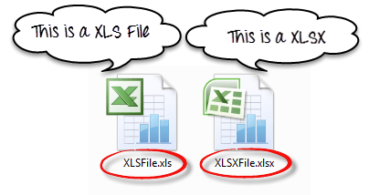

To Read and Write Excel file in Java, Apache provides a very famous library POI. This library is capable enough to read and write both**XLS** and**XLSX** file format of Excel.

To read**XLS** files, an**HSSF** implementation is provided by POI library.

To read**XLSX, XSSF** implementation of**POI library** will be the choice. Let’s study these implementations in detail.

**Installation -**

you can simply download the latest version POI jars from [http://poi.apache.org/download.html](https://poi.apache.org/download.html) & download the latest zip file

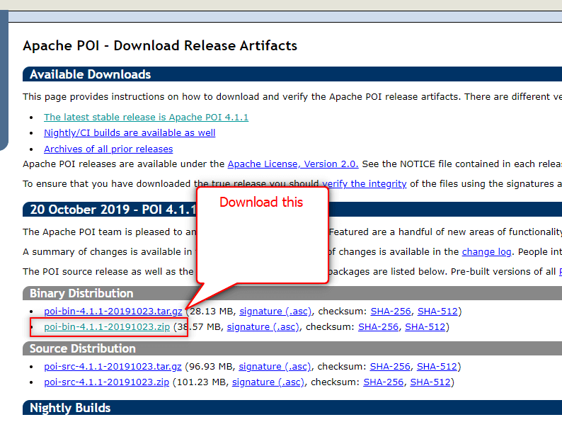

When you download the zip file for this jar, you need to unzip it and add these all jars to the class path of your project.

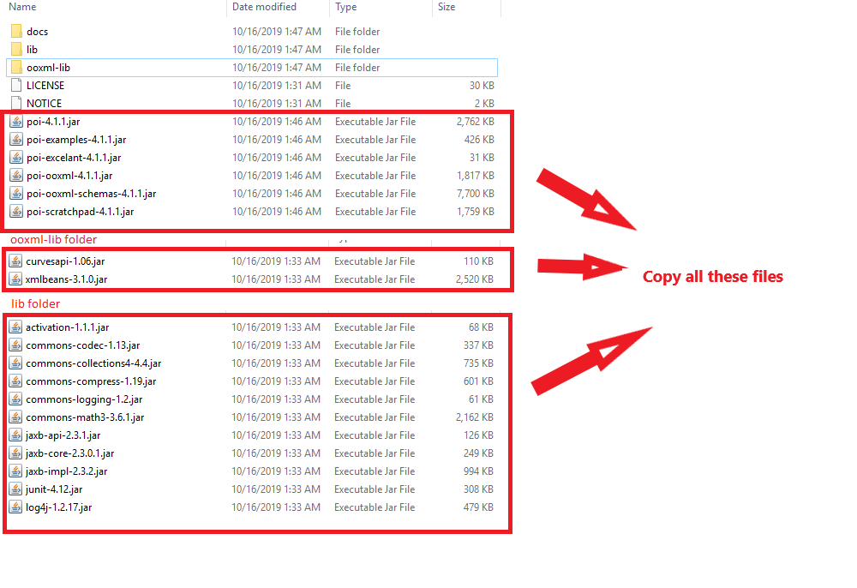

## Classes and Interfaces in POI:

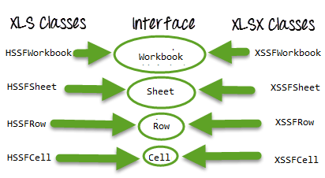Classes and Interfaces in Apache POI

Following is a list of different Java Interfaces and classes in **POI** for reading **XLS** and **XLSX** file-

* **Workbook**: XSSFWorkbook and HSSFWorkbook classes implement this interface.
* **XSSFWorkbook**: Is a class representation of XLSX file.
* **HSSFWorkbook**: Is a class representation of XLS file.
* **Sheet**: XSSFSheet and HSSFSheet classes implement this interface.
* **XSSFSheet**: Is a class representing a sheet in an XLSX file.
* **HSSFSheet**: Is a class representing a sheet in an XLS file.
* **Row**: XSSFRow and HSSFRow classes implement this interface.
* **XSSFRow**: Is a class representing a row in the sheet of XLSX file.
* **HSSFRow**: Is a class representing a row in the sheet of XLS file.
* **Cell**: XSSFCell and HSSFCell classes implement this interface.
* **XSSFCell**: Is a class representing a cell in a row of XLSX file.
* **HSSFCell:** Is a class representing a cell in a row of XLS file.

## ****Read/Write operation-****

For our example, we will consider below given Excel file format

