**SOAP-UI**

**What is SOAP UI?**

* SOAP UI is the leading open source cross-platform API Testing tool
* SOAPUI allows testers to execute automated functional, regression, compliance, and load tests on different Web API.
* SOAPUI supports all the standard protocols and technologies to test all kinds of API’s.
* SOAPUI interface is simple that enables both technical and non-technical users to use seamlessly.

**Why use SOAPUI?**

SOAPUI is not just a functional [Api Testing](https://www.guru99.com/api-testing.html) tool but also lets us perform non-functional testing such as performance and security test.

Let us discuss the 5 important features of SOAPUI

**1) Functional Testing**

* A powerful tool allows testers to write Functional API Tests in SoapUI
* Supports Drag-Drop feature which accelerates the script development
* Supports debugging of tests and allows testers to develop data driven tests.
* Supports Multiple Environments – Easy to switch between QA, Dev and Prod Environments
* Allows advanced scripting (tester can develop their custom code depending on the Scenario)

**2) Security Testing**

* Has the capability to perform a complete set of vulnerability scan.
* Prevents[SQL](https://www.guru99.com/sql.html)Injection to secure the databases
* Scans for Stack overflows that are caused by documents huge in size
* Scans for Cross Site Scripting, which usually occurs when service parameters are exposed in messages.
* Performs Fuzzing scan and Boundary scan to avoid erratic behavior of the services.

**3) Load Testing**

* Distribute the Load Tests across any number of loadUI Agents.
* Simulate high volume and real-world load testing with ease.
* Allows Advanced custom reporting to capture performance parameters.
* Allows End-to-End System Performance Monitoring

**4) Supported Protocols/Technologies:**

SoapUI has the most comprehensive Protocol Support

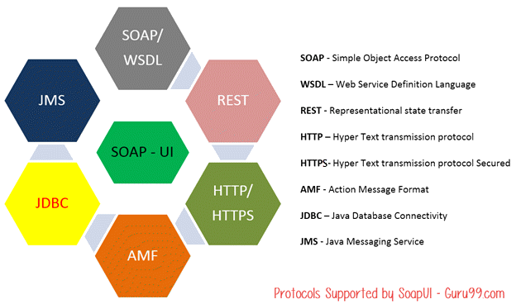

**5) SOAP-INTEGRATION with Other Automation Tools:**

SoapUI integrated very well with popular tools

* Maven

What is SoapUI? Introduction to SoapUI Testing

Apache **Maven** is a software project management tool that can manage a project’s build, reporting and documentation from a central repository. Maven can also execute SOAPUI tests within Maven Build using simple commands.

* HUDSON

What is SoapUI? Introduction to SoapUI Testing

HUDSON, a[Java](https://www.guru99.com/java-tutorial.html)based Continous integration tool and integrates with tools such as CVS, Subversion, Git, Perforce, Clearcase, and RTC. SOAPUI also integrates with HUDSON, which helps us to spot bugs quickly for each and every commit by the developers.

* JUnit

What is SoapUI? Introduction to SoapUI Testing

JUnit is a [Unit Testing](https://www.guru99.com/unit-testing-guide.html) framework built in Java, which can control the flow of tests from SOAPUI as well.

* Apache – Ant

What is SoapUI? Introduction to SoapUI Testing

[Apache](https://www.guru99.com/apache.html)Ant, a Java library which is a command-line tool that helps in building software. Using SOAP UI’s Command line, we can execute tests within an ANT Automated Build.

**SOAP UI Vs Selenium:**

Let’s compare SoapUI with Selenium

| **SOAP UI** | **Selenium** |
| --- | --- |
| SOAP UI is NOT used for User Interface Testing. It is only used for WebAPI or WebService Testing | Selenium is used for User Interface Testing. |
| Capability to test the data sent and received between the web browser and a web server. Can test the protocols/technologies such as REST, SOAP. | Selenium cannot test protocols, but they can test the UI behavior. |
| Able to perform functional, load and [Security Testing](https://www.guru99.com/what-is-security-testing.html) of the above-mentioned technologies. | Selenium can perform only[Functional Testing](https://www.guru99.com/functional-testing.html). [Performance Testing](https://www.guru99.com/performance-testing.html) to some extent because we can track execution time with regards to the performance but cannot test multi user and multi tenancy.[Selenium](https://www.guru99.com/selenium-tutorial.html)certainly cannot be used for security testing. |
| It is PROTOCOL Dependent and NOT browser dependent. | Selenium depends on the browser capabilities. |

# How to create Test Suite & Test Case in SoapUI

**Understanding the SOAP Protocol**

Before we create a SOAPUI Test case, let us understand basics about the SOAP Protocol. This will help you use SOAP UI to test SOAP requests and response effectively.

SOAP stands for **S**imple **O**bject **A**ccess **P**rotocol. Below are the properties of a SOAP Protocol.

* It is an XML-based protocol for communicating between two different systems.
* It is a platform and language independent. Hence, a system developed using[Java](https://www.guru99.com/java-tutorial.html)can communicate with a system developed in.NET.
* SOAP requests/response are transported via HTTP.

**Learn the SOAP Message FORMAT**

A SOAP message is an ordinary XML document containing the following elements. Message can be either a request message or a response message.

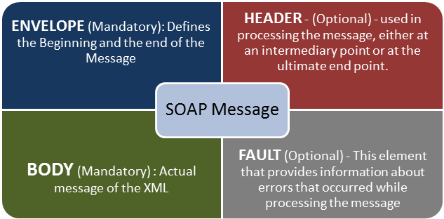

SOAP Message FORMAT

After setting up the workspace which we had performed in the last tutorial, we have to create SoapUI project structure, test suites, test cases in order to test a given web service. Let us understand a SoapUI Project example to create a new SOAP project.

**Creating a SOAP Project**

**Step 1)**Now, depending upon the project, we need to import SOAP/REST protocol. We will create a new SOAP Project.

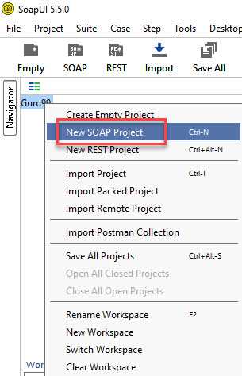

**Step 2)**We will make use following SOAP request <http://www.dneonline.com/calculator.asmx?wsdl>

1. Enter the Project Name
2. Enter the path of the WSDL request. In this case http://www.dneonline.com/calculator.asmx?wsdl
3. Click OK

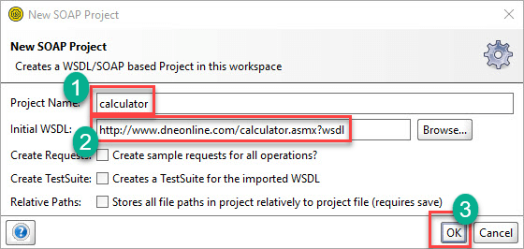

**Note:**

* **Create sample request for all operations?**It creates a sample request for all the available operations in the given WSDL. As soon as you enter the WSDL address, this option is checked automatically. You may uncheck it.
* **Create, a Test Suite for the imported WSDL:** Creates a SoapUI test suite within the project for the imported WSDL.
* **Relative Paths**: It enables the user to save all the files relative to the project file.

**Step 3)**Upon creating the SOAP project with the above-said WSDL, we will be able to see that there are two operations that will be imported into the project.

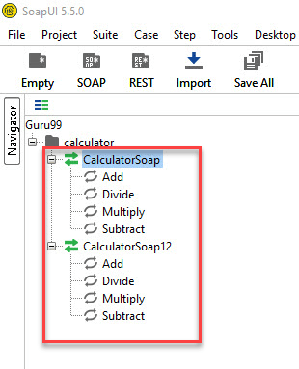

**Step 4)**

Expand the first request and right-click on the ‘Add.’ Then click on ‘New Request’.

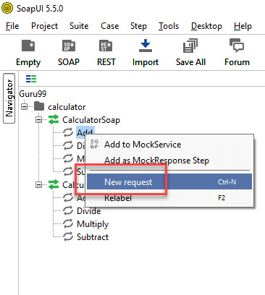

Then Click on ‘OK’. It will display the SOAP request in the XML format

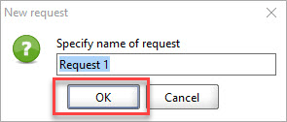

1. Enter the ‘intA’ and ‘intB’
2. Click on the submit button
3. Response XML will be displayed right side pane.

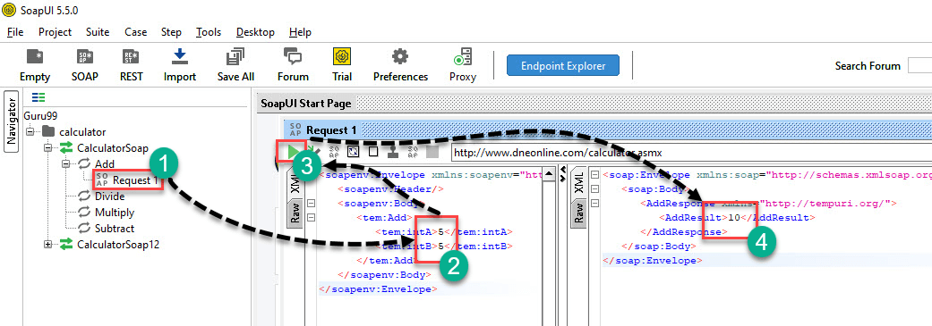

You may wonder why create Test Cases? When you can directly test Webservice here…

Well, you can send a request for one operation. What about others? How many combinations of inputs for Additions can you do using this operation? You have to edit the request for each and every combination.

For example: If you want to add from 4 and 4 instead of 5 and 5… You need to edit the operation again. So, one has to create a test suite/cases to have all possible scenarios tested without having to directly edit the operation itself.

**How to Create Test Suite in SoapUI**

Below are the steps to create Test Suite in SoapUI:

**Step 1) Right-click on the root of the project**

Within the project, testers can create a test suite by performing a right-click on the root of the project.

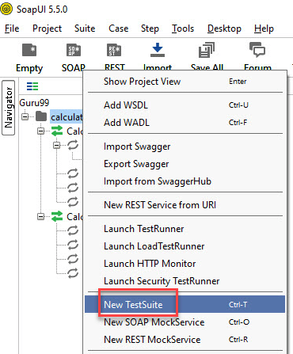

**Step 2) Enter the Test suite details**

We need to enter the name of the test suite and press OK.

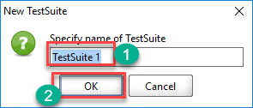

**Step 3) Verify the created Test suite**

The created test suite is displayed the navigator pane as shown below.

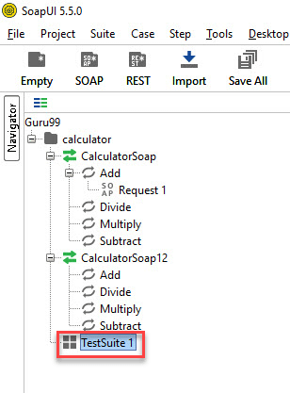

**Step 4) Open the Test suite**

The test Suite window opens in the Right Pane. As we have just created there are NO SoapUI test cases. Hence all options are disabled.

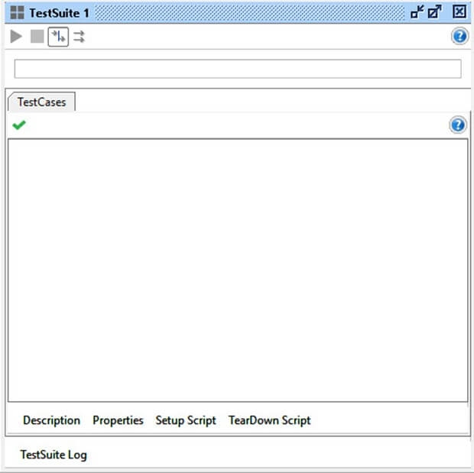

**How to Create Test Case in SoapUI**

Here is a step by step process for creating a test case in SoapUI:

**Step 1)**Within a test suite, we can create multiple tests by performing right click on the ‘test suite’ and choosing ‘New TestCase’.

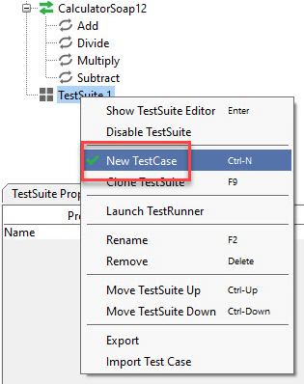

**Step 2)**Specify the name of the[Test Case](https://www.guru99.com/test-case.html)and click ‘OK’.

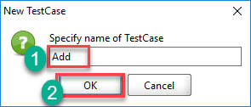

**Step 3)**The created test case has zero steps as shown below.

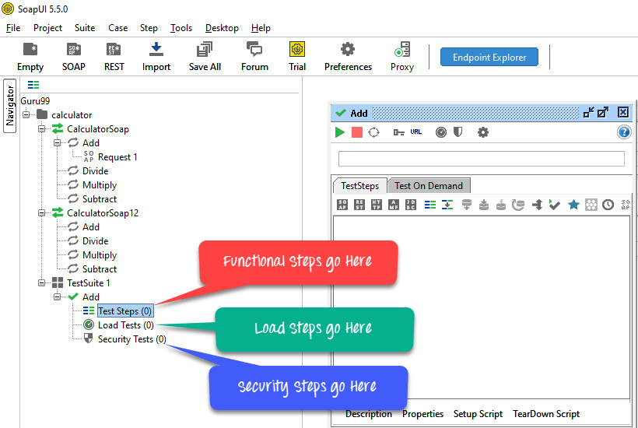

**Note**: We can see that the test case is added with zero test steps for all kinds of tests available. Upon adding the test steps, the numbers in the bracket would change automatically.

The functional test step should go into ‘Test Steps’ while a performance test step should go into ‘Load Test’ and a security test step should go into ‘security Tests’.

**Step 4)** We can insert a variety of test steps by performing a right-click on test steps and selecting an appropriate test step as shown below. So, if you were to test a REST Webservice, you would select the REST Test Request.

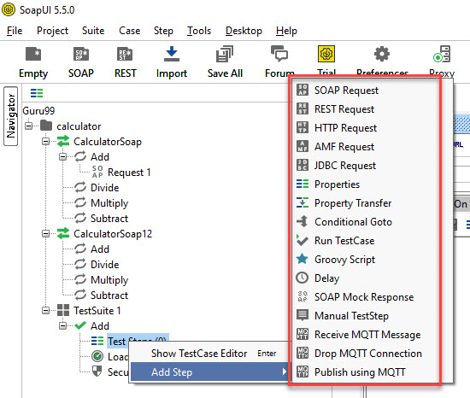

**Adding a Test Step in SoapUI**

Now let us add a test step to validate the imported SOAP testing request:

**Step 1)**Add a new step ‘SOAP Request’ as shown below.

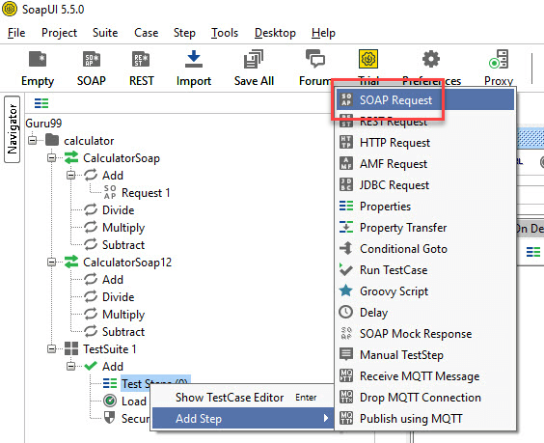

**Step 2)**Enter the step name and click OK.

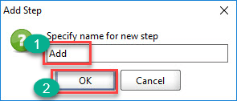

**Step 3)**Upon clicking ‘OK’, a dialog pops up to select the operation to invoke. All the operations are listed, and user can select the operation that they would like to invoke.

* There are many operations that will be listed. The Operations are the same except the SOAP version used.CalculatorSoap – uses SOAP version 1.1 whereas,CalculatorSoap12 – uses SOAP version 1.2
* The Version does not matter for us in this context. Hence you can select the one of your choice.
* Upon Selecting the operation, click ‘Ok’

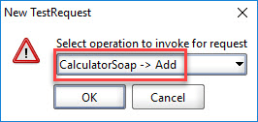

**Step 4)**Whileaddinga test case, we can add standard assertions. Assertions also called as checkpoints/validation points which we will be dealing in detail in the next tutorial.

We can add following checkpoints/assertions while creating test case. Let us create a test case with the option which means creating test step WITHOUT any of the below validation points

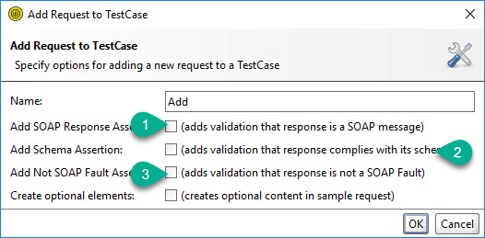

1. Verifies if the response message is SOAP, upon executing the test.
2. Verifies if the response schema is valid.
3. Verifies if the SOAP response contains FAULT.

**Step 5)**Upon creating the test case, the request XML is shown below. The structure of the XML is explained within the below snapshot.

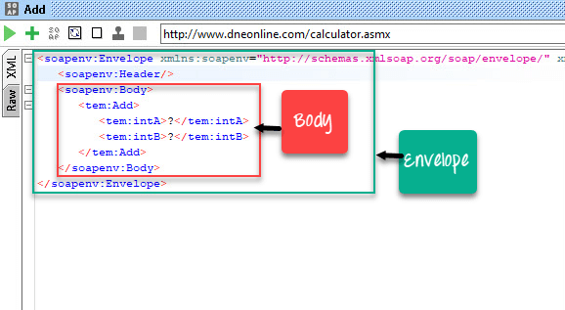

**Step 6)**The test step count is now incremented to one as we have just added one test step. Similarly, upon adding load and security tests step, the corresponding number would be automatically incremented based on the number of steps added.

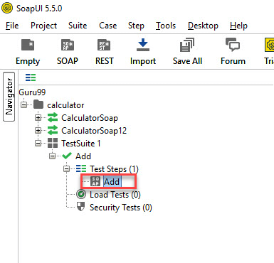

**Sending Request Manually & Reading Response in SoapUI**

**Step 1)**We would like to add two Integer Number.

* intA – 5
* intB – 5

Next,

1. We need to enter these inputs in place of the question mark which will be sent as request XML.
2. After inputting those values into the corresponding XML tags, click ‘submit request’ button to check the response.

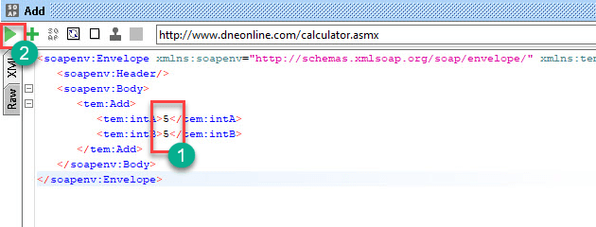

**Step 2)**Upon submitting a request the web service request is processed by the webserver and sends back a response as shown below.

By reading the response, we are able to conclude 5 plus 5 is 10.

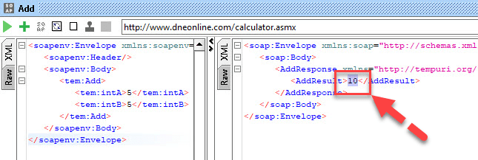

**Understanding the Soap Response & Log Panels**

As explained at the beginning of this SoapUI testing tutorial, the SOAP messages are transported via HTTP protocol. Let us take a look at the RAW messages. This will help us learn how the SOAP request and response were transported by HTTP.

**Step 1)**Click ‘RAW’ Tabin both SOAP-UI request Window.

1. The Request is posted to the webserver. Hence, the POST method of Http is used.
2. The SOAP Request is transported in the body of the Http message.

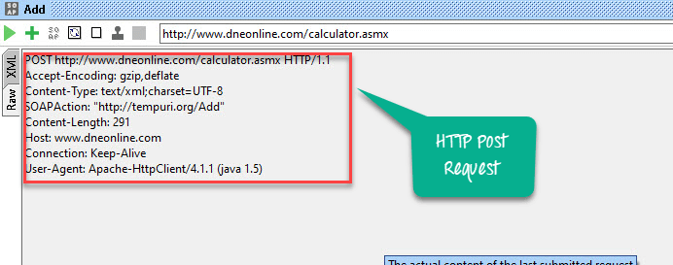

**Step 2)**Nowclick ‘RAW’ Tabin SOAP-UI Response Window to understand how the response is sent via HTTP.

1. After processing the request, the Http response code (200) is shown which means it is a success. The webserver has processed it successfully.
2. The SOAP response is sent back to the client as part of the body of the HTTP message.

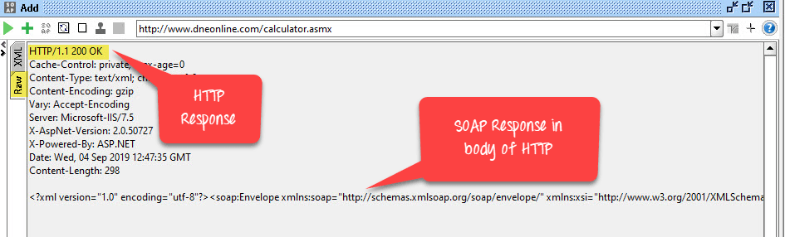

A Quick snapshot of the Http Response codes for easy understanding and debugging. The below table will help you to trouble shoot based on the HTTP code received from the webserver.

| **Http Code** | **Description** |
| --- | --- |
| **1xx:** | **Informational –**This means a request received and continuing process. |
| **2xx:** | **Success –**The action was successfully received, understood, and accepted. |
| **3xx:** | **Redirection –**This means further action must be taken in order to complete the request. |
| **4xx:** | **Client Error –**This means the request contains bad syntax or cannot be fulfilled |
| **5xx:** | **Server Error –**The server failed to fulfil an apparently valid request |

**Step 3)**Let us understand the other information that are displayed in the test case window.

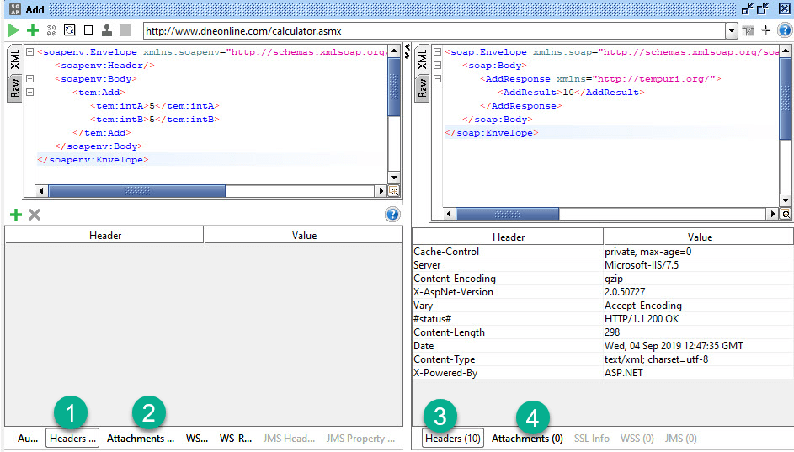

1. Represent NO header in the request that is being sent
2. Represents NO attachments in the request that is being sent to the web server.
3. Represents 10 header information and the same are displayed upon clicking on it.
4. Represents that there are no attachments from the response message.

**LOGS PANE:**

Logs pane has complete information regarding the transaction between the client and the server. Users will be able to see the tabs of the Log pane as shown below. We will discuss the most commonly used log panes when working with SOAP-UI.

Logs Pane in SoapUI

**SoapUI Log** – Displays the response information from the webserver. The same information is stored in soapui.log file of the SOAP-UI installed folder under ‘bin’ directory.

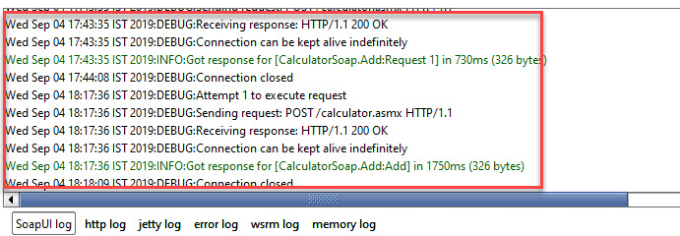

**Http Log –**Displays all the HTTP packet transfer. All the information in ‘RAW’ is shown in HTTP log.

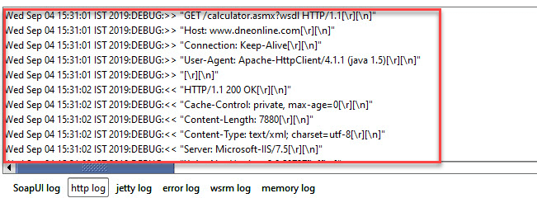

**Error Log –**Error log displays all the errors that we have encountered during the entire project session. The same information is available in ‘soapui-errors.log’ present in the ‘bin’ directory of the SOAP UI installed location.

**Memory Log –**This tab monitors the memory consumption and displays it in the form of the chart as shown below. It is really helpful when there is a memory intensive operation is performed.

