Software Design Document

For

Distributed Informative System for Library Management

Version 0.3

Made by

Group Name: Team RECT

|  |  |  |
| --- | --- | --- |
| Draghiceanu Roberto | Group CEN 3.1A | [Draghiceanu.roberto@gmail.com](mailto:Draghiceanu.roberto@gmail.com) |
| Barbu Theodor | Group CEN 3.1A | [Barbu.theodor1998@gmail.com](mailto:Barbu.theodor1998@gmail.com) |
| Ganea Eduard | Group CEN 3.1A | [Ganea.edi55@gmail.com](mailto:Ganea.edi55@gmail.com) |
| Serban Cornel | Group CEN 3.2B | [serbancorneld@gmail.com](mailto:serbancorneld@gmail.com) |

|  |  |
| --- | --- |
| Instructor: | Stoica Spahiu Cosmin |
| Course: | Proiect 2 “Use of DataBases” |
| Lab: | *Software Engineering* |
| Assistent: | Sbora Mihai-Catalin |

## 1. Introduction

### 1.1 Scope

In this report, we are planning to give information for programmer to write a code. Therefore, the document includes needs of the programmer for code development.

### 1.2 Purpose

This document describes the conceptual design of the Project according to the document guidelines presented in the IEEE 1016-1998 Recommended Practice for Software Design Descriptions (SDD).

The SDD shows how the software system will be structured to satisfy the requirements identified in the software requirements specification. It is a translation of requirements into a description of the software structure, software components, interfaces and data necessary for the implementation phase. In essence, the SDD becomes a detailed blueprint for the implementation activity. In a complete SDD, each requirement must be traceable to one or more design entities.

### 1.3 Overview

The purpose of this document is to help the reader visualize the solution to the project presented. This document verifies how the design meets the requirements stipulated in the SRS document through design viewpoints. The design viewpoints will cover all design elements presented before.

By using information from IEEE 1016-1998, this document will provide a direct approach to the development of this project hence reducing feature creep and pointedly determine the quality of the design.

### 1.4 Reference Material

IEEE, *IEEE Std 1016-1998 Recommended Practice for Software Design Descriptions*, 199809-23, The Institute of Electrical and Electronics Engineers, Inc., (IEEE )

IEEE, *IEEE 1016* Software Design Document (SDD) Template for CENG491

### 1.5 Definitions and Abbreviations

## 2. Conceptual model for software design descriptions

Information about concepts and context of SDD , the stakeholders will be given in this part

|  |  |  |
| --- | --- | --- |
| Number of uses | Definition Name | Description |
|  |  |  |
|  |  |  |
|  |  |  |

|  |  |  |
| --- | --- | --- |
| Number of uses | Acronim Name | Description |
|  |  |  |
|  |  |  |

|  |  |  |
| --- | --- | --- |
| Number of uses | Abbreviation Name | Description |
|  | SRS | Software Requirements Specification |
|  | Admin | Administrator |

### 2.1 Software design in context

#### 2.1.1 Technologies Used

The system is coded with Java programming language by using Visual Studio 2019 integrated development environment. We will use MySQL for database. ASP.NET will be used for web application.

#### 2.1.2 Application Overview

The main goal of the project is to enable Admin to create a virtual library owned by him/her. The final product of the project will be a web platform for personal computer systems that will enable third party application developers to easily develop ASP.NET based collection applications by utilizing the common ASP.NET services.

### 2.2 Software design descriptions within the life cycle

#### 2.2.1 Influences on SDD preparation

System Requirements Specifications is the main sources for SDD preparation. The functional and non-functional requirements are main factors to determine the design of the project.

#### 2.2.2 Influences on software life cycle products

In the process of implementation of the project and preparation of the SDD, Some requirements can be changed due to unexpected constraints.

Testing part of the project can be prepared by using the information in System Design Documents.

**2.2.3 Design verification and design role in validation**

Verification is the determination whether a software work product fulfills specified requirements. Validation is the determination that the requirements for a specific intended use of a software work product are fulfilled. Therefore, verification and validation results are controlled by the requirements.

## 3. Design description information content

### 3.1 SDD identification

At the end of the semester the web application will be fully usable.

### 3.2 Design stakeholders and their concerns

In this project, we will use accounts and passwords. Therefore, the stakeholders’ main concern is security and efficiency.

### 3.3 Design views

Unified Modeling Language (UML) 5.02 is used for graphical representations of viewpoints in

Project in Diagrams. Draw.io is used for user interface design in sixth section of this project.

### 3.4 Design viewpoints

Interface, Logical, information, context and use case are design viewpoints which we provide information about in this document.

### 3.5 Design rationale

We mostly focus on sustainability and efficiency features because it is important for us that the application can be used all kind of students and Library guests.

### 3.6 Design Languages

Unified Modeling Language (UML) 5.02 is used for graphical representations of viewpoints in Project in 3.System Architecture, 4.Data Design and 5.Component Design parts. Draw.io is used for user interface design in sixth section of this project.

## 4. Design Viewpoint

### 4.1 Logical viewpoint

This viewpoint aims to show the key abstractions such as classes and interactions among them. UML Class diagram is provided for this aim which can be seen as below;

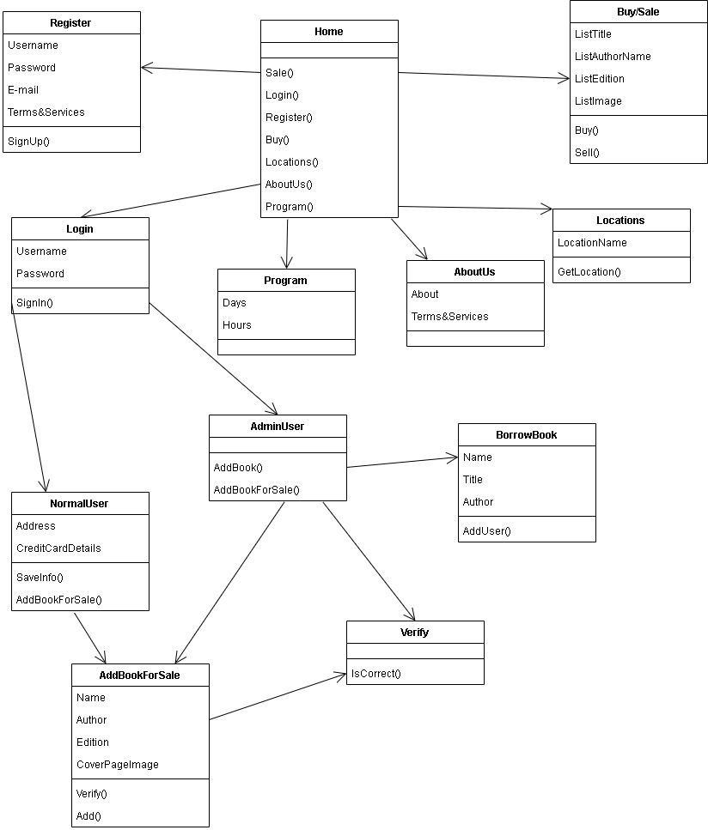

**Figure 1 – Class Diagram**

#### 4.1.1 Design concerns

The Logical viewpoint is used to address the development and reuse of adequate abstractions and their implementations.

#### 4.1.2 Design elements

**register:**

**user_name:** Name of the account for the user.

**user_password:** Password of the account for the user.

**user_email:** email for the account for the user.

**Terms_and_services:** check-box used for agreeing with the library rules.

**Register():** used for confirming that the account was created.

**Login:**

**user_name:** name of the account for the user

**User_password:** Password of the account for the user

**Login():** used for signing in

**Home:**

**Sale():** go to the Sale page

**Login():** go to the Login page

**Register():** go to the Register page

**Buy():** go to the Buy Page

**Locations():** go to the Locations Page

**AboutUs():** go to the About Us page

**Program():** go to the Program page

**Program:**

**Days:** the days when the library is open

**Hours:** the hours of the days when library is open

**About Us:**

**About:** the about section

**Terms and Services:** library’s rules

**Locations:**

**LocationName:** the name of the location of the library

**GetLocation():** give the location to the customer

**Buy/Sale:**

**ListTitle:** list with the titles of the books

**ListAuthorName:** list with the authors of the books

**ListEdition:** list with the editions of the books

**ListImage:** list with the images of the cover of the books

**Buy():** the option to buy a book

**NormalUser:**

**Address:** the address of the user

**CreditCardDetails:** the card details of the user

**SaveInfo():** confirmation of the information of the user

**AddBookForSale():** option for redirection to the Add Book for Sale Page

**AdminUser:**

**AddBook():** add a book to the library

**AddBookForSale():** add a book to the library store

**BorrowBook:**

**Name:** the name of the user that borrowed the book

**Title:** the title of the borrowed book

**Author:** the author of the borrowed book

**AddUser():** add the user that borrowed the book

**AddBookForSale:**

**Name:** the title of the book

**Author:** the author of the book

**Edition:** the edition of the book

**CoverPageImage:** the cover image of the book

**Verify():** verifies the integrity of the book

**Add():** add the book

**Verify:**

**IsCorrect():** verifies if the book added by the NormalUser is ok to be put to the store

### 4.2 Information viewpoint

An Entity Relationship Diagram is shown as below;

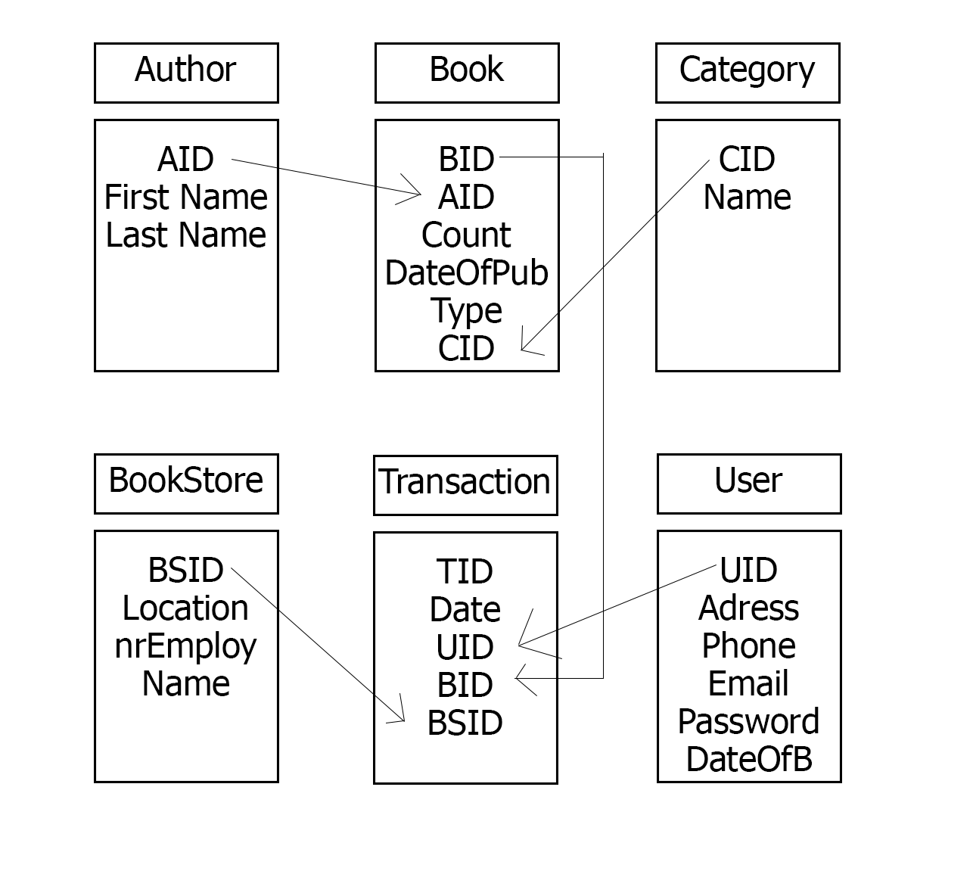

**Figure 2 – DataBase Diagram**

#### 4.2.1 Design Concern

This viewpoint aims to show the way that the system stores, manages, manipulates, the persistent information that the system will maintain.

#### 4.2.2 Design Elements

Alphabetically list the system entities or major data along with their types

**1. Author:**

**Parameter: Parameter Type:**

**AID:** Double

**First Name:**  String

**Last Name:**  String

|  |  |  |
| --- | --- | --- |
| **2.Book:** | |  |
| **Parameter:** | |  |  | **Parameter Type:** |
| **BID:** | |  |  | Double |
| **AID:** | |  |  | Double |
| **Count:** | |  |  | Int |
| **DateOfPub:** | |  |  | Date |
| **Type:** | |  |  | String |
| **CID:**    **3.Category:** | |  |  | Double |
| **Parameter:** | |  |  | **Parameter Type:** |
| **CID:** | |  |  | Double |
| **Name:** | |  |  | String |
|  |
|  |
| **4.BookStore** |
| **Parameter:** | |  |  | **Parameter Type:** |
| **BSID:** | |  |  | Double |
| **Location:** | |  |  | String |
| **NrEmploy:** | |  |  | Int |
| **Name:**    **5.Transaction:** | |  |  | String |
| **Parameter:** | |  |  | **Parameter Type:** |
| **TID:** | |  |  | Double |
| **Date:** | |  |  | Date |
| **UID:** | |  |  | Double |
| **BSID:** | |  |  | Double |
| **BID:** | |  |  | Double |

**6.User:**

**Parameter: Parameter Type:**

**Address:**  String

**UID:** Double

**Phone:** String

**Email:** String

**Password:** Password

**DateOfB:** Date

### 4.3 Interface viewpoint

This section briefly describes the interface and components of Project. In this viewpoint, there will be two different interfaces which are user-application interface and application-databases. Application and databases transforms the information about users and books via MySQL and ASP.NET

.

**4.3.1 Design Concern**

Concerns of the stakeholders in this document are simplicity and efficiency.

#### 4.3.2 Design Elements

##### 4.3.2.1 Home Page

Here you can redirect to the other pages.

##### 4.3.2.2 Register

Here is the Register page where an unregistered user can register to the library

##### 4.3.2.3 Login

Here is the Login Page where a registered user can login to do the actions that a registered suer can

##### 4.3.2.4 Buy

Here is the Store Page where a registered user can buy books

##### 4.3.2.5 Locations

Here is the Locations Page where will be the location of the libraries.

##### 4.3.2.6 About us

##### Here is the page where the users can find informations about the library

##### 4.3.2.7 Program

Here is the Schedule Page.

##### 

##### 4.3.2.8 Sale

##### Here is the Store Page.

##### 4.3.2.9 Normal User

Here is normal user page

##### 4.3.2.10 Admin User

Here is the Admin user page

##### 4.3.2.11 Add a book for sale

Here is the page where you can add a book

##### 4.3.2.12 Verify

Here is the Verify Page

##### 4.3.2.13 Borrow

Here is the Borrow Page

### 4.4. Context Viewpoint

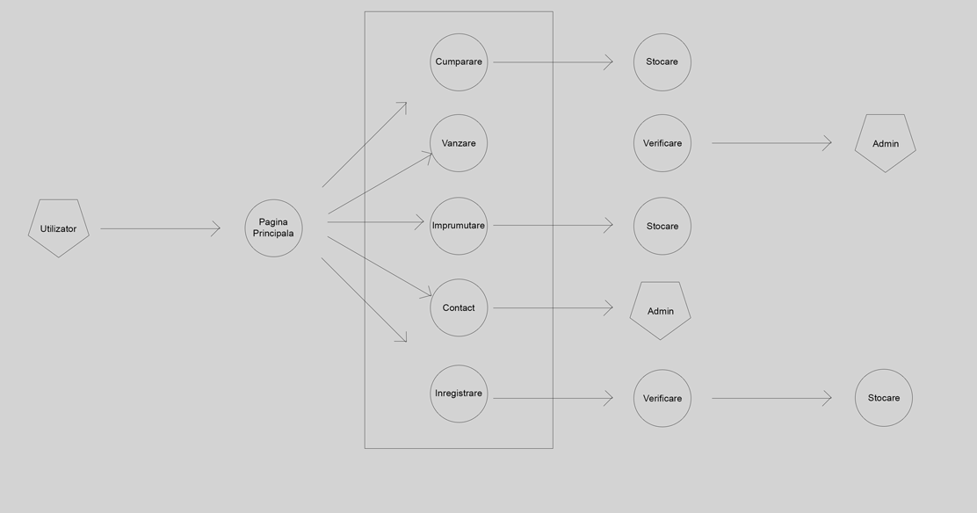

**Figure 3 – Use-Case Diagram of User**

#### 4.5.1 Design Concern

Concern of the context viewpoint is to determine properties of the user. In terms of the efficiency of the user features, it is important to give explicit definition to these features.

#### 4.5.2 Design Elements

Since almost all features are declared in System Requirement Specification documents, only new features are explained here

#### 

##### 4.5.3 Use Case: Login

The user can use this use case only if s/he logins into system.

##### 4.5.4 Use Case: Home

##### The user can use this page if s/he wants to navigate to another page

##### 4.5.5 Use Case: Buy

The user can use this page if s/he wants to buy a book

##### 4.5.6 Use Case: Sale

##### The user can use this page if s/he wants to sell a book

##### 4.5.7 Use Case: Borrow

##### The user can use this page if s/he wants to borrow a book

##### 4.5.8 Use Case: Contact

##### The user can use this page if s/he wants to contact the library

##### 

##### 