MICROCONTROLLER

(esp8266)

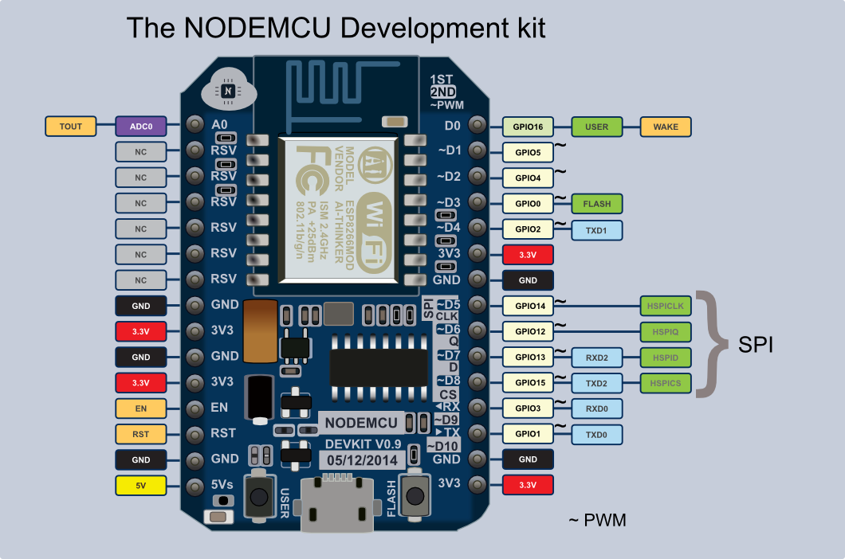

Driver for this nodemcu is available on the site:-www.silabs.com

link to download the driver:- <http://www.silabs.com/products/interface/pages/CP2102EK.aspx>

* It is easily programmable with the help of ARDUINO.

DESCRIPTION:-

 The ESP8266 WiFi Module is a self contained SOC with integrated TCP/IP protocol stack that can give any microcontroller access to your WiFi network. The ESP8266 is capable of either hosting an application or offloading all Wi-Fi networking functions from another application processor. Each ESP8266 module comes pre-programmed with an AT command set firmware, meaning, you can simply hook this up to your Arduino device and get about as much WiFi-ability as a WiFi Shield offers (and that’s just out of the box)! The ESP8266 module is an extremely cost effective board with a huge, and ever growing, community.

This module has a powerful enough on-board processing and storage capability that allows it to be integrated with the sensors and other application specific devices through its GPIOs with minimal development up-front and minimal loading during runtime. Its high degree of on-chip integration allows for minimal external circuitry, including the front-end module, is designed to occupy minimal PCB area. The ESP8266 supports APSD for VoIP applications and Bluetooth co-existence interfaces, it contains a self-calibrated RF allowing it to work under all operating conditions, and requires no external RF parts.

**Note:** The ESP8266 Module is not capable of 5-3V logic shifting and will require an external Logic Level Converter. Please do not power it directly from your 5V dev board.

**Note:** This new version of the ESP8266 WiFi Module has increased the flash disk size from 512k to 1MB.

**Features:**

* 802.11 b/g/n
* Wi-Fi Direct (P2P), soft-AP
* Integrated TCP/IP protocol stack
* Integrated TR switch, balun, LNA, power amplifier and matching network
* Integrated PLLs, regulators, DCXO and power management units
* +19.5dBm output power in 802.11b mode
* Power down leakage current of <10uA
* 1MB Flash Memory
* Integrated low power 32-bit CPU could be used as application processor
* SDIO 1.1 / 2.0, SPI, UART
* STBC, 1×1 MIMO, 2×1 MIMO
* A-MPDU & A-MSDU aggregation & 0.4ms guard interval
* Wake up and transmit packets in < 2ms
* Standby power consumption of < 1.0mW (DTIM3).

PROGRAM 1.(blinking of led) in ARDUINO

// the setup function runs once when you press reset or power the board

void setup()

{

// initialize digital pin LED_BUILTIN as an output.

pinMode(LED_BUILTIN, OUTPUT);

}

// the loop function runs over and over again forever // wait for 3 second

void loop()

{

digitalWrite(LED_BUILTIN, HIGH); // turn the LED on (HIGH is the voltage level)

delay(3000);

digitalWrite(LED_BUILTIN, LOW); // turn the LED off by making the voltage LOW

delay(3000); // wait for 3 second

}