MIDAS Touch: Magnetic Interface for Dermally Applied Sensation
Taylan Sen
Advisors: M. Ehsan Hoque and Randal C. Nelson

Figure 1 – The MIDAS Touch couples millimeter precision finger tracking with a realtime adjustable electromagnet to provide physical forces to a users finger in free space. The forces applied to a user’s finger change in realtime as a user interacts with a virtual world emulated on a PC.

ABSTRACT
This paper describes the development of a novel free-space haptic human-computer interface (“the MIDAS Touch”) based upon applying physical forces to a user’s finger through production of a dynamic magnetic field which is adjusted in reatime based upon the user’s movement of his/her finger through a virtual world as detected by an accurate hand/finger 3D tracking sensor. The MIDAS Touch is an inexpensive haptic device which combined with a typical computer has applications as: a supplementary mode of computer-to-human sensory input for the visually-impaired, a computer peripheral for increasing the productivity of a variety of professional computer users, and an accessory to make computer entertainment more immersive and enjoyable. These applications can be implemented with the MIDAS without the need of a restrictive physical interface such as an exoskeleton or force feedback joystick. The system works by tracking the three dimensional position of a user's fingertip and dynamically applying a vertical repulsive or attracting magnetic force to a permanent magnet mounted on the user’s fingertip. The magnitude and polarity of the magnetic force is varied as a function of the tracked finger position. The device was coupled to a computer emulating a virtual 3D world having a cube and displayed to the user on a 2D monitor. The sensation of object collisions were emulated by providing the user a force feedback each time the user’s fingertip penetrated the virtual cube. The MIDAS is also capable of emulating differing texture sensations (roughness) by repetitively changing the magnitude of the applied force at a given frequency as a user moves his/her fingertip across/through a virtual object of a given texture. The device is capable of applying a maximum force of 60 mN (i.e. 6 grams in 1 G) at a frequency of 500Hz over a three dimensional region of about a small mousepad (6x8cm) with a useable height range of 1-3cm. A tracking resolution of 0.2cm at a frequency of 20Hz are achieved when coupled to a modest computing platform (AMD A4 based notebook).

I - INTRODUCTION
Motivation
A free space haptic interface has the potential to significantly affect several fields. The number of blind or visually impaired individuals in the world has reached an estimated 285 million people, over 6 million of whom are in the U.S.. The ubiquity of computer use in the business world suggests that even a small increase in human computer interface efficiency would have significant economic impact overall. Indeed, studies have shown merely increasing the human-computer visual field by adding a second monitor increases productivity by over 39% for some tasks,. The video game industry is expected to have sales exceeding $76 billion in 2013, the sales of video game accessories alone in 2009 is estimated at $5 billion. These statistics suggest that an improved haptic human computer interface has substantial potential to improve many lives and increase productivity.
Summary
It is believed that the MIDAS is the first free space haptic device combining millimeter precision finger tracking with a magnetic based force delivery system having a realtime adjustable force output. Contributions of this paper include a description of the design and a demonstration of the viability of the MIDAS as a platform for delivering free-space haptic sensations. Also provided is a description of future planned testing protocols to establish whether free-space haptic feedback limited to vertical repulsive and attractive forces less than 60 mN over an envelope of 6 x 8 x 3 cm is capable of increasing user productivity for a variety of tasks.

Background
Most haptic interfaces in use typically have a mechanical linkage with which a user must come into physical contact with in order to use, such as for a force feedback joystick or exoskeleton/glove. The concept of a free-space haptic system, one in which the user does not need to physically engage a joystick or other bulky hardware, has been much less common. However, several recent free-space haptic systems have been implemented with varying limitations.

FingerFlux
As shown in Figure 1, the FingerFlux, developed by Weiss et al., is a near surface haptic feedback system which uses an array of electromagnets to produce a force on a permanent magnet coupled to a user’s fingertip or a stylus tip. A backlit LCD screen is placed over the magnetic array, creating a touch display with detectible haptic feedback up to 35 mm above the display surface. The FingerFlux does not have a tracking method, and does not describe changing the magnetic field in response to finger motion.

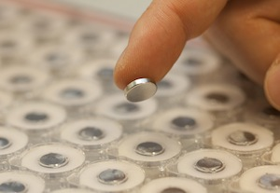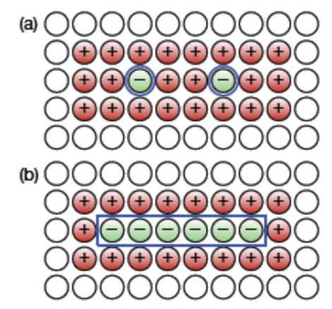
Figure 2 – FingerFlux electromagnet array Figure 3 – FingerFlux magnet drive pattern

MagMan

Hur´ak, et. al. developed an apparatus for controlling the 2D position of a steel ball with magnetic fields. Their system controls the 2D position of a steel ball on a horizontal surface with an array of electromagnets controlled by computer feedback using camera to measure ball position.
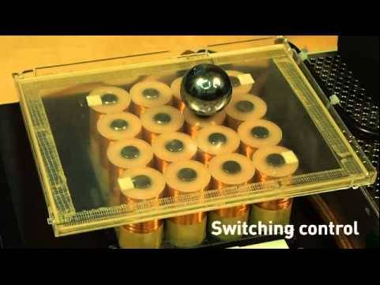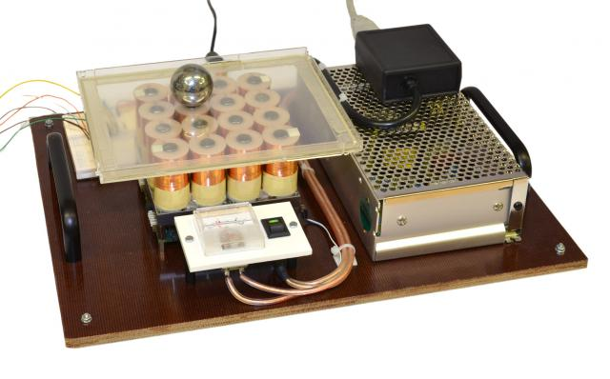

Ultrahaptics
Carter et al. at Univ. of Bristol have developed a free-space haptic interface, entitled “Ultrahaptics”, which is based upon using an array of ultrasound speakers, as shown in Figure 1, to project a sound pressure pattern over a three dimensional space to form a “volume map”. The pressure pattern causes a user to experience touch sensation only in areas of high pressure and/or changing pressure. As shown in Figures 2 and 3, the phase delay to each speaker is adjusted such that the pressure waves constructively interfere at the desired maximum pressure regions (Figure 3 blue cross) as specified by the volume map. In order to increase user sensation around the regions of high pressure, the speaker phase delays are also optimized to create regions of low pressure (Figure 3 red crosses) surrounding the high pressure regions.
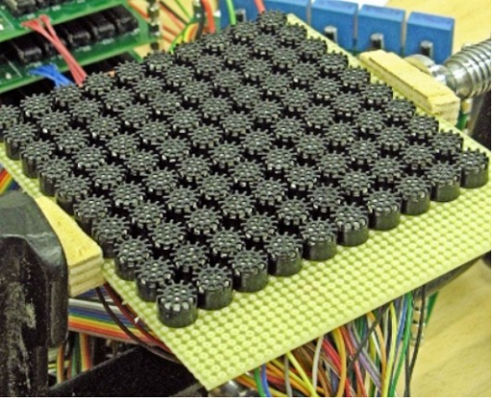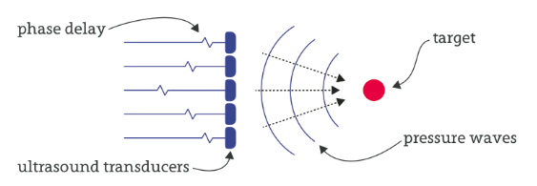
Figure 4 – Ultrahaptics speaker array Figure 5 – Ultrahaptics phase interference
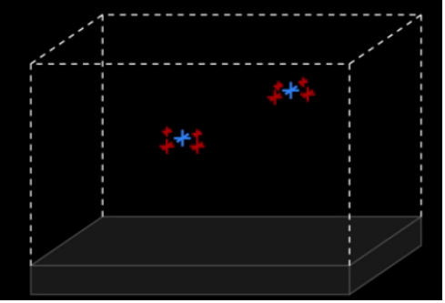
Figure 6 – Ultrahaptics high and low pressure regions

The envelope of usable space the Ultrahaptics device can project upon is approximately a 20cm x 20cm x 20cm region. A Leap Motion IR stereoscopic camera is used to track the 3D position of a user’s hand and fingers. A thin LCD display is placed over the speaker array to provide a visual display. Specific forces achieved with the Ultrahaptics device are not given. It appears that device is computationally very expensive as it describes setting up volume maps with one or two focal points and statically testing. The device does not appear to be capable of changing the volume map in realtime.

Magnetic Levitation Haptic Device
Berkelman et al. describe a magnetic levitation system for use in handheld haptics. A user holds a tool handle which is physically mounted to a structure having three semi-orthogonal coils. The coils and tool handle are not physically coupled to the rest of the device, which consists of three electromagnets with long extending curved iron pole pieces. In summary, magnetic fields are induced in the coils creating realtime controllable 3 dimensional forces and torques on the handle. The device is capable of applying up to a 1 N force over an envelope of 20 cm. Berkelman et al. further have developed electromagnetic array based devices used primarily for levitation as shown in Figure below. The electromagnetic array is capable of applying 6 DOF control (each dimension of translational force as well as each orthogonal angular torque) to the levitated device.

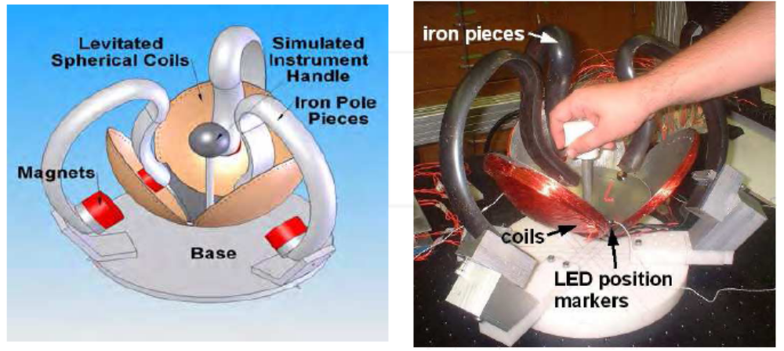
Figure 7 – Lorrentz force based haptic device Figure 8 – Lorentz force based implementation

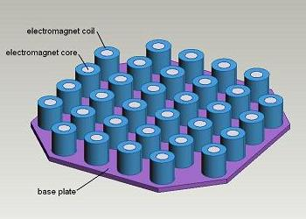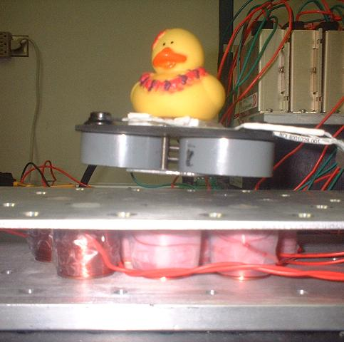
Figure 9 – Electromagnet array for levitation Figure 10 – levitation example

AIREAL
The AIREAL device is a pneumatic based free-space haptic device developed by Disney. A vortex generator mounted on a pan and tilt servo is capable of delivering targeted puffs of air with a latency of less than 150 msec. Vorticies can be reliably sensed as far as 1 meter away from the vortex generator.
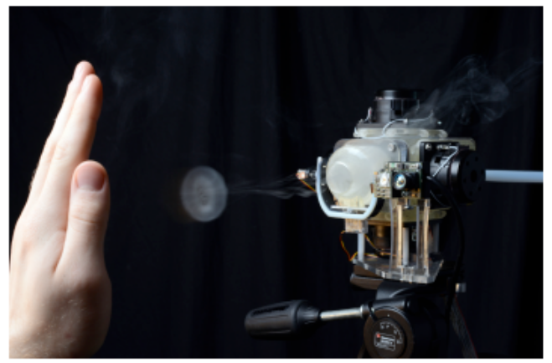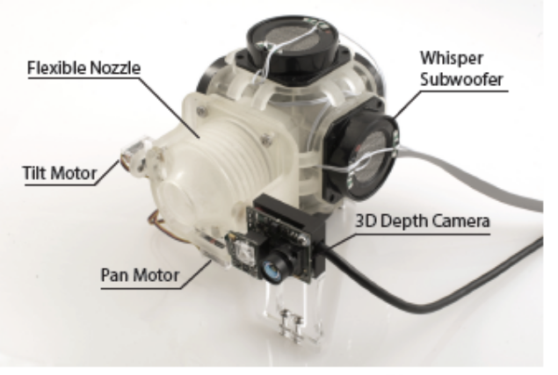
Figure 11 – AIREAL Pneumo-haptic device a) example vortex firing b) components of vortex generator

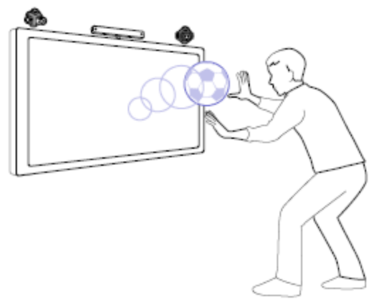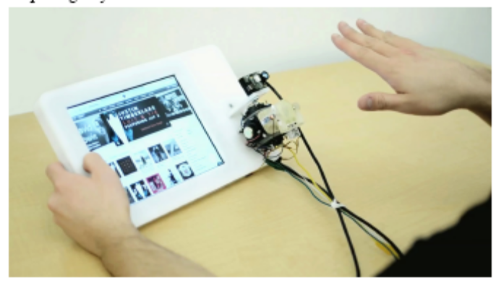
Figure 12 – AIREAL example uses a) video game b) gesture recognition feedback

The AIREAL haptic interface contains a 3D depth camera and is fast enough for use in interactive games. However, the sensor is limited to producing forces in the direction away from the device. Also, it does not appear that the AIREAL device is capable of generating the sensation of rough textures since a 150 msec latency seems to be too high to simulate the vibrations associated with running ones hand across a rough surface. Additionally, production of the vorticies produces an audible noise that may be especially disruptive to blind or visually impaired individuals who heavily rely upon their sense of hearing.

Other Haptic Devices
Kajimoto et al. developed a system which induces a touch sensation over free-space distances less than 3cm by using high voltage electrical fields to induce touch receptors in an individual’s skin to fire remotely. Marquardt et al. describe an interactive system consisting of a table top display interacting with a a “puck” which slides over the table surface like a mouse, but also provides up/down feedback to a user’s finger through a vertical rod passing through the top of the puck. Tamaki et a. describe a method of directly electrically stimulating a user’s own muscles to cause the sensation of virtual haptic forces wherever the user’s hand may be located.

II – DETAILED DESIGN

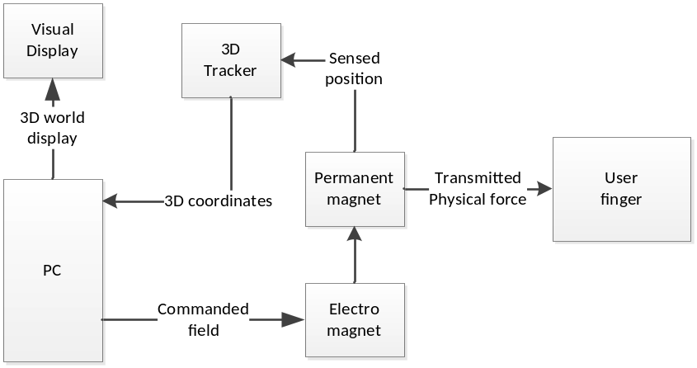
Figure 13 – MIDAS Touch block diagram

The major components of the MIDAS Touch are shown in the block diagram Figure 13 and consist of a 3D finger position tracker, an electromagnet, a computer, and a computer monitor. Operation begins with the computer monitor displaying a virtual 3D world to the user. The virtual 3D world may consist of 3 dimensional objects such as for example cubes or balls. The 3D finger position tracker determines the 3D position of the user’s fingers and hand and provides it to the PC. The PC maps the user’s index finger location to a position in a virtual world containing virtual objects. Based upon whether the user’s virtual finger position is colliding with a virtual object or not, the PC instructs the electromagnet to generate a magnetic field with a given magnitude. For example, if the user’s virtual finger position is not colliding with any virtual objects, the PC may command the electromagnet to be off, and if the user’s virtual finger position just comes into contact with a virtual object, the PC may command the electromagnet to generate a maximum strength magnetic field. The generated magnetic field causes a force to be applied to the permanent magnet coupled to the user’s index finger, which is perceived by the user.
As the user moves his/her hand through free space, the 3D position tracker logs the new finger position and relays it to the PC. The PC moves the virtual finger position corresponding to the updated tracked position of the user’s finger in the real world. As the virtual position of the finger collides or avoids virtual objects in the virtual world, the PC changes the commanded magnetic field strength to the electromagnet.
A gaming laptop running Windows 7 was used as the PC platform (with AMD A4 APU). The Processing programming language was used to implement a rudimentary 3D world consisting of a single cube for the simplest example. Processing is based on C++ and provides rudimentary graphical display functions. The 3D world (cube) was displayed on a single window, and a detected finger position was displayed as a sphere. The processing 3D world program operates a loop receiving finger position coordinates from the 3D tracker and updating the display in each iteration.
The 3D tracker used is a Leap Motion stereoscopic camera which connects to the PC via the USB interface. The Leap Motion device automatically calculated the 3D coordinates of up to ten fingers and hand positions. The coordinates are made available as an API to various programming languages. The Leap device claims to be accurate to sub millimeter precision with bandwidths up to 300 Hz. On the developed system a frame rate of 21 Hz was achieved.
An Arduino UNO microcontroller was used to implement the electromagnet controller, which relays commands from the Processing program to an electromagnet driver. The UNO communicates with the PC via USB interface, the communication with the Arduino available as an API in Processing. The Processing program sends a magnetic field strength command to the Arduino microcontroller as part of the Processing loop. The magnetic field strength is zero when the finger position is not penetrating the virtual cube and is a near maximal value when the finger penetrates the cube. The reason the maximal magnetic field strength is not always used is because the perceived force on the user’s finger needs to be normalized across the effective usable volume of the MIDAS device. Magnetic field equations and or calibration curve based on experimentally measured field strengths can be used to obtain the appropriate mapping g function.
The Arduino is connected to a Open Source Motor Driver (“OSMC”) voltage converter (i.e. coil driver) which is commercially available. The OSMC is connected to a 20 v power supply and the electromagnet. The voltage provided to the electromagnet is controlled by the Arduino using pulse width modulation (PWM). In other words, the Arduino causes the OSMC to pulse the output to the electromagnet with a duty cycle proportional to the voltage we which to drive the electromagnet with. The primary purpose of the OSMC is its abilty to provide up to 160 amps of current continuously and change the output voltage at a frequency of up to 4KHz.

III – RESULTS
The MIDAS Touch device was successfully able to provide realtime haptic feedback to a user as a user moved his/her hand through freespace. A digital scale showed that the maximum force applied over a 1-3 cm x 6 cm x 8 cm window was 6 grams (in 1G = 60 mN). The system latency was too low to perceive by the user.

IV - DISCUSSION
The feasibility of a novel free space magnetic haptic device using finger tracking has been demonstrated. For the next steps, the perceived haptic sensations provided by the MIDAS will be quantitatively measured through user test programs to be trialed on a group of individuals. Whether the MIDAS can increase user productivity will also be investigated by creating “games” which will measure the time it takes the user to perform certain tasks, and comparing the times to controls with the haptic force turned off.

V - CONCLUSION
The research described in this paper has contributed to the field of human computer interface by showing that a platform having a Leap Motion finger tracker coupled to a powerful dynamically controllable electromagnet is a viable platform to provide user’s with an augmented communication channel between a hunan and a computer which is worthy of further investigation.
\

WHO Estimates October 2013, http://www.who.int/mediacentre/factsheets/fs282/en/
National Federation of the Blind 2012 statistics, https://nfb.org/factsaboutblindnessintheus
NEC Productivity Survey, http://www.scribd.com/doc/34875662/NEC-Productivity-Study-0208 (Tests involving text and spreadsheet editing tasks showed an increase in productivity of 52% when using dual vs single monitor.)
Pfeiffer Consulting, http://images.apple.com/pro/pdf/Cin_Disp30_report.pdf (study found performance using InDesign, Photoshop, Word, Excel reduced task completion time between 39 to 74%)
Business Insights, http://www.reportlinker.com/ci02073/Video-Game.html
Electronic Entertainment Design and Research, http://www.technewsdaily.com/78-game-acessory-manufacturers-make-big-money.html
FingerFlux: Nearsurface Haptic Feedback on Tabletops Malte Weiss, Chat Wacharamanotham, Simon Voelker, Jan Borchers, UIST’11, October 16–19, 2011; http://hci.rwth-aachen.de/fingerflux
Id at pg 4.
Id at pg 1.
Id at pg 3.
UltraHaptics: Multi-Point Mid-Air Haptic Feedback for Touch Surfaces, Thomas Carter, Sue Ann Seah, Benjamin Long, Bruce Drinkwater, Sriram Subramanian, UIST 2013, 8-11 October, St Andrews, UK; http://big.cs.bris.ac.uk/wp-content/uploads/2013/10/Ultrahaptics.Carter.2013.pdf Group Website: http://big.cs.bris.ac.uk/projects/ultrahaptics
Id at pg 1.
Id.
Id.
Id.
Id at pg 5.
P. J. Berkelman and R. L. Hollis, "Lorentz Magnetic Levitation for Haptic Interaction: Device Design, Function, and Integration with Simulated Environments", International Journal of Robotics Research, Vol. 9(7), July 2000, Sage Science Press, pp. 644-667.
http://www.me.hawaii.edu/HRIL/maglev.html
Id.
Id.
H. Kajimoto, M. Inami, N. Kawakami, S. Tachi. SmartTouch - augmentation of skin sensation with electrocutaneous display. Proc. HAPTICS ’03, 40–46, 2003.
The Haptic Tabletop Puck: tactile feedback for interactive tabletops, Nicolai Marquardt, Miguel A. Nacenta, James Everett Young, M. Sheelagh T. Carpendale, Saul Greenberg, Ehud Sharlin ITS - 2009
E. Tamaki, T. Miyaki, J. Rekimoto. Possessedhand: Techniques for controlling human hands using electrical muscles stimuli. Proc. CHI ’11, 543–552, 2011.

