M.I.D.A.S. Touch: Magnetic Interactive Device for Alternative Sight through Touch

Taylan K. Sen
ROC HCI
Computer Science
University of Rochester
tsen@cs.rochester.edu
Morgan W. Sinko
ROC HCI
Computer Science
University of Rochester
Alex T. Wilson
ROC HCI
Computer Science
University of Rochester
Mohammed E. Hoque
ROC HCI
Computer Science
University of Rochester
mehoque@cs.rochester.edu

ABSTRACT
This paper describes a working prototype of a novel free-space haptic human-computer interface called MIDAS Touch. MIDAS Touch works by applying physical forces to a user’s finger through the production of a dynamic magnetic field. The magnetic field strength is adjusted in real-time based upon the user’s movement of his/her finger through a virtual world. As a person's finger collides with objects in the virtual world, the magnetic field strength is varied. A user's hand/finger motion in the real world is mapped to the virtual world through the use of a Leap Motion 3D tracking sensor. In this demo we present a use case of MIDAS Touch coupled to a standard PC as a drawing viewer and drawing application for helping individuals with visual impairment feel what they or others have drawn. Evaluating this framework with visually impaired individuals remains part of our future work.
Categories and Subject Descriptors
K.4.2 [Social Issues]: Assistive Technologies for persons with disabilities
H.5.1 [Multimedia Information Systems]: Artificial, augmented, and virtual realities.
General Terms
Algorithms, Design, Human Factors
Keywords
Haptic, Magnetic, Free-Space, Finger, Drawing, Accessibility, Visually Impaired, Blind, Leap Motion

INTRODUCTION
Imagine a daughter wishing to share the drawing she created of her family in daycare with her father. If her father is blind, he would have no easy way to see the drawing besides relying on another person's description of what was in the art. Having to rely on another individual's sight can not only be disempowering, but for elements of art, it may rob one of his/her own personal artistic interpretation. Whoever describes the drawing to the father will inadvertently add his/her own biases and interpretations in the description. Additionally, if the father wanted to share in a drawing activity with his daughter, he would have a hard time remembering exactly what he drew and where he drew things as his picture progressed. This would often result in disjointed figures in his drawing, limiting the experience with his daughter.
Conference’10, Month 1–2, 2010, City, State, Country.
Copyright 2010 ACM 1-58113-000-0/00/0010 …$15.00.

Permission to make digital or hard copies of all or part of this work for personal or classroom use is granted without fee provided that copies are not made or distributed for profit or commercial advantage and that copies bear this notice and the full citation on the first page. To copy otherwise, or republish, to post on servers or to redistribute to lists, requires prior specific permission and/or a fee.

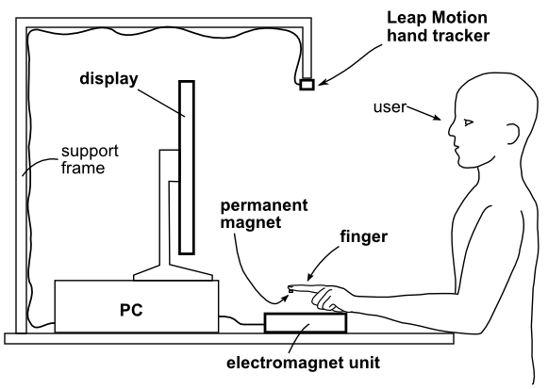
Figure 1. Side view of MIDAS Touch system.
Effective drawing typically requires either vision, or some other form of feedback to let the artist know what was drawn. Providing visually impaired individuals a feedback-enhanced drawing viewer and drawing application would augment their communication skills by empowering them to independently and personally perceive basic line art, and effectively create their own drawings.
As part of our demo, we have developed a computer based drawing application in which the MIDAS Touch system provides feedback for perceiving what has been drawn through physical touch. The prototype device allows a visually impaired user to control the position of a virtual drawing pen by moving the position of their finger under a hand tracker sensor. As the virtual drawing pen passes over a virtual drawing canvas, if the virtual pen passes over a region in which a line has been drawn, a haptic feedback force is applied to a user's finger. The force is applied by attaching a permanent magnet to the user's finger, and dynamically controlling the magnetic field generated by an electromagnet. Because the electromagnet can be rapidly turned on or off, a user may perceive the drawing made so far on the virtual campus by rapidly scanning his/her finger over the 2D canvas and sensing the changes in force applied by the electromagnet to their finger, in much the same way a blind individual may rapidly scan their finger tips over a line of Braille.

Prior Work
Haptic technology has been previously used to aid the blind and visually impaired. Optical to tactical displays have been developed as early as the 1970's [1]. Sjöström, et al. found that users could interpret simple line drawings and diagrams by touch alone after adding textures to the drawings through use of a force feedback stylus [2]. Another method of assisting the visually impaired to perceive their drawings involves the mechanical deformation of the drawing surface [3]. Force feedback based systems suffer from mechanical backlash which reduces fine resolution. Mechanical deformation based systems cannot be used to perceive drawings made by others. Further, none of the prior work to our knowledge provides a free-space haptic feedback, which dynamically changes its applied force as a function of the user's finger position, and is thus free from contacting mechanical linkages having limited resolution or backlash.

DESIGN
The MIDAS Touch system includes the major components of a Leap Motion 3D hand tracker, an electromagnet unit, a computer system hosting a virtual world, and a permanent magnet to be coupled to the user's finger through either tape or a finger glove. These components work together to apply a physical force to the user's index finger as a function of the user's finger position. More specifically, whenever the user move's his/her finger in the real world, it will control the movement of a virtual tool, such as a virtual pen, in a virtual world hosted on the computer system. Whenever the user moves the virtual pen over a region of the virtual world that contains virtual ink that has been drawn, a physical force is applied to the user. This force is realized when the computer system commands the electromagnet unit to turn on, which creates a magnetic field which causes a force to be applied to the permanent magnet coupled to the user's finger. This creates the sensation of touch. When the user moves his finger such that the virtual pen is no longer touching a region in the virtual world which has been drawn on, the computer system commands the electromagnet to turn off. Thus, a user can literally feel what has already been drawn in the virtual world simply by scanning his/her finger back and forth and side to side.
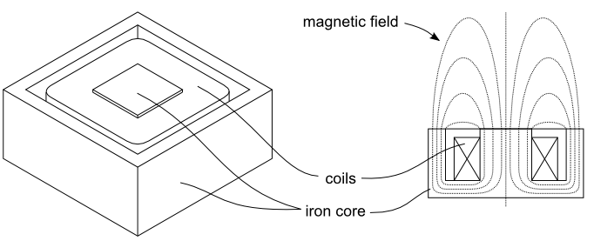Figure 2. a) isometric view of electromagnet b) side section view of electromagnet showing magnetic flux distribution.

Hardware Implementation
The Leap Motion 3D hand tracker is a binocular infrared camera which, in our experimental testing, was capable of reliably providing multiple finger tracking over a 5cm x 5cm x 5cm volume of space at a bandwidth of 30Hz. As shown in Figure 1, we mounted the Leap Motion sensor from above the user's hand using a rigid frame. The permanent magnet coupled to the user's finger is a 1/2" x 1/2" x 1/8" neodymium magnet. The magnet is held to the user's finger either with scotch tape, or a latex glove finger. The electromagnet unit contains an electromagnet converted from a 900W transformer with an estimated turns ratio of 20:1 and an E-shaped laminated iron core. The electromagnet is oriented with the E-shaped core on its side such that the magnetic flux is directed vertically upwards from the electromagnet unit towards a potential user's finger. The electromagnet unit contains a 3KW driver coupled to a 24 volt power supply. At full power, the electromagnet is capable of applying a dynamic force range of over 500 mN. The total volume of space where perceptible force may be applied ranges over a 3 cm x 3 cm x 1.5 cm volume. The driver is directly controlled by an Arduino Mega microcontroller board, which communicates with the computer system via a serial port. The computer system used is a Windows 7 based 1.9 GHz AMD A4 notebook computer.

Application Design
The drawing application was implemented in Python 2.7.7 using the Pygame game library. The drawing application runs as a continuous loop. As a first step, the user's finger positions are read from the Leap Motion sensor as x,y,z coordinates. A virtual pen is arranged at tip of the user's index finger. Whether the pen is "down" (i.e. in a state in which it is actively drawing) vs. "up" (i.e. the pen does not draw virtual ink, but still tracks its position for determination of haptic feedback) is controlled by the position of the user's middle finger. If a user holds their index finger and middle fingers apart (i.e. in the form of scissors), the virtual pen is placed in the "up" state by the application. Alternatively, when the user places his index and middle finger together, the software changes the pen state to the "down" (drawing) state. As the user moves his fingers around with the pen in the "down" state, virtual ink is drawn onto the virtual canvas. In each iteration of the software, after determining the pen location and state from the user's fingers, the software check whether the virtual pen is over a region in which virtual ink has already been drawn. If the pen is over a region of drawn ink, the application sends a message over the serial port to the Arduino microcontroller commanding the electromagnet to turn on. This causes a force to be applied to the user's finger, giving the user the perception of ink being present at his current finger position. The application repeats this loop of detecting finger position, mapping it to virtual pen position and state, determining whether to draw virtual ink, and determining whether to command the electromagnet to turn on. As the user moves his hand away from a region where ink was drawn, the application senses this and commands the electromagnet to turn off, and thus removing the applied force from the user's finger.

CONCLUSION
In this paper we discuss our prototype for providing a visually impaired individual the ability to feel drawings that he/she create. We designed MIDAS Touch with the motivation of helping the visually impaired improve their ability to perceive and create basic drawings. We hope that this demo will serve as a proof of concept that will establish the viability of low cost electromagnet-based haptic human computer interaction devices for assisting the visually impaired to interpret drawings, draw, and more generally to improve usability of a variety of computer applications.

REFERENCES
- J. Bliss, M. Katcher, C. Rogers, and R. Shepard. Optical-to-tactile image conversion for the blind. IEEE Transactions on man-machine systems, MMS-11(1), 1970.
[2] C. Sjöström, H. Danielsson, C. Magnusson, K. Rassmus-Gröhn. Phantom-based haptic line graphics for blind persons. Visual Impairment Research, 5(1), 13-33, 2003.
[3] J. Kennedy. How he Blind Draw. Scientific American, 16, 44 - 51, 2006.

