**Collaborative filtering** and **Content-Based filtering** are two different approaches used in recommender systems to suggest items of interest to users. Both approaches have their advantages and disadvantages, and the choice of approach depends on the type of data available and the specific goals of the recommendation system.

**Collaborative filtering:**

**Collaborative filtering** is a method that relies on the past behavior and preferences of users to recommend new items. It works by analyzing the user's interaction history with the system and finding other users who have similar preferences or behavior. It then recommends items that these similar users have liked or consumed in the past. It does not require any explicit knowledge about the items being recommended; instead, it focuses solely on the user's behavior and preferences.

**There are two types of collaborative filtering:**

**User-based collaborative filtering**: In this method, the system recommends items that users with similar preferences have liked in the past. For example, if user A and user B have similar purchase histories, then the system might recommend items that user B has liked to user A.

**Item-based collaborative filtering**: In this method, the system recommends items that are similar to items the user has liked in the past. For example, if user A has liked item X, the system might recommend item Y, which is similar to item X.

**Collaborative filtering** has the advantage of being able to recommend items that the user may not have discovered otherwise. However, it requires a large amount of data to be effective and can suffer from the cold start problem when new users or items are added to the system.

**Content-Based filtering:**

**Content-Based filtering** is a method that recommends items based on the characteristics of the items themselves. It works by analyzing the features of the items and finding other items that are similar to the ones the user has liked in the past. It does not require any explicit knowledge about the user's preferences; instead, it focuses solely on the properties of the items being recommended.

**There are two types of content-based filtering:**

**Item-based content-based filtering**: In this method, the system recommends items that are similar to items the user has liked in the past based on their attributes such as genre, actor, author, etc.

**User-based content-based filtering**: In this method, the system recommends items that are similar to items that the user has liked in the past. For example, if a user has liked a number of science fiction books, the system might recommend other science fiction books to that user.

**Content-Based filtering** has the advantage of being able to make recommendations for new users or items that have no history in the system. It can also provide explanations for its recommendations by pointing to the specific attributes of the items that are being recommended. However, it can suffer from the problem of overspecialization, where the system recommends only a narrow range of items to the user based on their past behavior.

In conclusion, **Collaborative filtering** and **Content-Based filtering** are two different approaches used in recommender systems, and the choice of approach depends on the type of data available and the specific goals of the recommendation system. Collaborative filtering focuses on the past behavior and preferences of users, while Content-Based filtering focuses on the characteristics of the items being recommended.

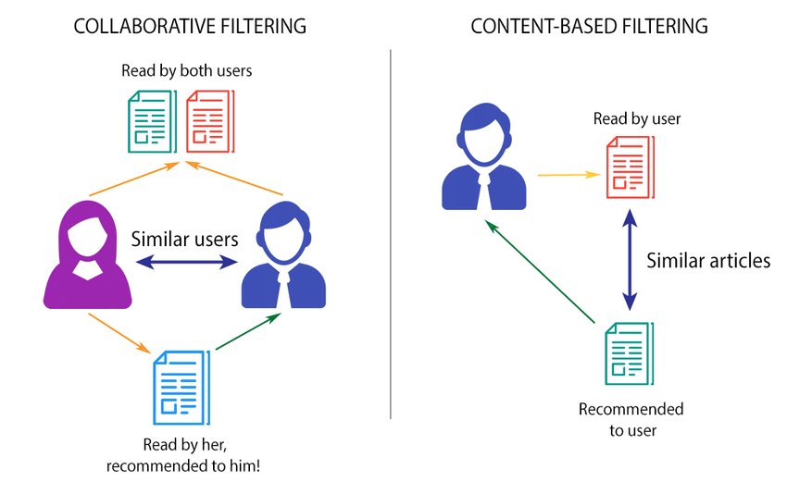(Source: <https://www.researchgate.net/figure/Content-based-filtering-vs-Collaborative-filtering-Source_fig5_323726564>)