***BUS RESERVATION SYSTEM***

***Netbeans 8.0.1 and MySQL is used***

*A Simple Bus Reservation System where we can book ticket, cancel reservations and view the currrent booking status. The admin has the privilage to view all the active users booking status.(This folder also contains the sql database schema and dump)*

***Sankar Ramaswamy***

***S4 BCA***

***AM.SC.U3CSC18043***

***OUTPUT***

***WELCOME PAGE***

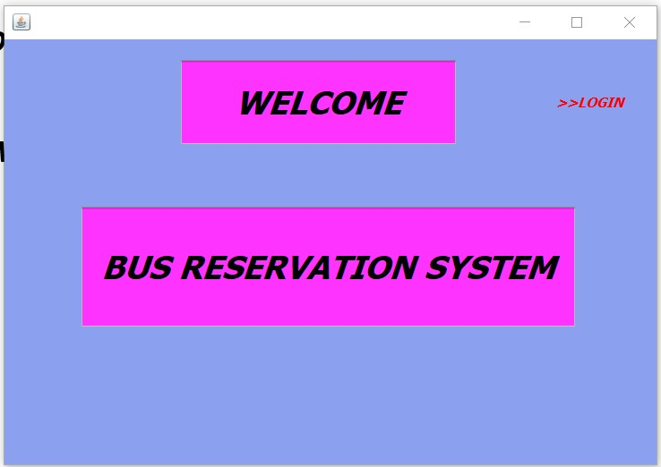

***USER LOGIN PAGE***

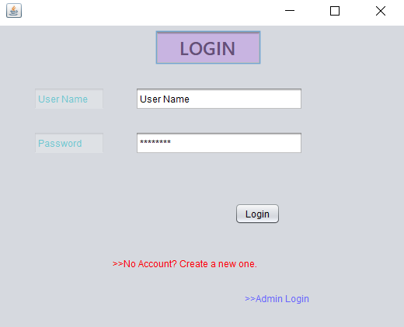

***USER MENU***

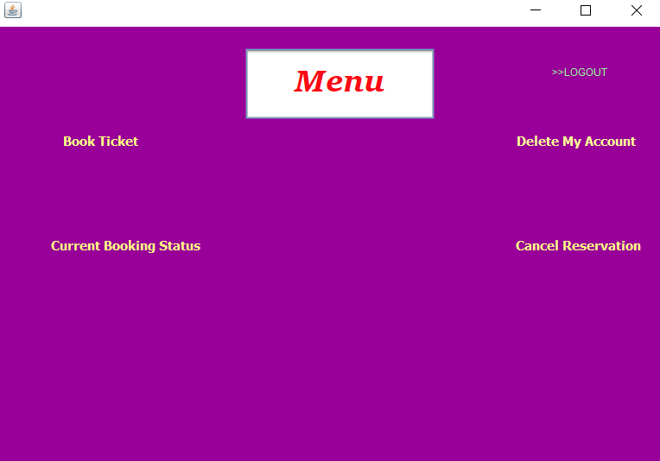

***BOOK TICKET***

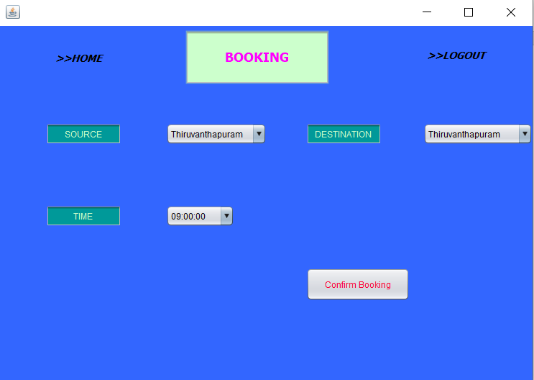

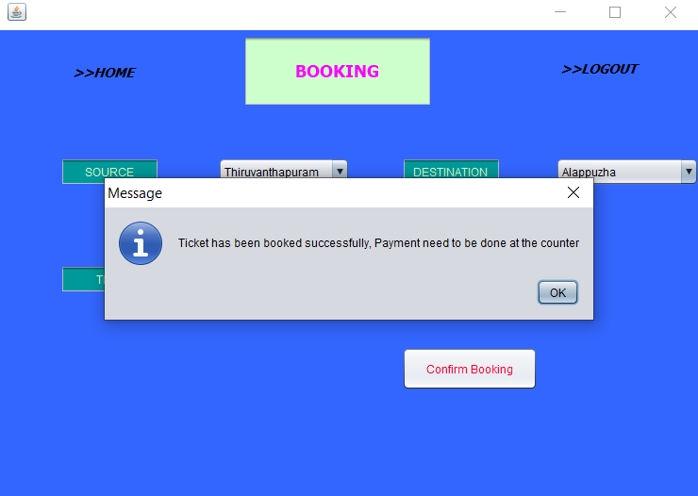

***CURRENT BOOKING STATUS***

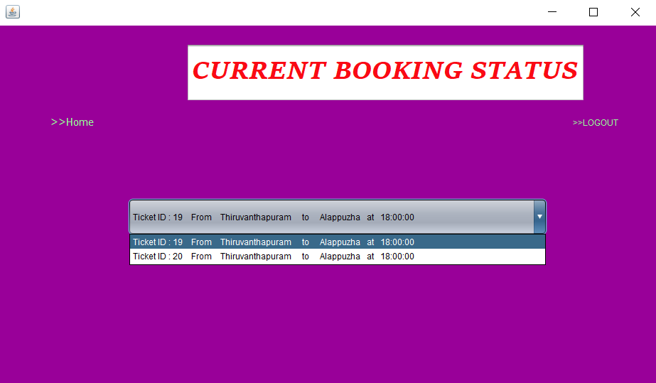

***CANCEL RESERVATION***

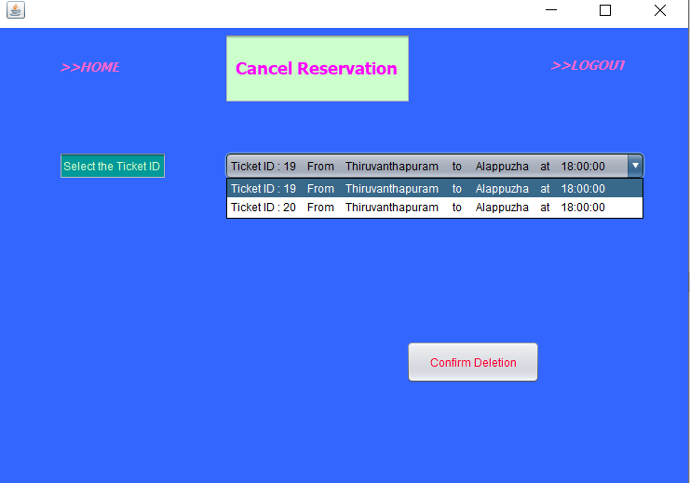

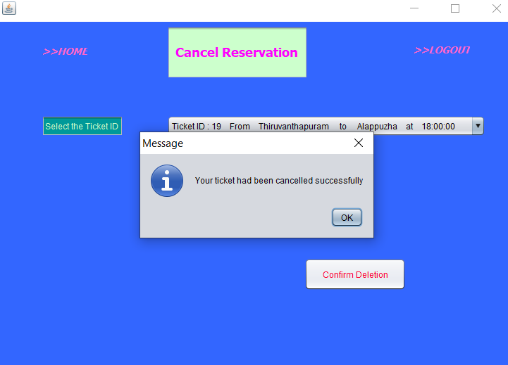

***BOOKING STATUS BEFORE AND AFTER CANCELLATION***

***BEFORE***



***AFTER***

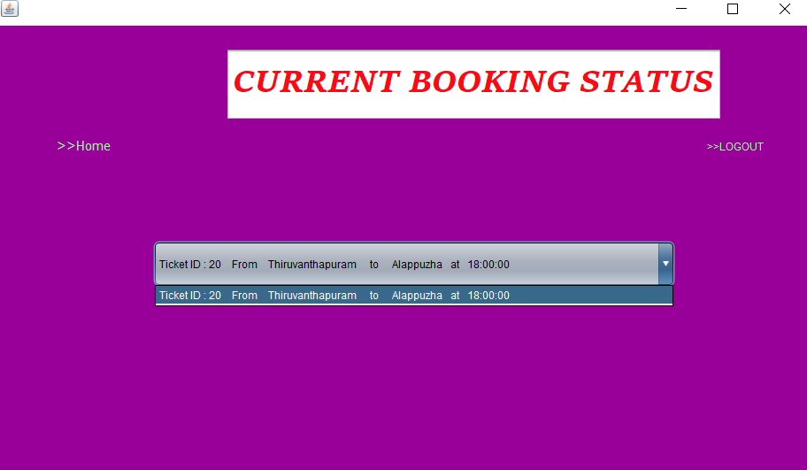

***DELETE MY ACCOUNT***

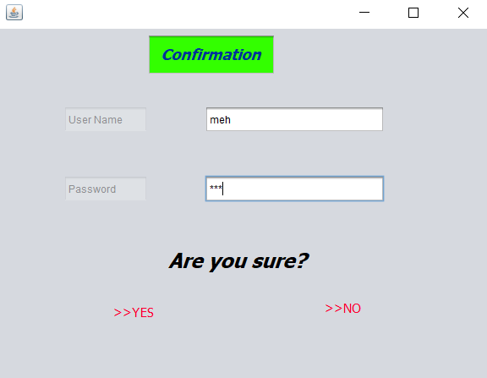

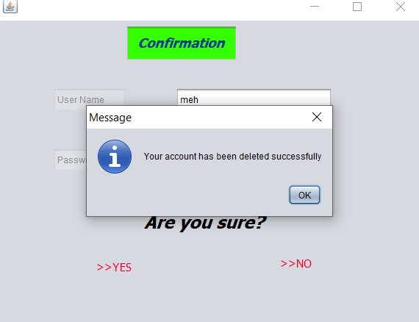

***ADMIN LOGIN PAGE***

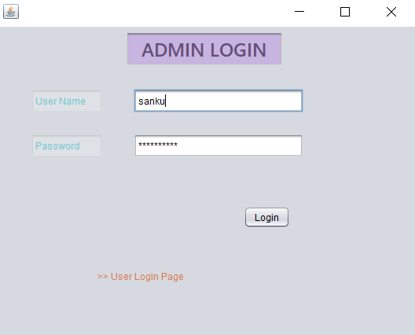

***ADMIN MENU***

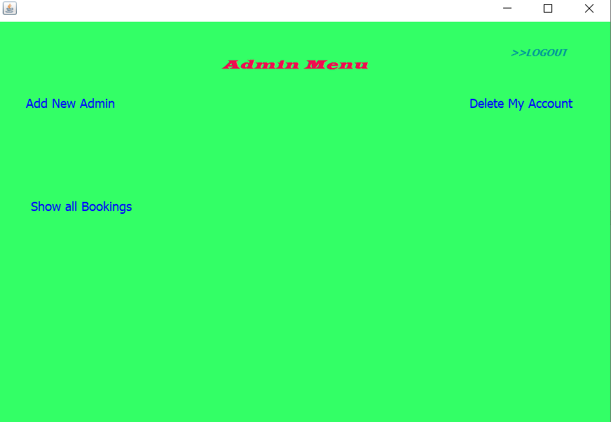

***ADD NEW ADMIN***

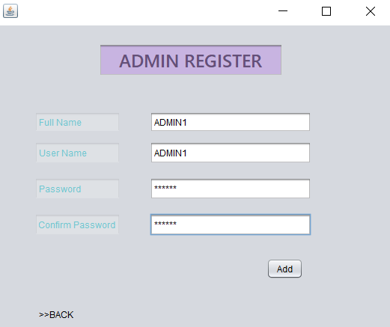

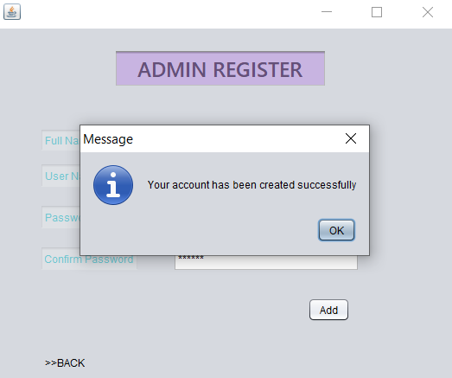

***ALL THE CURRENT BOOKING STATUS***

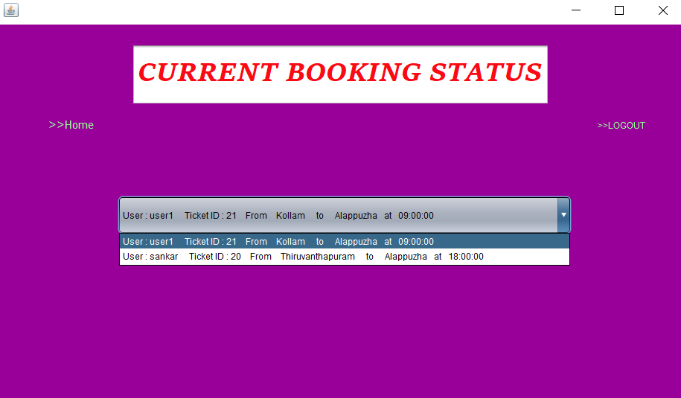

***DELETE ADMIN ACCOUNT***

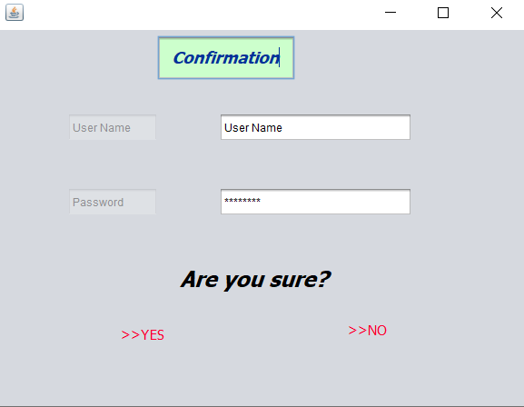

***REGISTER ACCOUNT***

