electrical
in order to implement the hand we had the following specifications:
- bi-directional speed control for 16 DC motors rated 12V 400mA
- position feedback for all drivable joints,with sufficient resolution to implement stable PID control.
- over-current and force-feedback for all motors.
- local controller capable of PID control and interpretation of inputs and feedback.
- common interface for control.
- Minimum size
- short turnaround

due to the short timescale ,there wasn't sufficient time to order a custom PCB, as such the entirety of the electronics needed to be designed to fit on single-sided dot-matrix prototyping boards. this limits the project to through-hole components on a 26 by 18, 0.1 inch grid.

In order to be able to read the current to each motor a pair of 1Ω 0.25W resisters in parallel are used as a high side shunt, for each motor driver. This gives a sense voltage of 12V to 11.8V.

This sense voltage is then be mapped to the 0-5V range of the intended microcontrollers ADC using a differential amplifier with a twenty five times gain.
A 5.1V zener is used to prevent damage to the ADC, should the motors draw over their rated current.

Cd4051 analogue multiplexers are used to cycle each sense line to the differential amplifier.
As these chips cannot be driven by TTL logic above an input voltage of ~10v each input requires a level shifter,in this case an NPN transistor.
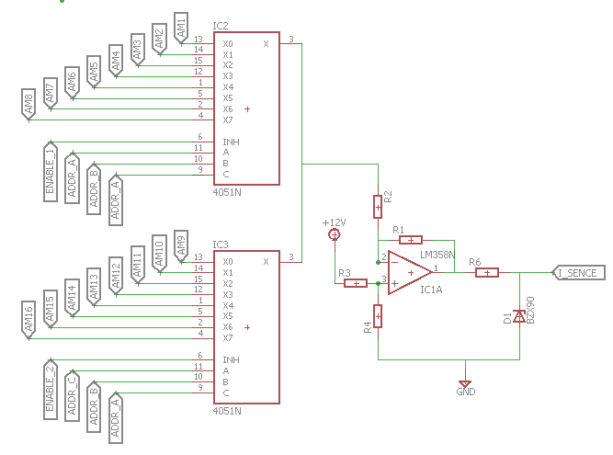
each motor requires a driver with separate power inputs ,in order to implement the current sensing ,and the projects limitation to through hole components ,this left the l9110 as the most practical chip.
note power should be distributed to the drivers in a star arrangement,such that all parasitic resistance from the cables is common to all drivers ,and thus eliminated by a correctly placed reference line,or unique to each, where errors can be removed in code.
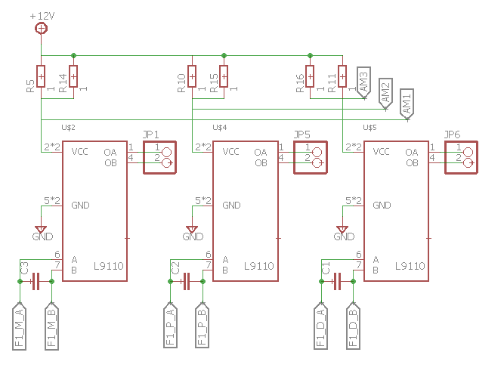
Position feedback is given using two potentiometers embedded in the driven joints. these are a generic trimmer potentiometer chosen for its low profile and square package. these can be powered from 5v and the output fed directly to the ADC.
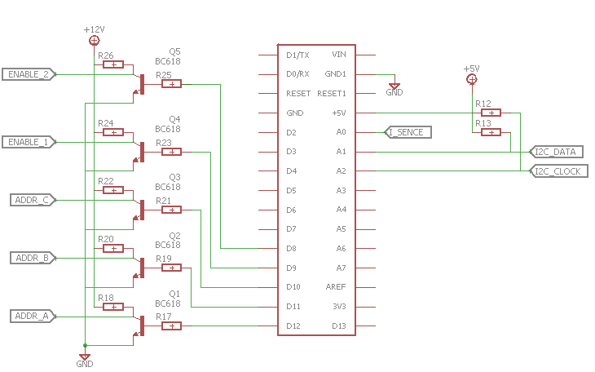
The thumb uses an analogue servo to rotate the finger around the wrist, as such it requires a DAC connection or a filtered pwm.

This gives 2 ADC connection and 6 GPIO connections per finger; with 5 GPIO and one ADC for the current sensing. and a DAC output for the servo.
As this is too much for a single through-hole microcontroller to interface with,the task was split, with an attiny84 controlling each finger And an Arduino nano sensing current as well as providing master control and a virtual serial port via USB. Communication between microcontrollers was implemented with a two wire interface.

  - 1.75mm 3d printing filament
  - less compliant than ninjaflex
- nylon scp
  - a 0.2mm solid nylon line,twisted until it formed a super coiled polymer
- double nylon scp
  - nylon scp twisted further to form a stable double helix
- pp scp
  - a multicore polypropylene twisted to form a super coiled polymer
  - soaked in a rubberising agent to stabilise.
- Pp
  - a polypropylene thread with a natural twist

discussion
as expected ,neither of the two tested Non-linear samples are suitable to the task. The elastic/nylon weave has a non-linear extension region of ~80% of the original length,considering its large diameter this would require an unfeasibly large spool to hold.
The ninjaflex/nylon has a more reasonable ~40% non-linear region,however there where issues in preventing the nylon from slipping,especially at high loads. considering the small volume available for mounting the material at each end,this isn't suitable.

The various SCPs showed plastic deformation at high loads, and are thus unstable for absorbing shocks.

The ninjaflex, semiflex and nylon all produced a nice linear force extension plots at various gradients, and will be our tendons,depending on the properties required. note, ninjaflex and semiflex is best held by melting the end and forming a head as knots slowly untie.

