1. Who are we?

We are based in Jiangmen, China, start from 2014,

we have built a comprehensive value chain  
that encompasses research and development,  
manufacturing, sales, and exports, with a primary  
focus on new energy motorcycles. Our commitment  
to innovation is evident through our portfolio of over  
30 patents and 17 trademarks. Our products have  
been exported to numerous countries and regions  
including Egypt, Pakistan, Mexico, Costa Rica, Peru,  
Burkina Faso, Ghana, Guinea, and Morocco, earning  
unanimous praise from our esteemed customers.

2. How can we guarantee quality?

Always a pre-production sample before mass production;

Always final Inspection before shipment.

3.What can you buy from us?

Electric motorcycle vehicles and scooters

4. Why should you buy from us not from other suppliers?

Our commitment  
to innovation is evident through our portfolio of over  
30 patents and 17 trademarks. Our products have  
been exported to numerous countries and regions  
including Egypt, Pakistan, Mexico, Costa Rica, Peru,  
Burkina Faso, Ghana, Guinea, and Morocco, earning  
unanimous praise from our esteemed customers.

5. What services can we provide?

Accepted Delivery Terms: FOB；

Accepted Payment Currency: USD, EUR, JPY, CAD, AUD, GBP, CNY;

Accepted Payment Type: T/T, L/C, D/P, D/A, MoneyGram, Credit Card;

Language Spoken: English, Chinese, Spanish, Japanese, Portuguese, German, Arabic, French, Russian, Italian.

**Initial reply to inquiry**

Hi my friend:

Glad to receive your inquiry.Thank you for your interest in our products,we are **Jiangmen Tengxin Motorcycle Technology Co., Ltd.**, Established in 2014 with a registered capital of 10  
million RMB, we are proud to be recognized as one of  
the designated motorcycle production enterprises  
appointed by Chinesegovernment. Our headquarters  
are located in Jiangmen City, the largest motorcycle  
production base in China. Jiangmen City is situated in  
the heart of the Guangdong-Hong Kong-Macao Greater  
Bay Area, andbenefitsfrom convenient transportation  
via land and water.

The more you buy ,the more discount for you!please feel free to ask me any question

This is our catalog

**Advance inquiry：**

**Q：**I'd like to have your catalogue

**A：**

Could you please tell me which product do you want?

Would you like to send me pictures that you want

**Glass wool felt：**

**Q：**I'm interested in your **glass wool felt**，/How much is the price of your **glass wool felt**

**A:** Can you tell me the product parameters you want so that I can give you a better quotation?

Can you tell me the length, width, thickness and density you want

Do you have requirement for color

Do you need a veneer

**Q：**I want xxxxxx (Density, Thickness, width,length....)

**A：** Thank you for the detailed data. Let me calculate it for you.（ the density of 24kg/m3, the thickness of 50mm, the width of 1.2m, the length of 20m,） our factory price is: $1.2/m2，please check it~

**Transport：**

**Q:** How much is the freight

**A:** As for the freight, could you tell me what shipping terms you would like to use（EXW/FCA/FOB/CIF/DDU/DDP）?

**Q:** I want FOB terms

**A:** Can you tell me the delivery address you need for shipping so that I can give you the best delivery plan

**Deal：**

If The price is OK：

If there is no problem, I will draft the order for you.

After your payment, I will arrange production for you and send you videos and pictures before delivery

If no reply message：

I noticed that you checked my information, Is the price not good or you not like this product,, can you tell me your concern?

If you have any concerns,please contact me anytime

规格，尺寸参数，数量，客户的订货时间，付款方式，条款，需要什么时间到达港口， 客户在中国是否有货代，货代的联系方式是多少

**Key words,**

**Product**

**Q:**

**A:** Could you please tell me which product do you want?

**Specification**

**Q:**

**A:** Can you tell me the length, width, thickness and density you need（key information）

**Note：When we ask the key information that the customer wants, we can also tell the customer our specification range for the customer to choose, such as density: 10-48kg/m3**

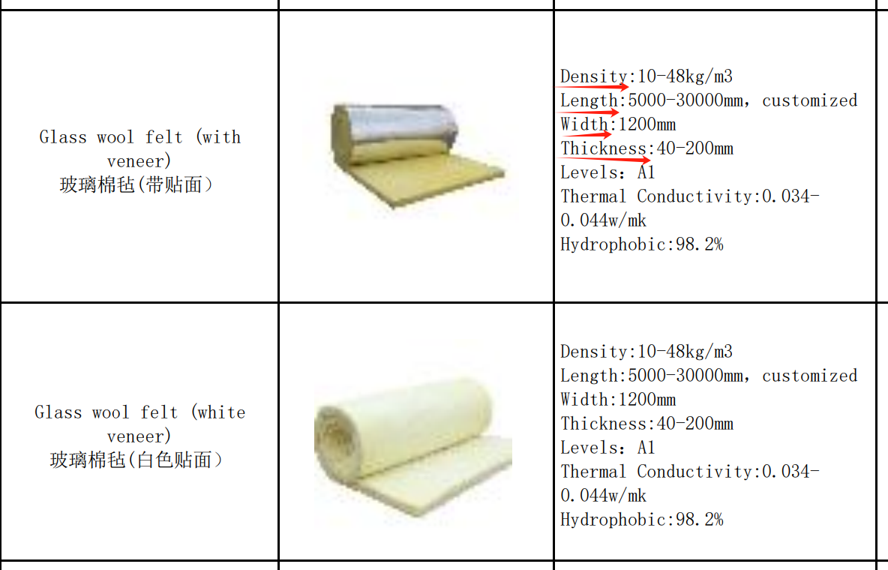

**Quantity**

**Q:**

**A：**Can you tell me how much area you need to cover

**What time does it take to get to the port**

**Q:**

**A：**Do you have any requirement for the time of arrival at the port

**Order time**

**Q:**

**A：**Can you tell me when you need to start construction

**Transport term：**

**Q:** How much is the freight

**A:** As for the freight, could you tell me what shipping terms you would like to use（EXW/FCA/FOB/CIF/DDU/DDP）?

**Market conditions**

Q:

**A:**Can you tell me something about the market in your country

**Does the customer have a forwarder in China**

**Q:**

**A：**Do you have a freight forwarder in China

**What is the contact information of freight forwarder**

**Q:**

**A：**Could you tell me your company name and your other contact information? In this way, I can give you a quotation and communicate with you in time

**Payment method**

Q:

A：Could you tell me which payment method you would like to use? Usually we support T/T, L/C, D/P, D/A, MoneyGram, Credit Card;

**Note：Is it possible to summarize the key information (from key words to there) asked into an Excel table**