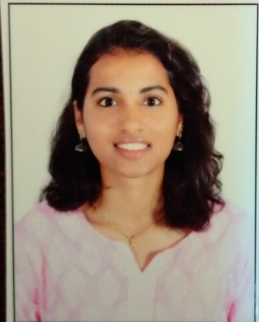M.ROHINI

www.linkedin.com.rohini-m-b04501272 , mandatirohinib4u@gmail.com ,

Ph.no:9113573283

# SUMMARY

Dedicated Bachelor's student in Computer Science and Electronics with a proven aptitude for project management and leadership. Equipped with strong organizational skills and a strategic mindset, poised to contribute to company growth while advancing personal career objectives. Eager to leverage academic background and practical experience in collaborative settings to drive innovation and achieve impactful results.

Top of Form

Bottom of Form

# EDUCATION

## Bachelor of Science in Computer science and Electronics Sep 2022 – Sep 2025

MS Ramaiah college of Arts, Science and commerce, Bengaluru

* coursework in Electronics and communication
* coursework in computer programming languages
* CGPA – 9.03

**Senior Secondary Education June 2022- March 2022**

* Sri Chaitanya Junior College, Bengaluru
* CGPA-8.3

**Secondary School April 2019- March 2020**

* Jai Gopal Garodia Rashtrothana Vidya Kendra, Bengaluru
* Percentage-77%

# PROJECTS

* **Automatic doorbell system using Arduino UNO**

The automatic doorbell system using Arduino UNO detects visitors through a motion sensor and triggers a doorbell sound automatically. It eliminates the need for manual doorbell pressing and enhances convenience and security.

* **Large Language Model (Research paper - National Conference MSRCASC)**

Presented a research paper on Large Language Models (LLMs) for a National Conference that explores the architecture, capabilities, and applications of LLMs like GPT, highlighting their impact on natural language processing tasks. It emphasizes advancements, challenges, and potential areas for future research.

# COURSE:

# Completed ROBO AI (industrial training program on robotics and artificial intelligence)

# Completed the ROBO AI industrial training program, gaining hands-on experience in robotics and artificial intelligence, including design, programming, and real-world applications of AI-driven robotic systems.

# INTERNSHIPS

# FRONT END DEVELOPER: INDPRO (January-2025 – March-2025)

# Pursuing a 2-month internship at Indpro primarily focusing on front-end development

✅ **Edu-Space – Demo project (Angular)**

* Developed a web application to evaluate an organization’s AI readiness.
* Implemented an interactive UI using Angular and integrated dynamic assessment modules.

✅ **AI-Readiness Evaluation Platform (React)**

* Built a React-based website to assess organizations’ preparedness for AI adoption.
* Designed intuitive user interfaces and incorporated scoring algorithms to provide detailed readiness reports.

✅ **AI-Powered Resume Screener (React & Backend)**

* Developed a full-stack web application for HR departments to automate resume screening.
* Created the frontend using React and integrated a backend for resume uploading and job matching.
* Implemented AI-based matching algorithms to identify the most suitable candidates.
* Deployed the project on Render for real-world testing and accessibility.

# SKILLS

**Programming Languages:**

* Python
* Angular JS framework
* React framework