SPI Protocol

Verilog code

`timescale 1ns / 1ps

//////////////////////////////////////////////////////////////////////////////////

// Company:

// Engineer:

//

// Create Date: 25.07.2023 13:55:38

// Design Name:

// Module Name: spi_state

// Project Name:

// Target Devices:

// Tool Versions:

// Description:

//

// Dependencies:

//

// Revision:

// Revision 0.01 - File Created

// Additional Comments:

//

//////////////////////////////////////////////////////////////////////////////////

module spi_state(

input wire clk,

input wire reset,

input wire [15:0] datain,

output wire spi_cs_l,

output wire spi_sclk,

output wire spi_data,

output [4:0]counter

);

// reg dclk;

reg [15:0] MOSI;

reg [4:0] count;

reg cs_l;

reg sclk;

reg [2:0]state;

always@(posedge clk or posedge reset)

if(reset) begin

MOSI <= 16'b0;

count <= 5'd16;

cs_l <= 1'b1;

sclk <= 1'b0;

end

else begin

case (state)

0: begin

sclk <= 1'b0;

cs_l <= 1'b1;

state<=1;

end

1: begin

sclk <= 1'b0;

cs_l <= 1'b0;

MOSI<=datain[count-1];

count<=count-1;

state<=2;

end

2: begin

sclk <= 1'b1;

if(count > 0)

state<=1;

else begin

count<=16;

state<=0;

end

end

default:state<=0;

endcase

end

assign spi_cs_l = cs_l;

assign spi_sclk = sclk;

assign spi_data = MOSI;

assign counter=count;

endmodule

TESTBENCH

`timescale 1ns / 1ps

//////////////////////////////////////////////////////////////////////////////////

// Company:

// Engineer:

//

// Create Date: 25.07.2023 13:57:13

// Design Name:

// Module Name: tb_spi_state

// Project Name:

// Target Devices:

// Tool Versions:

// Description:

//

// Dependencies:

//

// Revision:

// Revision 0.01 - File Created

// Additional Comments:

//

//////////////////////////////////////////////////////////////////////////////////

module tb_spi_state;

// Inputs

reg clk;

reg reset;

reg [15:0]datain;

// Outputs

wire spi_cs_l;

wire spi_sclk;

wire spi_data;

wire [4:0]counter;

spi_state dut (

.clk(clk),

.reset(reset),

.counter(counter),

.datain(datain),

.spi_cs_l(spi_cs_l),

.spi_sclk(spi_sclk),

.spi_data(spi_data)

);

initial begin

clk = 0;

reset = 1;

datain = 0;

end

always #5 clk=~clk;

initial begin

#10 reset=1'b0;

#10 datain=16'hA569;

#335 datain=16'h2563;

#335 datain=16'h9B63;

#335 datain=16'h6A61;

#335 datain=16'hA265;

#335 datain=16'h7564;

end

endmodule

DEVICE

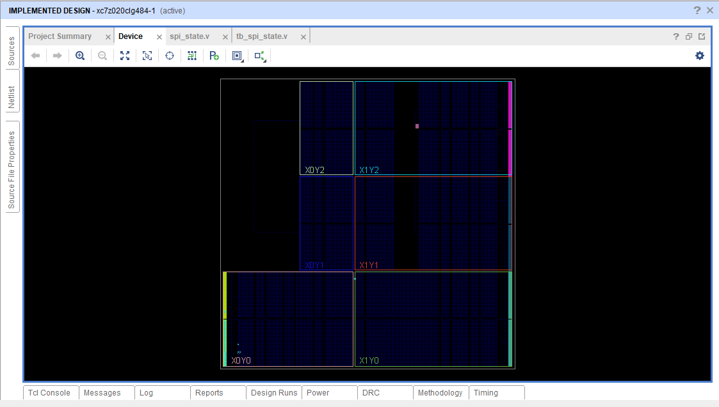

SIMULATION

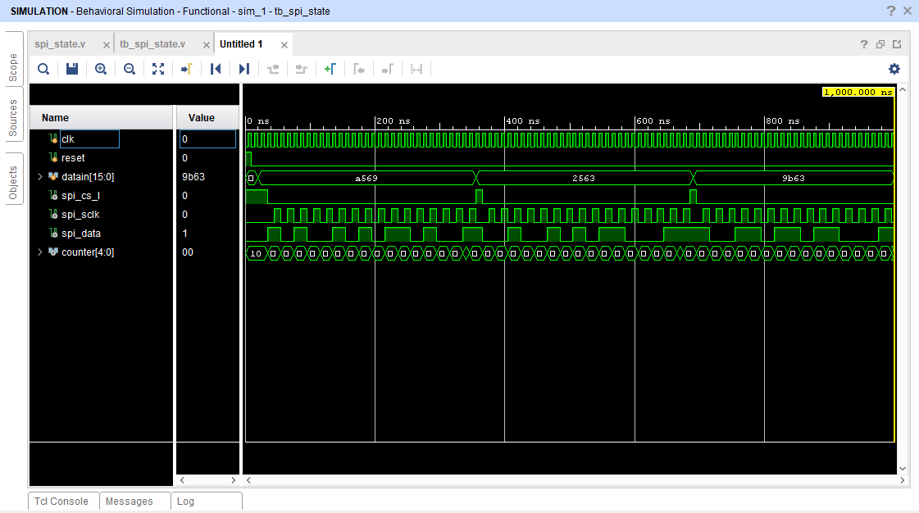

SCHEMETIC

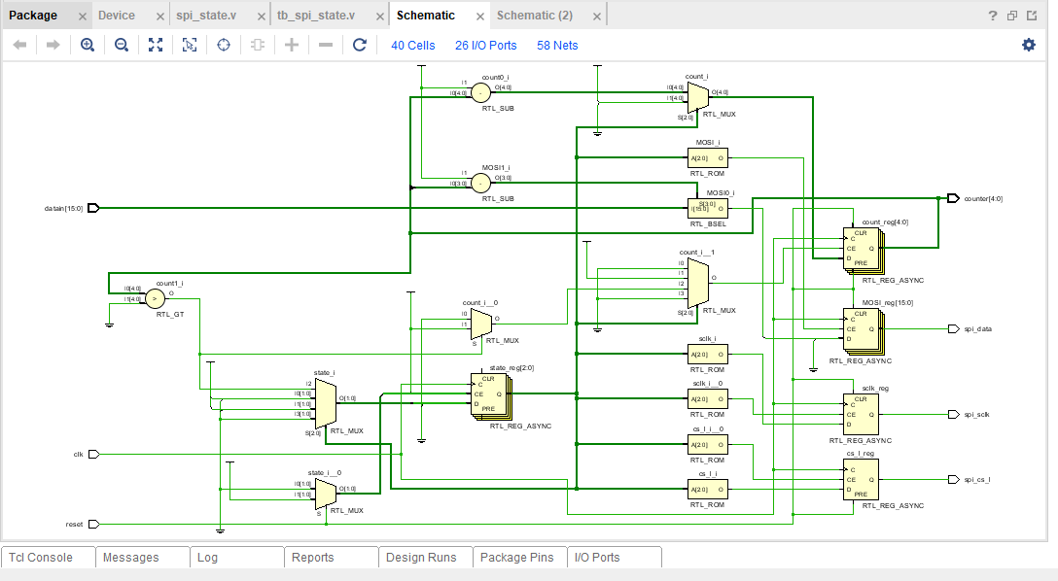

IMPLEMENTED DESIGN

