Sangam — EEG Report
Generated: 2025-12-10 21:13:19
Name | Sangam
Age | 20
Gender | Male
Mental state | anxious
Long-term issues | heart_disease
Short-term issues | dehydration, sleep_deprivation
Wants to listen | True
Music genre | rock
Music onset (s) | 10.0
Music duration (s) | 60.0

Band RMS (per channel) + Best candidate
Channel | DELTA | THETA | ALPHA | BETA | GAMMA | BEST_CANDIDATE
Fp1 | 4.793 | 10.645 | 5.550 | 13.154 | 0.936 | anxious, heart_disease, dehydration (0.975)
Fp2 | 14.835 | 17.497 | 3.996 | 3.586 | 3.258 | anxious, epilepsy, dehydration (1.035)
F3 | 15.505 | 12.289 | 6.214 | 11.027 | 3.013 | anxious, heart_disease, dehydration (1.043)
F4 | 16.889 | 9.286 | 8.742 | 7.248 | 2.134 | anxious, epilepsy, dehydration (0.993)
F7 | 7.043 | 11.840 | 9.239 | 10.533 | 4.168 | anxious, heart_disease, dehydration (1.038)
F8 | 5.968 | 16.111 | 9.032 | 5.184 | 3.376 | anxious, post_heart_surgery, fatigue (0.990)
Fz | 2.871 | 14.732 | 5.542 | 3.492 | 3.751 | anxious, chronic_liver_disease, fatigue (0.953)
C3 | 11.811 | 11.889 | 8.232 | 10.253 | 2.973 | anxious, heart_disease, dehydration (1.050)
C4 | 14.031 | 15.297 | 3.154 | 15.790 | 2.804 | anxious, heart_disease, dehydration (1.032)
Cz | 14.728 | 9.942 | 9.789 | 9.380 | 3.478 | anxious, heart_disease, dehydration (1.026)
T3 | 11.185 | 13.442 | 7.627 | 10.368 | 2.818 | anxious, heart_disease, dehydration (1.053)
T4 | 17.076 | 7.400 | 2.491 | 5.894 | 2.456 | anxious, epilepsy, dehydration (0.982)
T5 | 14.068 | 10.535 | 5.370 | 8.631 | 4.071 | anxious, heart_disease, dehydration (1.050)
T6 | 17.877 | 6.228 | 10.398 | 6.755 | 0.692 | anxious, epilepsy, dehydration (0.917)
P3 | 4.057 | 7.397 | 4.616 | 6.014 | 2.675 | anxious, heart_disease, dehydration (1.050)
P4 | 11.081 | 16.024 | 6.516 | 7.060 | 2.996 | anxious, chronic_liver_disease, dehydration (1.045)
Pz | 16.330 | 20.199 | 6.202 | 11.639 | 1.243 | anxious, chronic_liver_disease, dehydration (1.032)
O1 | 18.038 | 18.149 | 4.189 | 9.641 | 4.189 | anxious, epilepsy, dehydration (1.051)
O2 | 10.127 | 14.443 | 4.770 | 10.683 | 1.417 | anxious, heart_disease, dehydration (1.034)
Oz | 20.536 | 8.679 | 9.474 | 4.341 | 2.557 | anxious, epilepsy, dehydration (0.957)
AF3 | 15.404 | 15.278 | 6.978 | 7.890 | 2.857 | anxious, epilepsy, dehydration (1.045)
AF4 | 15.112 | 9.390 | 5.761 | 12.943 | 0.597 | anxious, heart_disease, dehydration (0.997)
FC5 | 13.533 | 22.049 | 5.895 | 5.155 | 2.908 | anxious, epilepsy, dehydration (1.019)
FC6 | 17.265 | 12.804 | 5.854 | 7.438 | 2.381 | anxious, epilepsy, dehydration (1.034)

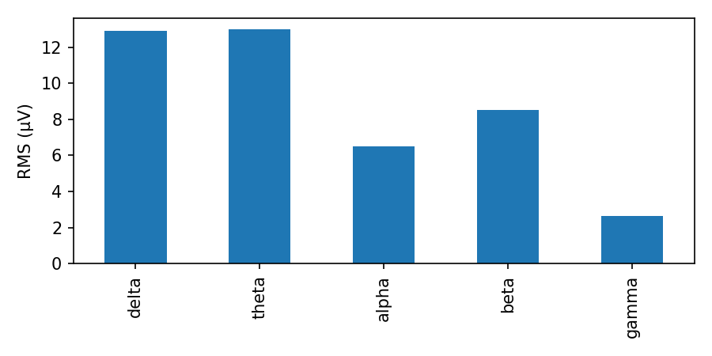

Inter-channel correlation (band RMS)
Heatmap of Pearson correlation between channel band RMS vectors.
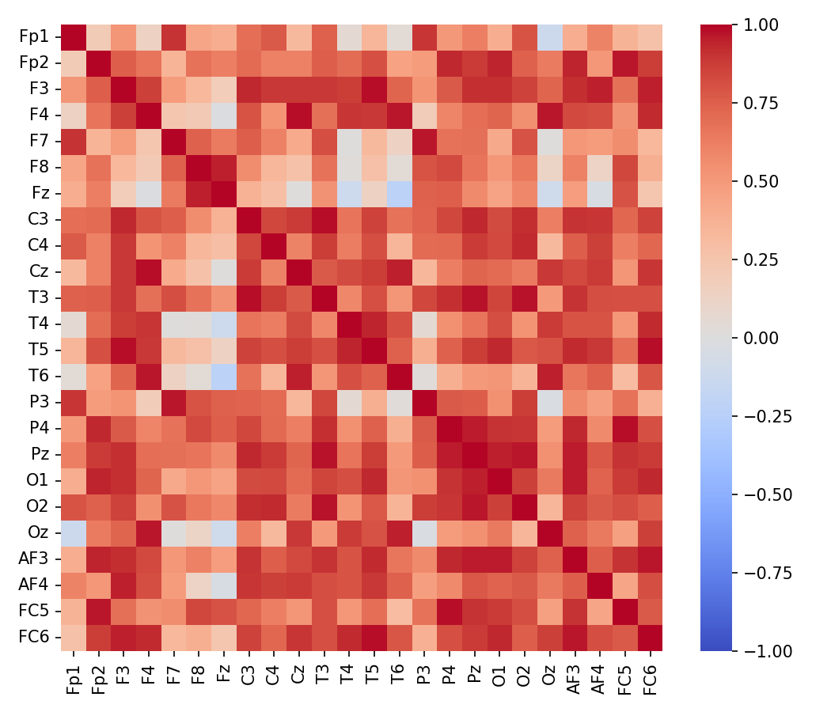

Interpretation (heuristic)
Overall: Slow-wave dominance overall: drowsiness or slow-wave activity; interpret cautiously.
- Per-channel quick notes:
- Fp1: beta-dominant (alert/muscle-artifact)
- Fp2: slow-wave dominant (drowsy/slow-wave)
- F3: slow-wave dominant (drowsy/slow-wave)
- F4: slow-wave dominant (drowsy/slow-wave)
- F7: slow-wave dominant (drowsy/slow-wave)
- F8: slow-wave dominant (drowsy/slow-wave)
- Fz: slow-wave dominant (drowsy/slow-wave)
- C3: slow-wave dominant (drowsy/slow-wave)
- C4: beta-dominant (alert/muscle-artifact)
- Cz: slow-wave dominant (drowsy/slow-wave)
- T3: slow-wave dominant (drowsy/slow-wave)
- T4: slow-wave dominant (drowsy/slow-wave)
- T5: slow-wave dominant (drowsy/slow-wave)
- T6: slow-wave dominant (drowsy/slow-wave)
- P3: slow-wave dominant (drowsy/slow-wave)
- P4: slow-wave dominant (drowsy/slow-wave)
- Pz: slow-wave dominant (drowsy/slow-wave)
- O1: slow-wave dominant (drowsy/slow-wave)
- O2: slow-wave dominant (drowsy/slow-wave)
- Oz: slow-wave dominant (drowsy/slow-wave)
- AF3: slow-wave dominant (drowsy/slow-wave)
- AF4: slow-wave dominant (drowsy/slow-wave)
- FC5: slow-wave dominant (drowsy/slow-wave)
- FC6: slow-wave dominant (drowsy/slow-wave)

Notes: This interpretation is heuristic and provided for exploratory research. For clinical conclusions, consult domain experts and use clinical-grade recordings and validated pipelines.

