Sumit — EEG Report
Generated: 2025-12-10 11:13:28
Name | Sumit
Age | 52
Gender | Male
Mental state | stressed
Long-term issues | chronic_liver_disease, cancer
Short-term issues | headache, fever
Wants to listen | True
Music genre | silence
Music onset (s) | 10.0
Music duration (s) | 60.0

Band RMS (per channel) + Best candidate
Channel | DELTA | THETA | ALPHA | BETA | GAMMA | BEST_CANDIDATE
Fp1 | 30.266 | 24.015 | 2.424 | 10.025 | 2.309 | stressed, epilepsy, sleep_deprivation (1.009)
Fp2 | 8.355 | 28.649 | 4.980 | 6.787 | 1.096 | depressed, chronic_liver_disease, headache (0.962)
F3 | 27.530 | 4.234 | 5.825 | 4.706 | 2.498 | stressed, epilepsy, post_surgery_recovery (0.847)
F4 | 15.900 | 32.978 | 5.278 | 5.471 | 2.347 | drowsy, chronic_liver_disease, headache (1.001)
F7 | 33.524 | 18.264 | 2.083 | 11.264 | 1.747 | stressed, epilepsy, sleep_deprivation (0.974)
F8 | 13.623 | 7.427 | 5.883 | 7.308 | 3.000 | stressed, chronic_liver_disease, headache (1.006)
Fz | 37.654 | 15.544 | 1.952 | 6.745 | 3.379 | stressed, epilepsy, sleep_deprivation (0.935)
C3 | 24.957 | 20.010 | 5.897 | 8.034 | 1.695 | stressed, epilepsy, sleep_deprivation (1.013)
C4 | 30.406 | 27.183 | 2.911 | 12.096 | 3.384 | stressed, chronic_liver_disease, sleep_deprivation (1.022)
Cz | 14.942 | 15.357 | 6.588 | 7.917 | 2.376 | stressed, chronic_liver_disease, sleep_deprivation (1.043)
T3 | 20.498 | 7.930 | 1.829 | 7.519 | 2.533 | stressed, epilepsy, post_surgery_recovery (0.953)
T4 | 19.281 | 17.879 | 4.417 | 8.446 | 2.488 | stressed, chronic_liver_disease, sleep_deprivation (1.036)
T5 | 11.930 | 22.123 | 4.569 | 8.298 | 0.849 | stressed, chronic_liver_disease, sleep_deprivation (1.020)
T6 | 25.491 | 21.808 | 2.569 | 7.095 | 2.862 | drowsy, chronic_liver_disease, headache (1.015)
P3 | 20.446 | 4.581 | 4.424 | 5.018 | 2.135 | stressed, epilepsy, post_surgery_recovery (0.892)
P4 | 8.456 | 20.074 | 2.099 | 4.130 | 3.725 | stressed, chronic_liver_disease, sleep_deprivation (0.998)
Pz | 23.870 | 5.721 | 5.189 | 8.646 | 2.642 | stressed, epilepsy, post_surgery_recovery (0.908)
O1 | 22.073 | 11.997 | 2.095 | 8.099 | 2.053 | stressed, epilepsy, post_surgery_recovery (0.984)
O2 | 19.126 | 22.548 | 2.564 | 4.214 | 2.673 | drowsy, chronic_liver_disease, headache (1.026)
Oz | 11.030 | 24.018 | 5.341 | 9.289 | 2.342 | stressed, chronic_liver_disease, sleep_deprivation (1.020)
AF3 | 13.783 | 19.198 | 5.015 | 7.263 | 1.966 | stressed, chronic_liver_disease, sleep_deprivation (1.040)
AF4 | 21.051 | 8.227 | 4.016 | 5.351 | 3.186 | stressed, epilepsy, post_surgery_recovery (0.957)
FC5 | 7.824 | 17.961 | 4.177 | 8.600 | 3.411 | stressed, chronic_liver_disease, headache (1.035)
FC6 | 10.091 | 21.599 | 6.344 | 9.733 | 2.177 | stressed, chronic_liver_disease, sleep_deprivation (1.022)

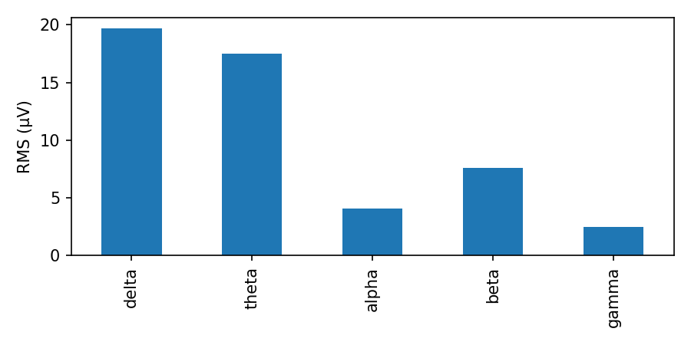

Inter-channel correlation (band RMS)
Heatmap of Pearson correlation between channel band RMS vectors.
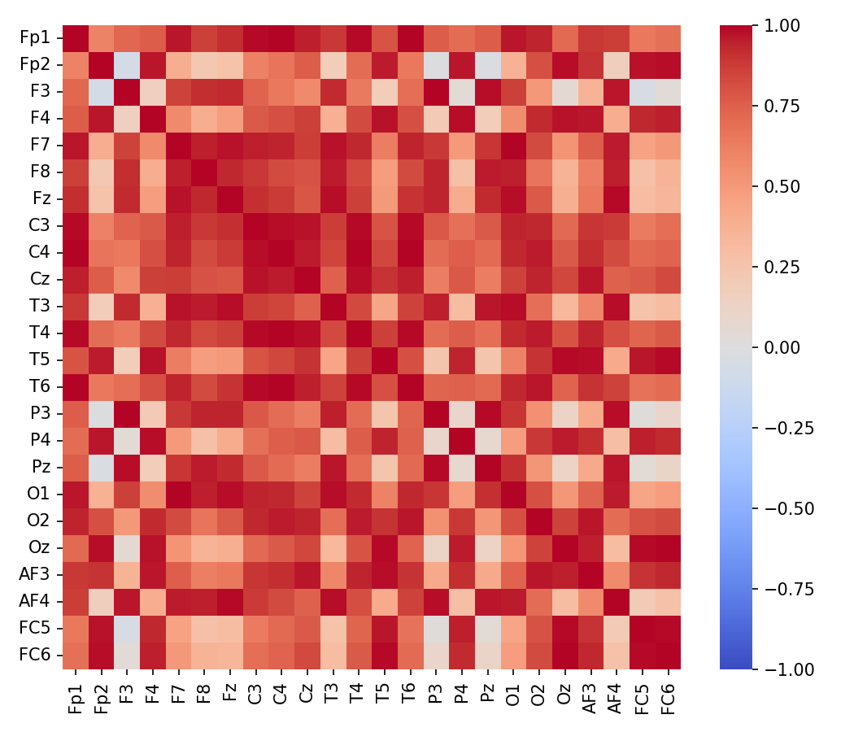

Interpretation (heuristic)
Overall: Slow-wave dominance overall: drowsiness or slow-wave activity; interpret cautiously.
- Per-channel quick notes:
- Fp1: slow-wave dominant (drowsy/slow-wave)
- Fp2: slow-wave dominant (drowsy/slow-wave)
- F3: slow-wave dominant (drowsy/slow-wave)
- F4: slow-wave dominant (drowsy/slow-wave)
- F7: slow-wave dominant (drowsy/slow-wave)
- F8: slow-wave dominant (drowsy/slow-wave)
- Fz: slow-wave dominant (drowsy/slow-wave)
- C3: slow-wave dominant (drowsy/slow-wave)
- C4: slow-wave dominant (drowsy/slow-wave)
- Cz: slow-wave dominant (drowsy/slow-wave)
- T3: slow-wave dominant (drowsy/slow-wave)
- T4: slow-wave dominant (drowsy/slow-wave)
- T5: slow-wave dominant (drowsy/slow-wave)
- T6: slow-wave dominant (drowsy/slow-wave)
- P3: slow-wave dominant (drowsy/slow-wave)
- P4: slow-wave dominant (drowsy/slow-wave)
- Pz: slow-wave dominant (drowsy/slow-wave)
- O1: slow-wave dominant (drowsy/slow-wave)
- O2: slow-wave dominant (drowsy/slow-wave)
- Oz: slow-wave dominant (drowsy/slow-wave)
- AF3: slow-wave dominant (drowsy/slow-wave)
- AF4: slow-wave dominant (drowsy/slow-wave)
- FC5: slow-wave dominant (drowsy/slow-wave)
- FC6: slow-wave dominant (drowsy/slow-wave)

Notes: This interpretation is heuristic and provided for exploratory research. For clinical conclusions, consult domain experts and use clinical-grade recordings and validated pipelines.

