Sumit — EEG Report
Generated: 2025-12-10 21:41:30
Name | Sumit
Age | 36
Gender | Male
Mental state | depressed
Long-term issues | diabetes, heart_disease
Short-term issues | headache, fever
Wants to listen | True
Music genre | electronic
Music onset (s) | 10.0
Music duration (s) | 60.0

Band RMS (per channel) + Best candidate
Channel | DELTA | THETA | ALPHA | BETA | GAMMA | BEST_CANDIDATE
Fp1 | 26.310 | 4.991 | 4.465 | 8.150 | 3.171 | depressed, epilepsy (0.870)
Fp2 | 20.663 | 30.504 | 3.118 | 8.048 | 2.427 | depressed, epilepsy, headache (1.036)
F3 | 8.163 | 23.625 | 4.725 | 4.438 | 3.121 | depressed, diabetes, sleep_deprivation (1.006)
F4 | 12.564 | 13.378 | 5.692 | 3.416 | 2.663 | depressed, epilepsy, headache (1.047)
F7 | 23.489 | 19.150 | 6.565 | 4.368 | 2.144 | depressed, epilepsy, headache (1.030)
F8 | 13.807 | 18.513 | 7.455 | 4.126 | 4.315 | depressed, diabetes, sleep_deprivation (1.049)
Fz | 16.568 | 19.888 | 4.597 | 7.672 | 2.512 | depressed, epilepsy, headache (1.052)
C3 | 17.990 | 22.840 | 2.327 | 9.145 | 3.662 | depressed, epilepsy, headache (1.048)
C4 | 17.836 | 12.434 | 5.666 | 3.518 | 2.799 | depressed, epilepsy, headache (1.023)
Cz | 11.841 | 14.058 | 5.828 | 2.331 | 3.994 | depressed, epilepsy, headache (1.044)
T3 | 19.767 | 14.700 | 4.710 | 5.300 | 3.510 | depressed, epilepsy, headache (1.036)
T4 | 12.392 | 30.749 | 1.712 | 5.351 | 2.929 | depressed, diabetes, sleep_deprivation (0.997)
T5 | 22.475 | 8.324 | 4.905 | 4.334 | 3.296 | depressed, epilepsy, headache (0.946)
T6 | 15.772 | 12.455 | 4.598 | 6.395 | 1.832 | depressed, epilepsy, headache (1.036)
P3 | 26.322 | 8.923 | 1.664 | 5.979 | 3.715 | depressed, epilepsy, headache (0.928)
P4 | 14.677 | 18.165 | 3.077 | 4.840 | 0.361 | depressed, epilepsy, headache (1.037)
Pz | 25.611 | 10.732 | 1.973 | 8.634 | 0.512 | depressed, epilepsy, headache (0.945)
O1 | 18.141 | 24.040 | 5.818 | 5.292 | 3.684 | depressed, epilepsy, headache (1.049)
O2 | 11.710 | 15.385 | 5.179 | 5.334 | 3.016 | depressed, diabetes, headache (1.060)
Oz | 17.083 | 14.538 | 3.002 | 8.022 | 2.065 | depressed, epilepsy, headache (1.038)
AF3 | 13.446 | 23.326 | 6.411 | 2.811 | 3.111 | depressed, diabetes, sleep_deprivation (1.030)
AF4 | 12.131 | 17.291 | 6.974 | 5.540 | 1.636 | depressed, diabetes, sleep_deprivation (1.046)
FC5 | 25.180 | 21.392 | 6.488 | 7.872 | 4.038 | depressed, epilepsy, headache (1.045)
FC6 | 15.193 | 23.170 | 6.488 | 7.618 | 1.017 | depressed, diabetes, sleep_deprivation (1.042)

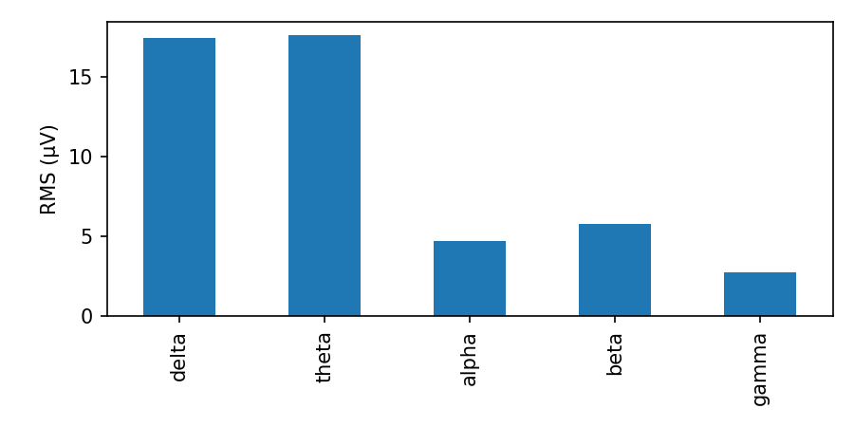

Inter-channel correlation (band RMS)
Heatmap of Pearson correlation between channel band RMS vectors.
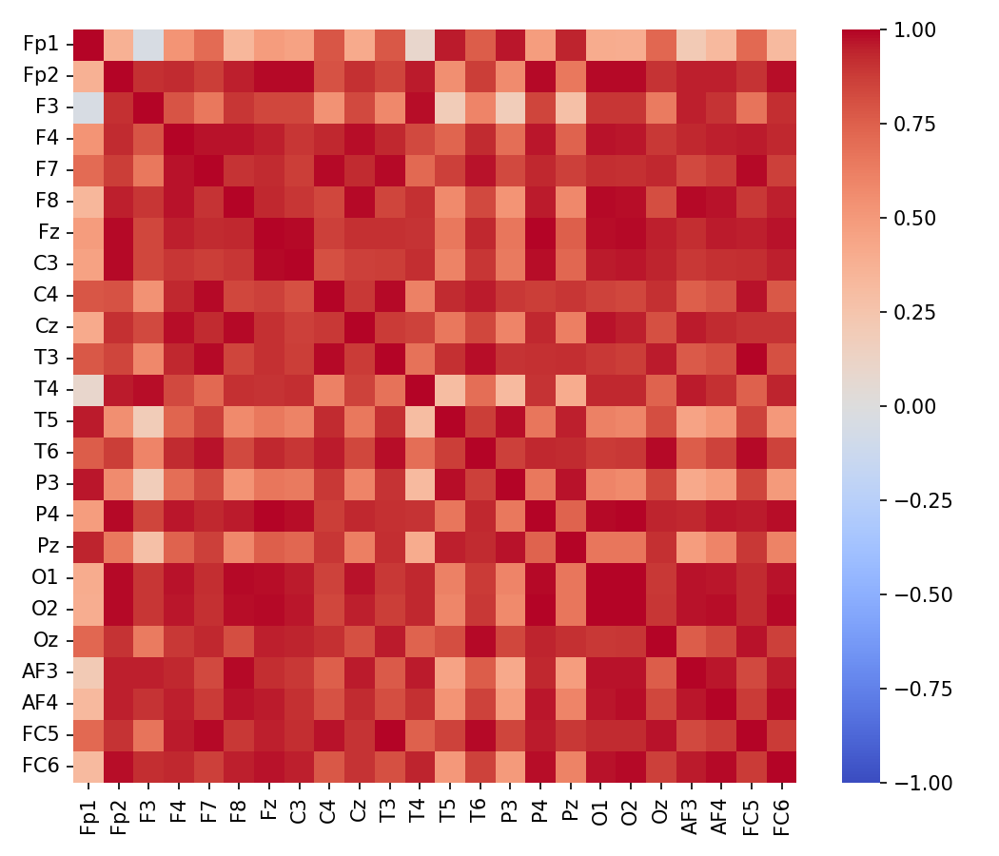

Interpretation (heuristic)
Overall: Slow-wave dominance overall: drowsiness or slow-wave activity; interpret cautiously.
- Per-channel quick notes:
- Fp1: slow-wave dominant (drowsy/slow-wave)
- Fp2: slow-wave dominant (drowsy/slow-wave)
- F3: slow-wave dominant (drowsy/slow-wave)
- F4: slow-wave dominant (drowsy/slow-wave)
- F7: slow-wave dominant (drowsy/slow-wave)
- F8: slow-wave dominant (drowsy/slow-wave)
- Fz: slow-wave dominant (drowsy/slow-wave)
- C3: slow-wave dominant (drowsy/slow-wave)
- C4: slow-wave dominant (drowsy/slow-wave)
- Cz: slow-wave dominant (drowsy/slow-wave)
- T3: slow-wave dominant (drowsy/slow-wave)
- T4: slow-wave dominant (drowsy/slow-wave)
- T5: slow-wave dominant (drowsy/slow-wave)
- T6: slow-wave dominant (drowsy/slow-wave)
- P3: slow-wave dominant (drowsy/slow-wave)
- P4: slow-wave dominant (drowsy/slow-wave)
- Pz: slow-wave dominant (drowsy/slow-wave)
- O1: slow-wave dominant (drowsy/slow-wave)
- O2: slow-wave dominant (drowsy/slow-wave)
- Oz: slow-wave dominant (drowsy/slow-wave)
- AF3: slow-wave dominant (drowsy/slow-wave)
- AF4: slow-wave dominant (drowsy/slow-wave)
- FC5: slow-wave dominant (drowsy/slow-wave)
- FC6: slow-wave dominant (drowsy/slow-wave)

Notes: This interpretation is heuristic and provided for exploratory research. For clinical conclusions, consult domain experts and use clinical-grade recordings and validated pipelines.

