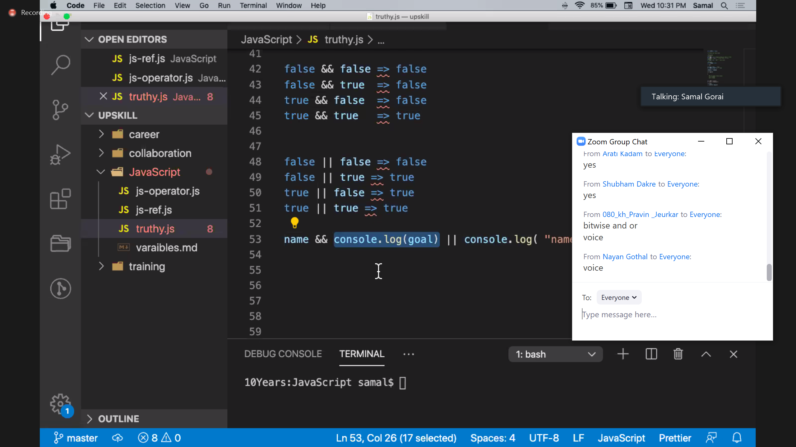

var I,add=0;

var arr=[34,"35",,35,"25",76,"",89,null];

for(i=0;i<8;i++)

{

If(!!arr[i])

{

Add=add+arr[i];

}

Else

Break;

};

While(arr[i])

{

Total+=arr[i]

I+=1

}

