**Q1. Difference between ES5 & ES6 variable? What are their properties?**

=>

In ES5 Daclare with var keyword where ES6 Let and Const keyword used.

In ES5 hoisting is possible where in ES6 hoisting is not possible

In ES5 redeclaration and reassigning is possible but in ES6 with Let keyword we can reassigning multiple times but we cannot redeclare again and with respect to const keyword once we can declare any value with variable we cannot reassign or redeclare the value.

In ES5 var has a functional scope while in ES6 let and const has lexical or block scope

e.g. functional scope

a=10;

function scope()

{

a=20;

console.log(a);

}

Var a;

Lexical scope or block scope:

Let scope{

Let scope

{

Let scope

{

}

}

}

**Q2. What is EcmaScript ?**

ECMAScript is an simple standard for JavaScript and adding new features to JavaScript.ECMAScript is a subset of JavaScript. JavaScript is basically ECMAScript at its core but builds upon it. Languages such as ActionScript, JavaScript, JScript all use ECMAScript as its core.

**Q3. Difference between let & const in ES6?**

* Let and const keyword use in ES6.
* Functionality of both let and const are almost same only the difference is In let we can assign multiple times but in const we cannot reassign.
* Both does not support redaclaration and hoisting
* With const it is compulsory to assigning value while declaring variable but with respect to let it is not compulsory.

**Q4. What will be the output of console 1st, 2nd and 3rd and explain the**

**occurance of value a & b at each step.**

1. let a = 2;
2. let b = 4;

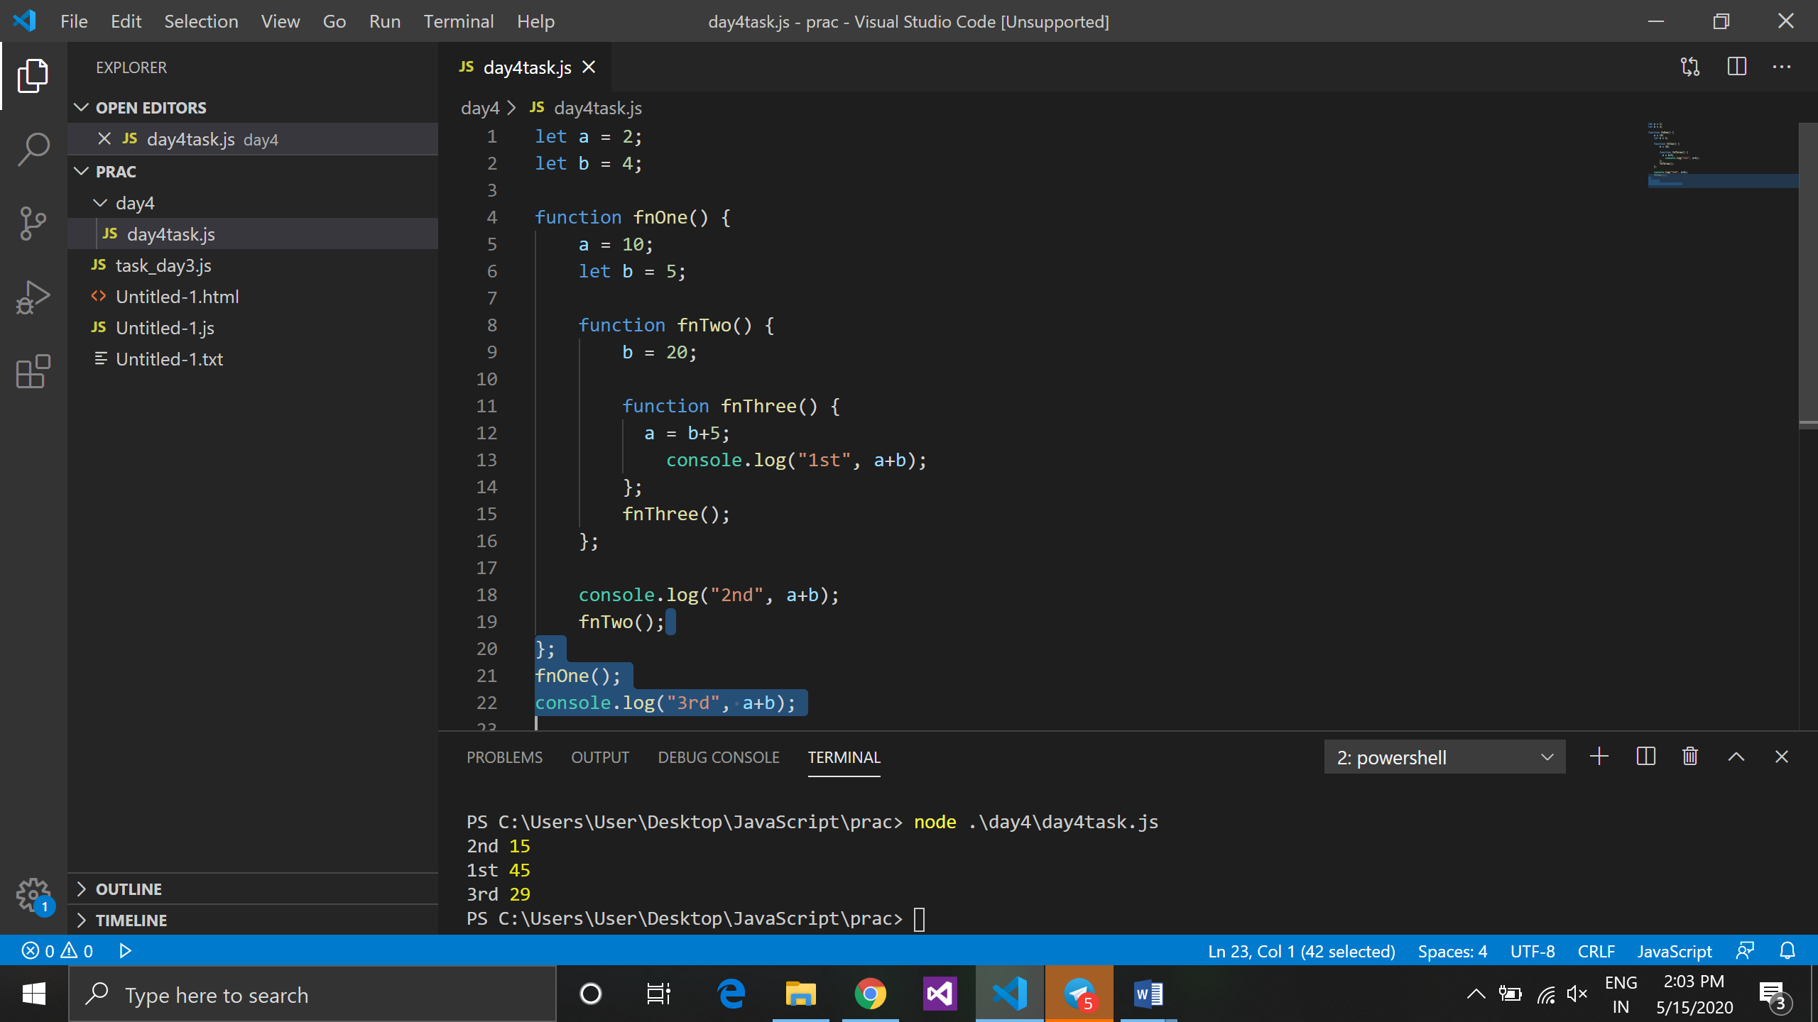

1. function fnOne() {
2. a = 10;
3. let b = 5;
4. function fnTwo() {
5. b = 20;
6. function fnThree() {
7. a = b+5;
8. console.log("1st", a+b);
9. };
10. fnThree();
11. };
12. console.log("2nd", a+b);
13. fnTwo();
14. };
15. fnOne();
16. console.log("3rd", a+b);

=>

at line no. 10 means 1st ans is 45 because a became a 25 at line no. 9 and b’s value is already assigned that is 20 so a+b=20+25=45.

Then at line no. 14 means 2nd value is 15 because a a is assigned as value 10 and b as 5 so the addition will be 15.

Then at line no. 18 3rd ans is 29 because the value of a is override with a=2 and now its became a 20 and the value of b is 4 so the ans will be 29.

******************************************************************************

1. let a = 5;

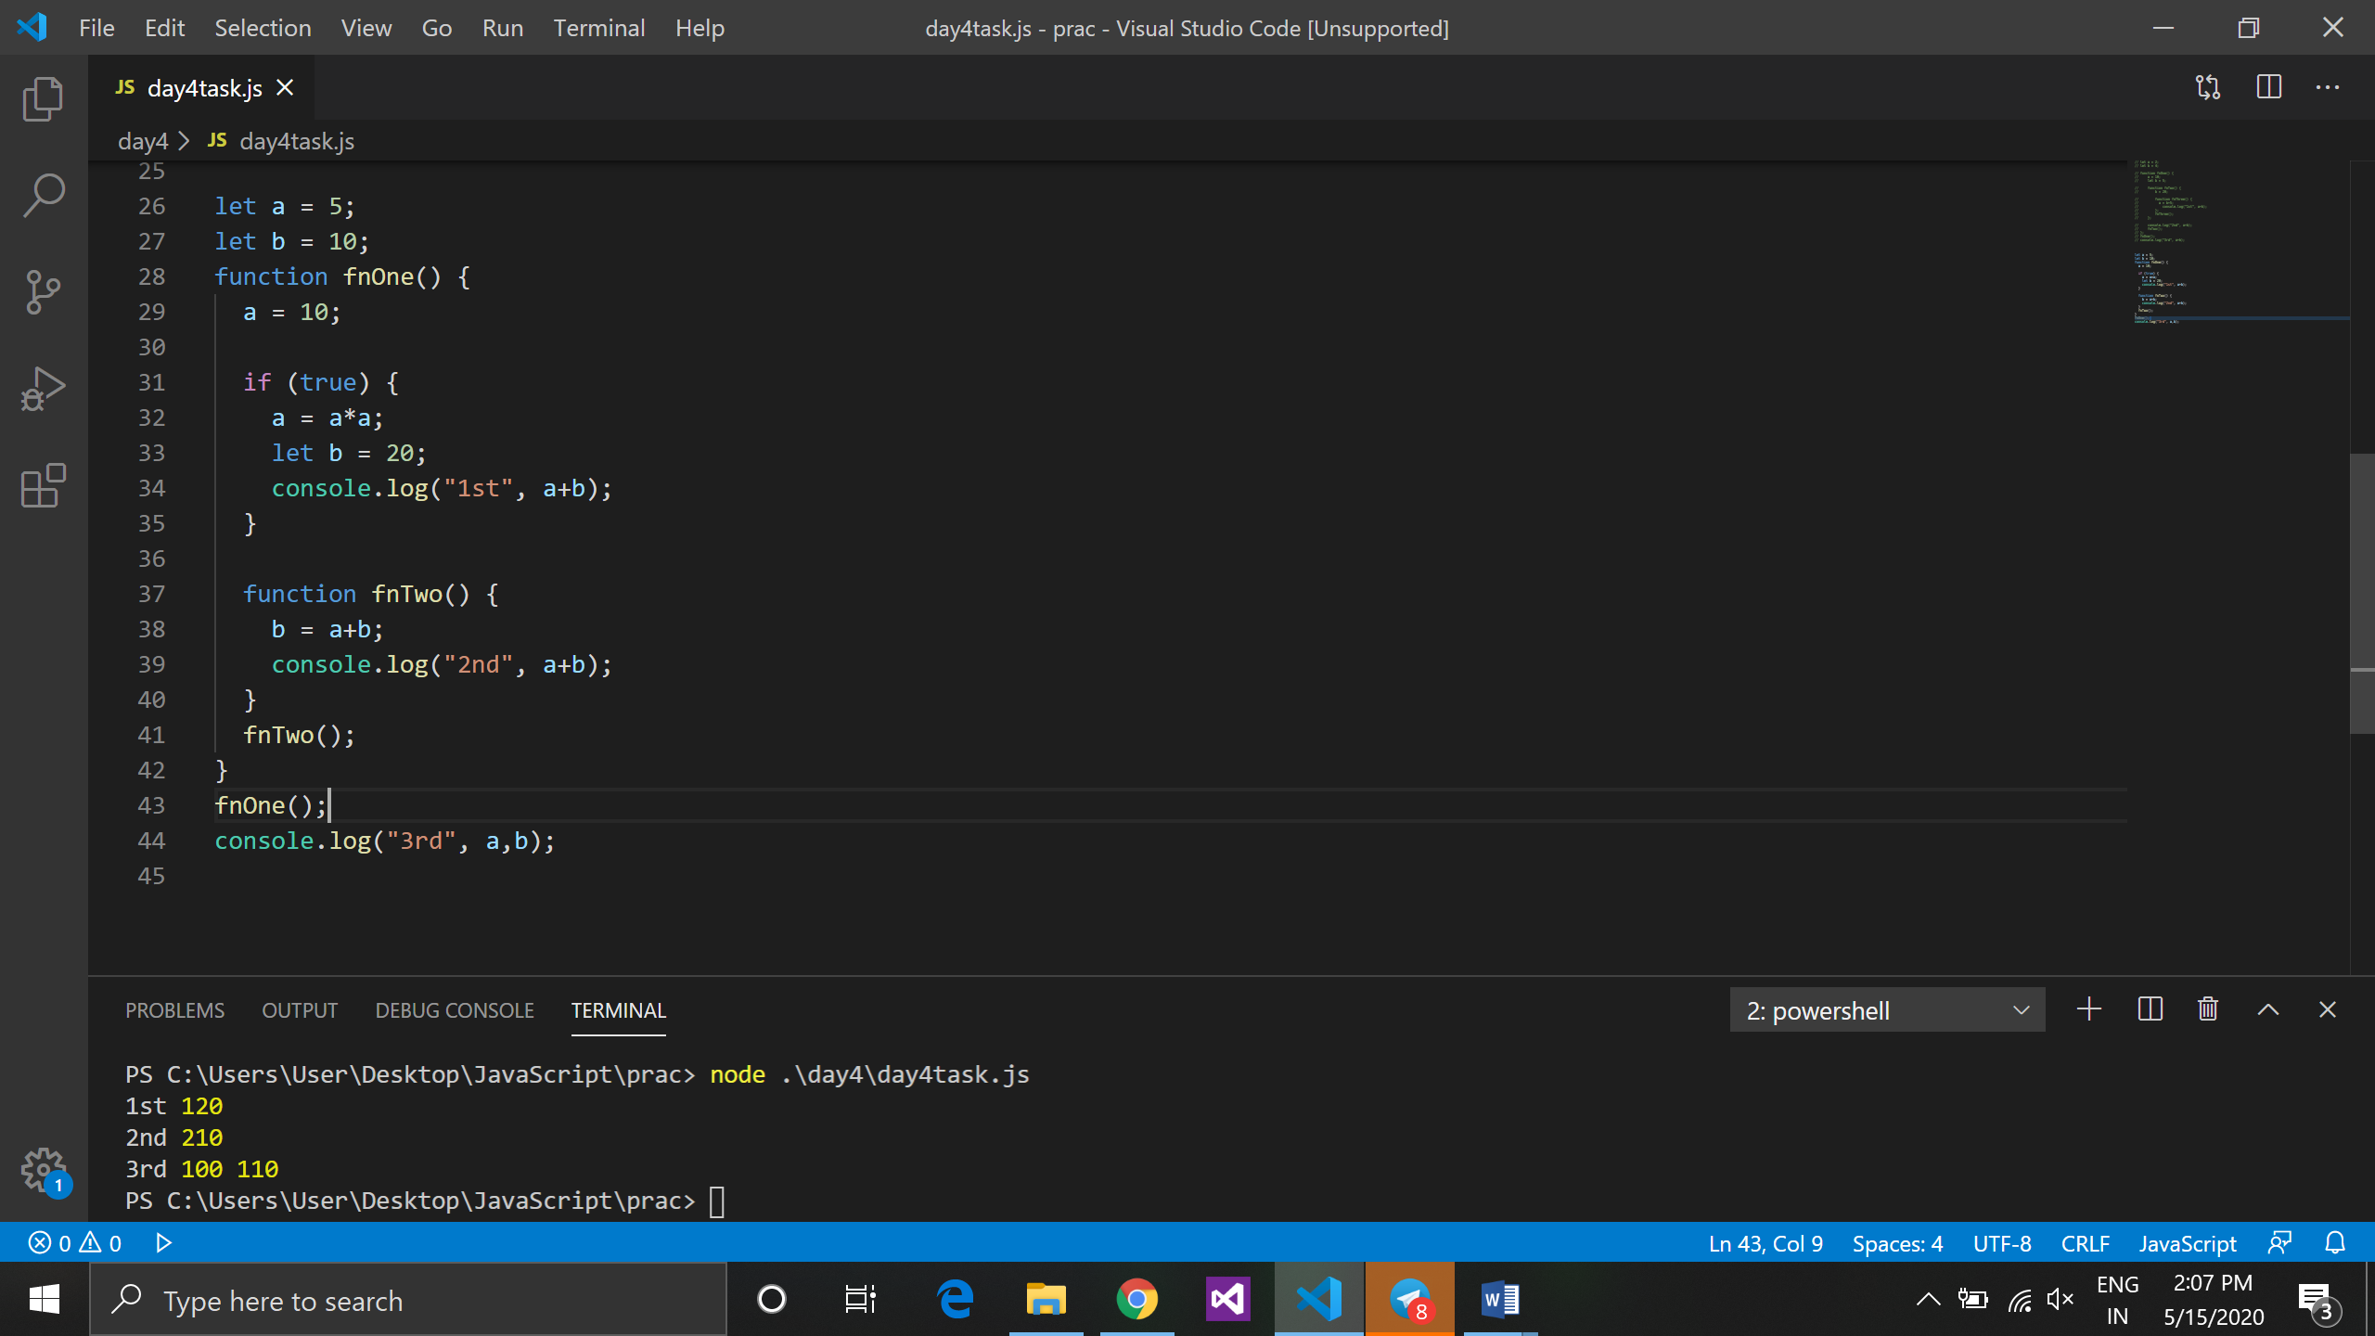

1. let b = 10;
2. function fnOne() {
3. a = 10;
4. if (true) {
5. a = a*a;
6. let b = 20;
7. console.log("1st", a+b);
8. }
9. function fnTwo() {
10. b = a+b;
11. console.log("2nd", a+b);
12. }
13. fnTwo();
14. }
15. fnOne();
16. console.log("3rd", a,b);

=>

at first both a and b will be declared as 5 and 10,after that a will be reassigned to 10,then in if condition a again reassign to 100, so at line no. 26 means 1st ans is 120 (a=100 & b=20).

In fntwo(), b will become a 110 (in fnOne() b=20 will not get override) so the value of a=100 and b=10.

At last,3rd the value of a=100 and b=110,because value of a is override with a=5 from fnOne() and the value of b is override with b=10 from funTwo().