**1.Affine Rectification**

The problemof affine rectification of a plane, i.e., the problem of transforming an image by a homography so that the vanishing line of the plane becomes the line at infinity. It has various applications

* document processing
* detection of repetitive structures
* texture analysis

The plane of interest appears in the rectified images as if viewed by an affine camera (projected by a set of parallel rays and scaled).

The restoration of affine properties like parallelism and global scale simplifies subsequent application-dependent processing steps like geometric normalization, detection and recognition.

A general and simple algorithm for affine rectification of a plane exploits knowledge of relative scale changes in the local neighbourhood of image points lying in the plane.

The rectifying transformation is fully specified by the relative scale change at three non-collinear points.

This method also applies for two pairs of points the relative scale change is known; the relative scale change between the pairs is not required.

A situation in which the relative scale change is known at different points arises often in practice.

Example -The problem of affine rectification of a repeated pattern on a planar surface.

In a perspective image of the facade, the features detected on the windows in general vary in size (area).

In reality, it is common that (at least some of) the windows are of the same size.

The task addressed in the paper is to find a planar homographythat transforms the image of the facade so that all the window features cover the same area.

This proposed method has the following advantages: (generality) no assumptions are made about either the shape of the features or their mutual position.

features need not lie on a regular grid nor on lines and may be arbitrarily rotated.

(stability) the rectification is computed from ratios of areas, a very stable property insensitive to many image degradations such as discretization.

(simplicity) the rectification algorithm is simple, easy to implement and without parameters.

(linearity) the constraints on the scale change are expressed as linear constraints on the entries of the homography matrix that represents the transformation.

Linear constraints are very convenient as they can be used with minimal sets as well as in (algebraic) least squares solutions from all available data.

The derivation of the algorithm assumes that the features are sufficiently small so that their scale change reasonably approximates the scale change at corresponding points.

An assumption is made by wide-baseline matching approaches using affine covariant feature points or affine invariant feature descriptors.

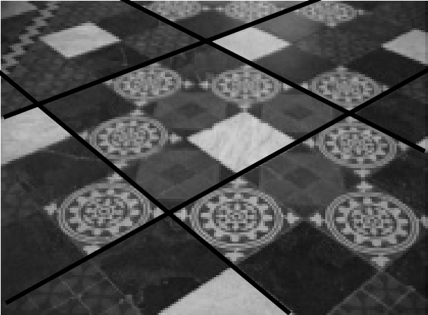

Original image

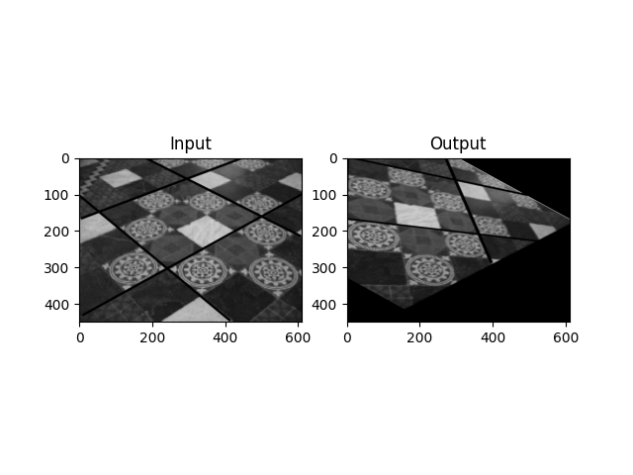

Rectification using an affine transformation

**2. The Gold Standard algorithm for estimating pointfrom world to image point correspondences**

**Objective**

Given n ≥ 6 world to image point correspondences {Xi ↔ xi}, determine the Maximum Likelihood estimate of the camera projection matrix P, i.e. the P which minimizes i d(xi, PXi)2.

**Algorithm (i) Linear solution.**

**(a) Normalization:** Use a similarity transformation T to normalize the image points, and a second similarity transformation U to normalize the space points. Suppose the normalized image points are x˜i = Txi, and the normalized space points are X˜ i = UXi.

**(b) DLT:** Form the 2n × 12 matrix A by stacking the equations (7.2) generated by each correspondence X˜ i ↔ x˜i. Write p for the vector containing the entries of the matrix P˜. A solution of Ap = 0, subject to p = 1, is obtained from the unit singular vector of A corresponding to the smallest singular value.

**(ii) Minimize geometric error.** Using the linear estimate as a starting point minimize the geometric error (7.4):

(xi , P˜X˜i)2

over P˜, using an iterative algorithm such as Levenberg–Marquardt.

**(iii) Demoralization.** The camera matrix for the original (unnormalized) coordinates is obtained from P˜ as

P = T−1PU˜ .

**3. Estimation of Affine Camera**

Consider what happens as we apply a cinematographic technique of tracking back while zooming in, in such a way as to keep objects of interest the same size1. We are going to model this process by taking the limit as both the focal length and principal axis distance of the camera from the object increase.

In analyzing this technique, we start with a finite projective camera. The camera matrix may be written as

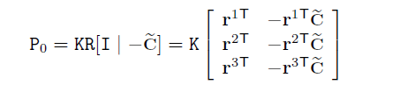

where **r**iT is the i-th row of the rotation matrix. This camera is located at position _**C** and

has orientation denoted by matrix R and internal parameters matrix K of the form given in (6.10–p157). From section 6.2.1 the principal ray of the camera is in the direction of the vector **r**3, and the value d0 = −**r**3T_**C** is the distance of the world origin from the camera centre in the direction of the principal ray.

Now, we consider what happens if the camera centre is moved backwards along the principal ray at unit speed for a time t, so that the centre of the camera is moved to _**C**− t**r**3. Replacing _**C** in by _**C** − t**r**3 gives the camera matrix at time t:

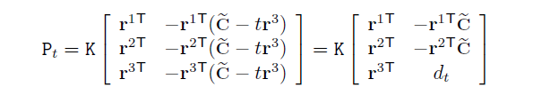

where the terms **r**iT**r**3 are zero for i= 1, 2 because R is a rotation matrix. The scalar

dt = −**r**3T_**C** + t is the depth of the world origin with respect to the camera centre in

the direction of the principal ray **r**3 of the camera. Thus

The effect of tracking along the principal ray is to replace the (3,4) entry of the matrix by the depth dt of the camera centre from the world origin.

Next, we consider zooming such that the camera focal length is increased by a factor k.

This magnifies the image by a factor k. It is shown in section 8.4.1 that the effect of zooming by a factor k is to multiply the calibration matrix K on the right by diag(k, k, 1).

Now, we combine the effects of tracking and zooming. We suppose that the magnification factor is k = dt/d0 so that the image size remains fixed.

The resulting camera matrix at time t , is

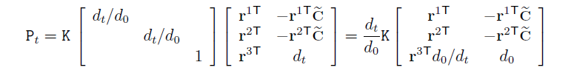

and one can ignore the factor dt/d0. When t = 0, the camera matrix Pt corresponds . Now, in the limit as dt tends to infinity, this matrix becomes

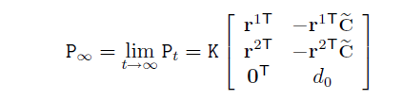

which is just the original camera matrix with the first three entries of the last row set to zero. From definition 6.3 P∞ is an instance of an affine camera.