2021101113_pvalue_Homework

Gowlapalli Rohit

13/2/2024

Table of Contents

p_values <- c(0.0050, 0.0010, 0.0100, 0.0005, 0.0009, 0.0400, 0.0560, 0.0500,  
0.0480, 0.0130, 0.0370, 0.0430, 0.0020, 0.0250, 0.1100, 0.0700, 0.0800)  
p_values <- sort(p_values)  
p_bonferroni <- p.adjust(p_values, method = "bonferroni", n =  
length(p_values))  
p_hochberg <- p.adjust(p_values, method = "hochberg", n = length(p_values))  
print(p_values)

## [1] 0.0005 0.0009 0.0010 0.0020 0.0050 0.0100 0.0130 0.0250 0.0370 0.0400  
## [11] 0.0430 0.0480 0.0500 0.0560 0.0700 0.0800 0.1100

print(p_bonferroni)

## [1] 0.0085 0.0153 0.0170 0.0340 0.0850 0.1700 0.2210 0.4250 0.6290 0.6800  
## [11] 0.7310 0.8160 0.8500 0.9520 1.0000 1.0000 1.0000

print(p_hochberg)

## [1] 0.0085 0.0144 0.0150 0.0280 0.0650 0.1100 0.1100 0.1100 0.1100 0.1100  
## [11] 0.1100 0.1100 0.1100 0.1100 0.1100 0.1100 0.1100

library(reshape2)  
library(ggplot2)  
data <- data.frame(x = c(1, 2, 3, 4, 5, 6, 7, 8, 9, 10, 11, 12, 13, 14, 15,  
16, 17), y1 = p_values, y2 = p_bonferroni, y3 = p_hochberg, y4 = c(0.0500,  
0.0500, 0.0500, 0.0500, 0.0500, 0.0500, 0.0500, 0.0500, 0.0500, 0.0500,  
0.0500, 0.0500, 0.0500, 0.0500, 0.0500, 0.0500, 0.0500))  
gfg_plot <- ggplot(data, aes(x)) +  
geom_line(aes(y = y1), color = "blue") +  
geom_line(aes(y = y2), color = "red") +  
geom_line(aes(y = y3), color = "green")+  
geom_line(aes(y = y4), color = "black", linetype = "twodash")+labs(title="Question 1", x = "sorted outcomes", y = "p-values")  
  
print(gfg_plot)

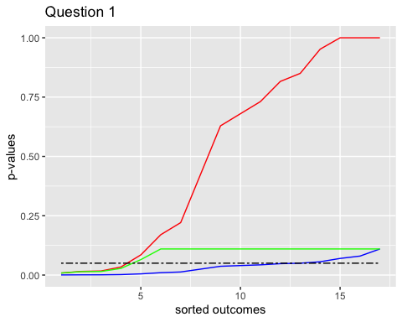 The following is the inference from the graph: High adjusted p values for the aforementioned tests indicate a lack of support for an impact. Bonferroni adjustment is more stringent since it yields larger adjusted p values. Because it correlates to lower adjusted p values for the experiment than our alpha, the Benjamini-Hochberg adjustment is less rigorous.