2021101113_Reliability_Class_Activity

Gowlapalli Rohit

13/2/2024

Table of Contents

# Advert Rating: Outlier Detection

library(readxl)  
data <- readxl::read_excel("BRSM_Assignment_Datasets.xlsx", sheet = 1)  
print(data)

## # A tibble: 110 × 26  
## A B C D E F G H I J K L M  
## <dbl> <dbl> <dbl> <dbl> <dbl> <dbl> <dbl> <dbl> <dbl> <dbl> <dbl> <dbl> <dbl>  
## 1 2 -1 -1 -1 -1 -1 4 -2 3 -2 -3 -1 -1  
## 2 -3 -2 -2 -3 -3 -4 -4 -2 -1 -3 -2 -4 -4  
## 3 2 3 1 0 -1 -1 2 -1 2 3 -3 -2 -3  
## 4 3 1 -1 -2 -1 -1 -4 -2 -3 0 -3 1 -3  
## 5 -2 3 -1 1 -1 1 -2 1 3 2 -3 1 -3  
## 6 -3 2 -2 0 -4 1 -2 -4 -1 -2 -3 -2 -2  
## 7 -1 -1 -2 -1 -3 -3 -3 -3 -1 -1 1 -3 -4  
## 8 -3 -3 -2 -4 -4 -4 -4 2 -4 -3 -3 -3 -4  
## 9 2 -1 -2 -3 -2 -2 -4 -3 -2 -3 -3 -2 -3  
## 10 3 4 -1 -1 -2 0 -2 3 -2 -2 -3 0 -2  
## # ℹ 100 more rows  
## # ℹ 13 more variables: N <dbl>, O <dbl>, P <dbl>, Q <dbl>, R <dbl>, S <dbl>,  
## # T <dbl>, U <dbl>, V <dbl>, W <dbl>, X <dbl>, Y <dbl>, Z <dbl>

library(reshape2)  
library(ggplot2)  
correlation_matrix <- round(cor(data), 2)  
melted_correlation <- melt(correlation_matrix)  
ggplot(data = melted_correlation, aes(x = Var1, y = Var2, fill = value)) +  
 geom_tile() +  
 geom_text(aes(label = value), size = 2) +  
 scale_fill_gradient2(low = "green", high = "black",  
 limit = c(-1, 1), name = "Pearson Correlation") +  
 theme(axis.text.x = element_text(angle = 90))

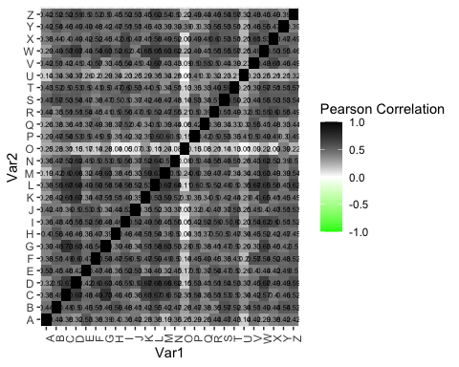

ratings <- data[, 1:26]  
correlation_matrix <- cor(ratings)  
heatmap(correlation_matrix,   
 symm = TRUE,   
 margins = c(12, 12),  
 main = "Correlation Heatmap of Ratings")

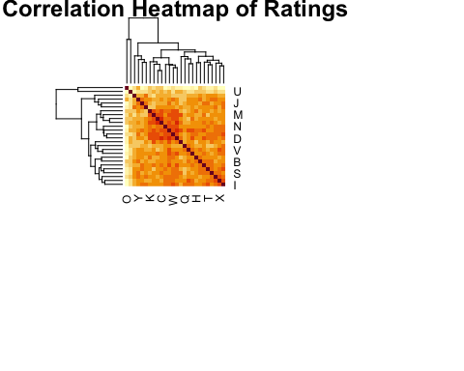

outlier <- which.min(apply(correlation_matrix, 1, function(x) sum(x)))  
outlier_label <- LETTERS[outlier]  
cat("Outlier participant:", outlier_label, "\n")

## Outlier participant: O

## Conclusion from the Correlation Heatmap

1. It’s evident from the correlation heatmap that participants labeled A through Z, except for O, exhibit positive correlations between them as anticipated, indicating similar rating patterns.
2. However, for participant O, it’s apparent that the correlations are consistently low, approaching zero in many instances. This suggests that participant O is an outlier, likely providing random ratings.

# Reliable Job: Internal Consistency

library(psych)  
data <- readxl::read_excel("BRSM_Assignment_Datasets.xlsx", sheet = 2)  
js_items <- data[, c("JS1", "JS2", "JS3", "JS4")]  
print(js_items)

## # A tibble: 30 × 4  
## JS1 JS2 JS3 JS4  
## <dbl> <dbl> <dbl> <dbl>  
## 1 9 9.5 9.75 7.88  
## 2 5 6.5 6.25 7.12  
## 3 4 5 3.5 6.75  
## 4 6 7 5.5 4.75  
## 5 7 7.5 6.75 7.38  
## 6 1 2.5 3.25 3.62  
## 7 1 5.5 7.75 7.88  
## 8 5 7.5 4.75 5.38  
## 9 6 4 3 2.5   
## 10 1 2.5 3.25 6.62  
## # ℹ 20 more rows

jp_items <- data[, c("JP1", "JP2", "JP3", "JP4")]  
print(jp_items)

## # A tibble: 30 × 4  
## JP1 JP2 JP3 JP4  
## <dbl> <dbl> <dbl> <dbl>  
## 1 1 1.5 1.75 4.88  
## 2 6 4 4 7   
## 3 5 6.5 5.25 4.62  
## 4 6 7 8.5 8.25  
## 5 6 5 4.5 9.25  
## 6 9 7.5 4.75 2.38  
## 7 8 8 6 5   
## 8 7 8.5 9.25 5.62  
## 9 2 3 6.5 5.25  
## 10 9 9.5 6.75 4.38  
## # ℹ 20 more rows

calculate_alpha <- function(items) {  
 cor_matrix <- cor(items, method = "spearman")  
 mean_corr <- mean(cor_matrix[lower.tri(cor_matrix)])  
 num_items <- ncol(items)  
 alpha <- (num_items * mean_corr) / (1 + (num_items - 1) * mean_corr)  
 return(alpha)  
}

alpha_js <- calculate_alpha(js_items)  
cat("Cronbach's Alpha for Job Satisfaction (JS):", alpha_js, "\n")

## Cronbach's Alpha for Job Satisfaction (JS): 0.8584497

cat("For Job Satisfaction (JS):\n")

## For Job Satisfaction (JS):

cat("Cronbach's Alpha:", alpha_js, "\n")

## Cronbach's Alpha: 0.8584497

if (alpha_js >= 0.7) {  
 cat("The internal consistency of the JS items is considered acceptable as Cronbach's Alpha is above 0.7.\n")  
} else {  
 cat("The internal consistency of the JS items is considered poor as Cronbach's Alpha is below 0.7.\n")  
  
}

## The internal consistency of the JS items is considered acceptable as Cronbach's Alpha is above 0.7.

alpha_jp <- calculate_alpha(jp_items)  
cat("Cronbach's Alpha for Job Performance (JP):", alpha_jp, "\n")

## Cronbach's Alpha for Job Performance (JP): 0.5242351

cat("\nFor Job Performance (JP):\n")

##   
## For Job Performance (JP):

cat("Cronbach's Alpha:", alpha_jp, "\n")

## Cronbach's Alpha: 0.5242351

if (alpha_jp >= 0.7) {  
 cat("The internal consistency of the JP items is considered acceptable as Cronbach's Alpha is above 0.7.\n")  
} else {  
 cat("The internal consistency of the JP items is considered poor as Cronbach's Alpha is below 0.7.\n")  
}

## The internal consistency of the JP items is considered poor as Cronbach's Alpha is below 0.7.

## Conclusions from the Cronbach alpha for Job Performance and Job Satisfaction.

1. We know that the Cronbach alpha ≥ 0.7 is treated as acceptable for internal consistency.
2. In the case of Job Satisfaction, Cronbach alpha = 0.858. Hence, the measure of Job satisfaction is acceptable.
3. But in the case of Job Performance, Cronbach alpha = 0.524. Hence, the measure of Job Performance is not acceptable.