Lab 1 R Basics

Student Name

9/1/2022

Table of Contents

# Lab 1 Lab Manual Exercise

copy and paste your work by following each example from the lab manual for this exercise

rm(list = setdiff(ls(), lsf.str()))  
# Vectors and Factors  
# Create a vector as input.  
data <- c("East","West","East","North","North","East","West","West","West","East","North")  
  
print(data)

## [1] "East" "West" "East" "North" "North" "East" "West" "West" "West"   
## [10] "East" "North"

print(is.factor(data))

## [1] FALSE

# Apply the factor function.  
factor_data <- factor(data)  
  
print(factor_data)

## [1] East West East North North East West West West East North  
## Levels: East North West

print(is.factor(factor_data))

## [1] TRUE

# Data frames  
# Create the vectors for data frame.  
height <- c(132,151,162,139,166,147,122)  
weight <- c(48,49,66,53,67,52,40)  
gender <- c("male","male","female","female","male","female","male")  
  
# Create the data frame.  
input_data <- data.frame(height,weight,gender)  
print(input_data)

## height weight gender  
## 1 132 48 male  
## 2 151 49 male  
## 3 162 66 female  
## 4 139 53 female  
## 5 166 67 male  
## 6 147 52 female  
## 7 122 40 male

# Test if the gender column is a factor.  
print(is.factor(input_data$gender))

## [1] FALSE

# Print the gender column so see the levels.  
print(input_data$gender)

## [1] "male" "male" "female" "female" "male" "female" "male"

# # Function Syntax  
#   
# function_name <- function(arg_1, arg_2, ...) {  
# Function body   
# }  
  
  
# Create a function with arguments.  
new.function <- function(a,b,c) {  
 result <- a * b + c  
 print(result)  
}  
  
# Call the function by position of arguments.  
new.function(5,3,11)

## [1] 26

# Call the function by names of the arguments.  
new.function(a = 11, b = 5, c = 3)

## [1] 58

# From Mariam Aly's tutorial  
##############################################################################  
## Factors  
##############################################################################  
# A factor is a vector object used to specify a discrete classification (grouping) of the components of other vectors of the same length.  
# can be ordered or unordered  
  
## Example for 'ragged arrays', which can have subclasses of different sizes  
# say you have 6 subjects and 3 conditions in your experiment  
# this is a list of the condition that each subject took part in  
condition=c('faces','scenes','objects','faces','scenes','objects')  
# can create a factor for condition  
conditionf=factor(condition) #use the factor() function  
# print to screen  
print(conditionf)

## [1] faces scenes objects faces scenes objects  
## Levels: faces objects scenes

# produces:   
# faces scenes objects faces scenes objects  
# Levels: faces objects scenes  
# can ask specifically for the levels of the factor  
levels(conditionf) # returns "faces" "objects" "scenes"

## [1] "faces" "objects" "scenes"

# you can then use the tapply() function to calculate things like the mean for a variable you have for each of your factors  
# continued from above  
accuracy=c(90,88,72,84,81,94) # accuracy for each of you 6 subjects, in the same order in which you input the conditions (i.e. f,s,o,f,s,o)  
  
# now calculate the mean accuracy for each condition using tapply()  
# this function takes this form: tapply(data,factor/index variable,function), where factor/index is the factor variable you created and function is what you want to do on the data  
# so if you want to see mean age for males and females, data=age, factor/index=gender, function=mean  
 # looks at data in the first variable as a function of different levels of the second variable  
# note that tapply() will work even if the second argument is not a factor, because the argument will be coerced into a factor when necessary (using as.factor())  
  
# e.g. calculate the mean  
condaccmeans=tapply(accuracy,conditionf,mean)  
print(condaccmeans)

## faces objects scenes   
## 87.0 83.0 84.5

# returns :  
# faces objects scenes   
 # 87.0 83.0 84.5   
 # would work if you use tapply(accuracy,condition,mean) because condition would be coerced into a factor  
   
# The function tapply() is used to apply a function, here mean(), to each group of components of the first argument, here accuracy, defined by the levels of the second component,here conditionf, as if they were separate vector structures. The result is a structure of the same length as the levels attribute of the factor containing the results.

# Lab 1 Generalization exercises

use the code from above to attempt to solve the extra things we ask you do for this assignment

View(cars)  
summary(cars)

## speed dist   
## Min. : 4.0 Min. : 2.00   
## 1st Qu.:12.0 1st Qu.: 26.00   
## Median :15.0 Median : 36.00   
## Mean :15.4 Mean : 42.98   
## 3rd Qu.:19.0 3rd Qu.: 56.00   
## Max. :25.0 Max. :120.00

plot(cars)

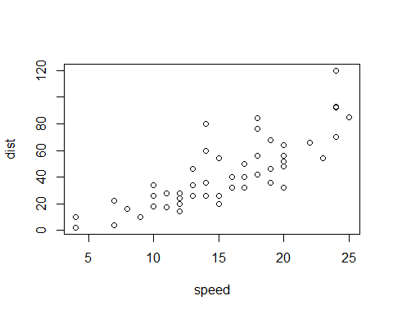

hist(cars$speed)

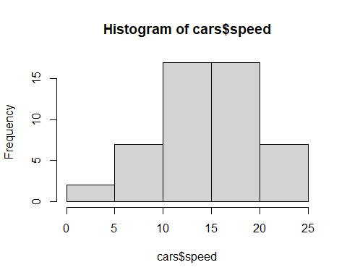

# Q1: what do you think is the relationship between speed and stopping distance based on the scatterplot? +, -, or no relationship? (use the plot function)  
# Q2: plot a histogram of car speeds (use hist)   
# Q3: what is the most frequent stopping distance in this dataset (an approx bin of distances is fine)?  
  
hist(cars$dist,10)

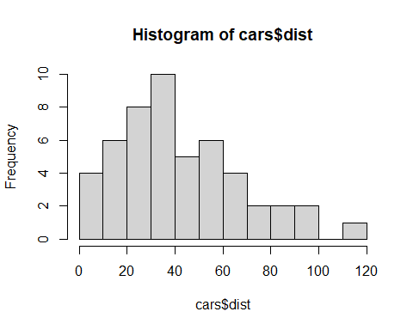 # Lab 1 Written answer question

# Grid of X-axis values  
x <- seq(-4, 4, 0.1)  
  
#-----------------------------------------  
# Same standard deviation, different mean  
#-----------------------------------------  
# Mean 0, sd 1  
plot(x, dnorm(x, mean = 1, sd = 0.1), type = "l",  
 ylim = c(0, 10), ylab = "", lwd = 2, col = "red")  
# Mean 3, sd 1  
lines(x, dnorm(x, mean = 3, sd = 1), col = "blue", lty = 1, lwd = 2)

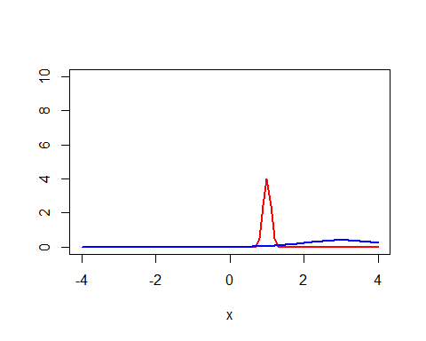

Write your answer here.