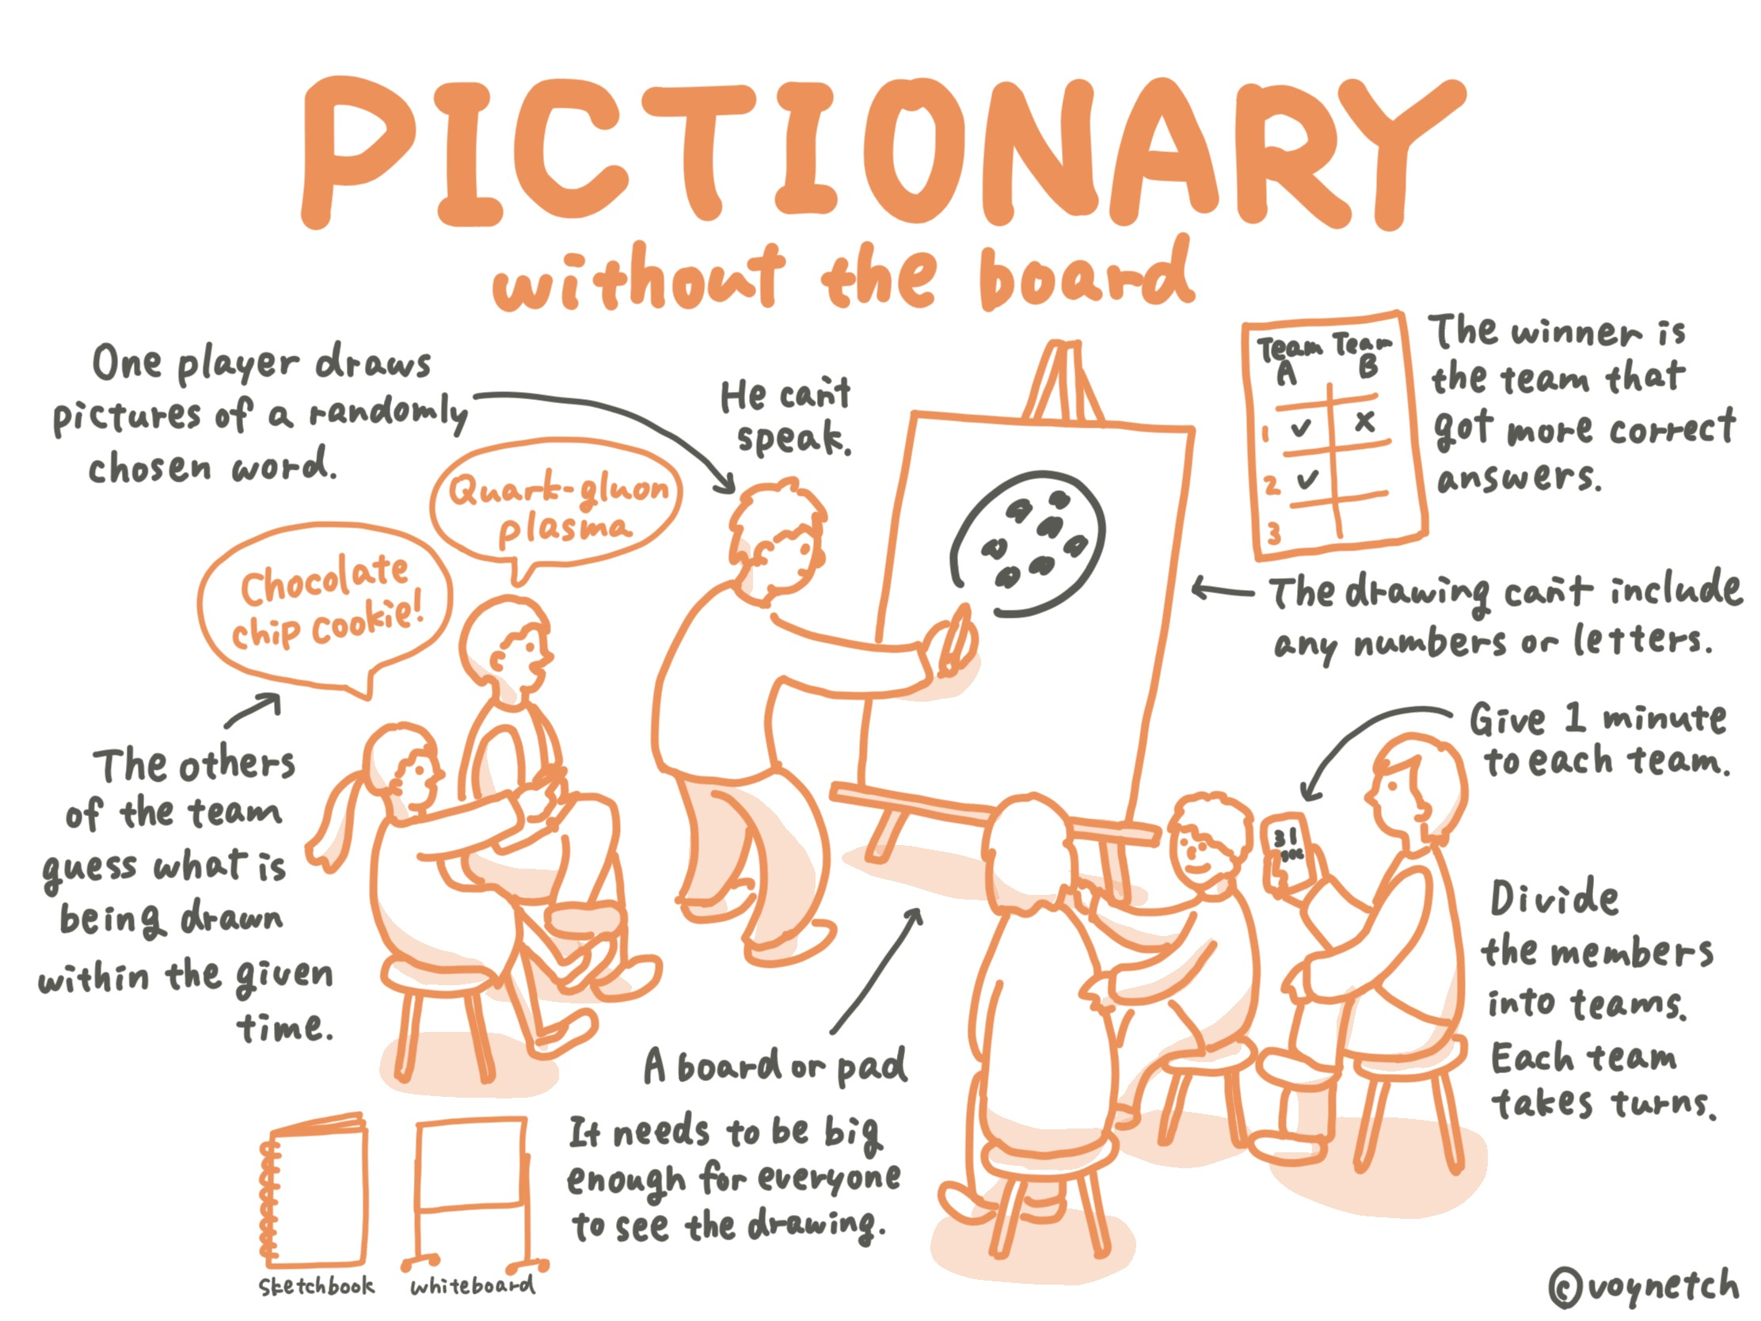

You have been provided a dataset of an online version of Pictionary game sessions. The players are assigned a Drawer or a Guesser role. The Drawer is tasked with conveying a given target phrase to a counterpart Guesser by sketching on a whiteboard within a time limit of 120 seconds. For the Drawer, the game interface provides a canvas with tools to draw, erase and highlight locations for emphasis. In addition, thumbs up and thumbs down , buttons enable Drawer to provide ‘hot/cold’ feedback on guesses. For the Guesser, a text box is provided for entering guess phrases. A question button is provided to the Guesser for conveying that the canvas contents are not informative and confusing. The canvas strokes are timestamped and stored in Scalable Vector Graphic (SVG) format for efficiency. In addition to canvas strokes (drawing and erasure related), guesses and secondary feedback activities mentioned previously (thumbs up, thumbs down, question mark, highlight) are also recorded with timestamps as part of the game session.

To characterize player behavior and interactive gameplay, we selected attributes that describe the player’s actions and game interactions (see Table below). For a player in Drawer’s role, we consider all sessions of the player in this role. For each Drawer attribute, the median attribute value across the sessions is considered the aggregated attribute score. A similar procedure is used to obtain the player’s Guesser aggregated attribute scores by considering all the sessions with the player in Guesser’s role.

Two CSV files (drawer_attributes.csv and guesser_attributes.csv) contain the values of these attributes. In drawer_attributes.csv file the first column is the Drawer ID and the next eight columns are the Drawer attributes. Similarly, in guesser_attributes.csv file the first column in Guesser ID followed by six Guesser attributes

