A
Project Report
On
POWERXCHANGE
AN ANDROID CLEAN ENERGY EXCHANGE APPLICATION

Academic Year 2026-2027
Under the Guidance of
Dr. Preetjot Kaur
Submitted by
Rohit Bhatt [Sap Id: 70022400811]
Sayan Biswas [Sap Id: 70022400663]
School of Technology Management and Engineering
SVKM’s NMIMS (Deemed-to-be-University)
Chandigarh

Table of Contents
S. No. | Title | Page
1 | Introduction | 1
2 | Problem statement and objectives | 2
3 | Scope and user requirements | 3-4
4 | Application design and navigation | 5-6
5 | Technical architecture and implementation | 7-8
6 | Data storage and transaction behavior | 9-11
7 | Security, privacy and operational boundaries | 12
8 | Verification and evaluation | 13-14
9 | Limitations and recommendations | 15
10 | Rubric alignment | 16-17
11 | Individual contribution | 18-19
12 | Conclusion | 20
– | References | 21-22
– | Appendix | 23-27

1. Introduction
PowerXchange is a native Android application prototype that presents a digital exchange for renewable energy. Its user-facing design combines energy listings with a wallet, shared buying, barter, and delivery coordination. This combination makes the project useful for examining how a mobile application can represent a multi-party service rather than a single-purpose information screen.
The project should be understood as a local demonstration. Account records, listings, wallet balances, orders, rules, and delivery tasks are stored in a SQLite database on the device. The code does not connect separate installations to a central marketplace. Likewise, the payment screens operate against seeded demo-card records and do not contact a payment provider. These boundaries shape the report’s claims about the application’s current operation.
The analysis is based on the Android manifest, Gradle configuration, Java source, XML layouts, and the project test source files in the supplied archive. The separate project rubric is used to organize the academic evaluation. The report describes implemented behavior separately from development recommendations so that the current prototype is not confused with a production service [1, 2].

1.1 Project overview
PowerXchange serves three kinds of participant. Consumers browse the marketplace and buy energy. Prosumers publish their own surplus and may also buy, join pools, or propose barter exchanges. Delivery partners accept the resulting delivery tasks and confirm them with a code. Around these roles the application offers a filtered marketplace, a wallet with a transaction ledger, community pools, barter offers, automated purchase rules, order tracking, and a profile that summarizes delivered energy and estimated CO2 impact.
The project is a prototype built to demonstrate mobile-development concepts. Java activities and fragments present the screens, a SQLite database holds the records, SharedPreferences keeps the signed-in user, and WorkManager runs periodic background checks for automated rules and stale pools.

1.2 Organization of this report
Section 2 sets out the problem statement and objectives. Section 3 defines the scope, user roles, and functional requirements visible in the code. Sections 4 to 6 describe the navigation, the technical architecture, and the data and transaction behavior. Section 7 reviews security, privacy, and operational boundaries, and Section 8 reports the verification evidence and the issues found by code inspection. Section 9 lists limitations and recommendations, Section 10 maps the project to the rubric, Section 11 records individual contribution, and Section 12 concludes. The appendix provides space for application screenshots. Statements about behavior are drawn from the supplied source, and gaps such as missing user research are stated rather than assumed.

2. Problem statement and objectives

2.1 Project problem framing
The application frames the problem as a coordination gap between people who can offer surplus clean energy and people who want to purchase it. Buyers need to discover supply and understand the cost of energy and delivery. Prosumers need a way to publish an offer and manage transactions. A third participant may need to carry out and confirm physical delivery. PowerXchange models these tasks in one application.
This problem statement is inferred from implemented screens and workflows. The supplied archive does not include interviews, surveys, field measurements, or a separate needs-assessment report. Therefore, the code shows what problem the developers chose to address, but it does not by itself demonstrate that the target users validated the problem or the proposed design.

2.2 Aim and objectives
The project aim is to design and implement an Android prototype that demonstrates local clean-energy exchange from listing creation through buyer checkout and delivery confirmation.
- Provide role-based entry for consumers, prosumers, and delivery partners.
- Display available energy listings with energy type, quantity, price, and location.
- Represent wallet debits, seller credits, delivery-fee allocation, and transaction history.
- Model shared pool participation, barter offers, and automated purchase rules.
- Track delivery work from availability through verification with a six-digit code.
- Present buyer and seller activity through profile metrics and impact indicators.

2.3 Stakeholder needs
Three stakeholder groups can be identified from the implemented roles. The needs below are inferred from the screens and workflows in the code, not from user research.
- Consumers need to see what energy is available, what it costs including delivery, and whether their wallet can cover the purchase. The marketplace filters, the checkout summary, and the wallet balance check address this need.
- Prosumers need to publish surplus energy and receive payment when it is sold. Listing creation, seller credits, and the sales view in the orders screen address this need.
- Delivery partners need to find work, accept it, confirm it, and be paid. The delivery dashboard queues, the six-digit confirmation code, and the earnings and withdrawal screens address this need.

3. Scope and user requirements

3.1 User roles
Role | Primary actions supported | Access boundary
Consumer | Browse listings, purchase energy, join pools, set auto-buy rules, view orders and profile. | Barter screen is hidden in the main navigation.
Prosumer | Publish listings, buy energy, create or join pools, propose or accept barter, review sales and impact. | Corporate or individual identity is selected during registration.
Delivery partner | View available work, accept a task, mark pickup, enter the delivery code, view earnings, withdraw wallet credits. | Routed to a separate delivery dashboard.

Table 1. Role capabilities implemented in the application source.

3.2 Functional requirements represented in code
Requirement | Application behavior
Account access | Local registration and login use an email and password. A local session stores the signed-in user ID.
Marketplace | Available listings can be filtered by energy type and corporate seller. Prosumers can create a listing.
Checkout | The app computes energy price and delivery fee, checks the wallet balance, creates a trade and opens a delivery task.
Community pool | A user can reserve a share of a listing; other users can join until full. Expiry and early close paths exist.
Barter | A prosumer can offer one energy type for another. Acceptance creates two delivery legs.
Automation | Rules match listing type and maximum price. Matching listings can trigger a wallet purchase and a history entry.
Delivery | A partner accepts a task, marks pickup, and confirms delivery with the generated code.
Profile | The app calculates delivered-energy totals, CO2 estimates, badges, and a monthly impact chart.

3.3 Non-functional and environmental assumptions
The app targets Android API level 37, sets minimum SDK 24, and uses Java 11 compatibility. The project includes AndroidX AppCompat, Material Components, ConstraintLayout, RecyclerView, CardView, and WorkManager dependencies. The manifest requests internet and notification permissions, but no remote API client or network call was found in the reviewed source. A network permission alone does not provide online marketplace synchronization.

4. Application design and navigation

4.1 Authentication and routing
LoginActivity is the launcher activity. Users can sign in or register, select a role, and, for corporate prosumers, select a company from a fixed list. On a successful login, the repository saves the user ID in SharedPreferences. Delivery users are routed to DeliveryDashboardActivity. Consumers and prosumers are routed to MainActivity.

4.2 Main navigation and screens
Screen | Main interaction | Implementation
Marketplace | Filter energy listings, publish surplus, buy or create a pool. | MarketplaceFragment and EnergyListingAdapter
Community Pools | Switch between open pools and the signed-in user’s pools; join or close early. | JoinPoolFragment and PoolsAdapter
Auto-Buy Rules | Add, toggle, or delete rules; review purchase history; schedule background work. | MyRulesFragment and AutoRulesAdapter
Barter Exchange | Create and review prosumer exchange offers; accept an offer to create delivery legs. | SwapRequestFragment and barter repository methods
Orders | Review active buyer orders, barter legs, or prosumer sales and delivery status. | OrdersFragment and OrdersAdapter
Profile and Wallet | Review wallet and impact metrics; add or withdraw demo credits; log out. | ProfileFragment and credit activities
Delivery dashboard | Work queues, delivery actions, partner balance, withdrawals, and earnings. | DeliveryDashboardActivity and DeliveryTaskAdapter

Table 2. Screen map and principal implementation classes.
The main navigation is defined in bottom_nav_menu.xml and wired by MainActivity. Consumers do not see the barter destination. Prosumer users have a buyer-orders and seller-sales tab in OrdersFragment. The delivery dashboard uses separate tabs for available, active, delivered, and earnings views. Orders are refreshed periodically while the order screen is active.

4.3 Typical user journeys
A typical consumer journey begins at LoginActivity, where the user signs in and is routed to MainActivity. From the marketplace the consumer filters listings by energy type, selects a listing, and reaches the checkout screen. After the purchase the app shows a six-digit delivery code. A delivery partner then accepts the task, marks it picked up, and enters the buyer’s code. The Orders screen follows the delivery status, and the profile reflects the completed delivery in its energy totals.

5. Technical architecture and implementation

5.1 Application layers
Layer | Responsibilities | Representative code
Presentation | Activities and fragments bind screen state, inputs, lists, and navigation. | LoginActivity, MainActivity, MarketplaceFragment, DeliveryDashboardActivity
Application and data logic | Repositories enforce business rules and coordinate database operations. | SQLiteRepository, WalletRepository
Persistence | SQLite stores domain records; SharedPreferences stores the local session. | DatabaseHelper, SQLiteRepository
Background execution | WorkManager runs periodic checks for rules and stale pools. | AutoTradeWorker, MyRulesFragment

Table 3. High-level architecture derived from the project source.

5.2 Main technologies
The project uses Java activities and fragments with XML layouts. RecyclerView adapters render listings, pools, orders, barter offers, auto-buy rules, and delivery tasks. Material Components provide the visual controls. SQLiteOpenHelper creates and upgrades the local database. WorkManager supports persistent periodic work. GreenImpactChartView draws the profile’s monthly impact display using calculated repository data.

5.3 Repository responsibilities
SQLiteRepository is the central application repository. It handles login and registration, listing queries, purchases, delivery task state, pool lifecycle, barter acceptance, automated rules, order queries, and profile totals. WalletRepository isolates balance adjustments, transfers, demo card loads and withdrawals, and wallet transaction records. Config contains market-price constants, delivery-fee constants, CO2 factors, company choices, formatting methods, and password hashing.
This organization keeps many business operations outside the screen classes, but transaction boundaries are uneven. Barter acceptance uses one database transaction for its two legs and fee debits. A regular purchase instead invokes wallet methods and updates the listing and trade/delivery tables as separate operations. The resulting purchase sequence can leave partial state if a later database write fails.

5.4 Design rationale
Placing business rules in repositories rather than in activities has practical benefits for a project of this size. A fee calculation, a wallet adjustment, or a pool transition is written once and reused by every screen that needs it. Constants such as market prices, delivery-fee values, and CO2 factors are held in Config, so a change to one value affects every screen that depends on it.

6. Data storage and transaction behavior

6.1 Local database model
Entity | Stored information | Purpose
users | Identity, role, company, city, wallet balance, profile totals | Local accounts and participant roles
listings | Seller, energy type, unit, quantity, unit price, location, status | Marketplace inventory
trades | Buyer, seller, energy quantity, prices, delivery code, timestamp, order type | Purchase, pool, and barter trade records
deliveries | Trade link, sender, receiver, route, fee allocation, status, partner and timestamps | Fulfillment lifecycle
pools and pool_members | Listing, creator, total and joined quantity, member payment and code | Group purchase reservation and membership
barters | Creator, offered and wanted energy, note, location, accepter and status | Energy exchange offers
auto_rules and auto_buy_history | User rule thresholds and execution outcomes | Automated buying behavior
wallet_transactions and demo_cards | Wallet change, type, reference; seeded card details and balance | Wallet audit trail and simulated payment source

Table 4. Principal SQLite entities and their purpose.

6.2 Marketplace purchase flow
A buyer selects an available listing and reaches a checkout screen. The checkout currently uses the listing’s full remaining quantity. The repository also has a partial-purchase method, primarily used by auto-buy rules. The energy amount is quantity multiplied by unit price. The default estimated distance is 5 km, and the fee formula is ₹15 plus ₹3 per kilometre. At that distance, delivery costs ₹30. The code allocates 20 percent of that fee to the platform and 80 percent to the delivery partner.
For example, the seeded Solar listing of 120 kWh at ₹2.34 per kWh produces an energy amount of ₹280.80. Adding the default ₹30 delivery fee produces a ₹310.80 buyer total. The repository transfers the energy amount from buyer to seller, debits the delivery fee, reduces listing quantity, generates a six-digit code, and inserts a trade and delivery record. The app shows the code to the buyer after purchase.

6.3 Wallet behavior
WalletRepository records balance changes as wallet transaction rows and rejects a balance adjustment that would create a negative wallet. Transfers debit the buyer and credit the seller. Delivery completion credits the delivery partner’s share. Add-credit and withdrawal screens validate details against local demo card rows and move balances between the card record and user wallet. They do not authorize or settle a real payment.

6.4 Community pools
A pool is created from an available listing. The creator pays for an initial share and a delivery fee; the remaining share is reserved for later participants. Additional users can join if they have not already joined and the requested quantity fits the remaining amount. When the pool fills, the repository creates one trade and one delivery task for each member. If a pool expires, the code refunds each member’s recorded energy payment and delivery fee and reopens the unjoined quantity. A creator can also close early, release the unjoined quantity, and finalize deliveries for existing members.

6.5 Barter and delivery
A barter offer records the creator’s offered energy and requested energy. Accepting an open offer creates two linked barter trades and two delivery tasks, one for each direction. Both participants pay a delivery fee. The delivery partner can accept a task, mark it picked up, and complete it with the delivery code. After both barter legs are delivered, the barter status becomes completed. The delivery partner receives the partner share recorded for the delivery.

6.6 Automated buying and impact metrics
Users define an energy type, maximum price, and maximum quantity for an auto-buy rule. When a new listing is published, the repository checks matching rules immediately. A user can also schedule a periodic WorkManager job that checks active rules across available listings and expires stale pools. The history table records purchases and low-balance skips.
Profile metrics query completed deliveries. The repository estimates avoided CO2 using fixed factors in Config for Solar, Wind, Battery, and Biogas. The profile shows buyer totals, seller totals for prosumers, badges based on trade/pool thresholds, and monthly data for a six-month chart. These values are modelled estimates based on fixed factors, not measured grid emissions or metered energy readings.

6.7 Consistency and traceability
Each purchase leaves a trail across several tables. The wallet_transactions rows record balance changes, the trades table records the sale, and the deliveries table records the fulfillment task and its fee allocation. This makes it possible to follow a single purchase from the buyer’s wallet to the seller’s credit and on to the delivery partner’s share. The same trail is the basis for checking correctness. After any flow, the wallet balances, transaction rows, listing quantity, trade record, and delivery task should agree with one another. Because regular purchases update these tables as separate actions, a reconciliation of this kind is the practical way to detect an interrupted operation until the flow is wrapped in a single transaction.

7. Security, privacy and operational boundaries
The current implementation is a demonstration architecture and has material security and operational limitations:
- Passwords are hashed with SHA-256 but without a per-user salt or a password-specific key-derivation function. Authentication occurs entirely on the device.
- The database stores demo card numbers, expiry dates, card type, and CVV in local SQLite. The source comments identify these records as demo-only and point to a payment gateway as a production replacement.
- SharedPreferences session state and the SQLite database are local to one installation. The app has no server identity, synchronization, authoritative ledger, or cross-device marketplace.
- The six-digit delivery code is stored in the local database and compared in local code. It is a prototype handoff mechanism, not a server-verified proof of delivery.
- The manifest requests INTERNET permission, but no online service calls were identified in the supplied source.
- The app’s transaction workflows do not all use one atomic database transaction, so concurrent or interrupted operations require stronger consistency controls before real use.
Production deployment would require secure authentication, server-side authorization and inventory control, encrypted payment-provider integration, audit logging, privacy and retention policies, and operational monitoring. These are recommendations, not features present in the supplied project.

7.1 Why these boundaries matter
Each boundary above is a reasonable simplification for a demonstration that runs on one device. They matter because the screens present wallet balances, card details, and delivery confirmation in a way that resembles a real service, so a reader could assume protections that the code does not provide.

7.2 Controls to prioritize
If the project were extended beyond a demonstration, the following controls would address the boundaries identified in this section. They are recommendations and are not present in the supplied source.
- Store passwords with a per-user salt and a password-specific key-derivation function, and move authentication to a server.
- Replace stored card details with a tokenized payment-provider flow, and stop storing the card verification value.
- Hold identity, listing availability, the wallet ledger, and delivery state on a backend service with server-side authorization.
- Verify delivery codes on the server so that confirmation does not depend on a value stored and compared on the device.
- Wrap purchase, pool, and barter operations in single database transactions with rollback on failure.

8. Verification and evaluation

8.1 Source-level findings
The project archive contains an example unit test that checks 2 + 2 = 4 and an example instrumentation test that checks the application package name. These are framework examples rather than tests of the marketplace, wallet, pools, barter, delivery, or auto-buy logic. This report did not run a new test suite. Accordingly, the presence of implementation code should not be read as proof that every user flow has been validated on a device.

8.2 Issues identified by code inspection
Finding | Observed behavior | Effect
Seeded listing ownership | All nine sample listings use seller_id 1, including rows whose seller_name identifies other organizations or individuals. | The seeded prosumer account appears to own every sample listing; other buyers credit that one account as seller.
Pool inventory reservation | Pool creation reduces the listing by the unjoined quantity, leaving the creator’s paid share in the marketplace quantity. Early close then adds released quantity back. | The visible inventory can include quantities already committed to pool members.
Purchase atomicity | Wallet movements, listing reduction, trade insertion, and delivery insertion are separate repository actions. | A failure between steps can leave balances and records inconsistent.
QR scan screen | A QR scan layout and icons exist, but no scanner activity, scanner dependency, or manifest entry was found. | QR scanning is not an available app flow; delivery uses manual code entry.

Table 5. Material gaps identified through source inspection.

8.3 Recommended demonstration acceptance checks
Before a live demonstration, the team should verify the main flows on a clean install using seeded accounts. The checks below are a proposed demonstration plan and are not reported as completed tests.
- Sign in as a consumer and confirm marketplace filters and listing details.
- Complete a purchase and compare wallet balances, transaction rows, listing quantity, order record, and delivery task.
- Sign in as a delivery partner, accept the available task, mark pickup, and complete it using the buyer’s code.
- Create a pool, join with another account, and verify quantity reservation, fee debits, completion deliveries, and expiry refunds.
- Create a barter offer, accept it from another prosumer, and complete both delivery legs.
- Publish a listing that meets an active rule and confirm the resulting trade and auto-buy history.
- Repeat the purchase and pool cases after correcting inventory ownership and reservation behavior.

9. Limitations and recommendations

9.1 Current limitations
The app has no external user-research evidence, real energy-meter integration, external marketplace, online messaging, or production payment service. Prices, estimated distances, delivery shares, and CO2 factors are constants. Pool and delivery actions depend on local records. These choices make the prototype suitable for demonstrating interaction and business logic, but they do not establish a service that can operate across independent users or verify real energy delivery.

9.2 Recommended development priorities
- Validate the target need with consumers, prosumers, and delivery participants, then document the method and findings.
- Correct the demo seed records so each listing is linked to the account that actually sells it.
- Reserve the full pool quantity atomically when a pool is opened, and use conditional database updates to prevent overselling.
- Wrap purchase debits, quantity updates, trade creation, and delivery creation in a single transaction with rollback on failure.
- Move identity, listing availability, wallet ledger, delivery state, and authorization to a backend service before supporting multiple devices.
- Replace stored demo card details with a tokenized payment-provider flow and remove card CVV storage.
- Add domain tests for fees, wallet invariants, pool transitions, duplicate acceptance, delivery-code mismatch, and auto-buy rules.
- Add a genuine QR-scanning workflow only if QR-based delivery confirmation is a project requirement.
These priorities address both the application’s product evidence and its technical reliability. The first priority matters to the rubric’s problem-analysis criterion. The data and transaction fixes matter to the workable-application criterion. Feature tests and accurate demo evidence would make the presentation and viva easier to evaluate.

9.3 Presenting the limitations
The limitations above are best presented openly. A prototype that states its boundaries clearly is easier to evaluate than one that appears to claim more than it delivers. During the presentation or viva the team should be ready to explain each of the following points:
- The marketplace, wallet, and delivery records are local to one installation, and no backend connects separate devices.
- The two known defects, seeded listing ownership and pool inventory reservation, and the planned correction for each.
- The included tests are framework examples, and the demonstration checks in Section 8.3 are a proposed plan rather than completed results.

10. Rubric alignment
The provided rubric assigns 40 marks across five categories. The table below maps those categories to evidence visible in the supplied app and to evidence the student should present. It does not predict or claim a score [1].
Rubric category | Weight | Evidence in this project | Evidence to provide in submission
Originality of problem statement and user needs | 5 | A defined clean-energy exchange workflow is visible in listings, pools, barter, and delivery. | Add documented user research or credible source evidence; describe the selected user need and why the app addresses it.
Self-learning / new logic or component | 5 | WorkManager scheduling, pool expiry/refunds, two-leg barter, wallet ledger, and delivery-code workflow. | Explain which components were learned and implemented by the team, with code or commit evidence.
Standardized workable application | 10 | Multiple roles, screens, local database schema, transaction flows, and a packaged Android app are present. | Demonstrate integrated flows and explain limitations. Resolve seeded ownership and pool inventory defects; provide feature-level test evidence.
Individual contribution | 10 | The source archive contains project-wide code but does not attribute files or commits to individual students. | Name the modules personally completed, show commits/screenshots, explain a problem solved, and document team coordination.
Viva / presentation / demo | 10 | The project supports a walkthrough from login through purchase and delivery, plus pools, barter, rules, and profile. | Present one end-to-end flow, explain architecture and calculations, and answer questions about local-only storage and known defects.

Table 6. Project evidence mapped to the five rubric criteria.

10.1 Using the evidence
The middle column of Table 6 shows what the source already supports, and the last column shows what the submission still needs to supply. Code on its own does not satisfy every criterion. The problem statement needs user or source evidence, the individual-contribution criterion needs student-specific artifacts, and the demonstration criterion needs a rehearsed walkthrough.

10.2 Pre-submission checklist
- Add at least one piece of documented user research or credible source evidence for the problem statement.
- Explain which components were newly learned and implemented, such as WorkManager scheduling, pool expiry and refunds, and the two-leg barter flow.
- Run the end-to-end flow on a clean installation and capture screenshots for the appendix.
- Correct the seeded ownership and pool inventory defects, or state them as known issues with a planned fix.
- Complete the individual-contribution table in Section 11 for each student.
- Prepare short answers on local-only storage, the architecture, and the fee and CO2 calculations.

11. Individual contribution
Complete this section with accurate student-specific information before submission. The supplied source archive does not identify which student implemented each module.
Required detail | Rohit Bhatt (70022400811) | Sayan Biswas (70022400663)
Student name and role | Rohit Bhatt, Android developer: authentication, marketplace and wallet | Sayan Biswas, Android developer: pools, barter, automation and delivery
Modules or screens implemented | LoginActivity and MainActivity (sign-in, registration, role routing, bottom navigation); MarketplaceFragment and TradeConfirmFragment (listings, filters, checkout); WalletRepository; AddCreditsActivity and WithdrawCreditsActivity | JoinPoolFragment (community pools); SwapRequestFragment (barter); MyRulesFragment and AutoTradeWorker (auto-buy rules, WorkManager); DeliveryDashboardActivity; OrdersFragment and ProfileFragment
Evidence | Demo: sign in as consumer, filter the Solar listing, check out (₹280.80 energy + ₹30 fee = ₹310.80), then show the wallet transaction rows. Commit IDs: [paste]. Screenshots: Appendix. | Demo: create a pool, join it from a second account, then accept a barter and complete both delivery legs. Delivery partner enters the six-digit code. Commit IDs: [paste]. Screenshots: Appendix.
Technical problem solved | [Confirm]: stopping a purchase from overdrawing the wallet. The balance is checked first, and WalletRepository rejects any adjustment that would go negative. | [Confirm]: stopping a pool member from joining twice or over-filling a pool. The join checks that the user has not joined and that the quantity fits the remaining amount. Expired pools are refunded.
Team contribution | Integrated the wallet and checkout flow with the delivery task created by Sayan's dashboard; reviewed fee calculations. | Integrated pool and barter trades with the wallet methods; tested end-to-end flows with Rohit's checkout.

The strongest contribution evidence connects a specific task to a verifiable artifact and explains the student’s own decisions. Team-level feature descriptions alone may not establish individual contribution under the rubric.

11.1 Guidance for completing the entry
Each student should complete the table above separately and keep the entries specific and verifiable. The following points help make an entry credible:
- Name the classes, layouts, or screens personally completed, rather than describing the whole application.
- Link each claim to an artifact such as a commit, a screenshot, or a short demonstration step.
- Describe one real technical problem, how it was diagnosed, and how it was resolved.
- Explain the decisions made, for example why a rule was placed in a repository or why a value was kept in Config.
- Describe how work was divided, reviewed, and integrated with the other team member.
The supplied archive does not attribute files or commits to individual students, so this evidence must come from the students themselves.

11.2 How the entry is assessed
The rubric assigns 10 marks to individual contribution, which is the same weight as the working application and the viva. An entry is stronger when it connects four things: the task the student took on, the artifact that proves it, the decision the student made, and the result that followed. For example, a student who implemented the pool-expiry refund logic would name the repository method, point to the commit or screenshot, explain why refunds are issued when a pool expires, and show the wallet rows that result.
Where two students worked on the same module, each entry should state which part was personally written and which part was shared. Honest, specific entries are easier to verify during the viva than broad claims about the whole project.

12. Conclusion
PowerXchange is a broad Android prototype for modelling a local clean-energy marketplace. It connects account roles to energy listings, wallet accounting, shared pools, barter, automated purchase rules, delivery tasks, and profile impact metrics. Its implementation demonstrates practical mobile-development concepts, including Java activities and fragments, SQLite persistence, repositories, RecyclerView adapters, and WorkManager.
The current design remains a local simulation. It does not synchronize users through a backend or settle real payments, and its sample ownership and pool reservation behavior require correction. The supplied test classes are framework examples rather than feature tests. A strong university submission should therefore explain both what the code implements and what remains unverified, support the problem statement with user evidence, and provide specific proof of each student’s contribution.

12.1 Key observations
- The project connects three participant roles through one coherent flow, from listing to checkout to delivery confirmation.
- Pools, barter, automated rules, and the impact profile extend the basic marketplace with additional business logic.
- The architecture separates screens, repositories, and persistence, although transaction boundaries are uneven.
- The verification evidence is limited, and two defects were identified by code inspection.

12.2 Future work
The most valuable next steps follow the priorities in Section 9.2. In order, they are to validate the problem with real users, correct the ownership and inventory defects, make purchase operations atomic, add feature-level tests, and move identity, inventory, and the wallet ledger to a backend service. Replacing stored demo card details with a tokenized payment flow would complete the move from a local demonstration toward a reliable trading service.

12.3 Closing remarks
As a Mobile Application Development project, PowerXchange shows that a small team can model a multi-party service on a single device. It exercises role-based routing, a relational local database, repository-based business logic, background scheduling, and list-driven interfaces. Its main value as a university submission lies in the breadth of flows it implements and in the clarity with which its boundaries can be explained.
The project will be most convincing when the demonstration is rehearsed, the known defects are acknowledged, and the claims in the report are matched to evidence that can be shown on screen.

References
[1] MAD Project Rubrics 2026. “Project Rubrics (40 Marks),” supplied course rubric, 2 pages.
[2] PowerXchange2 Android project source archive, supplied for project analysis. Java and resource files are cited by class or resource name in this report.
Selected source files consulted: AndroidManifest.xml; app/build.gradle.kts; DatabaseHelper.java; SQLiteRepository.java; WalletRepository.java; Config.java; LoginActivity.java; MainActivity.java; MarketplaceFragment.java; TradeConfirmFragment.java; JoinPoolFragment.java; MyRulesFragment.java; AutoTradeWorker.java; SwapRequestFragment.java; OrdersFragment.java; ProfileFragment.java; DeliveryDashboardActivity.java; AddCreditsActivity.java; WithdrawCreditsActivity.java; ExampleUnitTest.java; ExampleInstrumentedTest.java.
Source file | Role in this report
AndroidManifest.xml; app/build.gradle.kts | Launcher activity, permissions, SDK levels, and dependencies (Sections 3.3, 4.1)
DatabaseHelper.java | Local database schema, seeded listings, and demo accounts (Sections 6.1, 8.2)
SQLiteRepository.java | Central business logic: login, listings, purchases, pools, barter, rules, orders (Section 5.3)
WalletRepository.java | Balance adjustments, transfers, card loads, withdrawals, and wallet rows (Section 6.3)
Config.java | Market-price, delivery-fee, and CO2 constants (Sections 5.3, 6.6)
LoginActivity.java; MainActivity.java | Sign-in, registration, role routing, and main navigation (Section 4)
MarketplaceFragment.java; TradeConfirmFragment.java | Listing filters, publishing, and checkout (Section 6.2)
JoinPoolFragment.java | Community pool creation, joining, and early close (Section 6.4)
MyRulesFragment.java; AutoTradeWorker.java | Automated purchase rules and periodic background checks (Section 6.6)
SwapRequestFragment.java | Barter offers and acceptance (Section 6.5)
OrdersFragment.java; ProfileFragment.java | Order tracking, profile metrics, and impact display (Sections 4.2, 6.6)
DeliveryDashboardActivity.java | Delivery queues, pickup, code confirmation, and earnings (Section 6.5)
AddCreditsActivity.java; WithdrawCreditsActivity.java | Demo credit loading and withdrawal (Section 6.3)
ExampleUnitTest.java; ExampleInstrumentedTest.java | Framework example tests (Section 8.1)
Table 7. Source files and where they are discussed in this report.

Appendix
Login Signup Withdraw And Add Credits
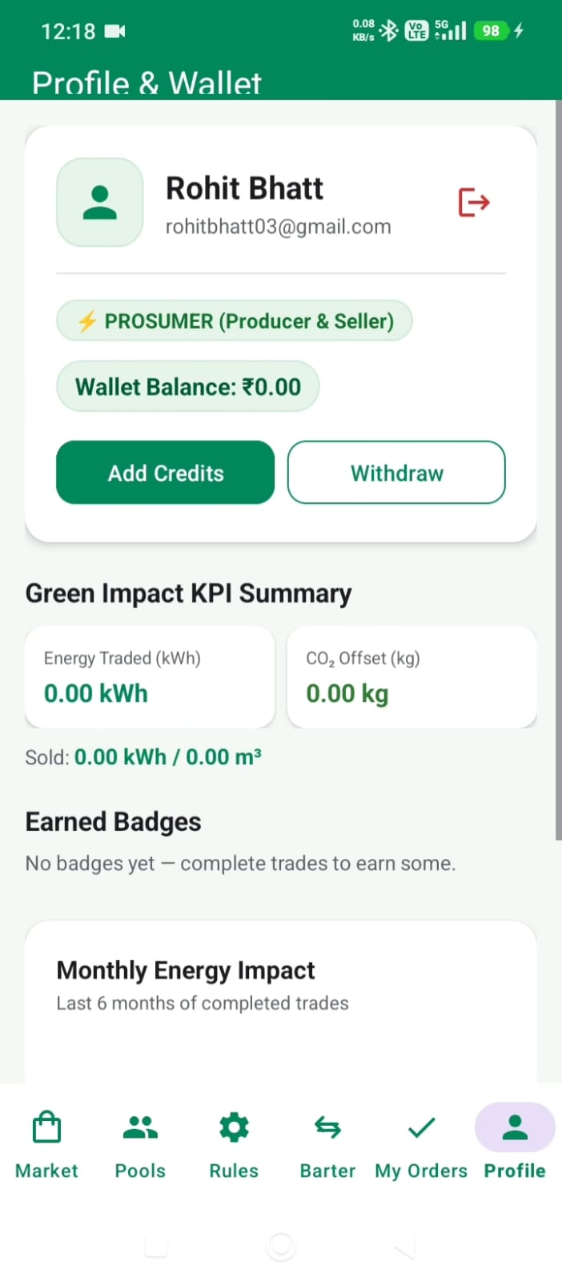
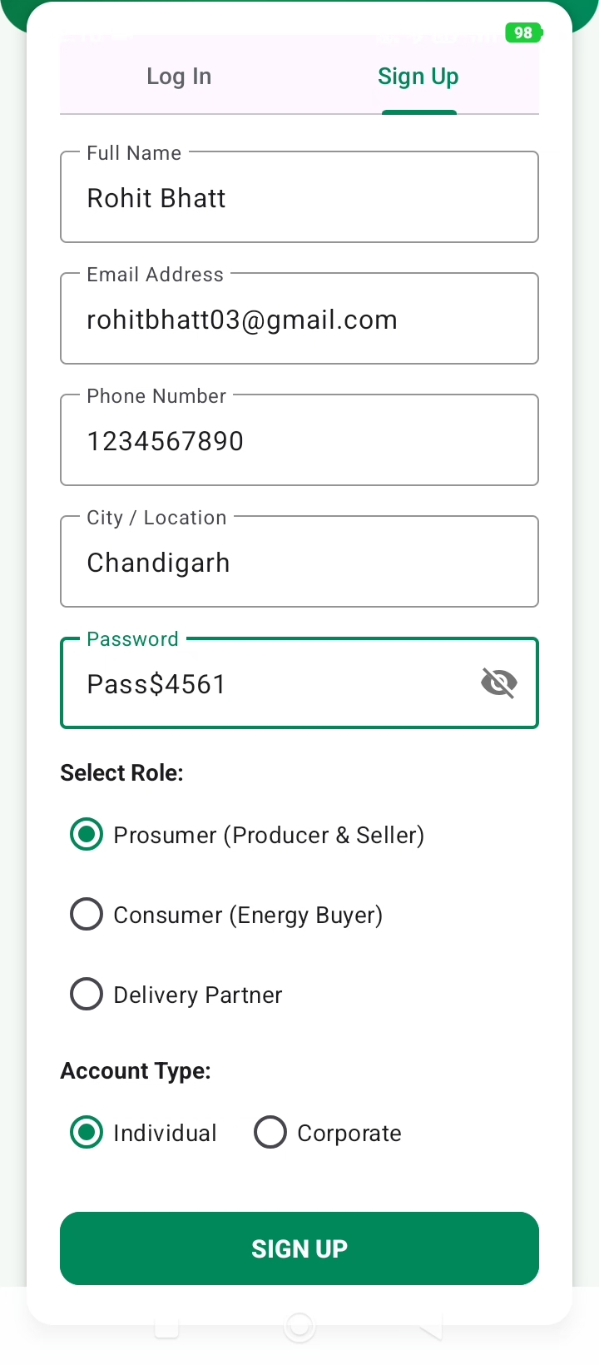
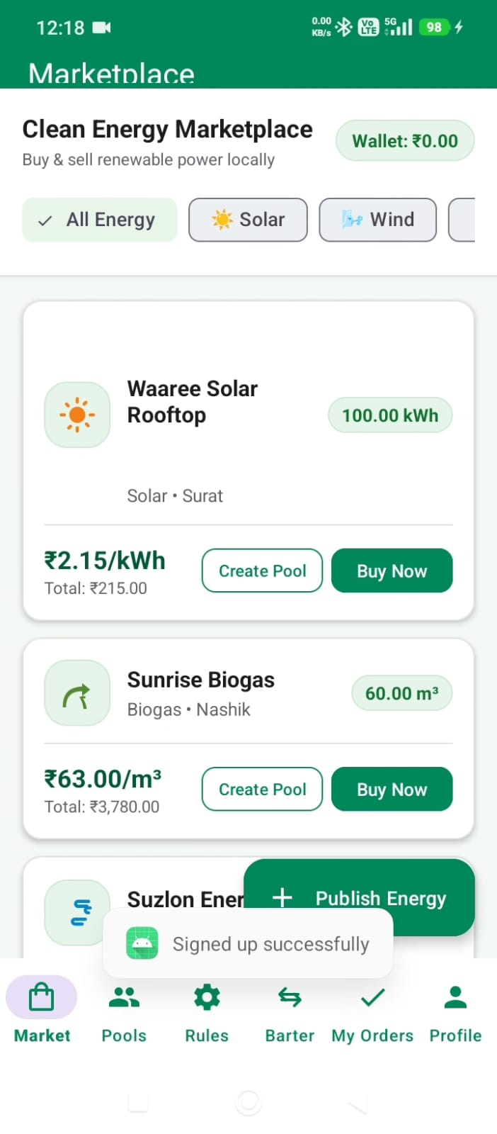

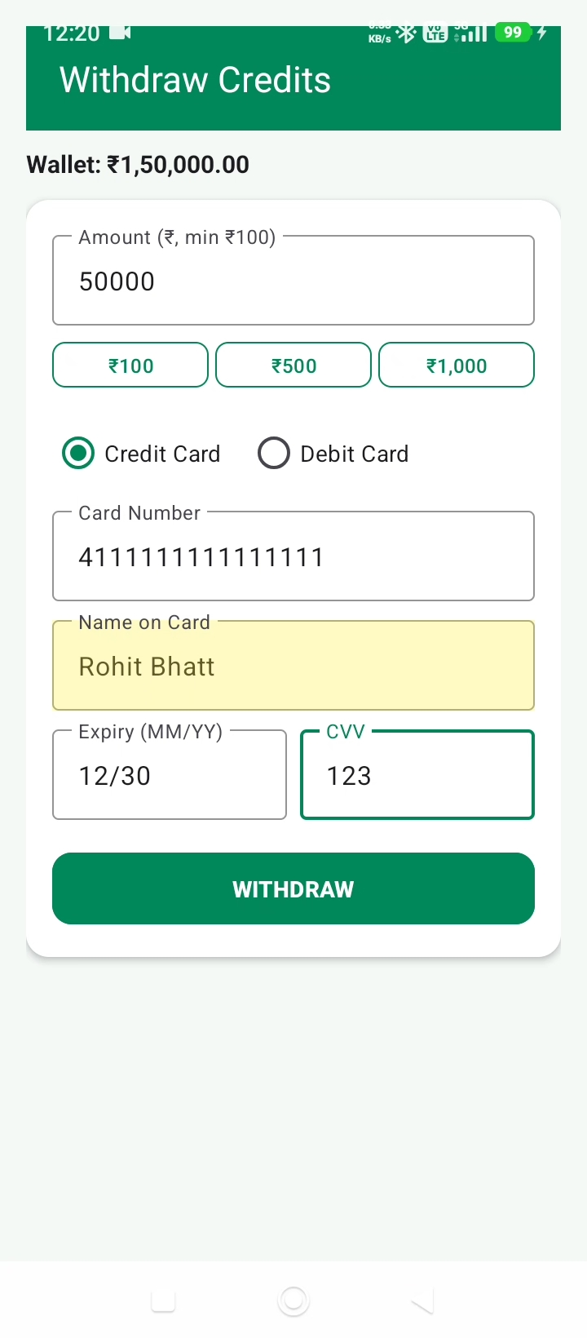
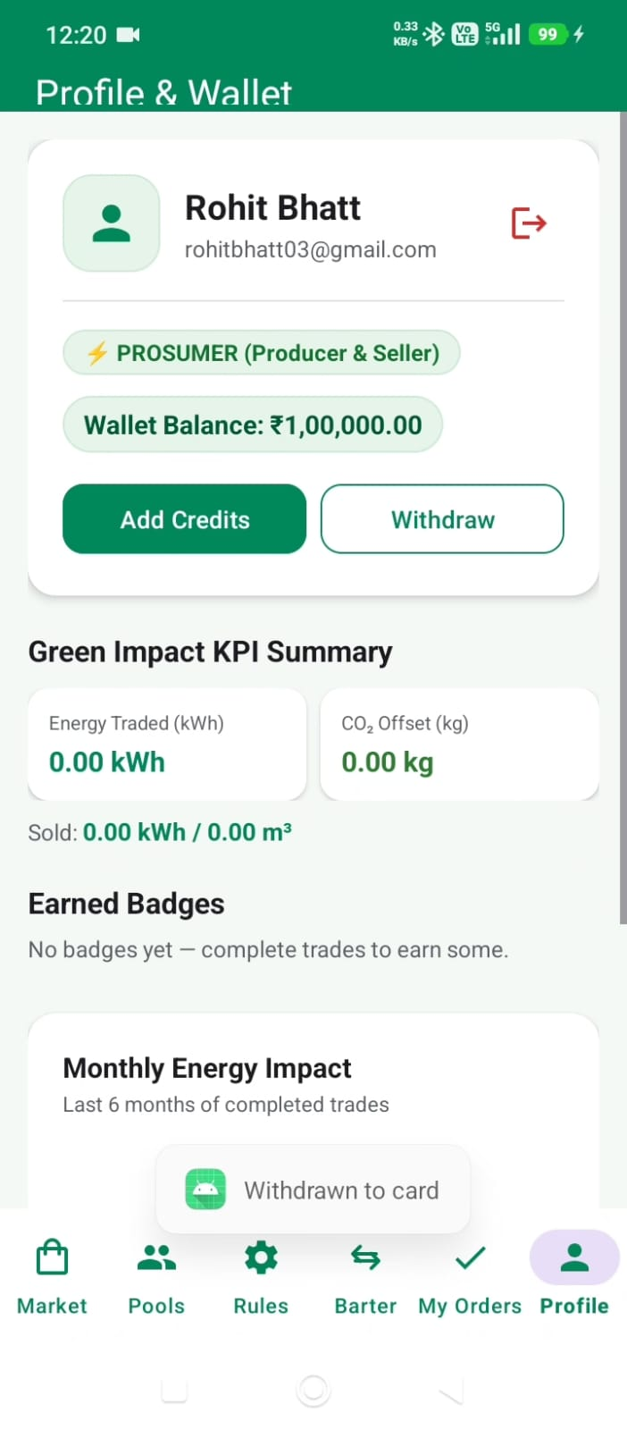
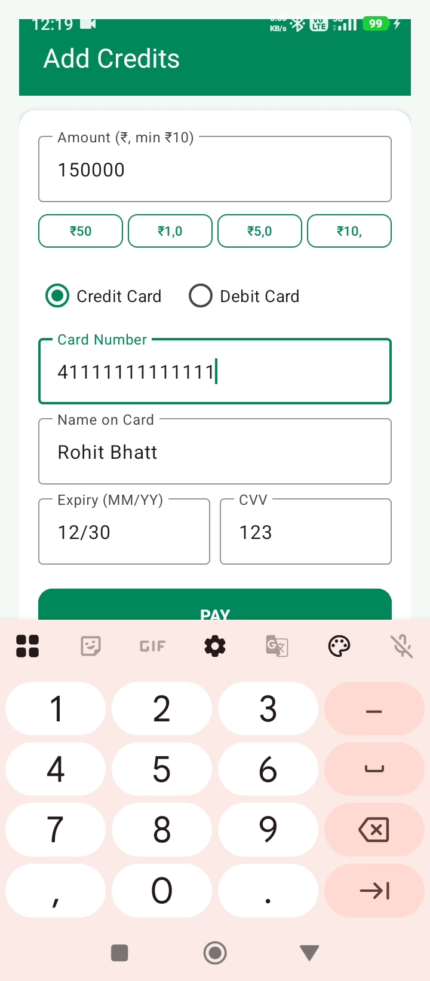

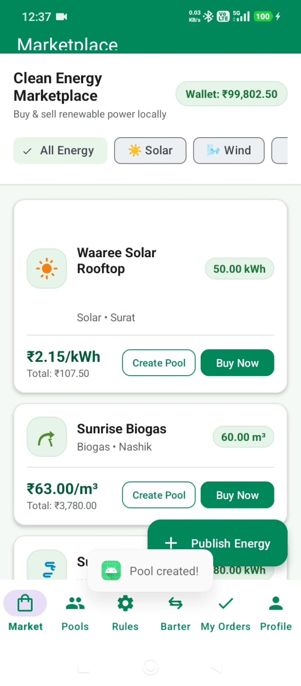
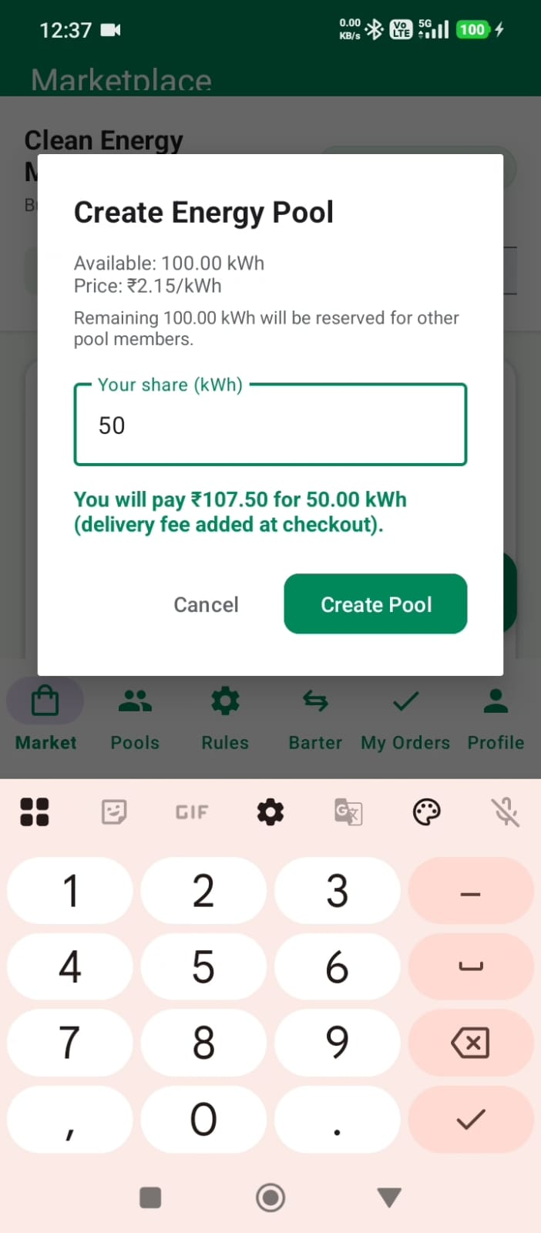
Pooling System
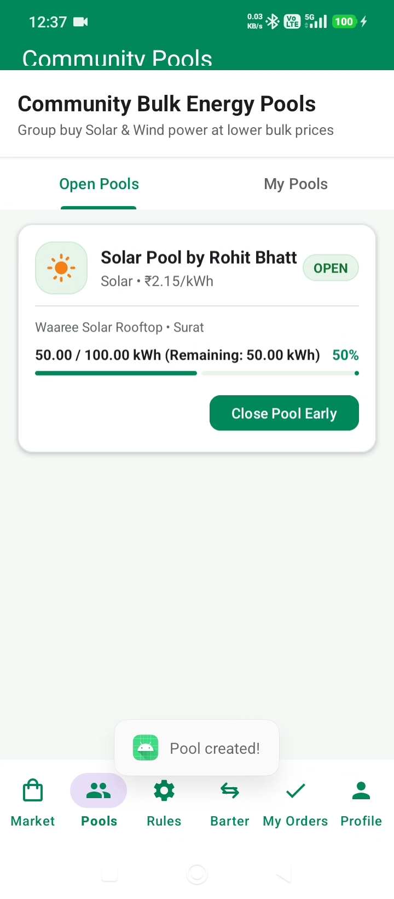

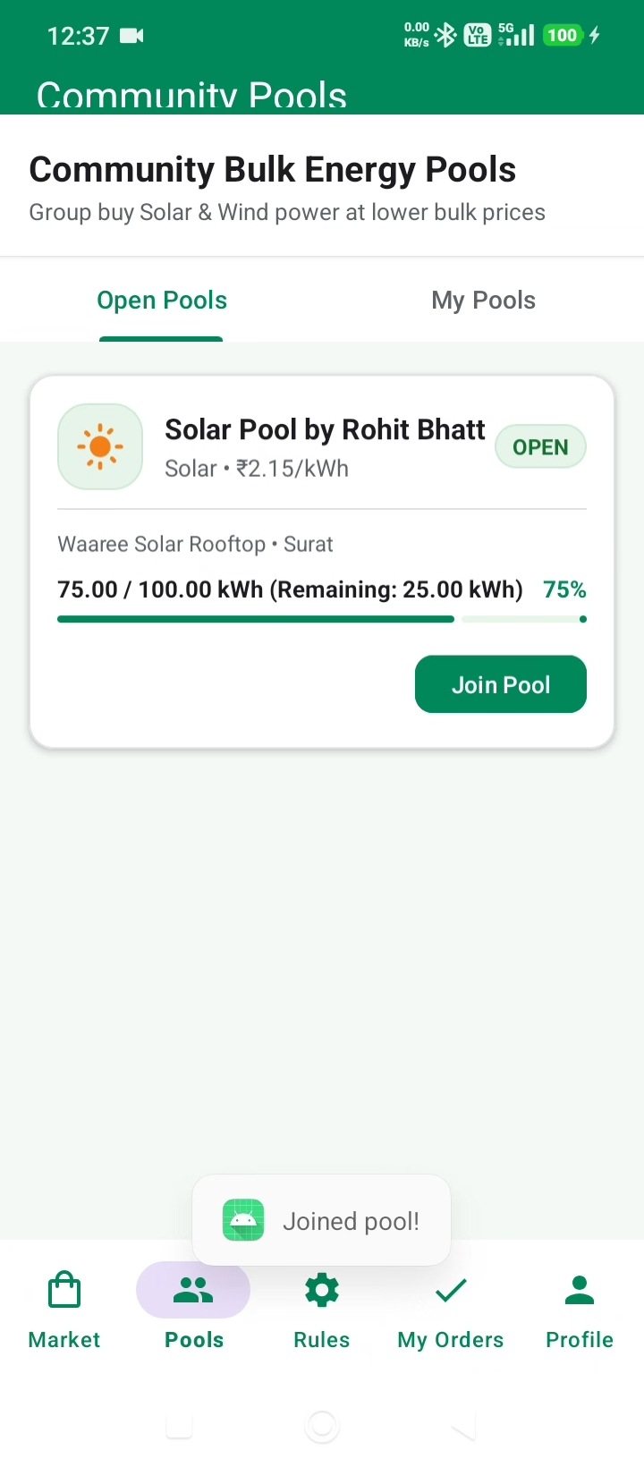
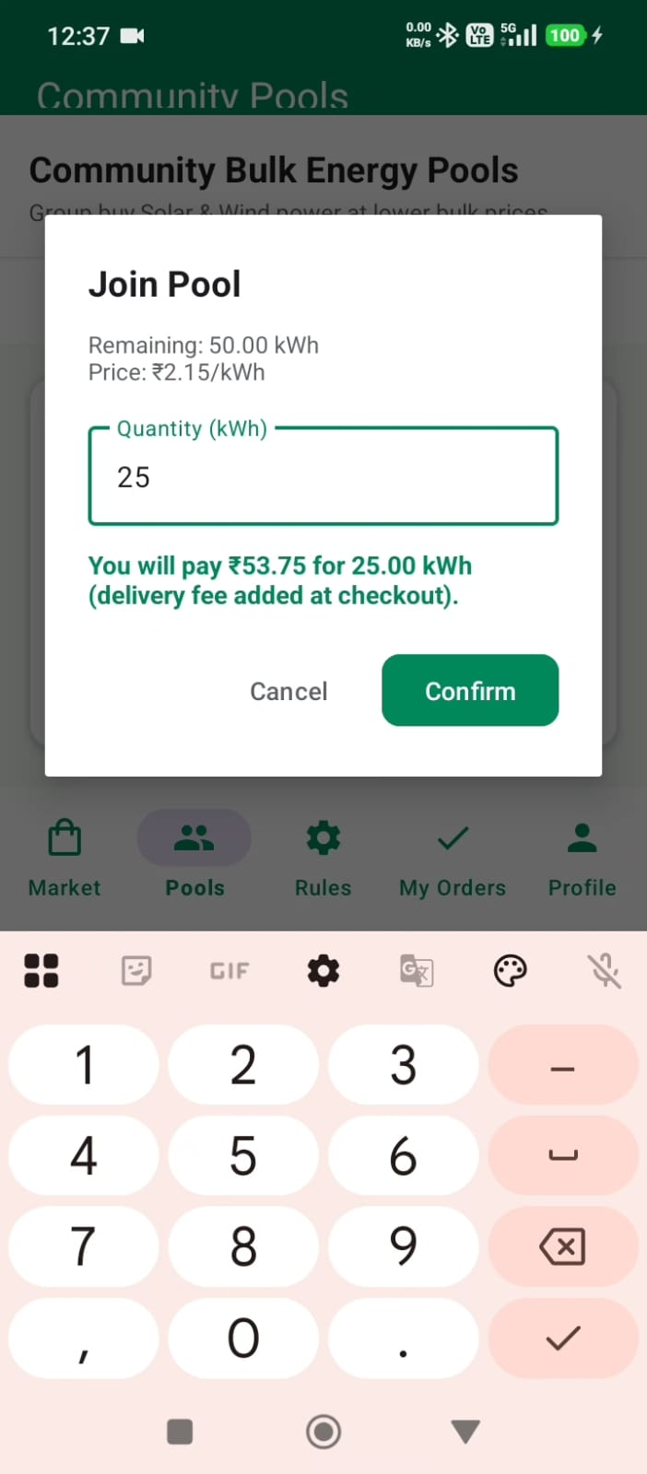

Barter System
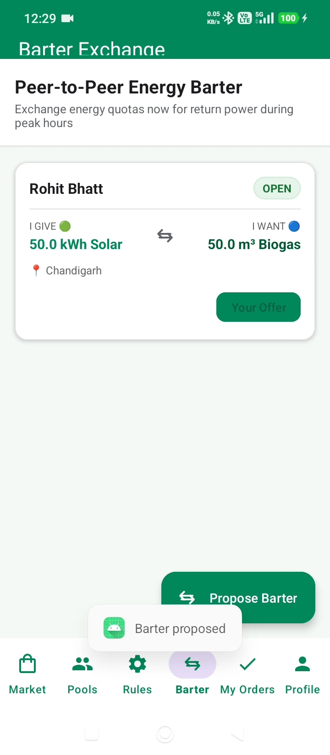
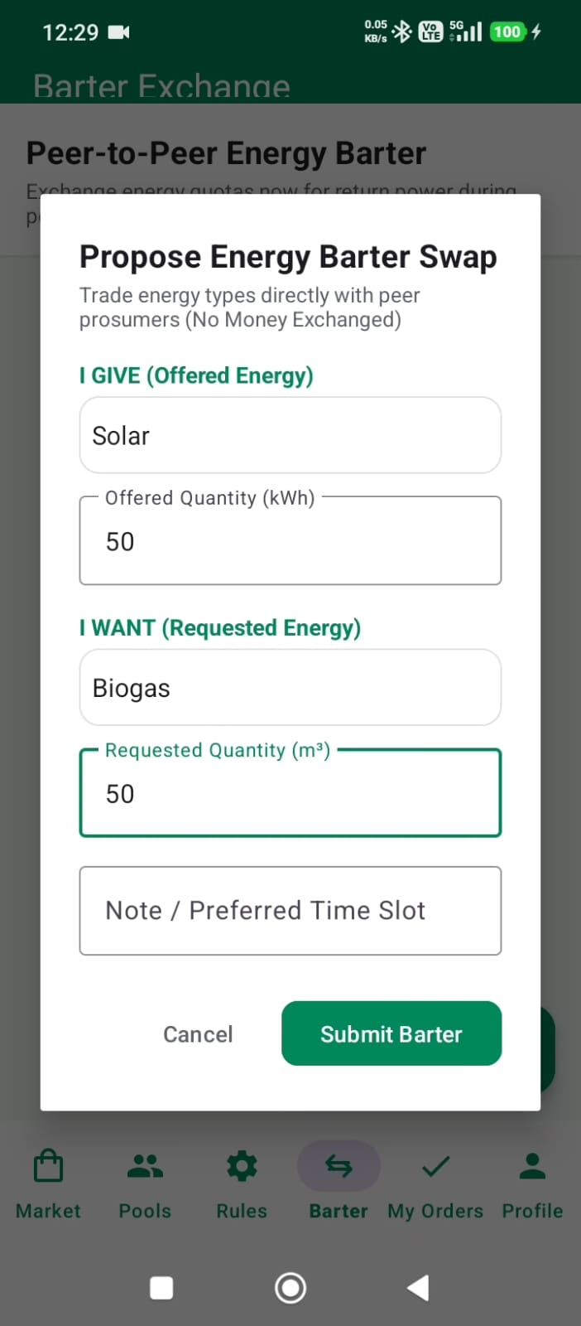
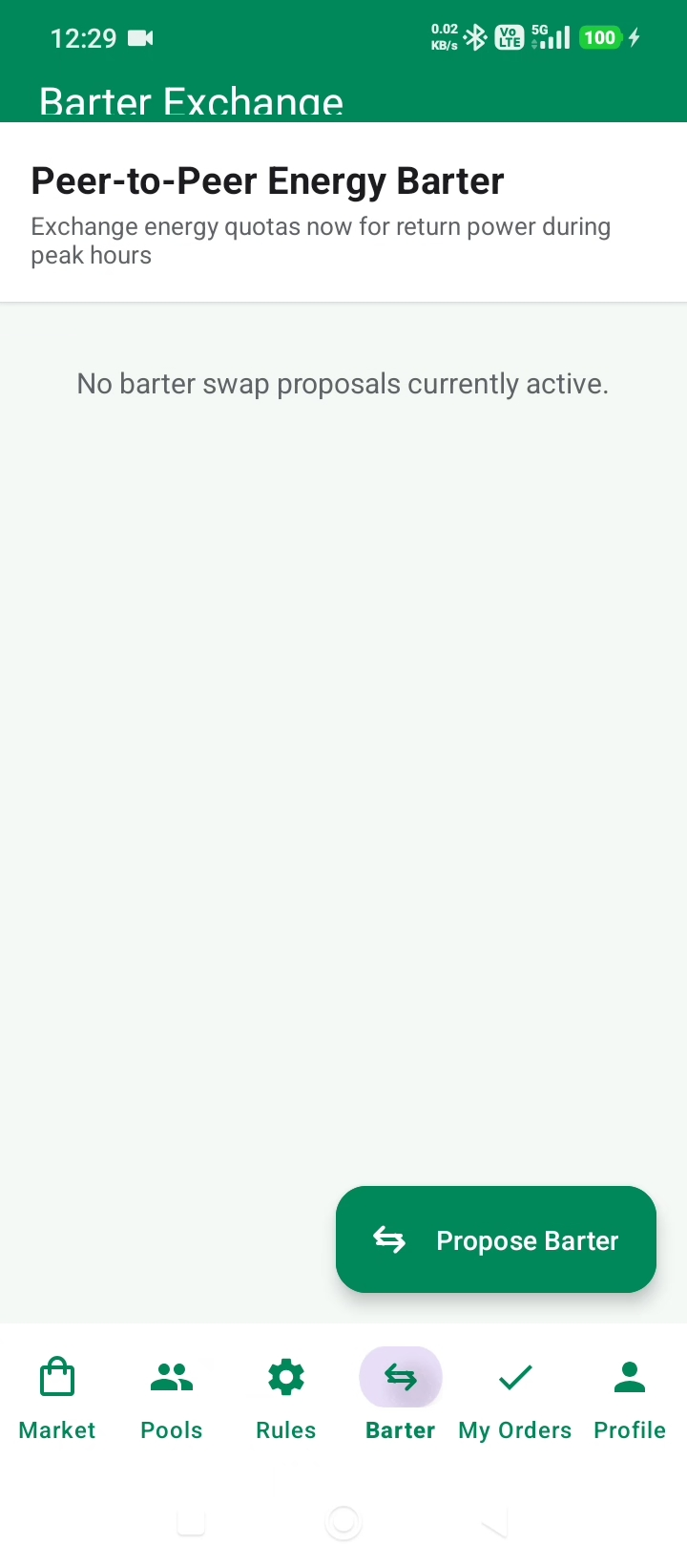

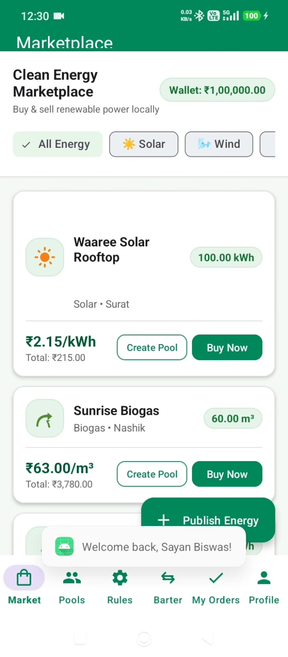
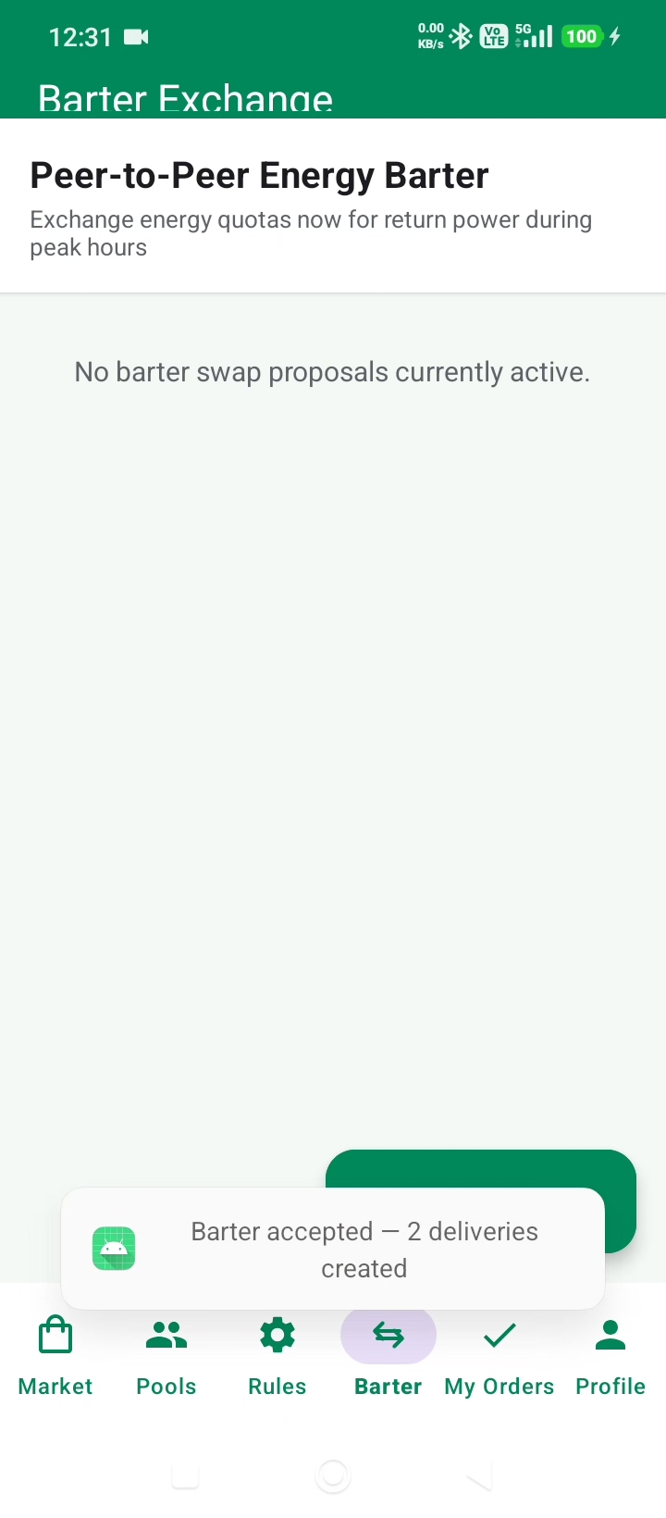
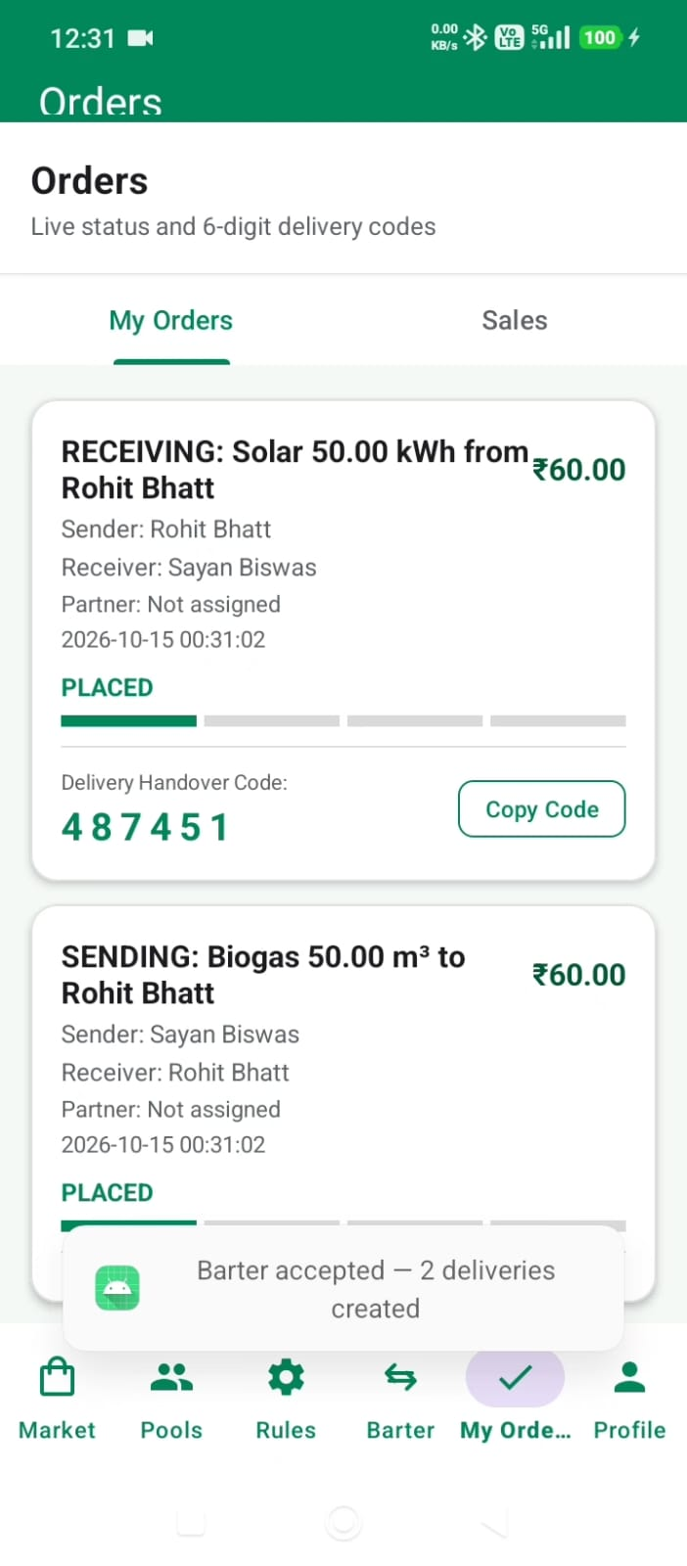

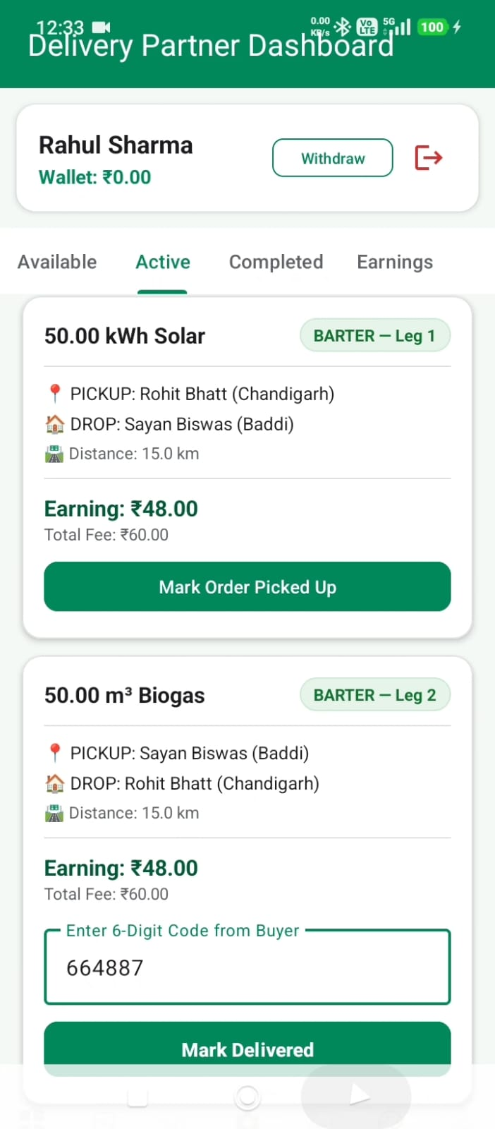
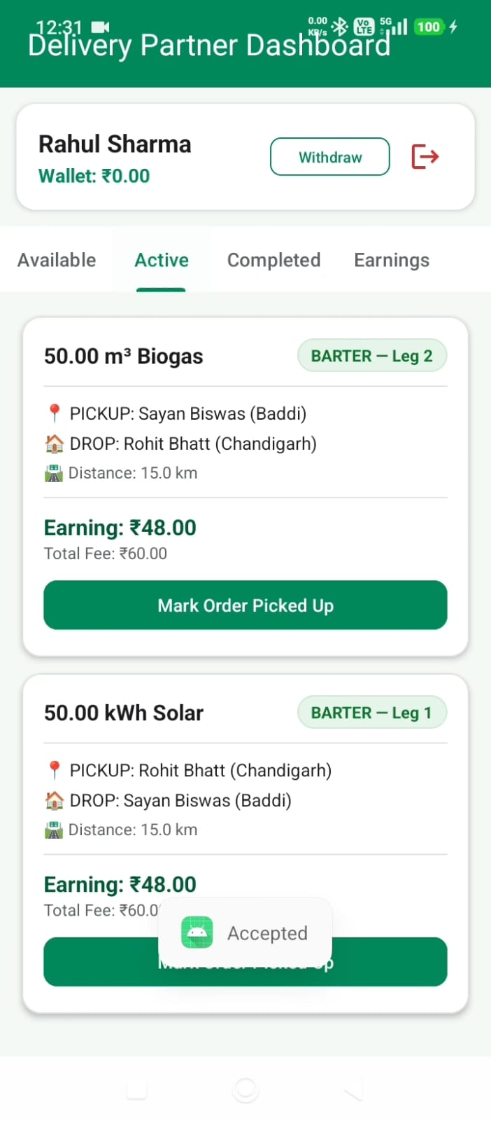
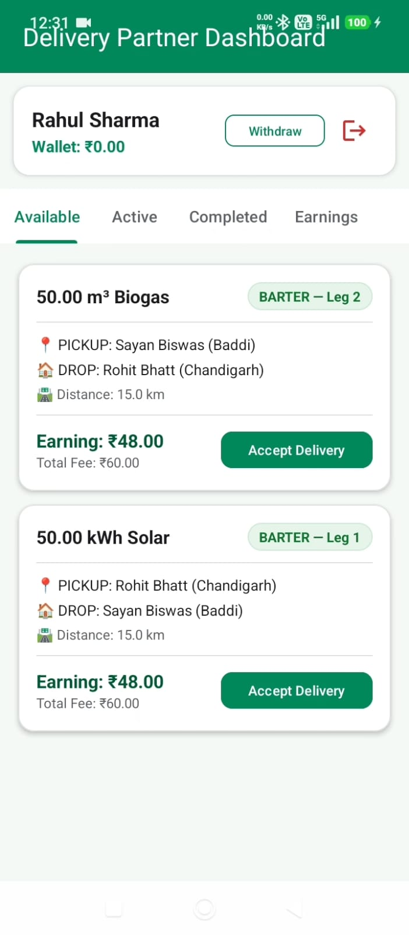
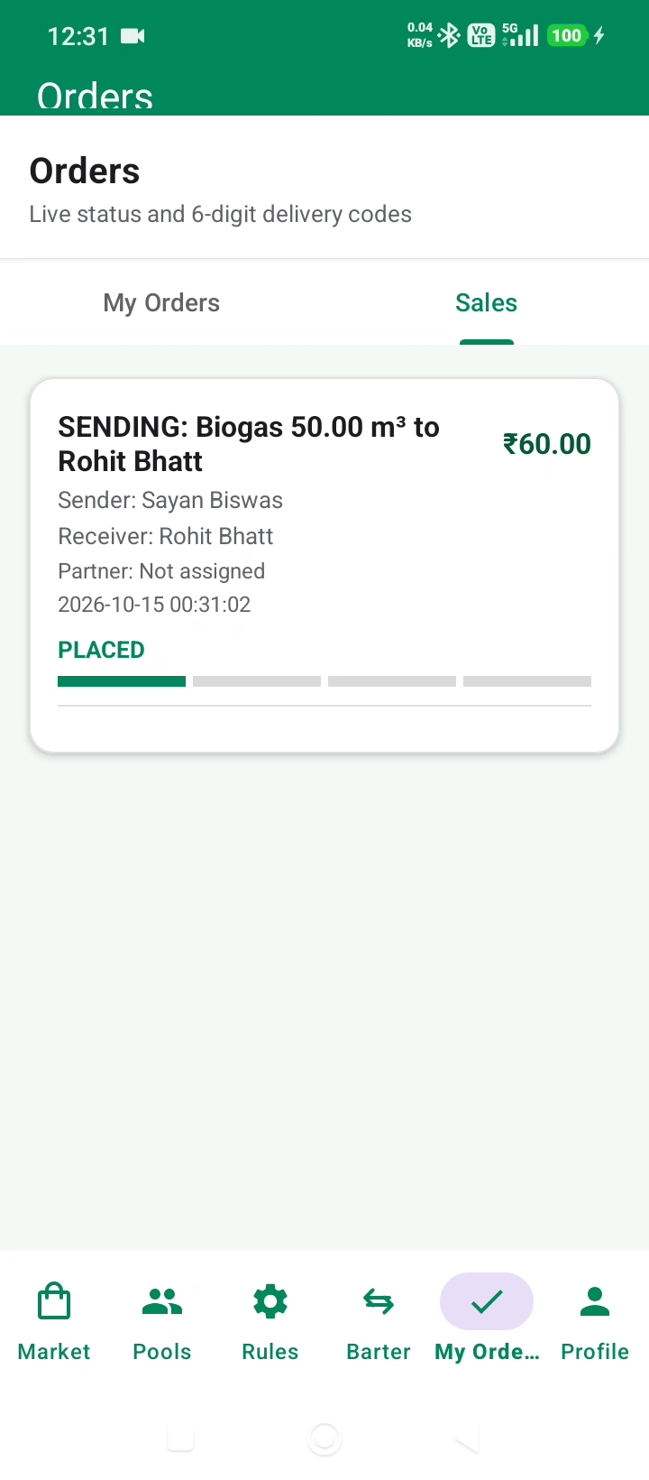
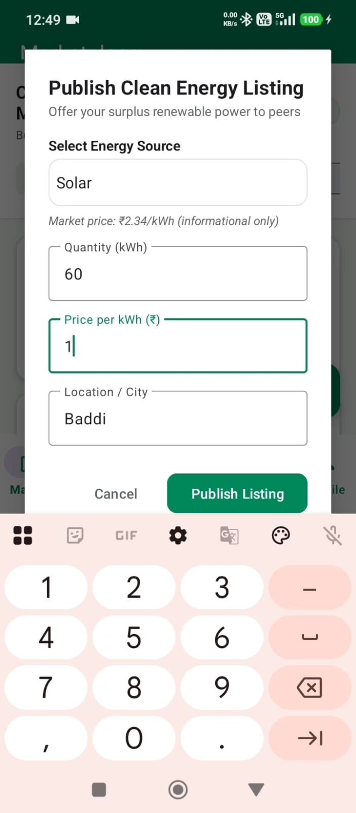
Auto Trade Rule System
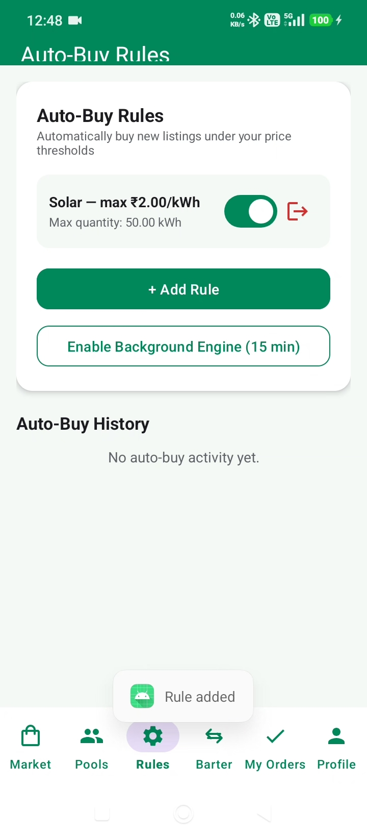
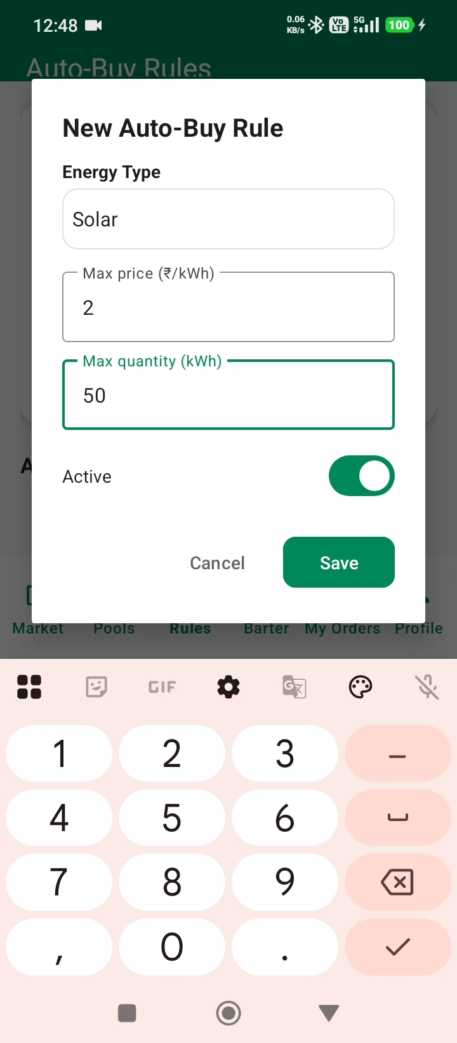

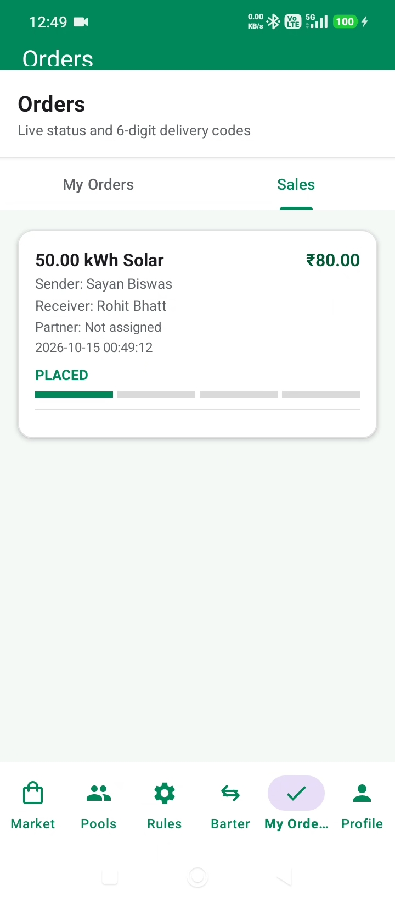
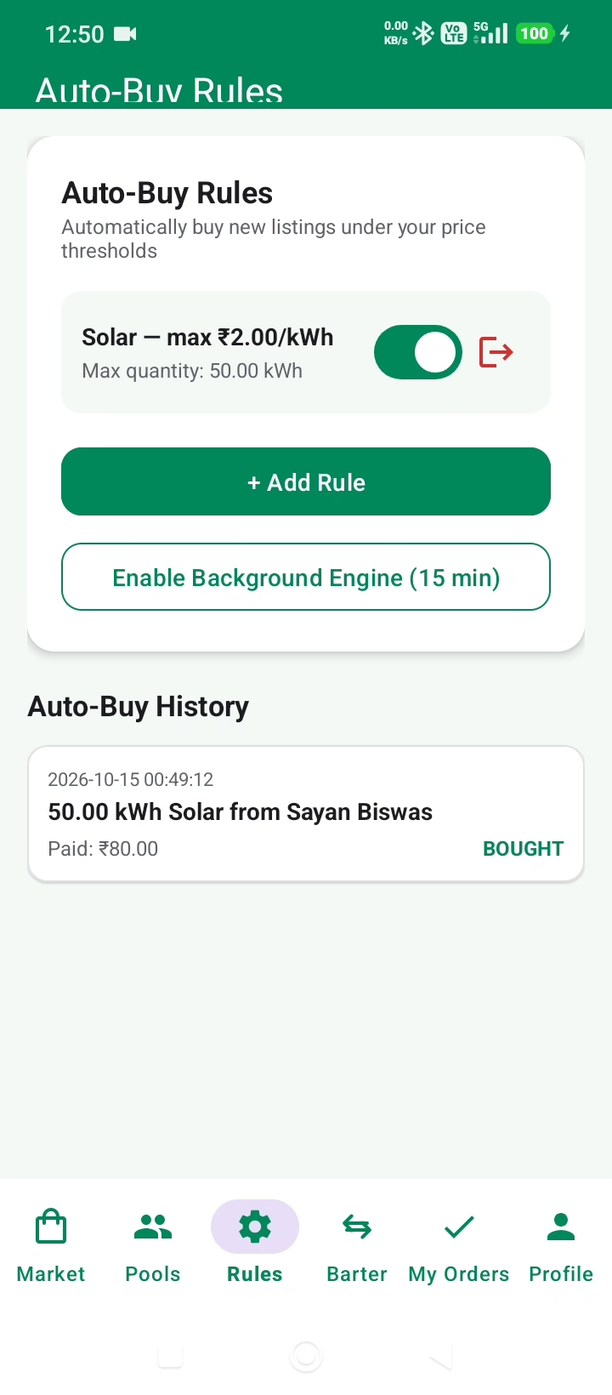
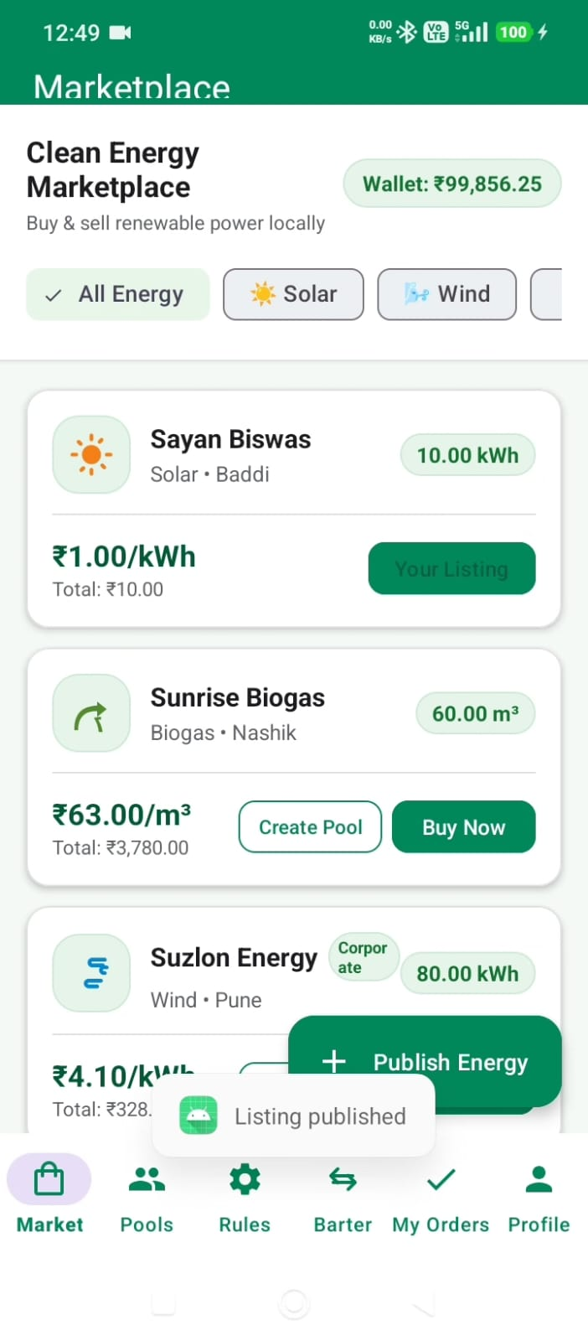

KPI summary , badges, Monthly impact
