**Internet of Things Based Home Automation-**

**1. INTRODUCTION**

IoT stands for Internet of Things. In a very simple manor IoT is use for controlling or nominating the device which are so far away from us. Using different types of protocol we can done easily.

As we know people are increasingly dependent on their smart phone. Using that smart phone they obvious get real-time message and take a decision accordingly. Now-a-days this can be done using TCP/IP protocol to send message directly from the mobile phone.

Therefore the simplest solution is to connect devices to the smart phone. Various advantages of HTTP protocol so that this is our choice. It is very simple, open, lightweight, low bandwidth and very easy to implement messaging protocol. This protocol is used in different types of embedded systems

In this, HTTP and TCP protocols are implementing in ESP8266 Wi-Fi module. With the help of this Wi-Fi device we can control and monitoring our home devices like fan, light, AC, or this type any devices. We can also interface different types of sensor like proximity, PIR sensor.

**1.1OBJECTIVE OF PROJECT –**

The main objective of this project is to design and implement a cheap and open source home automation system that is capable of controlling and automating most of the house appliances. This application is an easy and manageable

Web interface for user to run Home Automation System. In this project we have integrated technologies like Arduino with Wi-Fi to execute Home Automation System. The aim to take Wi-Fi as platform is because people are familiar as

many applications and uses. In this application, we used fans, bulbs etc depicted graphically for better understanding of the users. Users can switch ON/OFF any appliances like fan, tube lights etc as per their convenience through mobile.

This application is scalable to add or delete appliances as per user’s requirement. The project aims at designing advanced home automation system using Wi-Fi technology. The devices can be switched ON/OFF using a Personal Computer (PC) through Wi-Fi. Automation is the most frequently spelled term in the field of electronics.

**1.2 PURPOSE OF PROJECT**

This project deals with the ‘Home Automation’. The main purpose for the project is to be able to communicate with different electrical devices within the home wirelessly. The purpose of the project is to give powers to our smart phone to control any device in our surrounding using intranet or internet.

**1.3 SCOPE OF THE PROJECT-**

Home automation results in a smarter home and is used to provide a higher & healthier standard of living. The beauty of a home automation system is that it is highly scalable, flexible and its capabilities are limited only by our imagination. With the IoT revolution just around the corner, it is high time we move towards widespread adoption of such a system.

**Scope of this project is as follows:-**

* There are two basic element – Server(admin) and Client(user).
* All users have their own profiles.
* The interaction between Server and User is simple to understand.
* At Server side we can view that how many users are connected to the network
* Server can allow multiple users.
* A full suite of control features include remote on/off.

**2. SYSTEM ANALYSIS AND REQUIREMENT DEFINITION:-**

**2.1SYSTEM ANALYSIS-**

System analysis will be performed to determine if it is feasible to design information based on policies and plans of the organization and on user requirements and to eliminate the weaknesses of the present system.

* The new system should be cost effective.
* To augment management, improve productivity and services.
* To enhance user / system interface.
* To improve information qualify and usability

**2.2FEASIBILITY STUDY-**

Feasibility study identifying potential problems and attempts to answer the main question: Will the idea work and should we proceed with it? Before we begin writing your plan we need to identify how, where, and to whom we intend to sell a service or product.

Home automation system face four main challenges, these are high cost of ownership, inflexibility, poor manageability, and difficulty in achieving security. The proposed system has a great flexibility by using Wi-Fi technology to interconnect its distributed sensors to home automation server. This will decrease the deployment cost and will increase the ability of upgrading and system reconfiguration The concept of home automation has been around for a long time and products have been on the market for decades, though no one solution has broken through to the mainstream yet. Home automation for the elderly and disabled can provide increased quality of life for persons who might otherwise require caregivers or institutional care. It can also provide a remote interface to provide control and monitoring via a smart phone or web browser.

**2.3 MODEL USED-**

In this we will use the incremental model. The incremental model has same phases that are in waterfall model. But it is iterative in nature. The incremental model has following phases.

1. Analysis 2. Design 3. Code 4. Test

The incremental model delivers series of releases to the customer. These releases are called increments. More and more functionality is associated with each increment. The first increment is called core product. In this release the basic requirements are implemented and then in subsequent increments new requirements are added. The word processing software package can be considered as an example of incremental model. In the first increment only the document processing facilities are available. In the second increment, more sophisticated document producing and processing facilities, file management functionality are given. In the next increment spelling and grammar checking facilities can be given. Thus, in incremental model progressive functionalities are obtained with each release.

**2.4 SYSTEM REQUIREMENTS-**

**HARDWARE REQUIREMENTS-**

**ESP8266 WIFI MODULE-**

The ESP8266 is the name of microprocessor designed by Espressif system. Espressif is a Chinese company based out of Shanghai. The ESP8266 is a Wi-Fi device capable of running self-contained application. There are a variety of board’s styles available for ESP8266. Here important thing is there is only one ESP8266 processor and it is this processor that is found on all breakout boards.

**A. ESP- 01**

The Esp-01 board is an ESP8266 on an 8 pin board.



Figure : ESP8266 – 01 module Pin Diagram

The pin out of the device is as follows:

Table 1: Esp – 01 Pin

|  |  |
| --- | --- |
| Function | Description |
| TX | Transmit |
| RX | Receive |
| CH_PD | chip enable [0-disable, 1-enable] |
| GPIO 0 | Should be high on boot,low for flash update. |
| GPIO 2 | Should be high on boot |
| RST | External reset [0- reset,1-normal] |
| VCC | 3.3volt |
| GND | Ground pin |

* ARDUINO UNO R3 DEVELOPMENT BOARD

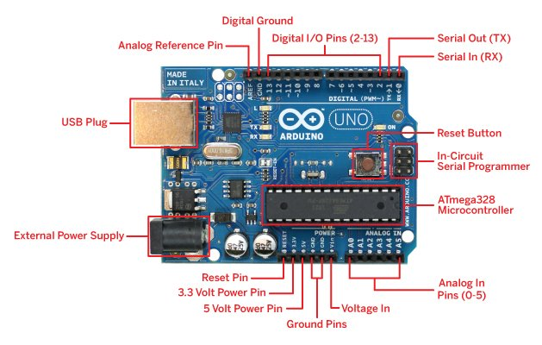

* PC HAVING ANY OS
* JUMPER WIRES
* USB CABLE
* WI-FI ROUTER[Cell phone hotspot]
* RELAY MODULE
* BULB

**SOFTWARE REQUIREMENTS-**

* ARDUINO IDE
* ESP8266 development board.
* Client with in a network with web browser of any OS

**LIBRARY USED-**

ESP8266 WEBSERVER

ESP8266 WIFI

ESP8266 WIFI-MASTER

**2.5 IMPLEMENTATION TOOLSAND LANGUAGE-**

* C
* java

**2.6 CONSTRAINTS**

* Login and Password is used for the identification of users.
* Only registered person will be authorized to use the services
* The clock speed of server should be almost 2.33 GHz.
* User must be connected to the network.

**3.SOFTWARE DESIGN-**

**3.1 USE-CASE DIAGRAMS:-**

**1.**

Ssid,Password

USER

SSid,pass

Wrong

Wrong SSID,Password

Fig. User connects to network

**2.**

0

USER

Ip address

Wrong 1

Ip address

Fig. User(Client) controlling devices through webpage

**3.2 ER Diagram:-**

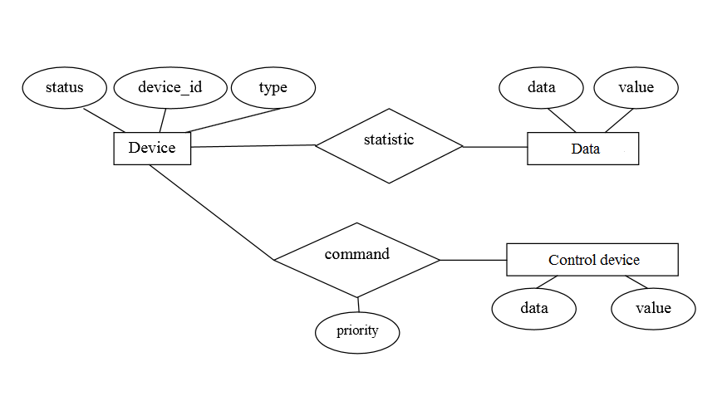

**3.3 Data Flow Diagram :-**



**Gpio/0**

SERVER

USER

(client)

**Gpio is low now**

**Fig.1.1**

**Gpio/1**

SERVER

USER

(client)

**Gpio is High now**

**Fig.1.2**

Fig. Communication b/w client and web server

**4. IMPLEMENTATION-**

**Basic Functions of Arduino IDE-**

The **setup()**function is called when a sketch starts. Use it to initialize variables, pin modes, start using libraries, etc. The setup function will only run once, after each power up or reset of the Arduino board.

After creating a setup() function, the **loop()** function does precisely what its name suggests, and loops consecutively, allowing your program to change and respond as it runs. Code in the loop() section of your sketch is used to actively control the Arduino board.

The code below won't actually do anything, but it's structure is useful for copying and pasting to get you started on any sketch of your own. It also shows you how to make comments in your code.

Any line that starts with two slashes (//) will not be read by the compiler, so you can write anything you want after it. Commenting your code like this can be particularly helpful in explaining, both to yourself and others, how your program functions step by step.

void **setup**() {

// put your setup code here, to run once:

}

void **loop**() {

// put your main code here, to run repeatedly:

}

▪ **setup()**

The setup() function is called when a sketch starts. Use it to initialize variables, pin modes, start using libraries, etc. The setup function will only run once, after each power up or reset of the Arduino board.

▪ **loop()**

After creating a setup() function, which initializes and sets the initial values, the loop() function does precisely what its name suggests, and loops consecutively, allowing your program to change and respond. Use it to actively control the Arduino board.

**Circuit Working Principle:**

1. The entire appliance attached to relay are controlled by Microcontroller.

2. ESP8266 is a wifi module interface to Microcontroller for wireless communication.

3. We create a web server using ESP8266 and monitor all changes by serial monitor and bulb along with controlling relays.

4. There is a webpage which can be access through any device connected to home wifi router, that page can be

access by putting IP address of ESP8266.

5. When we switch ON or OFF the button from web server wifi router gives command to wifi module and then itgives command to Microcontroller.

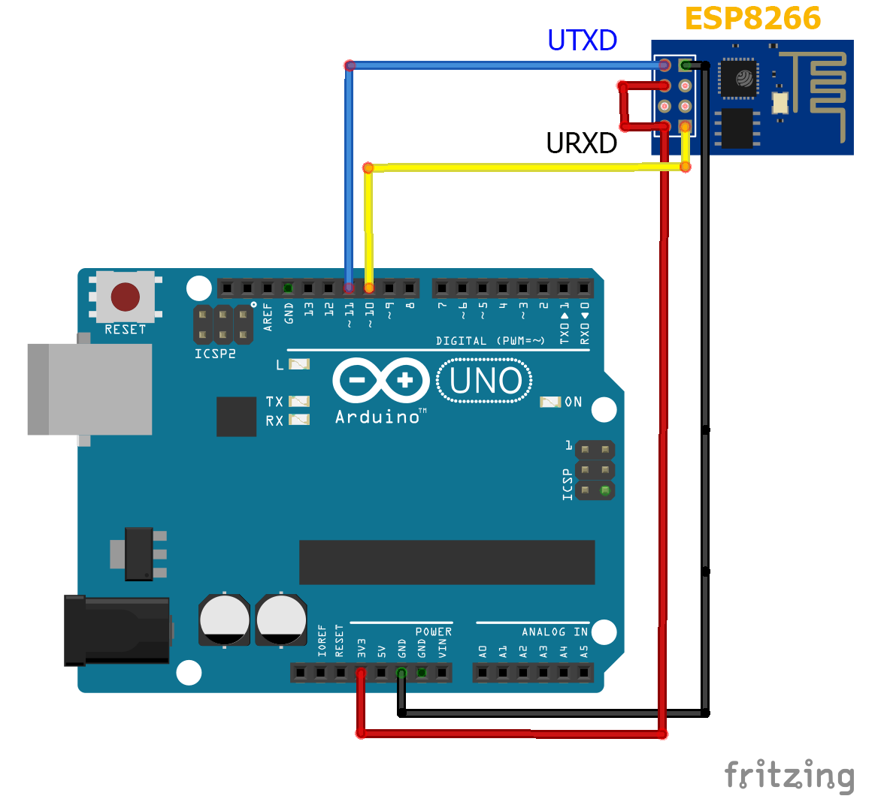

**Fig. ESP8266 AND ARDUINO UNO CONNECTION**

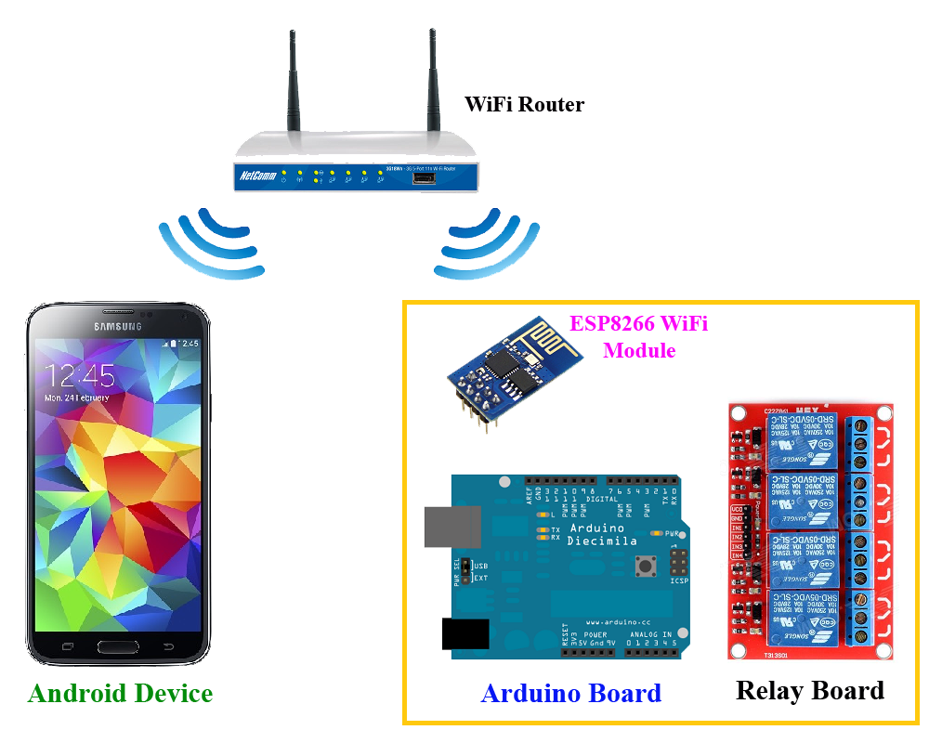

**FIG. COMMUNICATION BETWEEN CLIENT AND SERVER**

**5. System Testing**:

System testing is the stage of implementation that is aimed at ensuring that the system works accurately and efficiently for live operation commences. Testing is vital to the success of the system. System testing makes a logical assumption that if all the parts of the system are correct, then goal will be successfully achieved.

**Output Testing**:

Output testing of the proposed system since no system could be useful if it does not produce the required output in the specified format. The output format on the screen is found to be correct as the format was designed in the system designed phase according to the user needs. Hence output testing does not result any corrections in the system.

**User Acceptance Testing:**

User acceptance of a system is the key factor of the success of any system. The system under study is tested for the user acceptance by constantly keeping in touch with the prospective system users at the time of developing and making changes wherever required.

**Test Data:**

Preparation of test data plays a vital role in the system testing after preparing the test data the system under study is tested using the test data. While testing the system by using the test data errors are again uncovered and corrected by using testing steps and corrections are also noted from the future use.

**Testing Results-**

|  |  |  |  |  |
| --- | --- | --- | --- | --- |
| Name | Input Required | Expected Output | Actual Output | Test |
| Code compilation | input code | Error free compilation | Error free compilation | Pass |
| Deploy code to ESP8266 chip | Connect RX,TX of Arduino to ESP8266 | Blinking of blue LED of ESP8266 while uploading | Blinking of blue LED of ESP8266 while uploading | Pass |
| Run ESP8266(SERVER EXECUTION) | 5v supply from arduino | SERVER Started | SERVER Started | Pass |
| Client Connection With Network | SSID & PASSWORD OF Router | Connected with the Network | Connected with the Network | Pass |
| DEVICE Control Tesing | 1.AC Supply to the Electric Device  2. Input from the webpage of the Client | Switching ON/OFF of Electric Device according to Client input | Switching ON/OFF of Electric Device according to Client input | Pass |

**6. FUTURE SCOPE-**

This project is described architecture and implementation of home automation system. The implemented system uses basic electronic development boards to minimize the system development cost. Apart from this the low cost, the smartness of the automation system can be justified with the automation scripts that can be customized by the user, even at runtime. The complete system efficiently utilizes the existing network infrastructure with the help of TCP protocol. The ESP8266 Wi-Fi module only provides a single analog input, which creates difficulty in interfacing multiple analog sensors. The issue can be resolved by integrating a separate Analog IO Expander circuit with the Wi-Fi module.

**7.CONCLUSION-**

It is evident from this project that an individual control home automation system can be cheaply made from low cost ESP8266 & available components and can be used to control multifarious home appliances ranging from the security lamps, the television to the air conditioning system and even the entire house lighting system. And better still, the components required are so small and few that they can be packaged into a small conspicuous container. The designed home automation system was tested a number of times and certified to control different home appliances used in the lighting system, air conditioning system, heating system, home entertainment system and many more (this is as long as the maximum power and current rating of the appliance does not exceed that of the used relay).

**8. SCREENSHOTS-**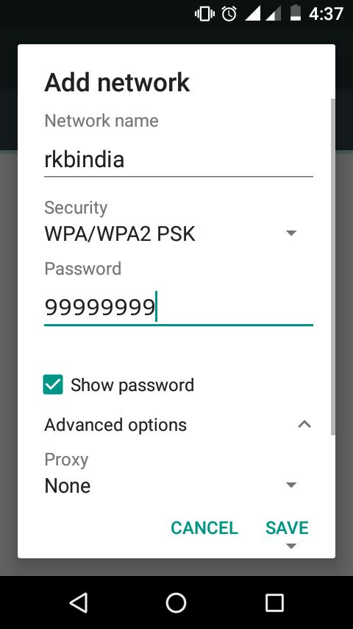

**Client communicating with GPIO through web browser-**

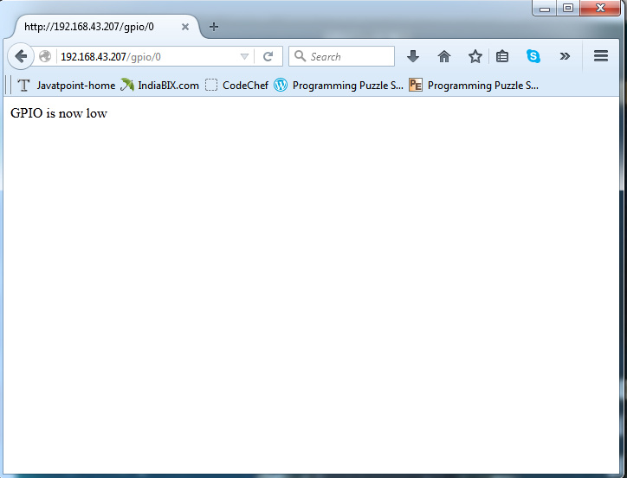

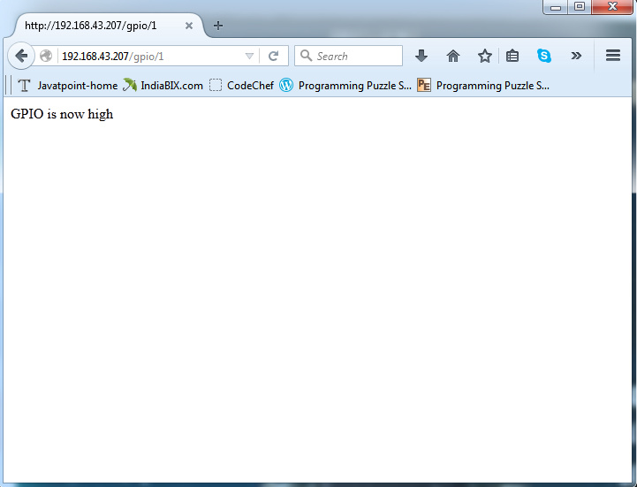

**9.REFERENCES-**

[WWW.ARDUINO.CC](http://WWW.ARDUINO.CC)

[WWW.ESP8266.COM](http://WWW.ESP8266.COM)

[WWW.WIKIPEDIA.ORG](http://WWW.WIKIPEDIA.ORG)

[WWW.ALLABOUTEE.COM](http://WWW.ALLABOUTEE.COM)