ASSIGNMENT-3

M.ROHITH

Rg.no: 192324121

# **1.** **Counting Elements**

Given an integer array arr, count how many elements x there are, such that x + 1 is also in arr. If there are duplicates in arr, count them separately.

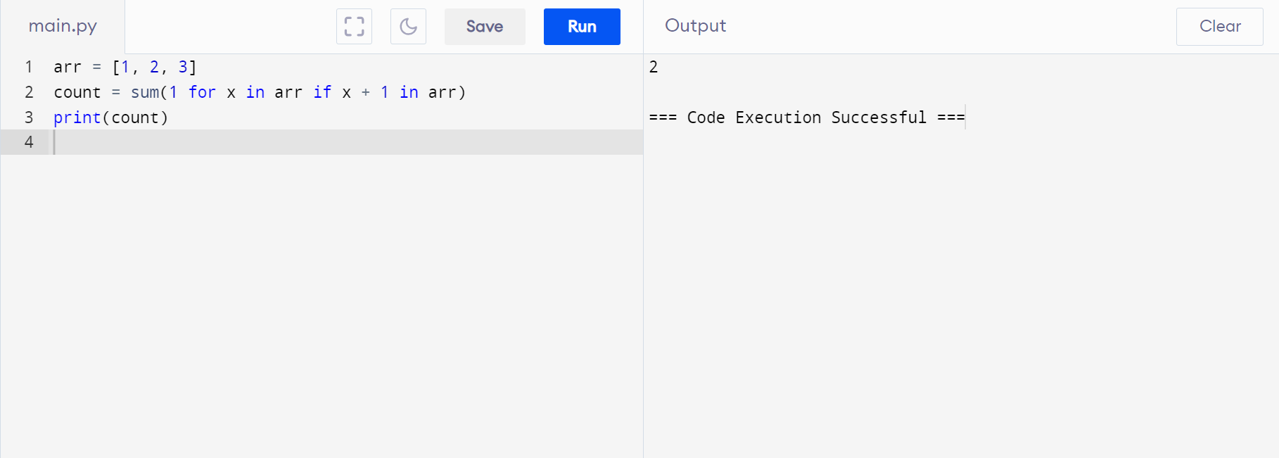

# 2. **Perform String Shifts**

You are given a string s containing lowercase English letters, and a matrix shift, where shift[i] = [directioni, amounti]:

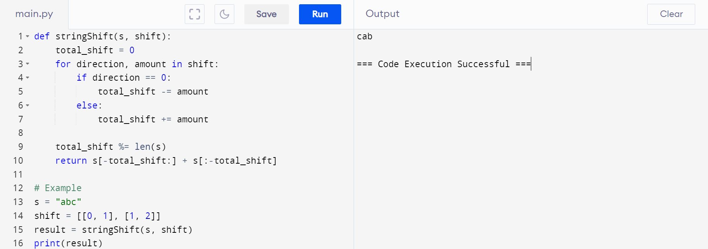

# **3.** . **Leftmost Column with at Least a One**

A row-sorted binary matrix means that all elements are 0 or 1 and each row is sorted in non-decreasing order.

Given a row-sorted binary matrix binary matrix, return *the index (0-indexed) of the leftmost column with a 1 in it*. If such an index does not exist, return -1.

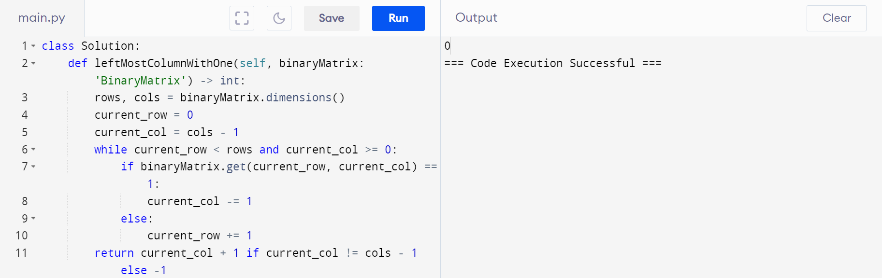

# **4.** . **First Unique Number**

You have a queue of integers, you need to retrieve the first unique integer in the queue. Implement the FirstUnique class

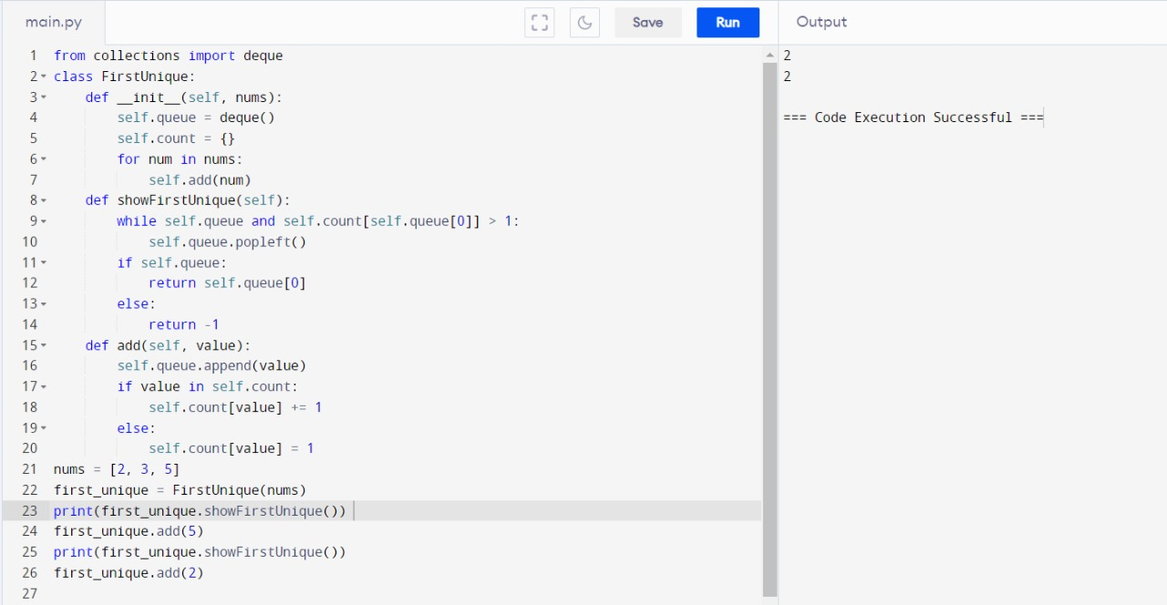

5. Check If a String Is a Valid Sequence from Root to Leaves Path in a Binary Tree Given a binary tree where each path going from the root to any leaf form a valid sequence, check if a given string is a valid sequence in such binary tree. We get the given string from the concatenation of an array of integers arr and the concatenation of all values of the nodes along a path results in a sequence in the given binary tree.

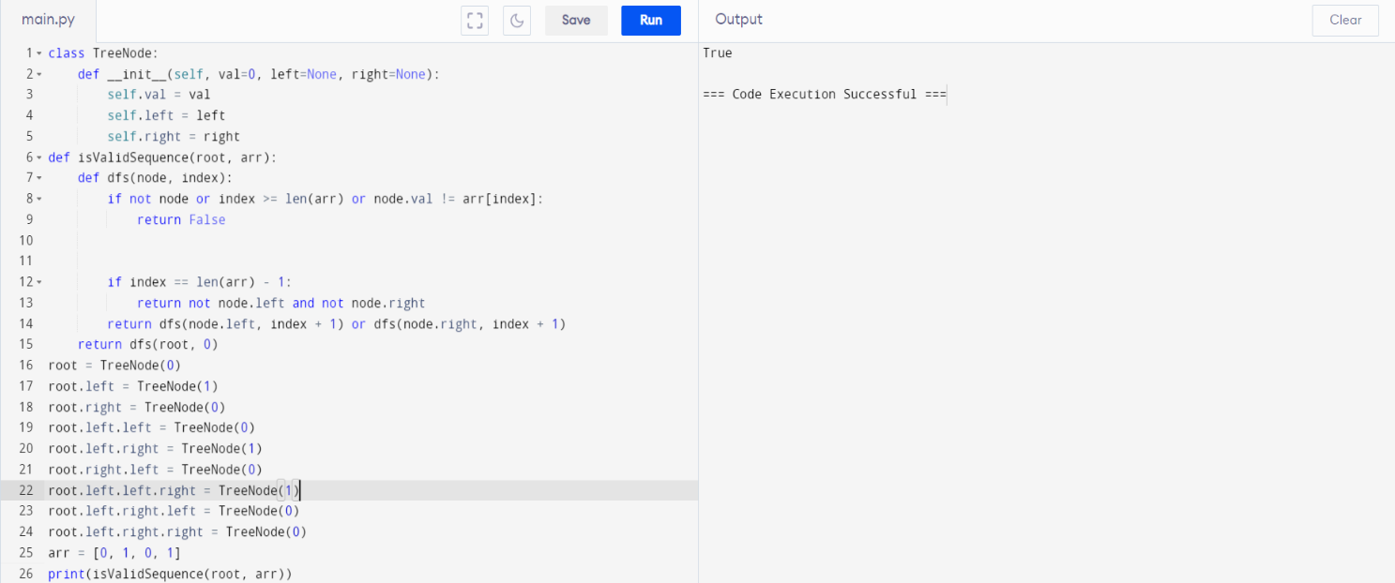

# **6.** **Kids With the Greatest Number of Candies**

There are n kids with candies. You are given an integer array candies, where each candies[i] represents the number of candies the ith kid has, and an integer extra candies, denoting the number of extra candies that you have.

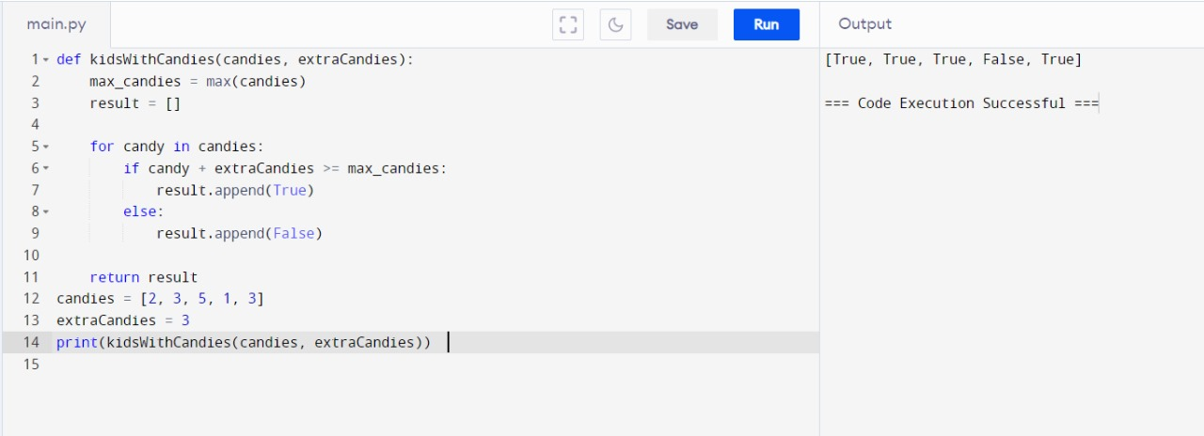

# **7. Max Difference**

# You Can Get From Changing an Integer You are given an integer number. You will apply the following steps exactly two times:

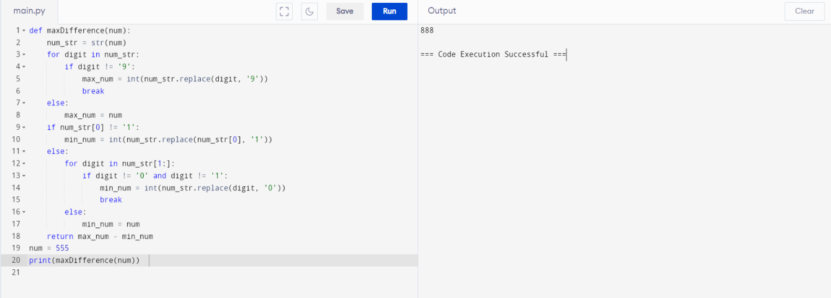

# **8.** Check If a **String Can Break Another String**

Given two strings: s1 and s2 with the same size, check if some permutation of string s1 can break some permutation of string s2 or vice-versa. In other words s2 can break s1 or vice-versa.

A string x can break string y (both of size n) if x[i] >= y[i] (in alphabetical order) for all i between 0 and n-1.

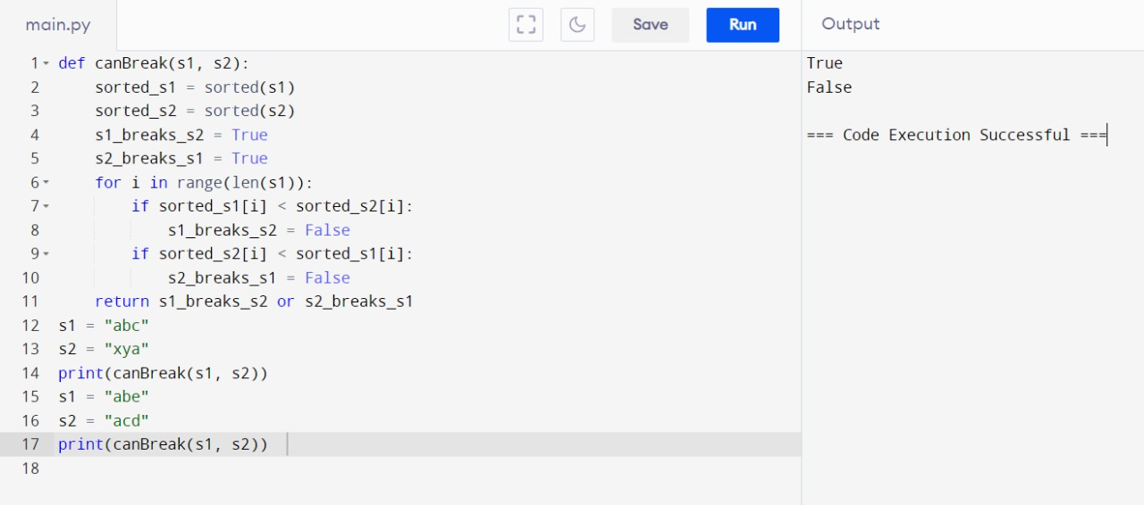

# **9.** . **Number of Ways to Wear Different Hats to Each Other**

There are n people and 40 types of hats labeled from 1 to 40.

Given a 2D integer array hats, where hats[i] is a list of all hats preferred by the ith person.

Return *the number of ways that the n people wear different hats to each other*. Since the answer may be too large, return it modulo 109 + 7.

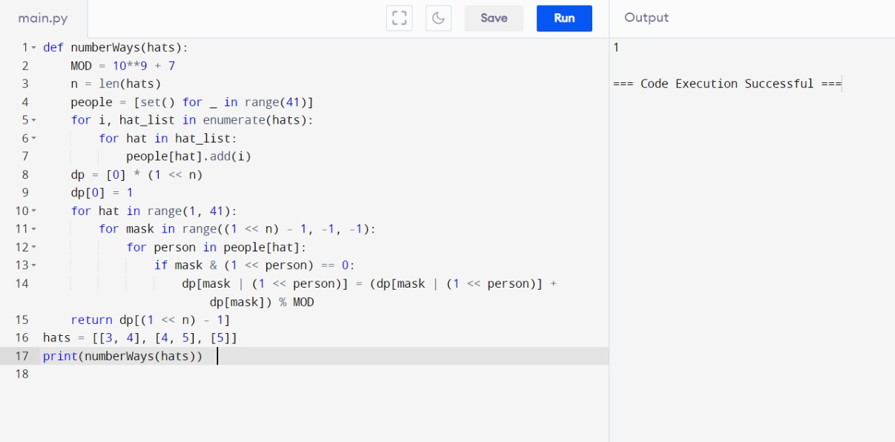

# **10. Next Permutation**

A permutation of an array of integers is an arrangement of its members into a sequence or linear order.

